Time Series Analysis Report
Retail Sales Data

Executive Summary
This report presents a comprehensive diagnostic analysis of the retail sales time series data spanning from 2015-01-01 to 2024-12-01 with 120 monthly observations.

Key Findings
- The data is FORECASTABLE - exhibits predictable patterns suitable for forecasting
- NON-STATIONARY series requiring 1 order of differencing (d=1)
- STRONG SEASONALITY detected with a 12-month period (strength: 0.95)
- STRONG UPWARD TREND with increasing direction (strength: 0.98)
- No transformation needed - variance is stable

1. Data Overview

1.1 Data Quality
Metric | Value
Observations | 120
Date Range | 2015-01-01 to 2024-12-01
Frequency | monthly
Missing Values | 0 (0%)

1.2 Distribution Statistics
Statistic | Value
Mean | 87131.27
Median | 88524.50
Std Deviation | 22759.07
Minimum | 33927.00
Maximum | 134022.00
Skewness | -0.0878
Kurtosis | -0.7220

1.3 Time Series Plot
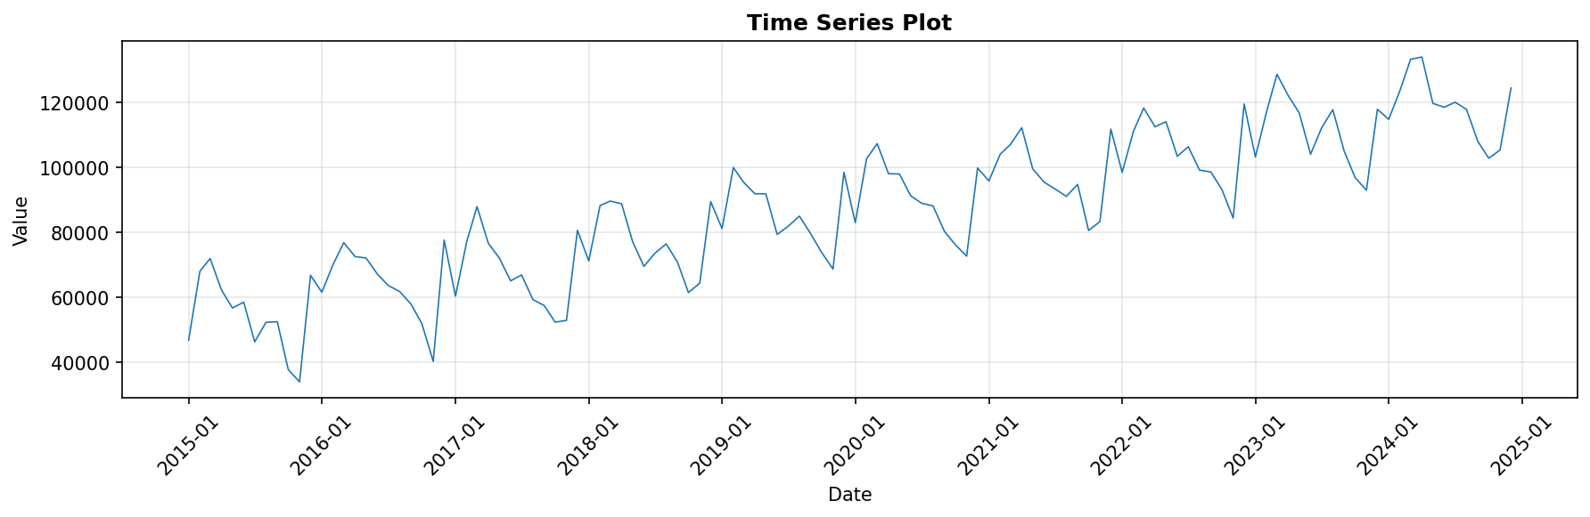

1.4 Distribution
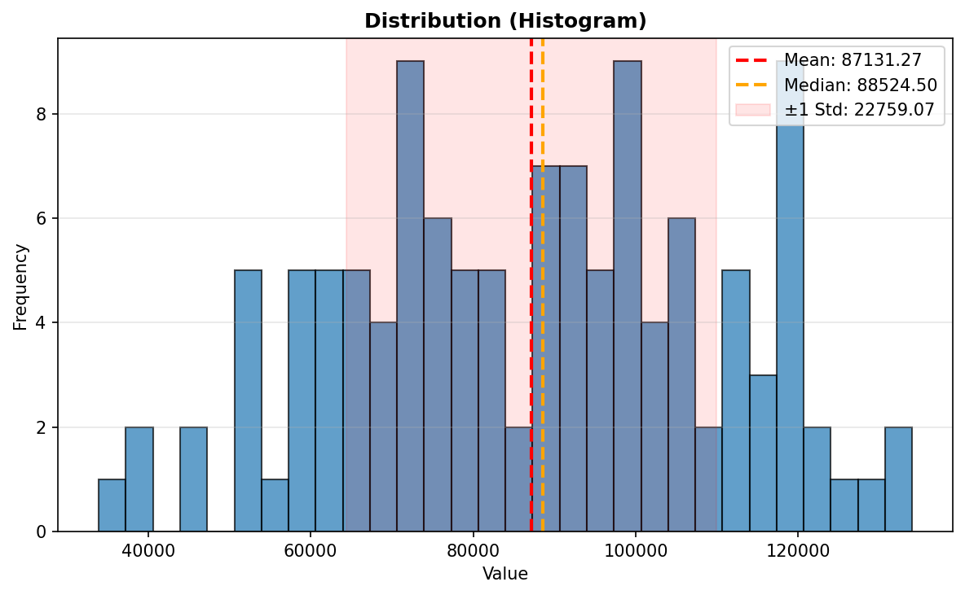

2. Stationarity Analysis
Stationarity tests assess whether the statistical properties of the series remain constant over time. Both the Augmented Dickey-Fuller (ADF) and KPSS tests indicate the series is non-stationary, requiring differencing for modeling.

Test | Statistic (p-value) | Result
ADF Test | -0.6415 (p=0.8613) | Non-stationary
KPSS Test | 1.6810 (p=0.0100) | Non-stationary
Differencing Needed | d = 1 | Verified

Interpretation: The series requires one order of differencing (d=1) to achieve stationarity. This is common in economic time series with trends.

2.1 Rolling Mean and Standard Deviation
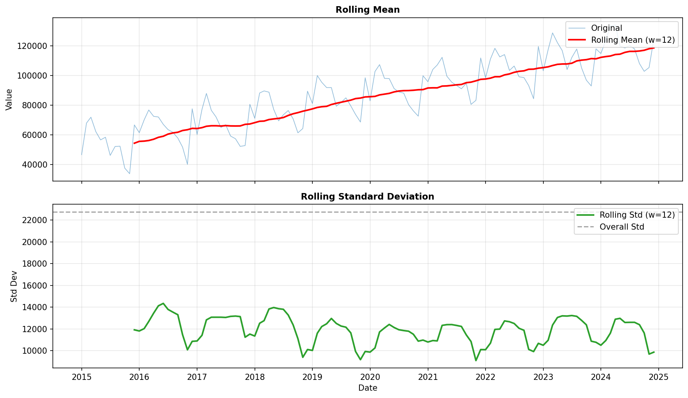

3. Seasonality Analysis
Seasonal decomposition reveals strong recurring patterns in the data.

Metric | Value
Seasonal | Yes
Period | 12 months
Strength | 0.9459 (strong)

3.1 Seasonal Decomposition (STL)
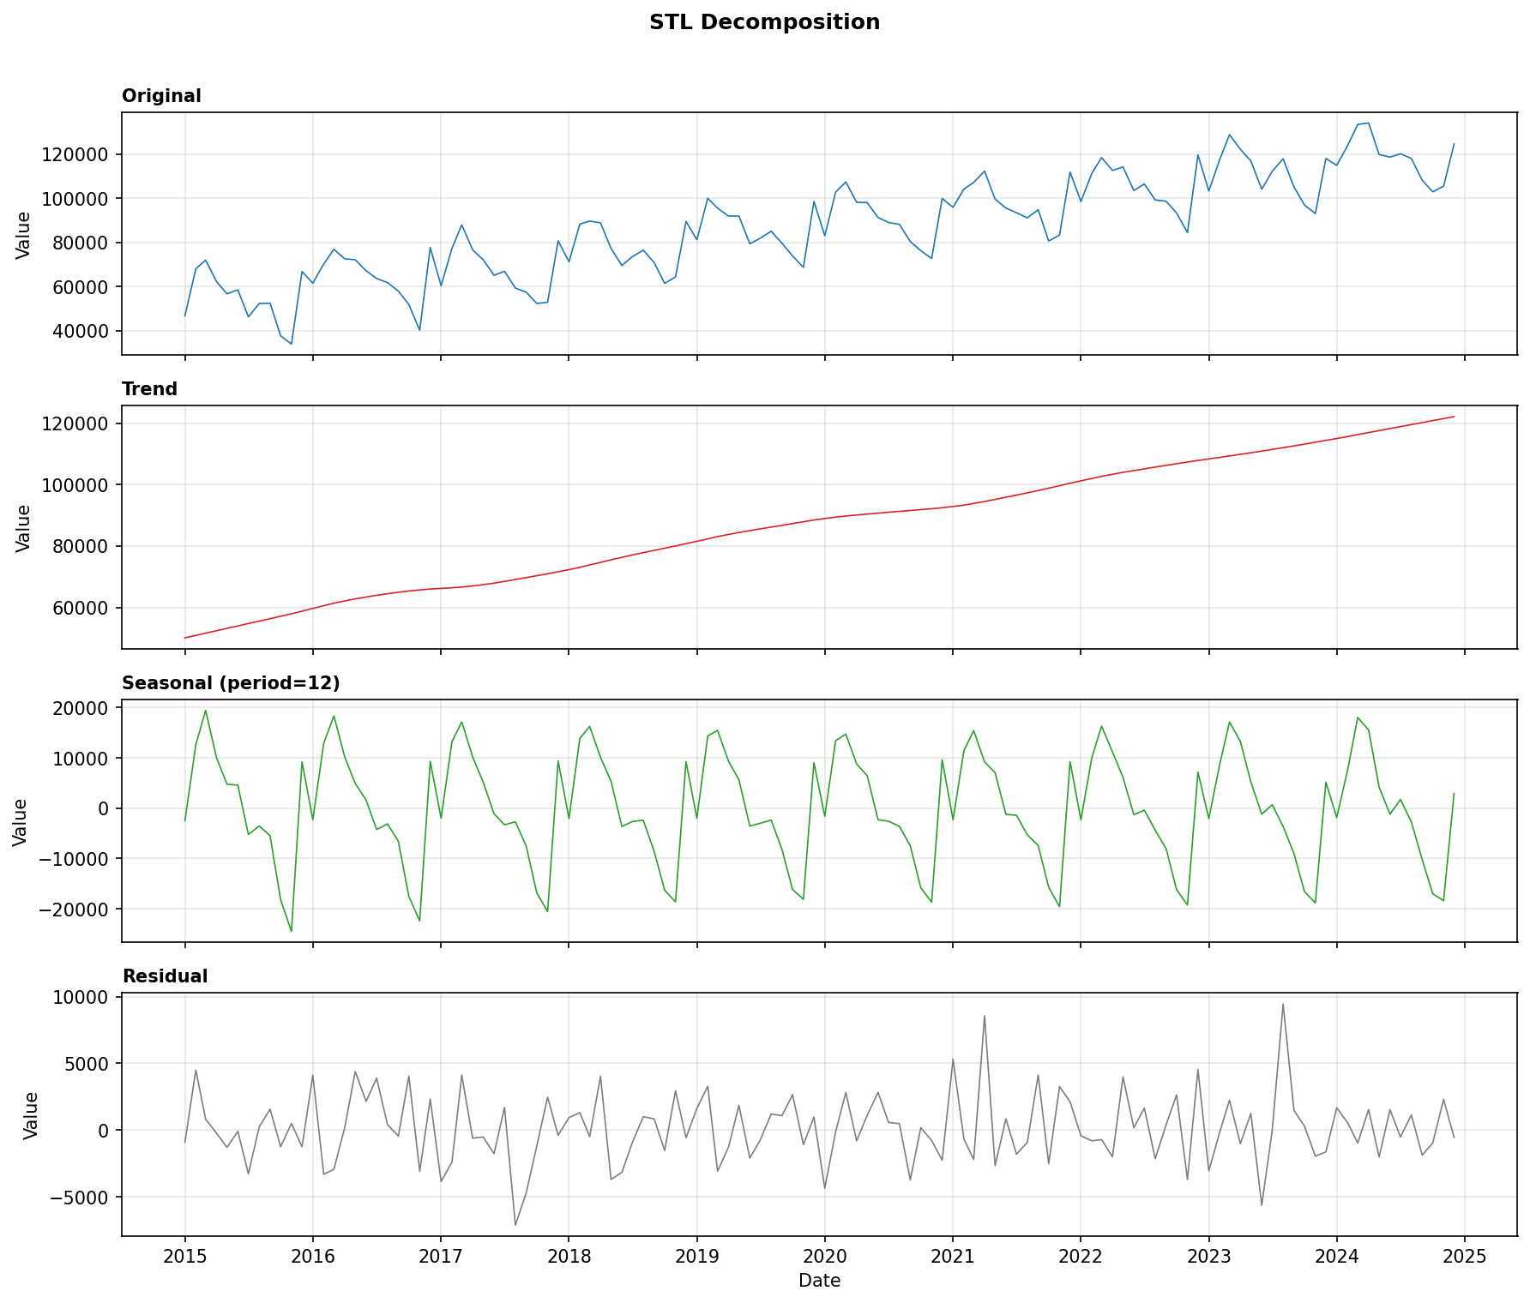

3.2 Seasonal Patterns by Month
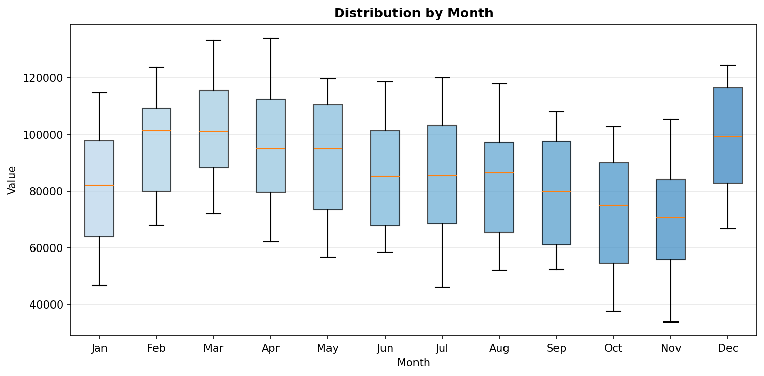

3.3 Seasonal Patterns by Quarter
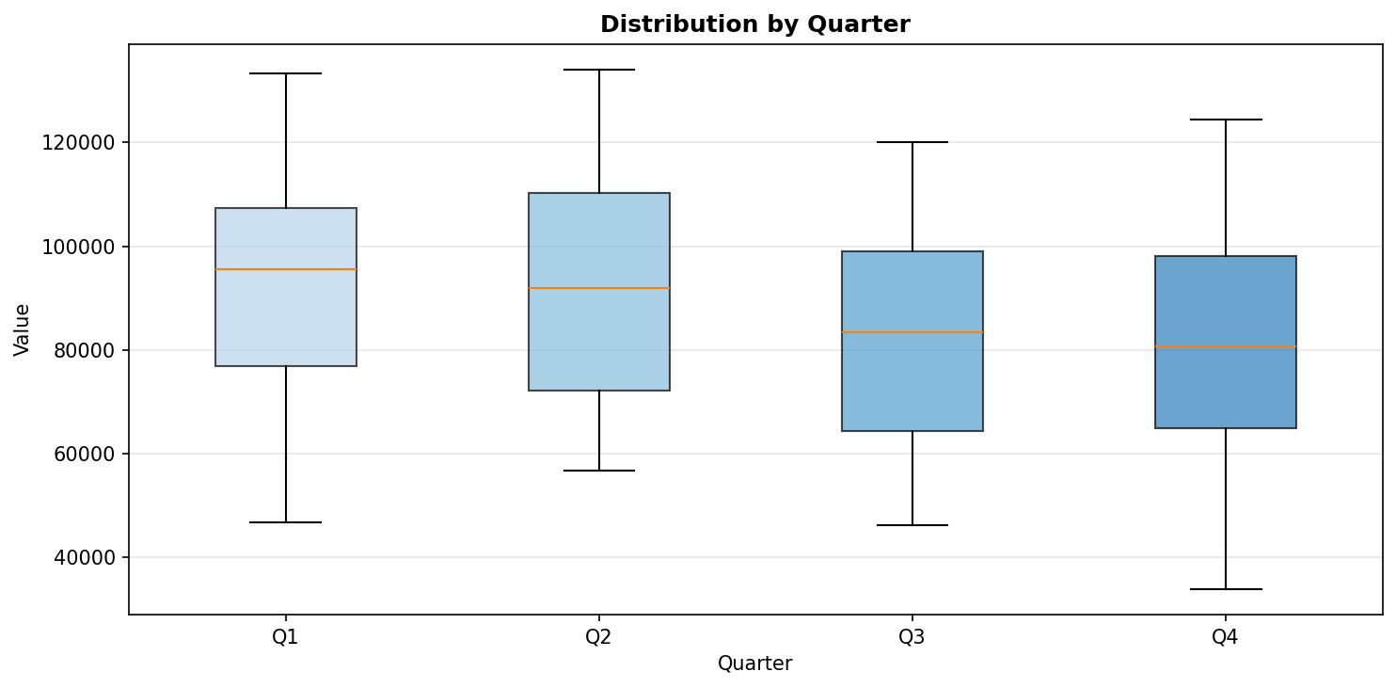

4. Trend Analysis
The data exhibits a strong upward trend, indicating sustained growth in retail sales over the observation period.

Metric | Value
Has Trend | Yes
Direction | increasing
Strength | 0.9837 (strong)
Slope (normalized) | 0.025717

5. Autocorrelation Analysis
ACF and PACF plots help identify the order of AR and MA components for ARIMA modeling. These plots show the differenced series (d=1).

- Significant ACF lags: 1, 6, 11, 12, 24, 30, 36
- Significant PACF lags: 1, 6, 7, 8, 9, 10, 11, 12, 13, 14
- Confidence threshold: ±0.1797

5.1 ACF and PACF Plots
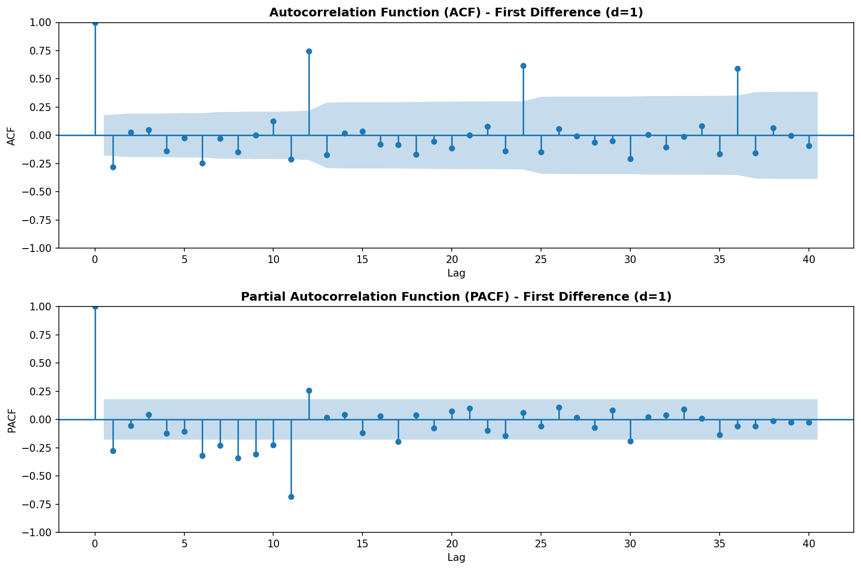

5.2 Lag Scatter Plots
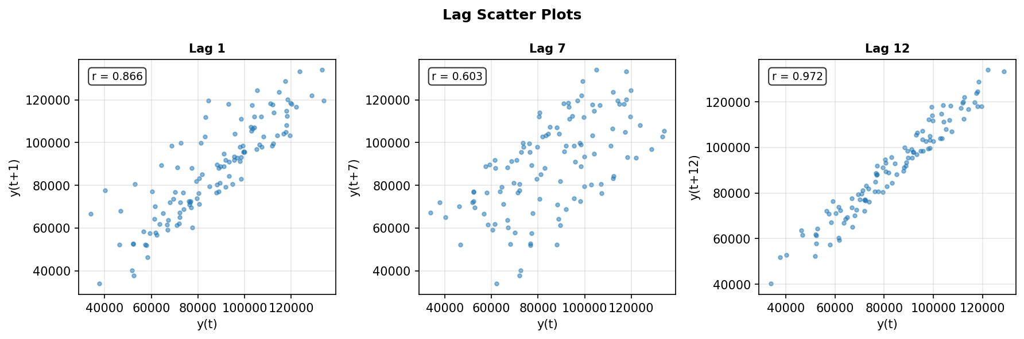

6. Forecastability Analysis
The Ljung-Box test assesses whether the series contains predictable structure. Low p-values indicate the presence of autocorrelation, making the series suitable for forecasting.

Test | Statistic | P-value
Ljung-Box (lag 10) | 25.1154 | 0.0051
Ljung-Box (lag 20) | 118.8107 | 0.0000
Ljung-Box (lag 23) | 122.5957 | 0.0000

Conclusion: The data is FORECASTABLE. All Ljung-Box tests show significant autocorrelation (p < 0.05), indicating predictable patterns suitable for time series forecasting models.

7. Transform Recommendation
Box-Cox transformation analysis determines whether the data needs variance stabilization.

Metric | Value
Variance Stable | Yes
Box-Cox Lambda | 1.0256
Recommendation | none
Note | Box-Cox λ ≈ 1, no transform needed

Interpretation: Since the optimal lambda is approximately 1.0, no transformation is needed. The variance is already stable across the series.

8. Modeling Recommendations
Based on the diagnostic analysis, the following modeling approaches are recommended:

- Use SARIMA (Seasonal ARIMA) models given the strong seasonality (period=12)
- Apply first-order differencing (d=1) to achieve stationarity
- Consider seasonal differencing (D=1) at lag 12 to handle seasonal patterns
- Suggested starting point: SARIMA(p,1,q)(P,1,Q)[12] where p,q,P,Q can be determined from ACF/PACF
- No transformation needed - model on original scale
- The strong trend component suggests models that can capture long-term growth

9. Conclusion
The retail sales data exhibits clear patterns suitable for forecasting:

• Predictable Structure: Ljung-Box tests confirm significant autocorrelation, making this series highly forecastable.
• Strong Seasonality: Monthly patterns repeat annually with high consistency (strength=0.95).
• Robust Trend: Sustained upward growth trend (strength=0.98) indicates continued expansion.
• Model-Ready: The data is well-suited for SARIMA modeling with d=1, seasonal period=12, and no transformation required.

