Title: | LIN Practice Slave2  SW Component , Complete project design

History
Issue status  (Index) | Maturity/Date  (draft/invalid/valid)  (dd-mmm-yyyy) | Author  Department | Check/Release  Department | Description
1.0 | Draft  04-0ct-09 | Miguel Garcia | Miguel Garcia | Creation of the document

Table of Contents
1 Purpose 3
2 Definitions and abbreviations 3
3 Realization constraints and targets 3
4 SW Component internal breakdown 4
4.1 Functional Decomposition 4
4.2 Function <Type> <function name> (type par 1, .., type par n) 5
4.3 Function <Type> <function name> (type par 1, .., type par n) 5

Purpose
This document has been created to explain to design the LIN slave functions that will control a led by the master module.
The slave module must obey four different message types, MASTER_CMD_ALL, MASTER_CMD_SLV2, SLAVE2_RSP and SLAVE2_ID that will be sent by the master module.
The led will have three states ON, OFF, TOGGLE.

Definitions and abbreviations
Definitions
Special Byte | Special byte received to change the baudrate 55h

Abbreviations
Only SW Component specific abbreviations.
References
N° | Document name | Reference
1  2 | LIN_Netwoerk_Database.xlsm  Traceability Matrix LIN_05Aug.xlsm

Realization constraints and targets

To create a robust and portable system, capable of functioning in any kind of event. Using LIN version 2.0

SW Component internal breakdown

Use Case Diagram

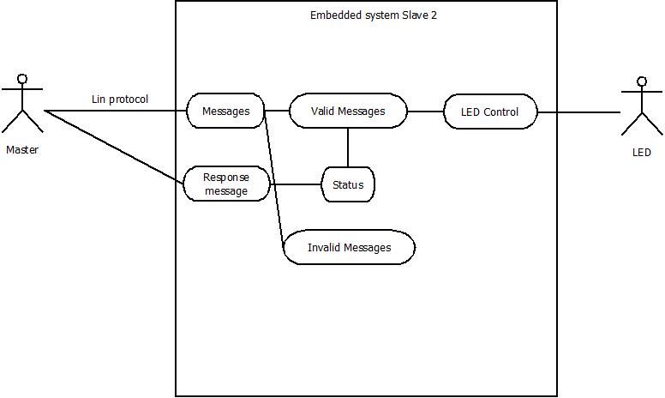
Use case diagram
Master the master module is who will send the messages that will control the LED using the LIN protocol.
Messages the messages have the Synch break, synch and ID
Valid Messages A valid message is when the sync was correct and the ID is in the database with a correct parity.
Status it is the Led’s status that indicate if the led is on/off or toggling.
Response message this is the message response to the master to indicate the status.
Invalid message A invalid message is when the sync was incorrect, the ID is not in the database or it has an incorrect parity.
LED Control it is the module that controls led behavior.
LED it is the system end, a led which will be turn on, off or toggling depending of the master messages.

Component diagram
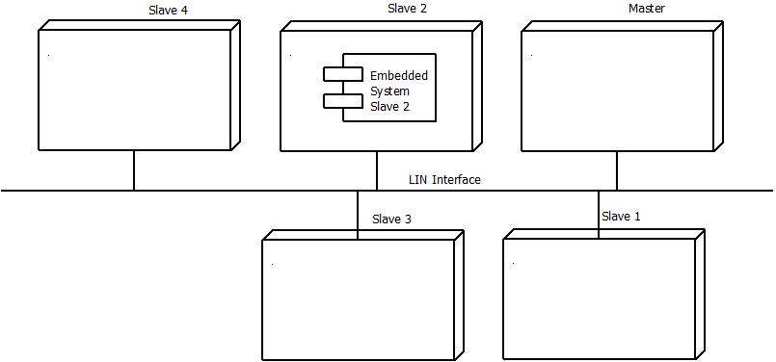
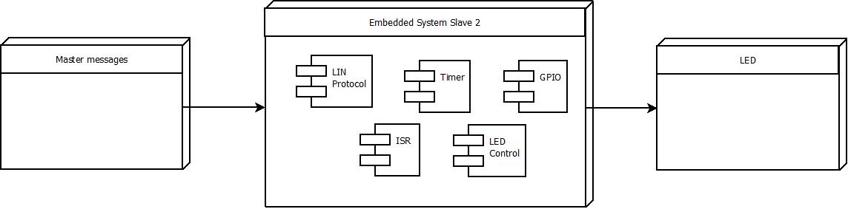
GPIO. This component contains the input and output initialization and configuration to use the internal leds of our freescale microprocessor.

Timers. This component involves the scheduler program. This component is configured to read the entries at a certain time periodically.

ISR. All internal interruptions are part of this component.

LIN Protocol the embedded system is using the version 2.0.

LED Control it is the module which will control the led behavior

Sequence Diagram
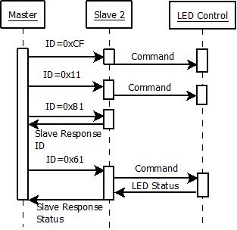
ID 0xCF and ID 0x11 are the ID that have commands to control the led
ID 0xB1 this id indicates to slave 2 that will response with his id
ID 0x61 this id indicates to slave 2 that will response with the led status

Functional Decomposition

Task State_Machine
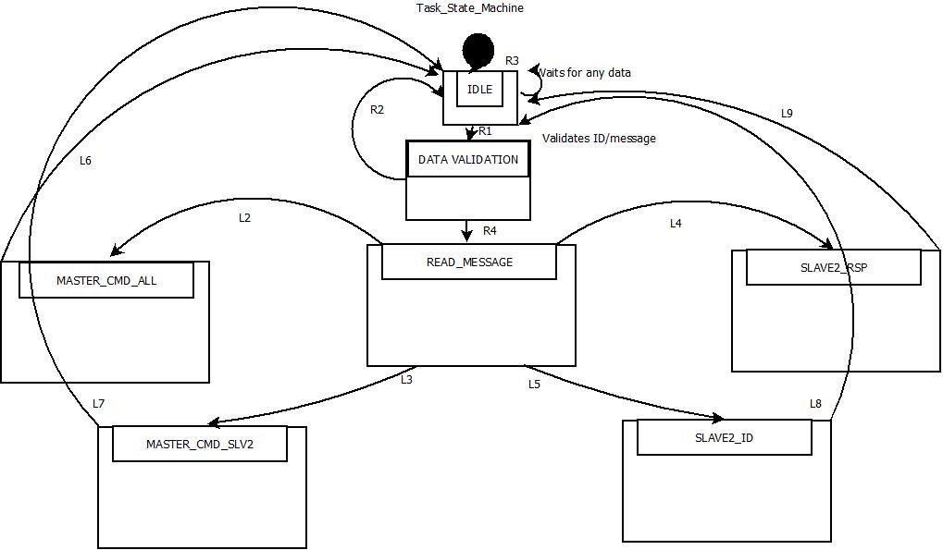
Task State Machine is called once the microprocessor is started.

R1. If any message is detected / DATA VALIDATION
R2. If data received is not valid / IDLE
R3. If no data is received / IDLE
R4. If data received is valid / READ MESSAGE

L2. If message ID = CF / MASTER_CMD_ALL
L3. If message ID = 11 / MASTER_CMD_SLV2
L4. If message ID = 61 / SLAVE_RSP
L5. If message ID = B1 / SLAVE2_ID
L6.Task completed /IDLE
L7.Task completed /IDLE
L8.Task completed /IDLE
L9.Task completed /IDLE

Function Description and Dynamic Behavior
Provide detailed static and dynamic description of all functions of the SW Component.
Functions which are defined in other SW Components shall only be referenced in the external interface description!
The signature description shall be done inside the function header in the source code.
For each function, the following section should be copied

Function <Type> <function name> (type par 1, .., type par n)

Description | Brief description of the function behavior and useful remarks
Parameter 1  <input| output| inout> | Give an explanation if the parameter shall be checked by the user, or if a check is implemented in the function here
Parameter 2..n
Return Value
Precondition | e.g. Function can only be called in a certain state, SW component is initialized  Relation between input parameters where applicable (Input for Module Test)
Post condition | e.g. specific State change e.g. car is locked, EEPROM Values written,  Relation between output parameters where applicable
Error Conditions

Dynamic Behavior
State Chart¹, Flow Chart¹
¹ Preferred
In this document, the dynamic behavior shall be designed on an abstract level showing the principle workflow of a function. Do not show the detailed implementation to ensure that the design description can be maintained with a reasonable effort. The target is not to show the complete detailed implementation 1:1.
The detailed design shall reflect in detail what a function is doing from a black box view. The internal details are useful on an abstract, but not very detailed level.
If the function is not complex a short textual description might be sufficient and a graphical description is not needed.
Symbol and function names shall be self explaining.
The link to the implementation may be provided by using the same names as in the design or by a comment showing the full name followed by the declaration showing the implementation.

Function <Type> <function name> (type par 1, .., type par n)
Description | Brief description of the function behavior and useful remarks
Parameter 1
<input| output| inout>
Parameter 2..n
Return Value
Precondition | e.g. Function can only be called in a certain state, SW component is initialized  Relation between input parameters where applicable (Input for Module Test)
Post condition | e.g. specific State change e.g. car is locked, EEPROM Values written,  Relation between output parameters where applicable
Error Conditions

Dynamic Behavior
State Chart¹, Flow Chart¹, Nassi Shneiderman
¹ Preferred
In this document, the dynamic behavior shall be designed on an abstract level showing the principle workflow of a function. Do not show the detailed implementation to ensure that the design description can be maintained with a reasonable effort. The target is not to show the complete detailed implementation 1:1.
The detailed design shall reflect in detail what a function is doing from a black box view. The internal details are useful on an abstract, but not on a very detailed level.
Symbol and function names shall be self explanatory.
The link to the implementation may be provided by using the same name as in the design or by a comment showing the full name followed by the declaration showing the implementation.

Macros

Only complex macros shall be described here. A complex macro is longer then one line or has more then one parameter or command. A complete description of all macros shall be done by code comments.
Be aware: macros shouldn’t be part of the interface: Don’t use macros at interface level!
If you still think you need macros: document them like functions.
Internal Interfaces
For internal interaction a data flow and/or a message sequence chart shall be provided. If the Static Function Tree already contains a data flow description then just reference it

SW module global variables
Where shared variables can not be avoided, a risk analysis is mandatory.
Name | Type | Memory section | Description | Shared
Klstrg_status | T_UBYTE | NON_INIT_RAM | Status of terminal control | X

Design solutions for general features
This project will be implemented based on the LINFlex feature part of the Freescale microprocessor.
The main project is settled on the scheduler tasks.
The project is based on layer programming, meaning that our application is portable , as well as the rest of the layers.

SW Component integration

Integration context / constraints
Tbd: help text

Include files
GPIO.h
PIT.h
SchM.h
SchM_Cfg.h
MemAlloc_Cfg.h

Initialization
e.g. Sequence Chart for initialization
All function bellow shall be called on initialization
Call Order | Service | Call constraints linked to an other module
1 | MemAllocInit(&MemAllocConfig); | Once main function starts
2 | initModesAndClock(); | Main functions initializes this func.
3 | vfnGPIO_LED_Init(); | Main functions initializes this func.
4 | vfnGPIO_BUTTON_Init(); | Main functions initializes this func,
5 | INTC_InitINTCInterrupts(); | Main functions initializes this func,
6 | EXCEP_InitExceptionHandlers(); | Main functions initializes this func,
7 | SchM_Init(&SchConfig); | Main functions initializes this func,

Interrupts
If described in the SW Architecture Document, just put the reference here.

Real time scheduler task
The preemptive scheduler used in this project counts with 6 different tasks:
3.125ms
6.25ms
12.5ms
25ms
50ms
100ms

Other entry points
Name | Service | Task level

