Title: | Window Lifter  SW Component < XXXXXXX >

History
Issue status  (Index) | Maturity/Date  (draft/invalid/valid)  (dd-mmm-yyyy) | Author  Department | Check/Release  Department | Description
1.0 | Draft  06-22-15 | David Rosales | David Rosales | Creation of the document

Table of Contents
1 Purpose 3
2 Definitions and abbreviations 3
3 Realization constraints and targets 4
4 SW Conceptual design 4
5 SW Component internal breakdown 5
5.1 Functional Decomposition 5
5.2 Function void dummy_1ms(void) 5
5.3 Function opening_func () 6
5.4 Function closing_func () 6
5.5 Function main () 7

Purpose
This document has been created as part of the documentation for the Window Lifter project, it contains a short review of all systems related to it.

Definitions and abbreviations
Definitions
LED_Blue | Output mode Pin 10
LED_Green | Output mode Pin 11
Push_Down | Input mode push button 64
Push_Up | Input mode push button 65
Push_Pinch | Input mode push button 66
Go_Down | Input initialization of push 64
Go_Up | Input initialization of push 65
Go_Pinch | Input initialization of push 66
No_Pressed | Numeric Value 0
Pressed | Numeric Value 1
Leds_Count0 Leds_Count10  Leds_Count9  Button_Validation Time_Count0  Pace_Restart | Led Counter in Zero  Led Counter in 10  Led Counter in 9  10 miliseconds  Time Counter in Zero  Pace Counter in Zero
Pace_Count400 Pace Counter in 400
Pace_Count401 Pace Counter in 401
Time_Count500 Time Counter in 500
AntiPinch_TimeLimit 5 seconds (5000ms)
Abbreviations
PIT | Programmable Interrupt Timer
GPIO | General Purpose Input/Output
SW | Software
HW | Hardware

References
N° | Document name | Reference
1 | Window lifter requirements

Realization constraints and targets

To control the car window movement (Up / Close and Down / Open) depending on the pressed button time. Anti-pinch feature will be included to prevent accidents when the window is closing.

SW Conceptual design
-As part of our our main system:
Microcontroller Freescale MPC 5606B

-C Program revised in CodeWarrior.

-Program assigns Inputs and Outputs as part of the main system.
Inputs have been assigned to our main push buttons, part of the microcontroller.
(GPIO module)

-Outside the system, a led bar works to identify and emulate the window movement.
-Our main system and the parts connected to it, use cables to transmit our output values.
-PIT module for software interruption.

SW Component internal breakdown
No complex components are part of this program.

Functional Decomposition
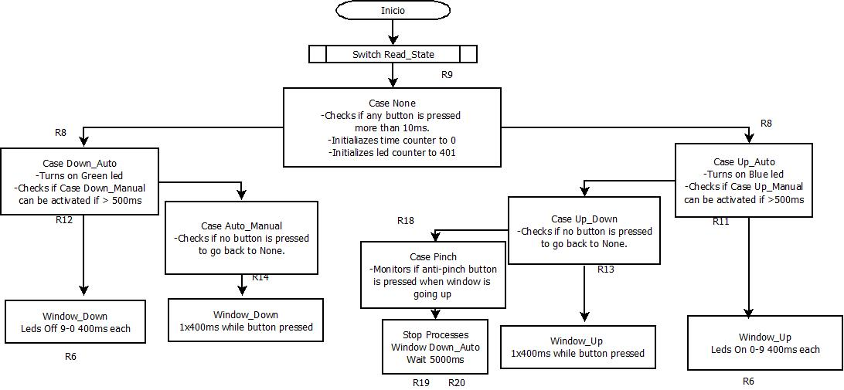
Function Description and Dynamic Behavior
Provide detailed static and dynamic description of all functions of the SW Component.
Functions which are defined in other SW Components shall only be referenced in the external interface description!
The signature description shall be done inside the function header in the source code.
For each function, the following section should be copied

Function void dummy_1ms(void)

Description | This function is called periodically every millisecond by the PIT, in order to enable the counters and manage the time according to the requirements.  It is the main functions for all processes, as it checks inputs, and sets outputs according to time. This is done based on a state machine.
Parameter 1  <input| output| inout> | No parameters are used.
Parameter 2..n
Return Value | No return values
Precondition | Function will be called by the PIT every 1 ms. PIT has been initialized to provide the interruption at this given time.
Post condition | This function contains the state machine of our program. It keeps the value of the state in current use.
Error Conditions

Dynamic Behavior
State Chart¹, Flow Chart¹
¹ Preferred
This function is periodically called by the PIT, every 1ms.

It consists of a state machine of 6 different states:
None, Window Up Manual , Window Up Auto, Window Down Manual, Window Down Auto and Anti-pinch.

The state or case None, is assigned by default and it checks if any buttons are pressed.

If button up is pressed, the program checks the time the button is pressed, and can either change the state to Window Up manual or Window Up auto.

If button down is pressed, the program checks the time the button is pressed, and can either change the state to Window Down manual or Window Down auto.

When the state of the machine is Window Up Auto, this state also checks if the button Anti pinch is pressed while the window is moving up.

If the anti-pinch button is pressed, the window stops all routines, opens the window automatically and completely and stops all entries for 5 seconds. Then the program starts again.

Function opening_func ()
Description | Emulates opening Window, turning off leds.
Parameter 1  <input| output| inout> | none
Parameter 2..n
Return Value | none
Precondition | Functions is called when the button up is pressed, and the time button press requirements have been met.
Post condition | This function modifies the led counter, so the machine state keeps on working based on the new value.
Error Conditions

Dynamic Behavior
State Chart¹, Flow Chart¹, Nassi Shneiderman
¹ Preferred
This functions received the signal of button validation, and depending on the time the push button is pressed, our leds will turn off to emulate the window is opening.

Function closing_func ()
Description | Emulates closing Window, turning on leds.
Parameter 1  <input| output| inout> | none
Parameter 2..n
Return Value | none
Precondition | Functions is called when the button up is pressed , (or at certain point, the anti-pinch button) and the button press requirements have been met.
Post condition | This function modifies the led counter, so the machine state keeps on working based on the new value.
Error Conditions

Dynamic Behavior
State Chart¹, Flow Chart¹, Nassi Shneiderman
¹ Preferred
This functions received the signal of button validation, and depending on the time the push button is pressed, our leds will turn on to emulate the window is closing.

Function main ()
Description | GPIOs and PIT initialization to call our dummy function every 1ms
Parameter 1  <input| output| inout> | none
Parameter 2..n
Return Value | none
Precondition | Functions is called as a main function once the program starts
Post condition | Loops forever
Error Conditions

Dynamic Behavior
State Chart¹, Flow Chart¹, Nassi Shneiderman
¹ Preferred
GPIOs and PIT initialization to call our dummy function every 1ms

