David ROUSSE, IS architect
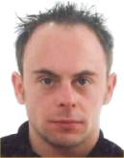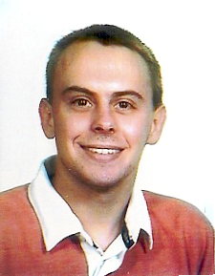

4, place Clémence Isaure
31320 CASTANET-TOLOSAN FRANCE
Phone number : (+33) 06.07.59.25.15
E-mail : david.rousse@gmail.com
Web site : http://david.rousse.sodetemplin.org/
Age 35, married

Profesional experience
Since August 2011 Functional and technical manager on PLUME-FEATHER, which promote open source software, National Centre For Scientific Research (Toulouse)

Sept. 2007 – July 2011 Business intelligence architect (SAP BI, Informatica, Qlikview), National Centre For Scientific Research (Toulouse)

Sept. 2002 – August 2007 Architect involved in EAI (webMethods) and EDI (CFT, Bank 500) projects of the National Centre For Scientific Research (Toulouse)

Feb. – June 2002 Building a datawarehouse with SAP BW for Airbus France (Toulouse)

Nov. – Dec. 2001 Overview of wireless network technologies with the IRIT (Toulouse)

May – June 2001 Building a distributed Information System with UML and CORBA
in the B&T Associés company (Toulouse)

June – December 2000 Analyst developer in the COM+ architecture for the CIMA company (Pau)

Feb. – March 1999 In charge of the development of an electronic boxes' management software in Visual Basic for the SOULÉ firm (Bagnères de Bigorre)

June 1998 Webmaster of the INFORADOUR ADIX's site (Tarbes)

Qualifications

2001 – 2002 DESS MIAGe, Computer Sciences Applied to Management (very good)
at the University Paul Sabatier (Toulouse, France)

2000 – 2001 Master’s degree of MIAGe, (good) at the University Paul Sabatier

1999 – 2000 Bachelor’s degree of MIAGe (very good) at the University Paul Sabatier

1997 – 1999 Graduate from Computer Sciences polytechnic (head of the list of the class)
at the faculty Saint John Perse (Pau, France)

1995 – 1997 Two years’s undergraduate degree in Mathematics at the National Center of Postal Tuition (Vances, France)

1994 – 1995 Obtained a baccalaureate equivalent to an A level in Mathematics and Physics
at the high school Victor Duruy (Bagnères de Bigorre, France)

Computer skills
Analysis and design Method MERISE, modeling language UML

Distributed architectures SOAP, CORBA, RMI, COM+

Databases DBMS Oracle and SQL Server, languages PL/SQL and T-SQL

Programming languages C, C++, Java, Visual Basic, COBOL, PRO*C, XML, PHP

EAI/EDI webMethods, Sunopsis, SeeBeyond, WBI, Axway CFT and SAGE Bank 500

SIA SAP BW and BI, Informatica, Qlikview

Miscellaneous
Languages Bilingual in French and English, good knowledge in Spanish

Interests Handisport (alpine skiing, wakeboard, swimming, scuba diving, biking), travel, astronomy, ATV in mountain

