- The Purpose of this PoW Template is to show evidence you have met requirements for each Project (or Lab)
- It is a Template so feel free to modify this document if you need including pasting the actual requirements
- Use the table below to embed any Solution Artifacts if you need however we prefer that you directly attach to the Teams Assignment - check with Trainer

Embed any Artefacts you have created here (Optional)
Word > Insert > Object > Object > Create from File  Make sure you Test you can open AFTER you embed it | 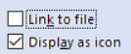 | 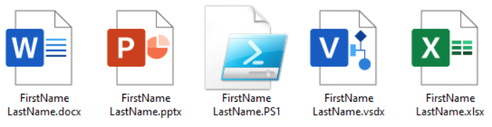
Solution Requirements - MUST
#
SR01 | GitHub project URL
SR01 | https://github.com/davidrozwod/minute_taker
SR02 | Prepare a project specification document
SR03 | Mock-up/Prototype
SR03 | 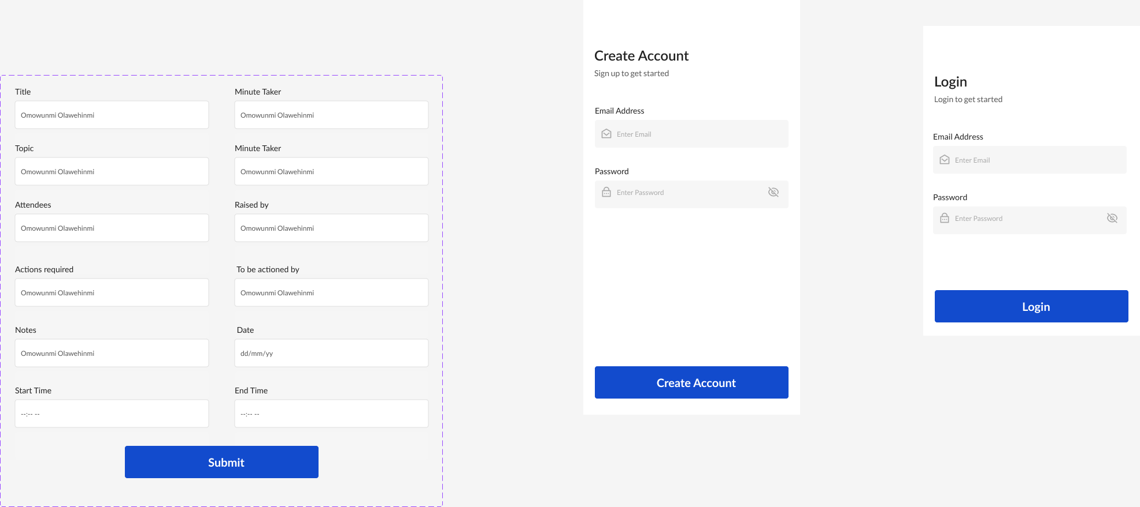
SR04 | Technology Stack Implementation
SR04 | 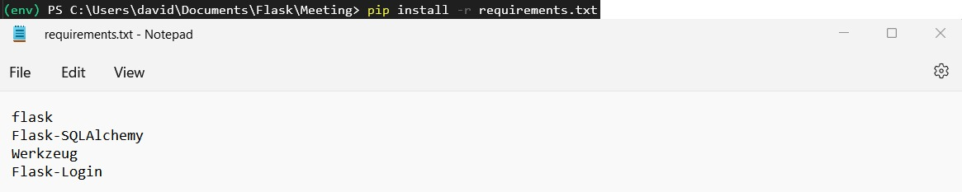
SR05 | Feature Implementation
SR05 | 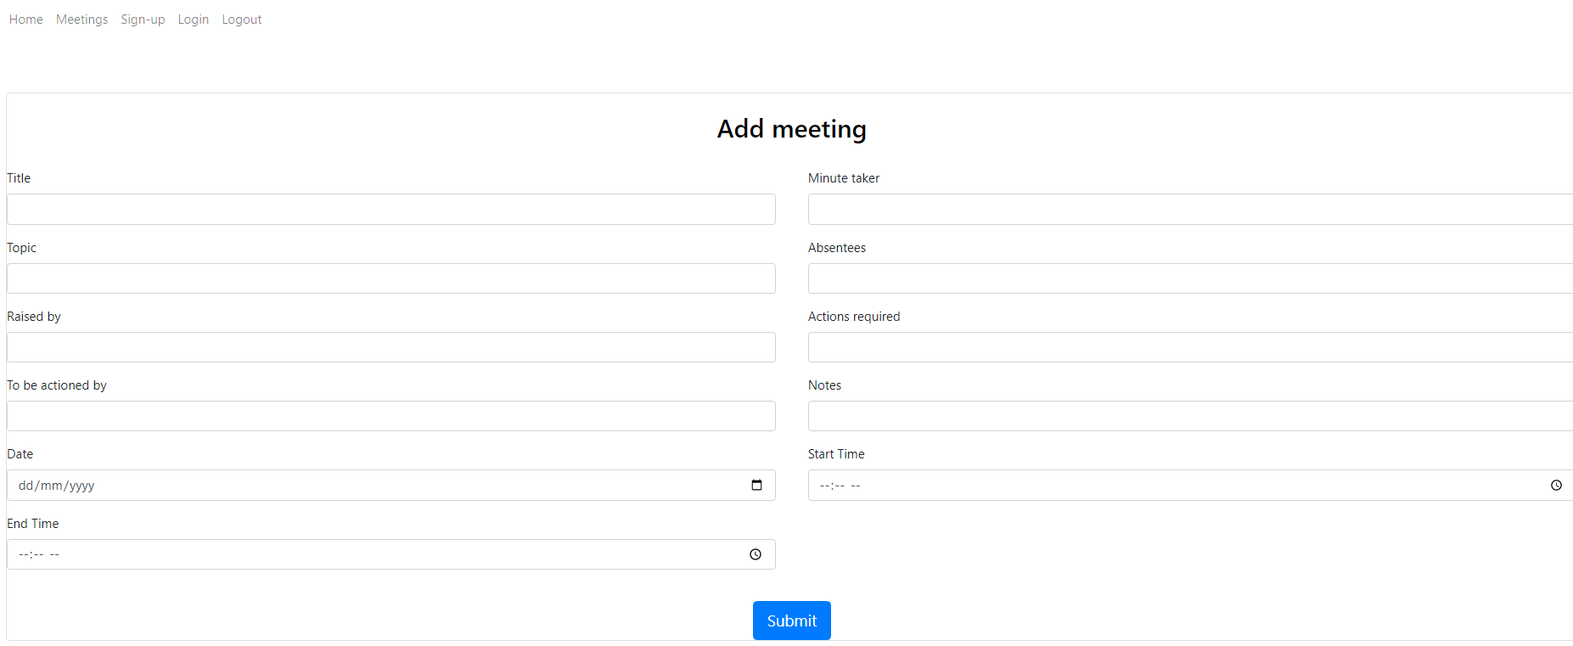  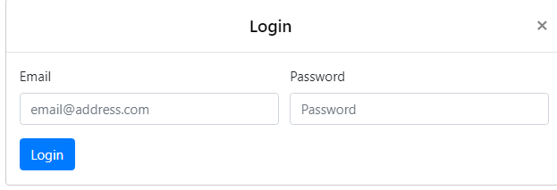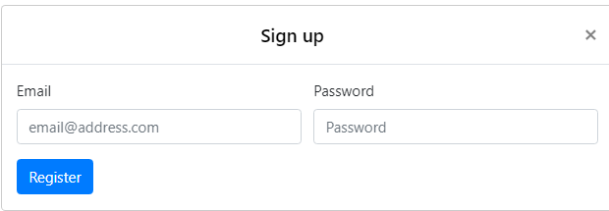  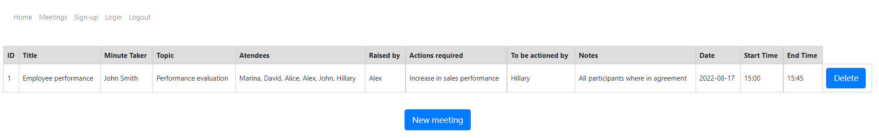
SR06 | Usability testing
SR07 | Object Oriented Programming
SR07 | 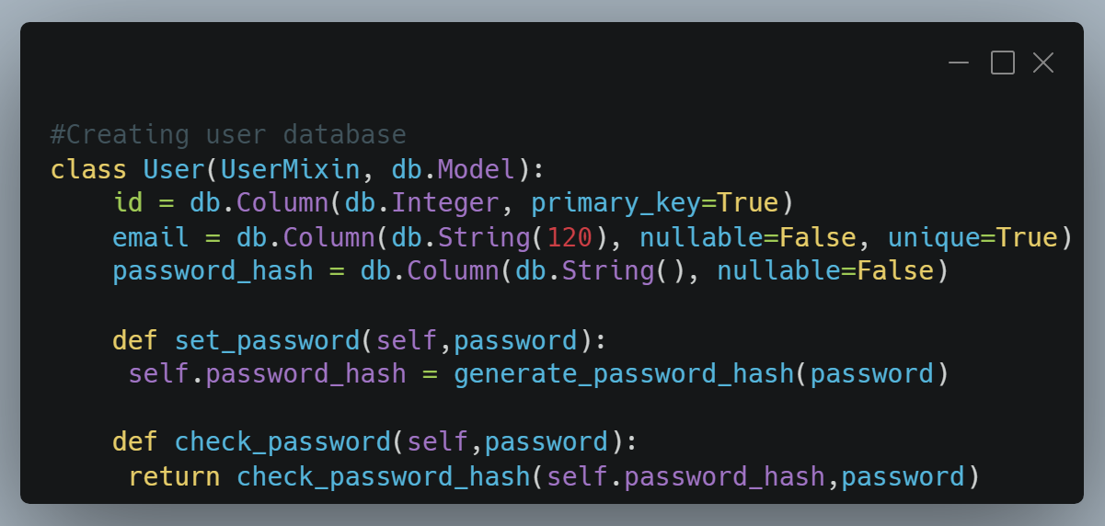  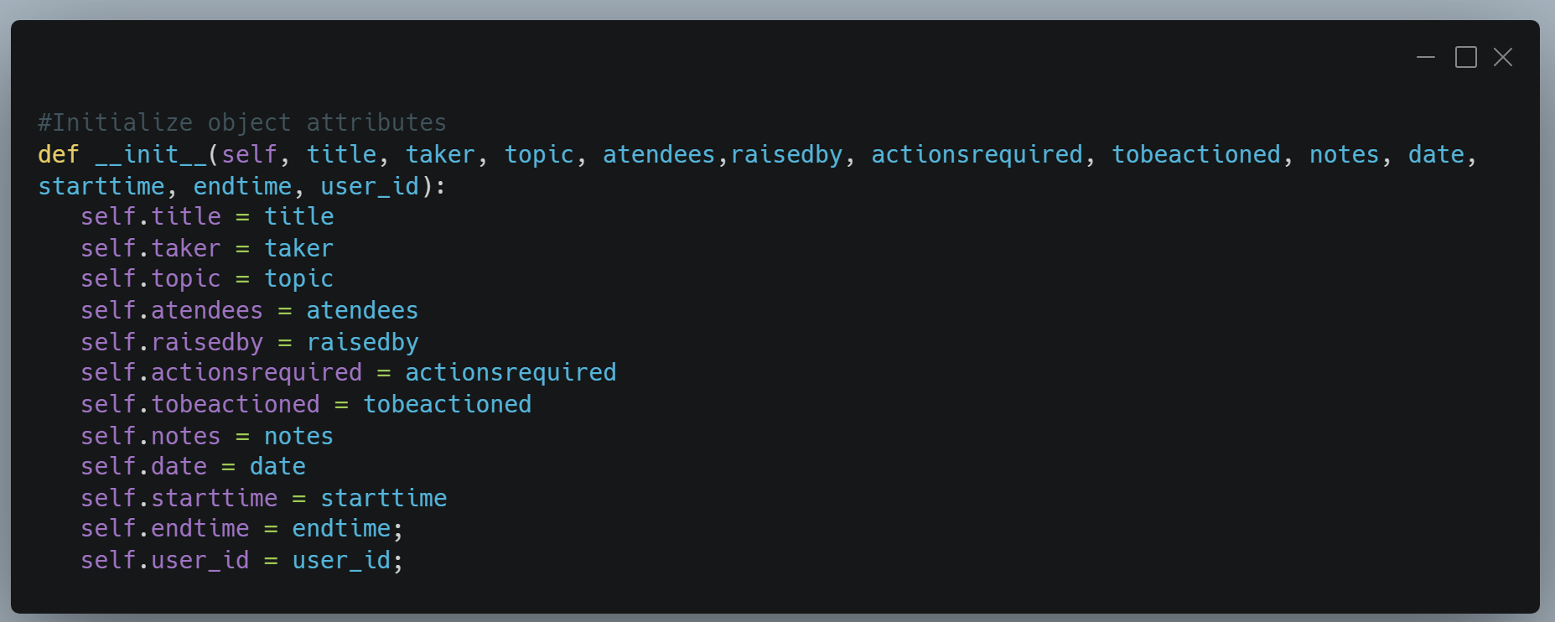  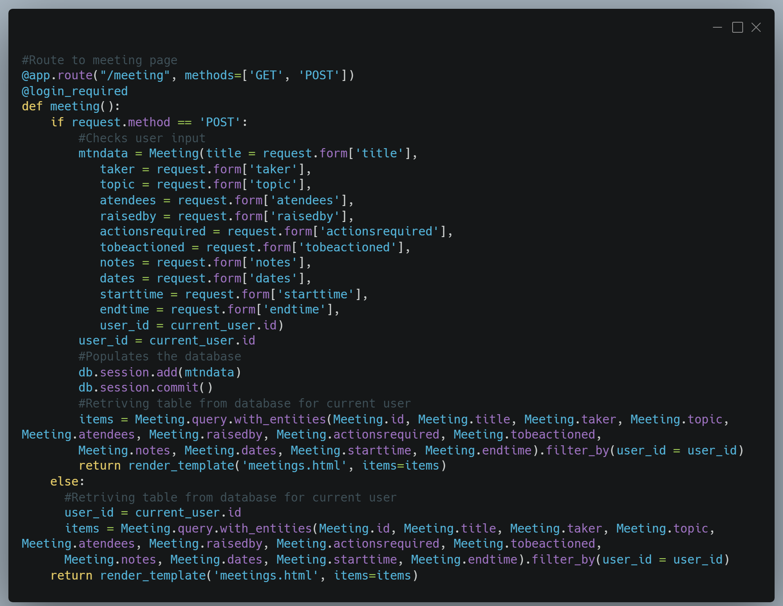
SR08 | System testing (Manual Testing)
SR09 | User acceptance testing
SR10 | Help document
SR11 | User instructions document

Marking Rubric
- 