- The Purpose of this PoW Template is to show evidence you have met requirements for each Project (or Lab)
- It is a Template so feel free to modify this document if you need including pasting the actual requirements
- Use the table below to embed any Solution Artifacts if you need however we prefer that you directly attach to the Teams Assignment - check with Trainer

Embed any Artefacts you have created here (Optional)
Word > Insert > Object > Object > Create from File  Make sure you Test you can open AFTER you embed it | 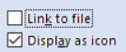 | 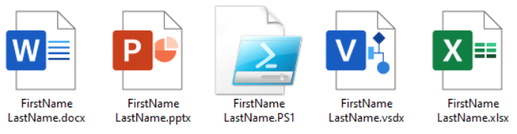
Solution Requirements - MUST
# | Sales Predictor | David Rozwod
SR01 | GitHub project URL
SR01 | https://github.com/davidrozwod/sales_predictor
SR02 | IDE Selection
SR02 | 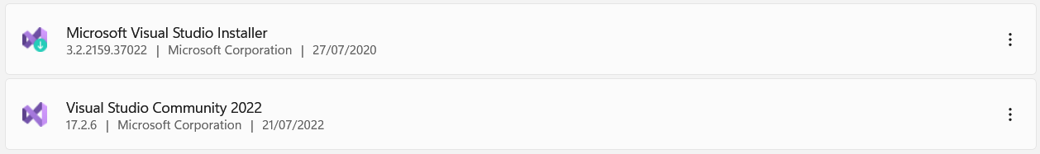
SR03 | Identify the library used to plot the dataset for visualization  Screenshot of the code showing the use of identified library in a project and to plot the dataset
SR03 | 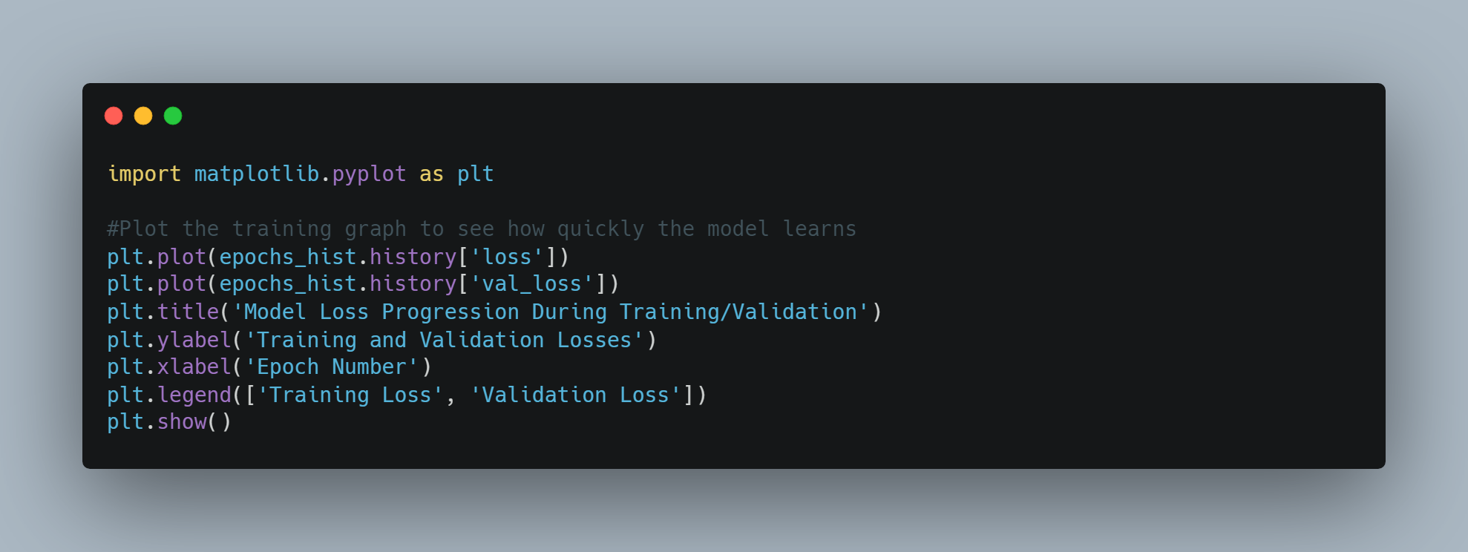  Screenshot of the plotted graph  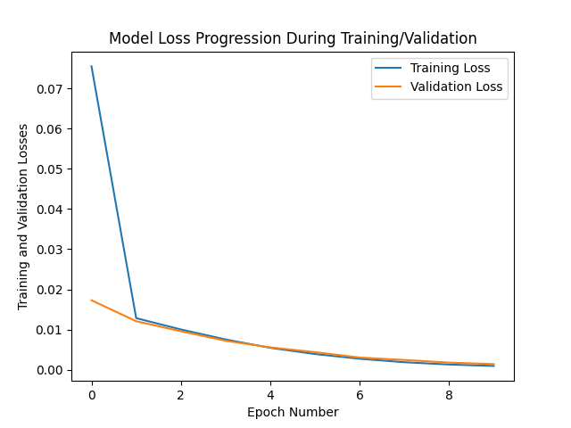  Screenshot of the code showing the identified required features for the input layer and identified required feature for output layer.  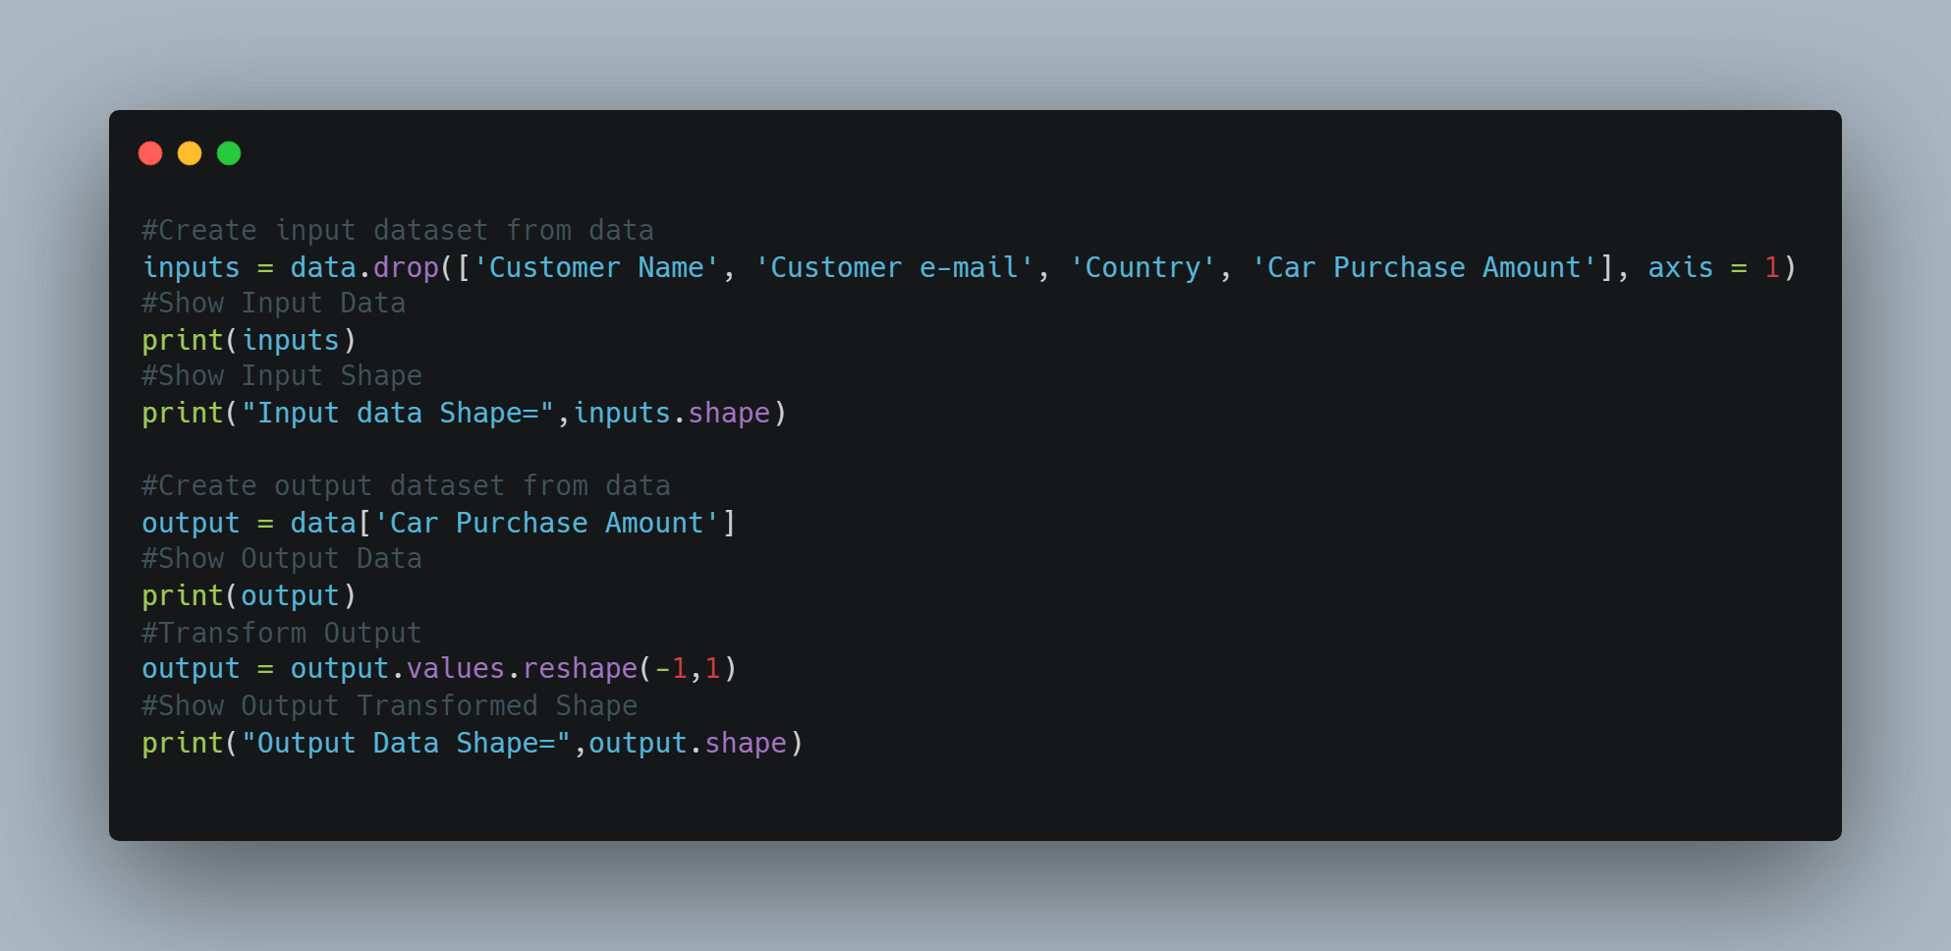
SR04 | Feature Scaling (Normalization)
SR04 | Screenshot of the code showing the use of identified library in a project  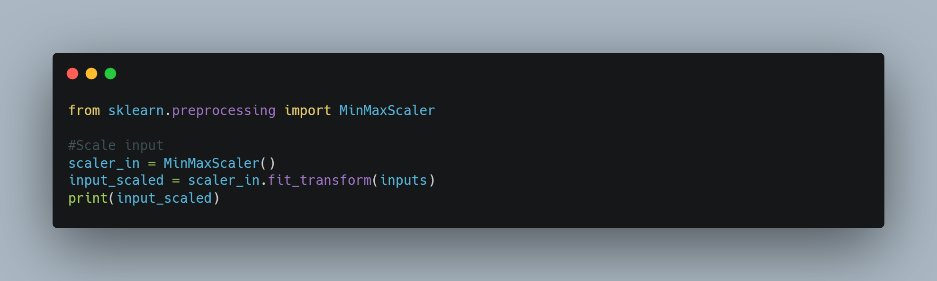  Screenshot of the code used to scale and transform the data for both the input and output layer. [use method/function]  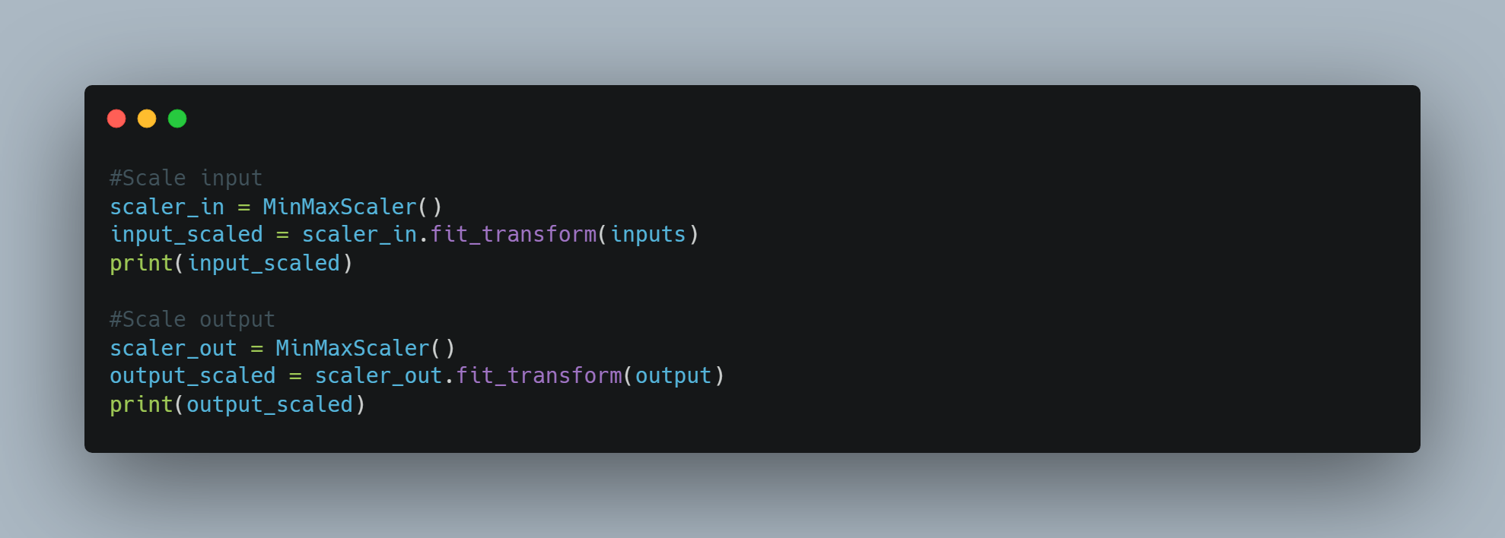  Screenshot of the output for both input and output layer  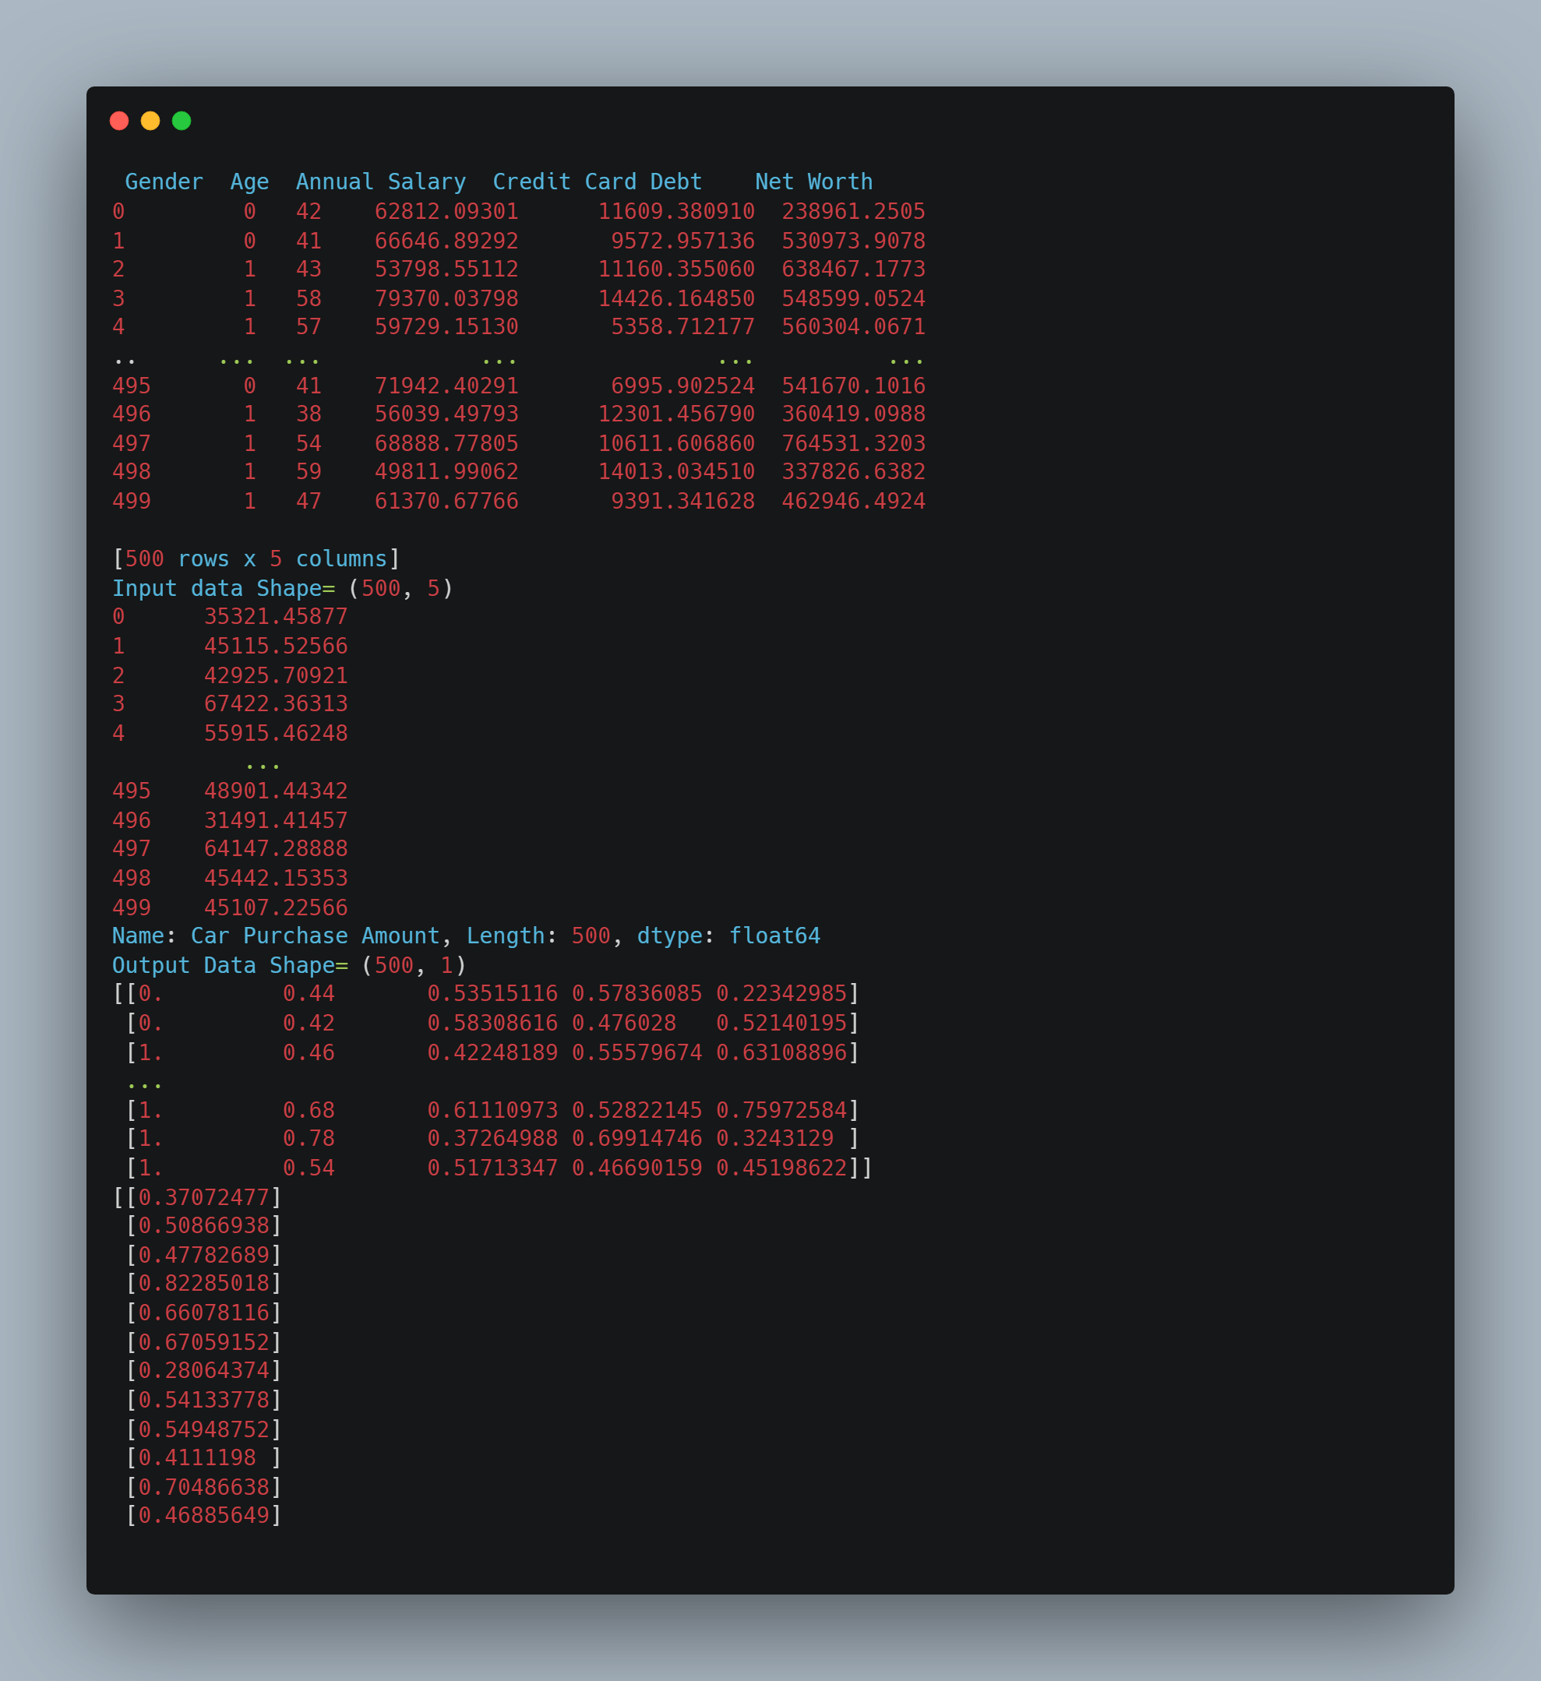
SR05 | Build the ANN
SR05 | Screenshot of the code showing the use of identified library in a project  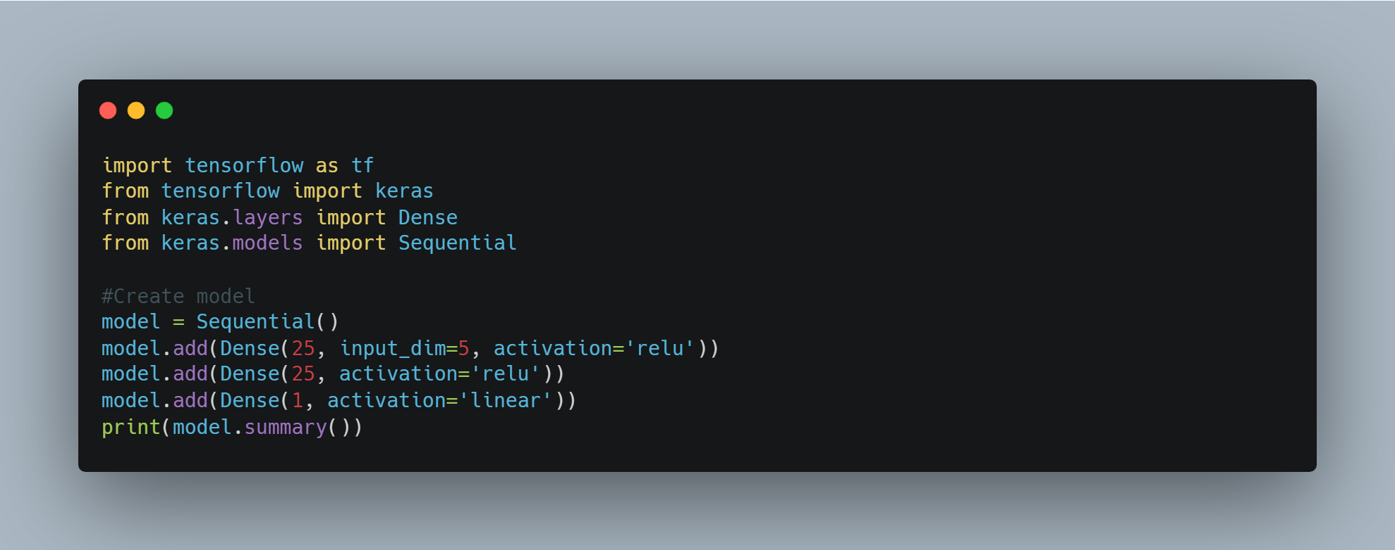  Screenshot of the code showing the use of activation function and adding the layers  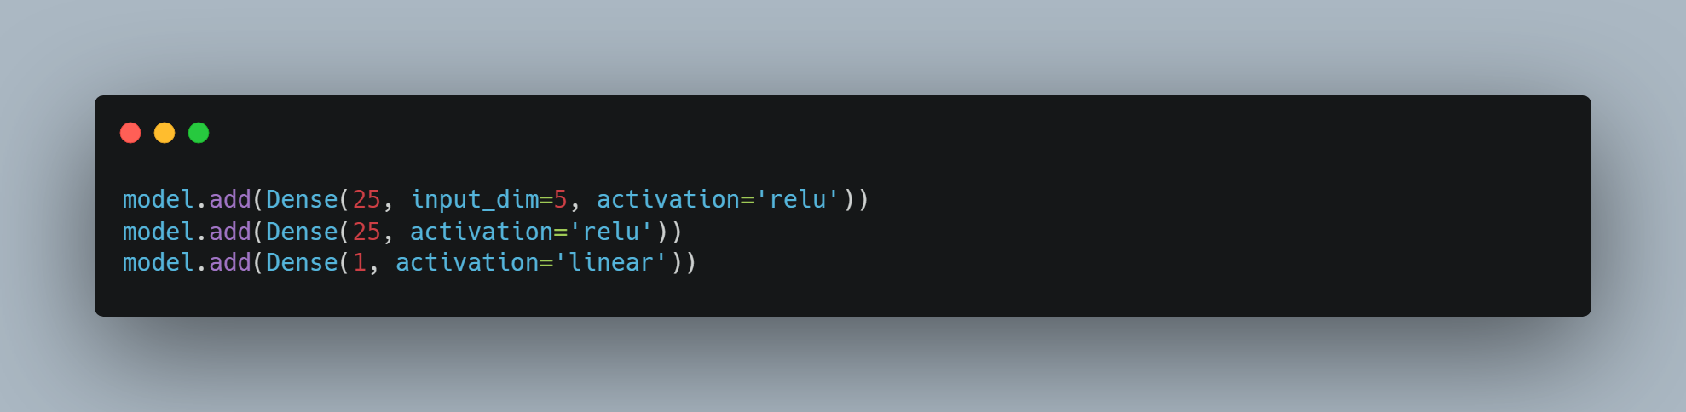  Screenshot of the output showing the summary of the model  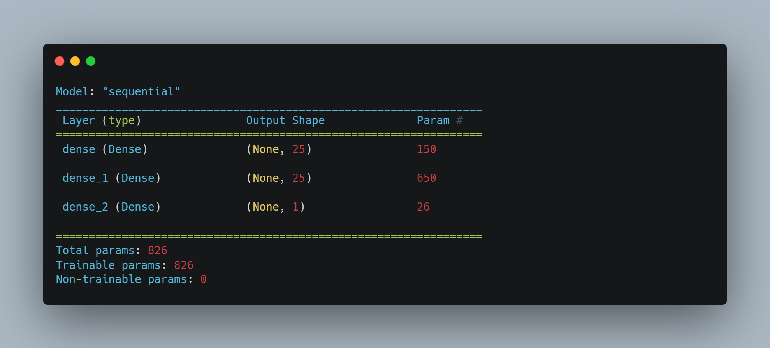  Screenshot of the code showing the use of optimizer in the ANN  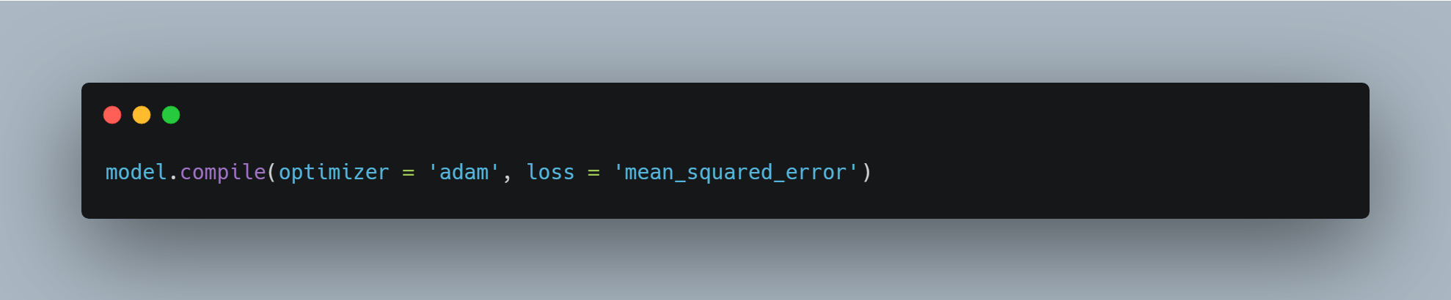  Screenshot of the code and output showing the running of your model [epochs history]  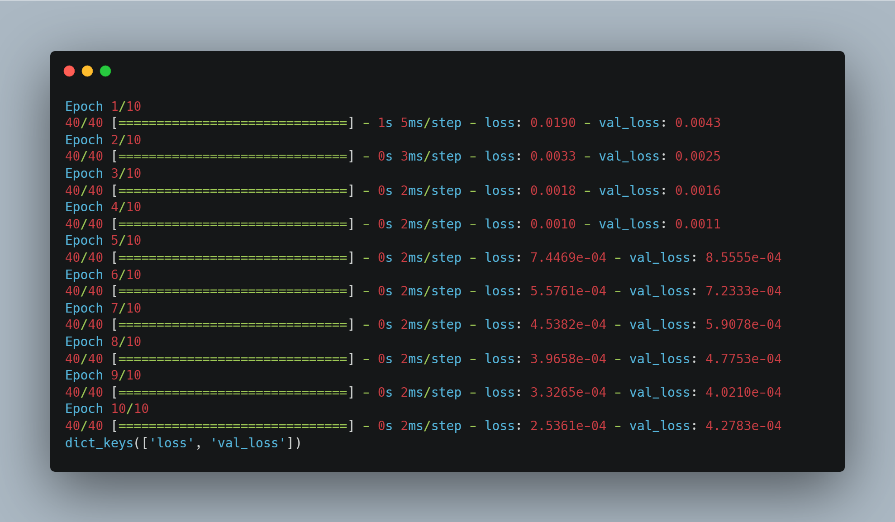  Plot the training graph to see how quickly the model learns  Screenshot of the pictorial view ofANN  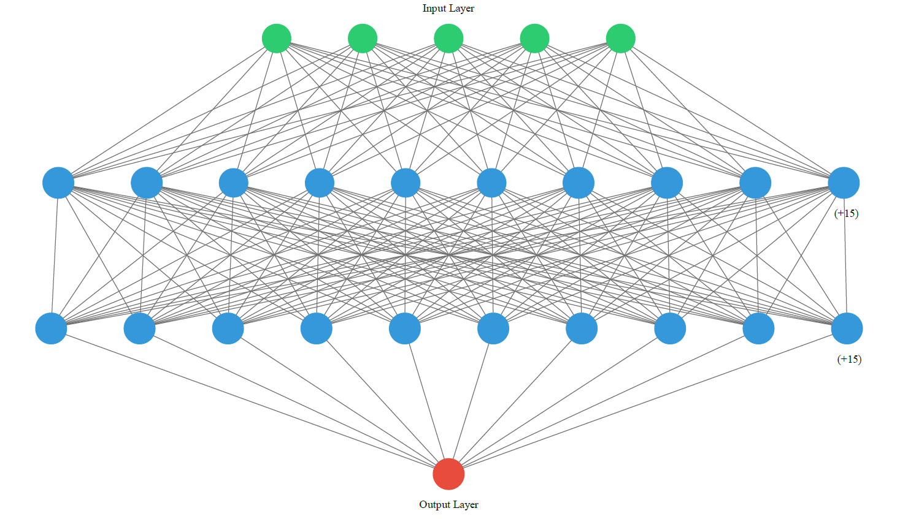
SR06 | Prediction on new data
SR06 | Screenshot of the code and output  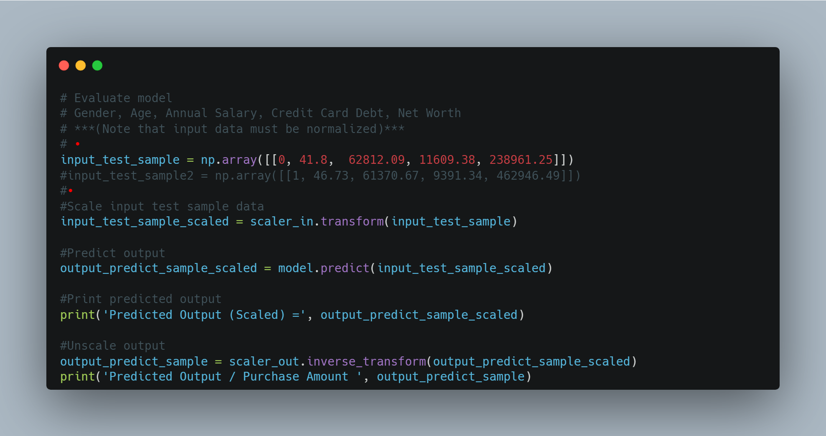  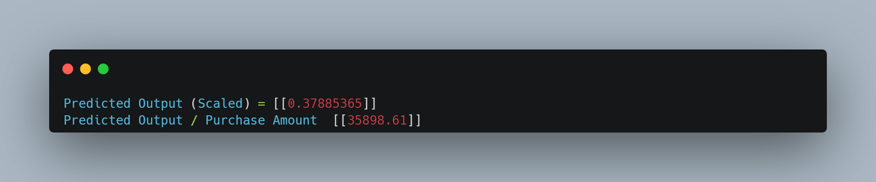
SR07 | Prepare a GUI for the user to enter custom values to test it
SR07 | Screenshot of the GUI  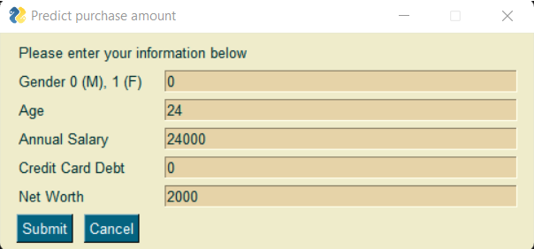  Screenshot of the predicted outcome by using GUI  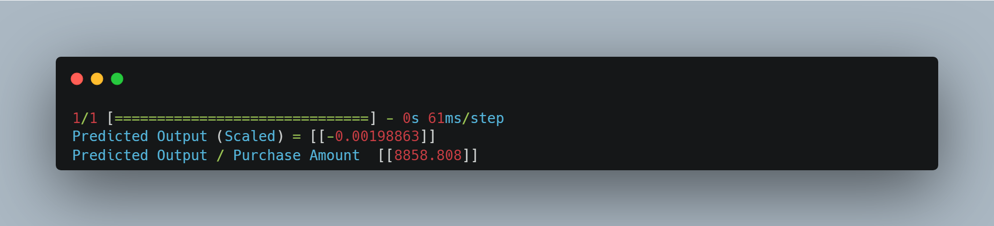
SR08 | Unit testing [Automated Approach]
SR08 | Could not find a way to predict model accuracy, requirement not met.
SR09 | Optimization
SR09 | Could not determine how to optimize code based on tests. But more neurons in each layers trained the model more quickly.
SR10 | System Testing
SR10 | System testing document – If embedding does not work please refer to Documentation folder on Github
SR11 | Debugging
 | Debugging document – If embedding does not work please refer to Documentation folder on Github

SR12 | User Acceptance Testing
 | User Acceptance Testing document – If embedding does not work please refer to Documentation folder on Github

SR13 | Run a Neural Network on the Tensorflow Playground with at least 2 features and 2 hidden layers.
Screenshot of playground running a neural network
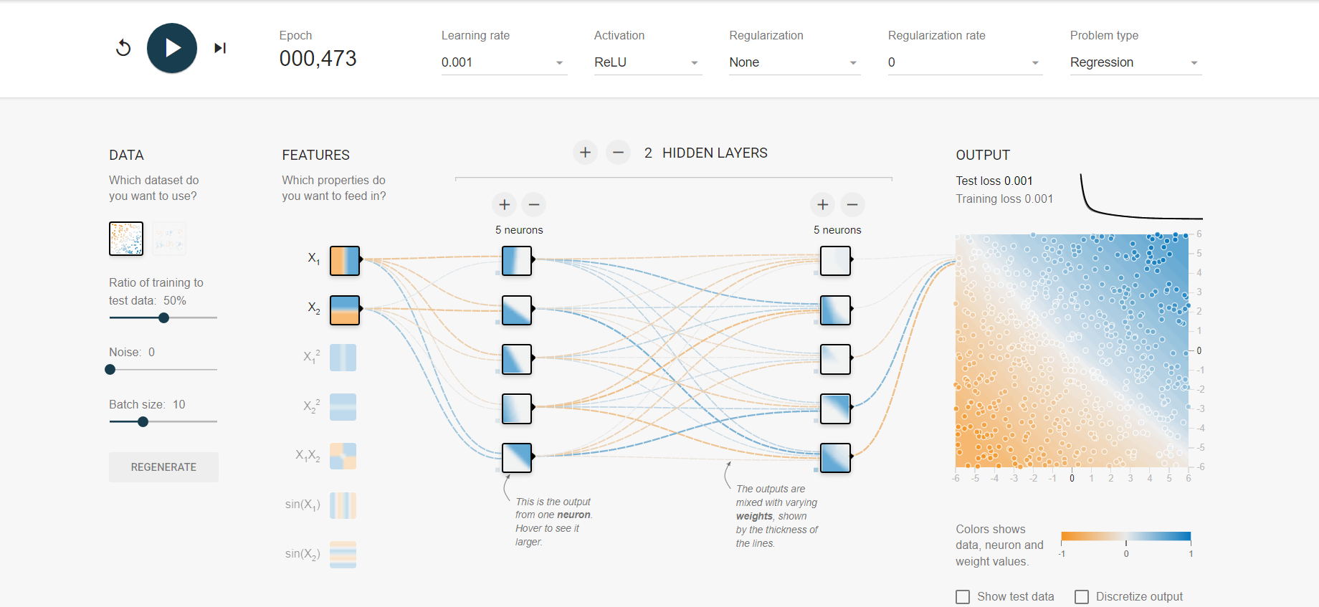

Marking Rubric
- 