**TELECOM-Nancy / 2A IL**

14

**English Project**

**Application to Test Your English Knowledge**

**David Rubino / Thibault Lesage**

Summary

Introduction 3

1. Description of the application 3

1.1 Objectives 3

2.2 Why use a TOEFL-type structure 4

2.3 User Guide 4

2. Choices of Implementation 8

2.1 Why use C# 8

2.2 Development Process 8

Conclusion 10

Addendum: External Resources 10

# Introduction

The objective of this project was to create an application to help non-native speakers to practice some aspects of English. Since we were free to choose what aspects we should work on, we decided to focus on three main points that most non-native speakers struggle with: listening comprehension, grammar constructions, and some fundamental notions of American culture.

The structure of our application is partly inspired by the TOEFL test – listening and text study – to whom we added an original culture quiz. Thus, this test would be suitable for people ranging from a medium to a fluent level of English.

In this report, we will first present a description of our application with a user guide. Then, we will detail the technical aspects of our app.

# Description of the application

## Objectives

The main objective of this application is to help non-native speakers to improve their level of English. For this purpose, we created three original exercises to practice three particular points of English.

First, the user can take a culture quiz on American culture. The purpose of this exercise is to introduce him to the mains aspects of American culture on various topics. Some of the questions are included in the famous test for citizenship. This exercise is then a good practice for those wishing to take that test one day. Questions range from fundamental concepts of America to geography and history.

The second exercise helps to practice some tricky points of grammar and vocabulary. For this purpose, we have selected a text from the San Jose Mercury News about a new technology used by Google. Adding to the interest of this new and interesting advancement in technology, the user will improve his level on how and when to use prepositions with verbs, along with other grammar aspects.

Finally, the last exercise is a listening comprehension based on a song by Carrie Underwood. The user will have to listen to the song while answering a multiple choice questioner. While it is possible to answer to the questions at the same time, it is highly recommended to listen carefully to the song, since it is possible to hear it only once – just like the TOEFL. This exercise, probably the most difficult in the whole test, will help the user to train his understanding of spoken English.

## 2.2 Why use a TOEFL-type structure

We have chosen to use a TOEFL-type structure because we think it is a really good way to practice English. We can propose different sorts of exercises that help the user work different aspects of English.

Another reason is that it is really entertaining for the user. We fear that doing many exercises of the same kind will appear really repetitive and without interest after practicing for a while. Thus, proposing various exercises – just like the TOEFL – helps the user to still have the desire to practice his English using our application. One does not have to do the three exercises at the same time, it gives the advantage that there is not a time restriction.

Of course, it makes the user familiar to TOEFL-type structure. Even if we have chosen not to include writing or speaking expression in our test, the structure of our app is close enough with the TOEFL to help the user to get familiar to it. Though our exercises may slightly change and be shorter, it still gives the user a taste of what to expect. Even if the goal of our app is not to train people to take the TOEFL, it can be useful to those wishing to do so.

## 2.3 User Guide

After launching the app, you arrive to the main window which will be the point where you can launch the different exercises.

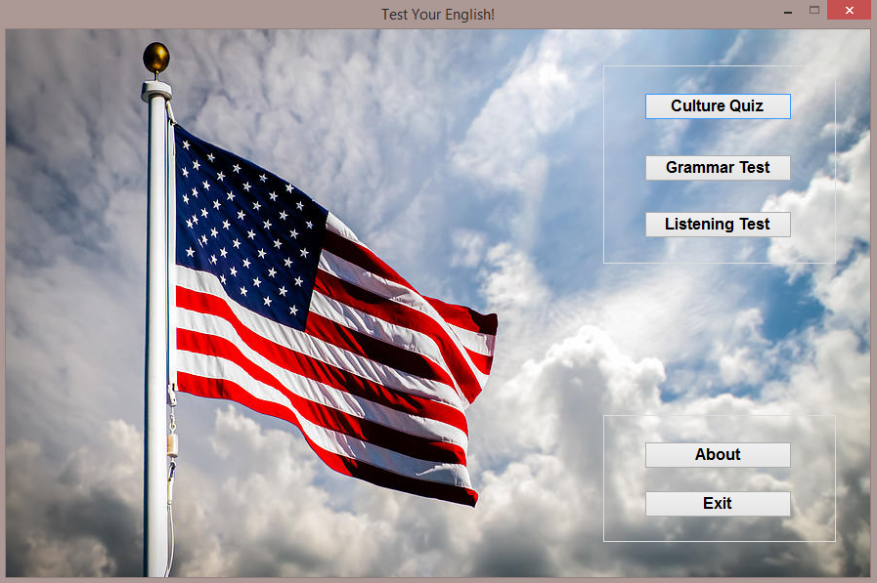

**Launching the Culture Quiz**

After clicking on the corresponding button, the quiz window opens. Be ready to start, since there is a 15 seconds timer per question.

The timer lets you know how much time remains before you are directed to the next question.

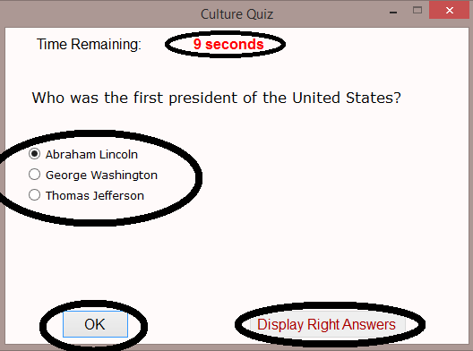

Once you are ready, press OK to submit your answer. If you fail to answer within the remaining time, the selected answer will be recorded.

Select your answer to the question. Only one is correct.

Once you have answered to all 30 questions, you can display the right answers and learn more about American culture!

Your score will be displayed on the screen after the completion of the exercise. Then, you can move to the next one.

**Launching the Grammar Test**

Go back to the main window to launch the next exercise. Next, a new window should appear. The main controls are detailed below.

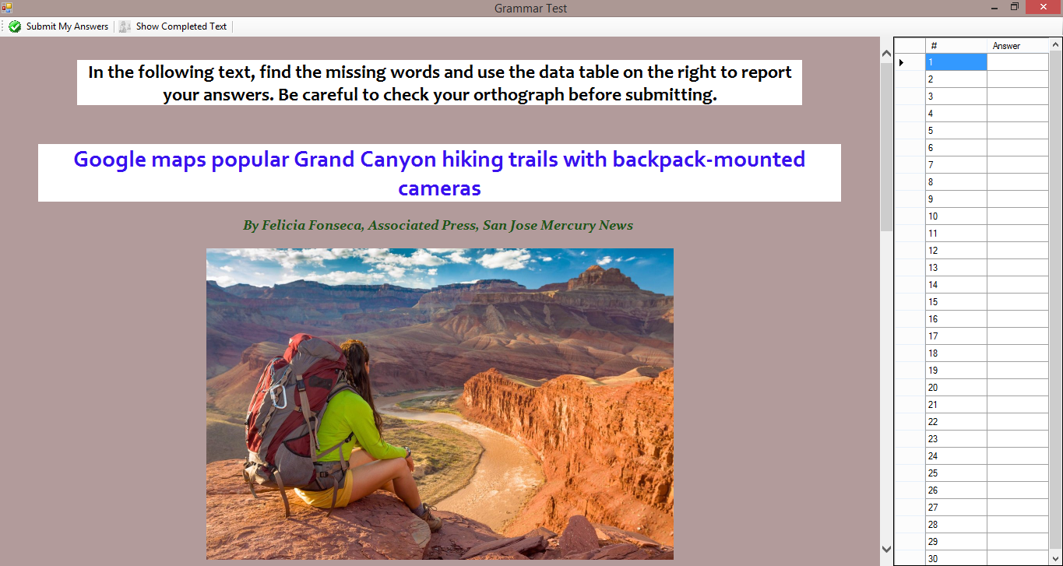

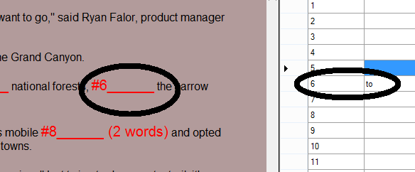

Report the missing word using the data table.

Write your answers in the data table.

Click on this button to submit your answers.

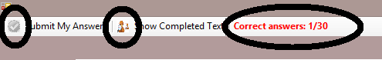

Your score will appear here once you have submitted your answer.

Once you have submitted your answers, you can display the original text.

**Launching the Listening Test**

Go back to the main window to launch the listening test. The next window should then appear on the screen.

Select the answer from the 3 choices proposed here. Keep in mind that only one answer is correct.

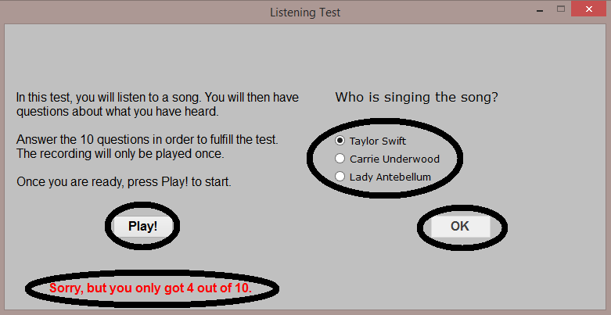

Once you have answered to all of the questions, your score will be displayed here.

Press OK to submit the answer to the question. Note that you will not be able to go back to your previous answers after you press this button.

Press this button to start the song. Be careful! You can do it only once!

# Choices of Implementation

In this part, we will detail the implementation of our application. We will start by presenting the language we used to implement our solution and the reasons why. Then, we will talk about the development process, the problems we faced and how we solved them.

## Why use C#

We have chosen to write our application in C#, which is an object-oriented language created by Microsoft. The reason that motivated us in doing so was first and foremost a personal choice. We wanted to learn a new language that we do not have the opportunity to learn at school. It is used in many companies and is really manageable to use compared to other object-oriented languages, such as C++. The performance of C# makes it a valuable asset for software companies and can be a plus for our professional life.

Another reason that motivated us is that it is very suitable for Microsoft running environments. We can deploy our application everywhere, and with a minimum of optimization, we could even use it as a Windows Phone app.

## Development Process

We used Microsoft Visual Studio to develop our application. This IDE provided us with many useful resources, such as the interface designer that allowed us to directly draw the components of our app instead of writing all the code to create them. Our project contains 5 forms – the Main Form, the Culture Quiz Form, the Grammar Test Form, the Listening Form and the Web Browser Form, which we use to display the answers for the first two exercises.

All the forms inherit from the Form class. This allowed us to customize our forms and assign them with specific behavior. We used inheritance to prevent some forms from being resized.

For both quizzes (culture and listening), we created a couple of classes to help us handle the checking and answering process. We have a class **Answer.cs**, which associated an assertion (string) with a state of truthfulness (Boolean). The class **Question.cs** defines a question with a title (string) and 3 answers, for which only one is correct (use of the truthfulness state). **QuestionGenerator.cs** defines all the questions we need for both tests, using the previous classes. Then, we only need to call the right method from the QuestionGenerator class in the specific form.

One of the major problems we faced was rendering the text for the grammar exercise. We could not use the simple labels from Visual Studio since it would be too long to render and not really friendly-user. We decided to incorporate HTML in our project along with some CSS to nicely render our text. We incorporated a Web Browser in the Grammar Test where we could load the rendered HTML. We later used the same process to display the correction of the Culture Quiz Form.

Another problem linked with the previous one was to make possible for the user to fill out the text. C# does not provide methods to parse HTML. We started to investigate in this process, but we soon realized it was much harder that we expected. We decided to go around that problem using a Data Table – a structure included in C# used to process data – along with our HTML file. The user would just need to report his answers in the table on the right. This also allowed us to keep the user’s answers visible when he displays the correction, so he can know what answers he did wrong.

For the Listening Form, we needed to include an audio file. We then thought about 2 possible ways: we could either implement a sound player similar to Windows Media Player that would allow the user to go to a specific timing of the song. However, this would have been much easier for the user to find the answers to the question and would have not been realistic compared to the TOEFL test, where one can listen to the audio files only once. Since we did not need more advanced audio software, we decided to simply use the SoundPlayer class of C# that provided us with all the methods we needed – basically, we only needed to start the song from the beginning and to stop it whenever the user felt he was ready to submit his answers.

A very handy thing in C# is the possibility to include external resources to our project, such as pictures and audio files. We used this to provide our interface with icons for our buttons in the Grammar Test. Of course, we also used it to include the song for the Listening Form. All we needed to do was to include our resources into a folder of the same name and to reference them using the C# Resources class. The main advantage of using the C# class is that it handles automatically the relative path, so that when you execute the app on another computer, the compiler will still find the files.

# Conclusion

This project gave us the opportunity to improve our level in C# programming on a real-life example. It was also a good occasion to improve our level of English by finding and thinking about questions that people would likely struggle with. The development process was a broad experience, since we had to conceive everything – concepts of the application included – and then develop it. We could then still improve our application in developing it into a mobile application or in deploying it on the cloud.

# Addendum: External Resources

Although we developed the whole application ourselves, we used some websites during the development process.

* **Microsoft Developer Network:** Microsoft official website for developers which provides the full documentation for C# and Visual Studio

<http://msdn.microsoft.com/en-US/#fbid=9AE0H62350r>

* **Stack Overflow:** a useful forum that helped a lot when we were stuck on a problem

<http://stackoverflow.com/>

* **Code Project:** gives examples of C# programs. Used when we needed an example of how to use Sound Player

<http://www.codeproject.com/>