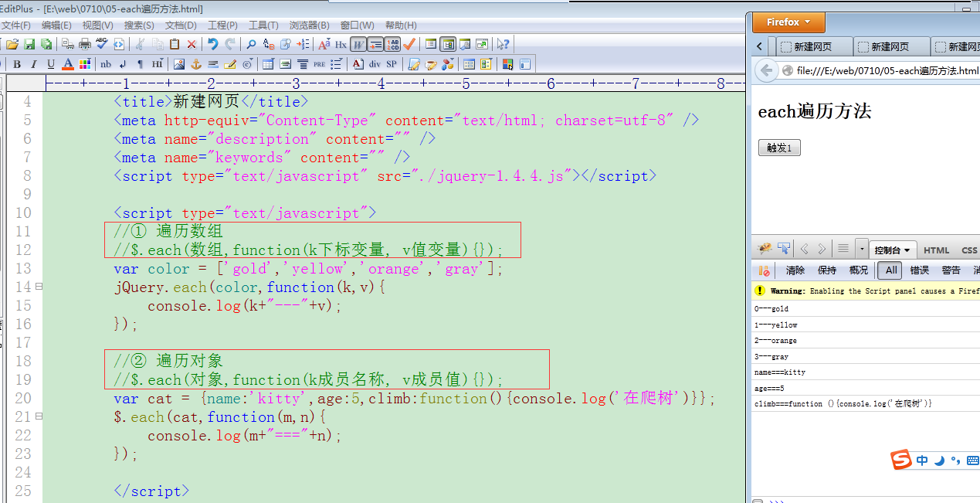

{

"comments": [

{

"content": "很不错嘛",

"id": 1,

"nickname": "纳尼"

},

{

"content": "哟西哟西",

"id": 2,

"nickname": "小强"

}

]

}