

**Development of Crash Modification Factors for Uncontrolled Pedestrian Crossing Treatments**

Charlie Zegeer, Craig Lyon, Raghavan Srinivasan, Bhagwant Persaud, Bo Lan, Sarah Smith, Daniel Carter, Nathan J. Thirsk, John Zegeer, Erin Ferguson, Ron Van Houten, and Carl Sundstrom

**The objective of this study was to develop crash modification factors for four treatment types: rectangular rapid-flashing beacon (RRFB), pedes- trian hybrid beacon (PHB), pedestrian refuge island (RI), and advance yield or stop markings and signs (AS). From 14 cities throughout the United States, 975 treatment and comparison sites were selected. Most of the treatment sites were selected at intersections on urban, multi- lane streets, because these locations present a high risk for pedestrian crashes and are where countermeasures typically are needed most. For each treatment site, relevant data were collected on the treatment char- acteristics, traffic, geometric, and roadway variables, and the pedestrian crashes and other crash types that occurred at each site. Cross-sectional regression models and before–after empirical Bayesian analysis tech- niques were used to determine the crash effects of each treatment type. All four of the treatment types were found to be associated with reduc- tions in pedestrian crash risk, compared with the reductions at untreated sites. PHBs were associated with the greatest reduction of pedestrian crash risk (55% reduction), followed by RRFBs (47% reduction), RIs (32% reduction), and AS (25% reduction). The results for RRFBs had their basis in a limited sample and must be used with caution.**

The safety of pedestrians who attempt to cross streets, particularly on high-speed, high-volume multilane roads, continues to be a prob- lem in the United States. Furthermore, the safety effects of some of the more promising treatments to reduce pedestrian crashes need to be better understood. Numerous studies have been conducted in the United States and abroad in recent years on the effects of various geometric and traffic control treatments at unsignalized crossings. However, most of those evaluations have relied on behavioral and operational measures of effectiveness (e.g., pedestrian–vehicle con- flicts, vehicle speeds, and driver yielding behavior) rather than on

C. Zegeer, R. Srinivasan, B. Lan, S. Smith, D. Carter, N. J. Thirsk, and C. Sundstrom, University of North Carolina Highway Safety Research Center, CB No. 3430, 730 Martin Luther King, Jr., Boulevard, Chapel Hill, NC 27599. C. Lyon, Persaud and Lyon, Inc., 663 Gainsborough Avenue, Ottawa, Ontario K2A 2Y9, Canada.

B. Persaud, Civil Engineering Department, Ryerson University, 350 Victoria Street, Toronto, Ontario M5B 2K3, Canada. J. Zegeer and E. Ferguson, Kittelson and Associates, Inc., No. 810, 300 M Street, SE, Washington, DC 20003.

R. Van Houten, Center for Education and Research in Safety, Western Michigan University, 1903 West Michigan Avenue, Kalamazoo, MI 49008. Corresponding author: R. Srinivasan, [srini@hsrc.unc.edu.](mailto:srini@hsrc.unc.edu)

*Transportation Research Record: Journal of the Transportation Research Board,*

No. 2636, 2017, pp. 1–8.

<http://dx.doi.org/10.3141/2636-01>

crashes as the measure of effectiveness (*1*). The lack of crash-based evaluations for such pedestrian treatments largely results from sam- ple size issues. That is, pedestrian crashes usually do not cluster to the same degree at specific sites, so a larger number of treatment and comparison sites are needed to obtain sufficient statistical power to detect a change in crashes as a result of the treatment, compared with the evaluation of countermeasures for vehicle–vehicle crashes that occur at a higher frequency.

Thus evaluations conducted over a wider region and over a longer time period are needed to obtain an adequate sample size to develop crash modification factors (CMFs) or crash modification functions (CMFunctions) that can provide guidance as to the most effective pedestrian crossing treatments to use. NCHRP Project 17-56 sought to develop CMFs for selected pedestrian crossing treatments for various traffic and roadway conditions to the extent possible (*2*). Initially, eight treatments were considered, but it was not possible to find a sufficient sample of sites for all of these treatments. Also, consideration was given to the selection of treatments for evalua- tion that were believed to be of the most interest to local and state traffic and safety officials. On the basis of these considerations, the following four treatments were selected for crash-based evaluation in this study:

* Rectangular rapid-flashing beacon (RRFB),
* Pedestrian hybrid beacon (PHB),
* Pedestrian refuge island (RI), and
* Advance yield or stop markings and signs (AS).

The next section describes the known research literature on these treatments and is followed by details on data, analysis, results, rec- ommendations, and limitations. Further details about the study are available in Zegeer et al. (*2*).

# Literature review

AS treatments are a type of pavement marking placed before a cross- walk to increase the distance at which drivers stop or yield to allow pedestrians to cross. An increase in the distance between yielding vehicles and pedestrians increases the ability of motorists in other lanes to see pedestrians as they cross and to yield accordingly. Pedes- trian visibility of oncoming traffic is improved. Ten previous studies indicated that AS treatment reduced pedestrian–vehicle conflicts and increased motorist yielding (*1*).

1

Pedestrian RIs, sometimes referred to as center islands or pedes- trian islands, are raised areas that help protect pedestrians who are crossing the road at intersections and midblock locations. The pres- ence of a median RI in the middle of a street or intersection allows pedestrians to focus on one direction of traffic at a time as they cross and gives them a place to wait for an adequate gap between vehi- cles. Islands are appropriate for use at uncontrolled and signalized crosswalk locations. In cases in which the road is wide enough and on-street parking exists, center islands can be combined with curb extensions to further enhance pedestrian safety (*3*).

Three reviewed studies reported crash reduction factors for the construction of raised medians or pedestrian islands. One study found that replacement of a 6-ft painted median with a wide raised median reduced pedestrian crashes by 23% (*4*), which was consis- tent with findings from another study that pedestrian crash rates for roads with 10-ft medians were 33% lower than for roads with 4-ft painted medians (*5*). Finally, a before–after study was conducted to evaluate the safety effectiveness of raised pedestrian RIs. The researchers found a 73% reduction in midblock pedestrian crashes but a 136% increase in total crashes. They noted that the decrease in safety related to vehicle–island crashes might be addressed through better island design and lane alignment (*6*).

PHBs, also known as HAWK (high-intensity activated crosswalk) beacons, were developed by Tucson, Arizona, traffic engineer Richard Nassi in the late 1990s to provide safe pedestrian crossings in cases in which minor streets intersected with major arterials (*7, 8*). A PHB is a special type of beacon used to warn and control traffic at an unsignal- ized location to assist pedestrians as they cross a street or highway at a marked crosswalk. The PHB signal head consists of two red lenses over a single yellow lens. It displays a red indication to drivers when activated, which creates a gap during which pedestrians can cross a major roadway. The PHB signal indication for motorists is not illuminated until it is activated by a pedestrian who triggers the warning flashing yellow lens on the major street. After a set amount of time, the traffic signal indication changes to a solid yellow light to inform drivers to prepare to stop. The beacon then displays a dual solid red light to drivers on the major street and a walking person symbol to pedestrians. At the conclusion of the walk phase, the bea- con displays an alternating flashing red light to drivers, and pedes- trians are shown an upraised hand symbol with a countdown display to inform them of the time left during which to cross. The first PHB was installed in Tucson in 2000. The PHB was considered an experi- mental treatment until 2009 when it was included in the *Manual on Uniform Traffic Control Devices* (*9*). PHBs are now widely used in Tucson and have since been installed in Georgia, Minnesota, Florida, Michigan, Virginia, Arizona, Alaska, and Delaware (*10*).

One reviewed study reported crash reduction factors with respect to the installation of PHBs in Tucson. Results of the analysis showed a statistically significant reduction in total crashes of 29% as well as a statistically significant reduction in pedestrian crashes of 69%. The reduction in severe crashes was 15%, although this result was not statistically significant (*7*).

An RRFB is a type of amber LED installed to enhance pedestrian crossing signs at midblock crossings or unsignalized intersections. An RRFB can be automated or pedestrian actuated and features an irregular, eye-catching flash pattern to call attention to the presence of pedestrians. The RRFB was given interim approval as a crossing sign enhancement by FHWA in 2008 (*11*). Nine studies were reviewed. All of them indicated that RRFBs increased motorist yielding to pedestri- ans, which thereby helped to reduce pedestrian–vehicle conflict (*1*). Figure 1 shows photographs of the four treatments evaluated in this study.

# Data CoLLeCtion

The research team used multiple methods to identify cities and states that had installed pedestrian crossing treatments at unsignalized intersections. The team conducted exploratory field work to iden- tify specific treatment and comparison sites in multiple cities across the United States. On the basis of detailed information obtained from each city, in terms of available treatments of interest for this study, U.S. geographic distribution of cities, and other factors, the 14 cities selected for data collection for this study were Alexandria and Arlington, Virginia; Cambridge, Massachusetts; Chicago, Illinois; New York City; Miami and St. Petersburg, Florida; Tucson, Scottsdale, and Phoenix, Arizona; Portland and Eugene, Oregon; Charlotte, North Carolina; and Milwaukee, Wisconsin.

The final database included 499 treatment sites and 476 com- parison sites. Comparison sites were selected to be as similar as possible to the treatment sites, except that no treatment was present. Efforts were made to select comparison sites similar to the treat- ment sites in terms of number of lanes, traffic volume, area type, nearby location, and other characteristics (e.g., at a school, bus stop, or shopping area). Table 1 summarizes the number of treatment and comparison sites that were found and coded into the database. As shown in Table 1, treatment sites often had combinations of two or more of the studied treatments.

Most of the sample sites were on roads with four or more lanes. Of the 975 sites, 136 (27%) treatment and 87 (18%) comparison sites were on two-lane roads. The project team decided to focus on sites with four or more lanes and pedestrian crossings on arterial streets and at transit stops, because these are the types of sites at which pedestrian crashes are more likely to occur (rather than on local two-lane streets) and at which pedestrian safety treatments are more likely to be needed.

The most common crosswalks in the database were those that had no marked crosswalk (e.g., at untreated comparison sites), continental- style crosswalks, or ladder crosswalks. The transverse lines cross- walks were found at about 100 crossing sites. Multiple crosswalk types (80 sites) were those that had two or more descriptive codes (combined); for example, a yellow crosswalk with transverse line markings, or a staggered crosswalk with continental markings, or a diagonal crosswalk with ladder markings. Most of the treatment (75%) and comparison (76%) sites were at intersections. Furthermore, a great majority of treatment and comparison sites were in suburban areas. In terms of transit use, approximately half the comparison sites were at transit stops, and 41% of treatment sites were at transit stops.

Data on pedestrian crashes and other crashes for each treatment and comparison study site were provided electronically by the agencies, as were data on annual average daily traffic (AADT). Few agencies were able to provide pedestrian counts. Thus pedestrian volume was collected in the field for 915 of the 975 sites. In the field, pedestrian counts were collected for 1 to 2 h. The team adjusted these short counts to daily volumes (i.e., 24-h volumes) on the basis of an analysis of city- wide, full-day pedestrian counts from Charlotte and previous research in Seattle, Washington.

# Data anaLysis anD resuLts

The aim of the analytical work was to use the most appropriate tech- niques to estimate CMFs or CMFunctions for pedestrian-involved crashes and for all crashes, by type, for various treatments and treatment combinations.

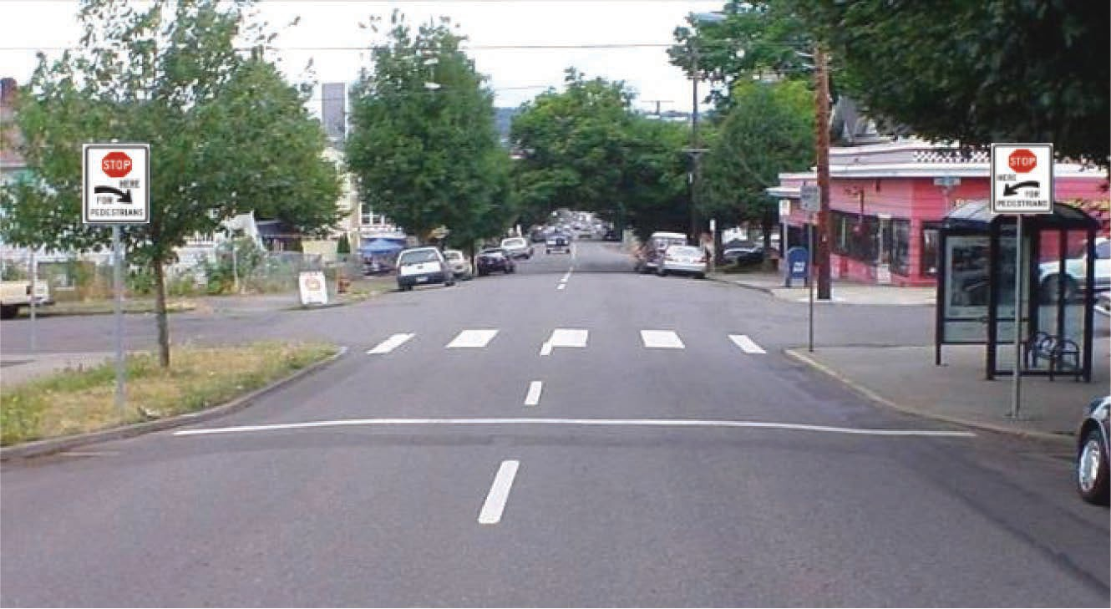 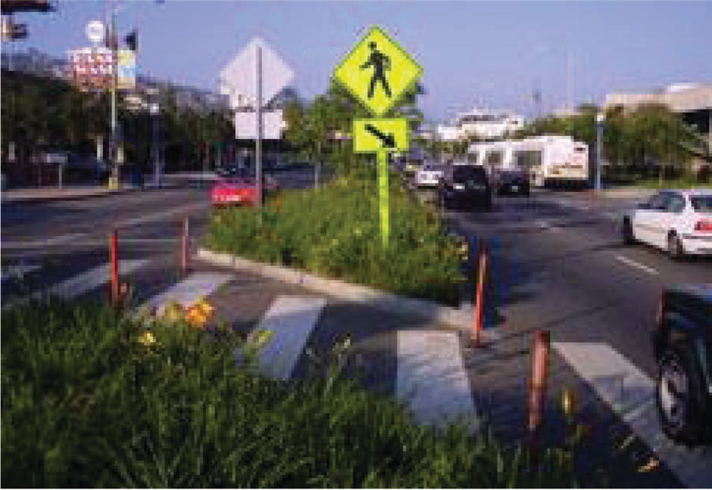

1. **(b)**

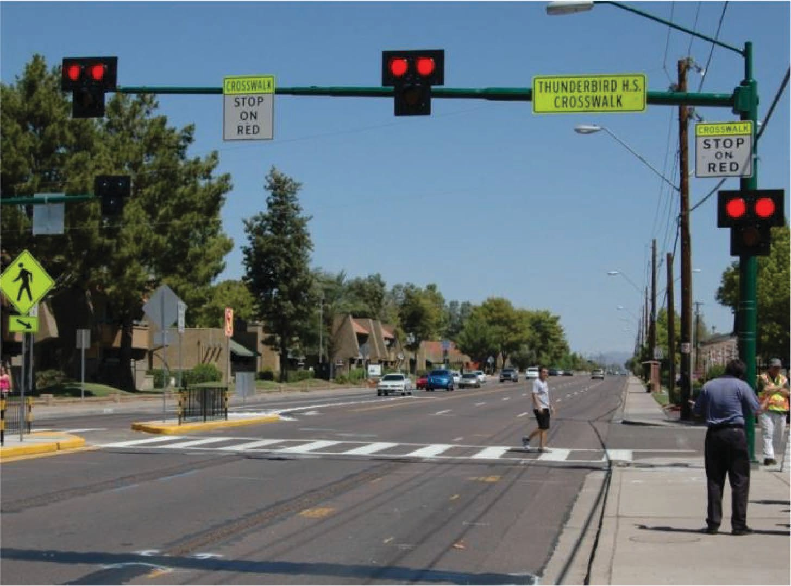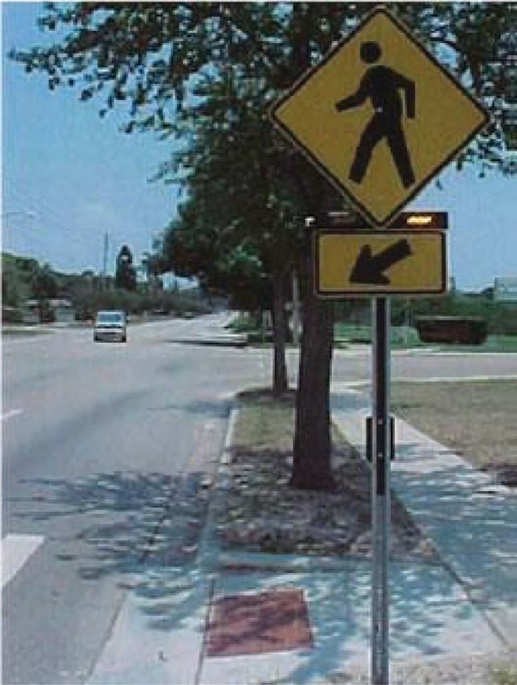

**(c) (d)**

**FIGURE 1 Examples of (*a*) AS, (*b*) raised median island, (*c*) PHB, and (*d*) RRFB. (Source: Pedestrian and Bicycle Information Center, FHWA, www.wichita.org.)**

**TABLE 1 Treatment and Comparison Site Totals, by City**

City AS RI RRFB PHB AS and RI

AS and RRFB

AS and PHB

RI and RRFB

AS and RI and RRFB

AS and RI and PHB

Total Treatment Sites

Total Comparison Sites

|  |  |  |  |  |  |  |  |  |  |  |  |  |
| --- | --- | --- | --- | --- | --- | --- | --- | --- | --- | --- | --- | --- |
| Arlington and Alexandria, | 1 | 21 | 0 | 0 | 1 | 0 | 0 | 0 | 0 | 0 | 23 | 22 |
| Virginia |  |  |  |  |  |  |  |  |  |  |  |  |
| Cambridge, Massachusetts | 2 | 9 | 0 | 0 | 8 | 0 | 0 | 0 | 0 | 0 | 19 | 25 |
| Charlotte, North Carolina | 0 | 34 | 0 | 0 | 0 | 0 | 2 | 0 | 0 | 0 | 36 | 112 |
| Chicago, Illinois | 0 | 33 | 0 | 0 | 0 | 3 | 0 | 0 | 0 | 0 | 36 | 37 |
| Eugene, Oregon | 0 | 22 | 1 | 0 | 1 | 0 | 0 | 3 | 2 | 0 | 29 | 27 |
| Miami, Florida | 0 | 24 | 3 | 0 | 1 | 0 | 0 | 0 | 2 | 0 | 30 | 36 |
| Milwaukee, Wisconsin | 0 | 11 | 0 | 0 | 0 | 0 | 0 | 1 | 0 | 0 | 12 | 18 |
| New York, New York | 0 | 17 | 0 | 0 | 0 | 0 | 0 | 0 | 0 | 0 | 17 | 24 |
| Phoenix, Arizona | 4 | 2 | 0 | 0 | 6 | 0 | 3 | 0 | 1 | 2 | 18 | 16 |
| Portland, Oregon | 18 | 6 | 1 | 2 | 33 | 0 | 0 | 0 | 1 | 0 | 61 | 33 |
| Scottsdale, Arizona | 0 | 14 | 0 | 0 | 2 | 0 | 1 | 0 | 0 | 1 | 18 | 16 |
| St. Petersburg, Florida | 72 | 1 | 0 | 0 | 7 | 22 | 3 | 0 | 10 | 0 | 115 | 45 |
| Tucson, Arizona | 0 | 2 | 0 | 0 | 1 | 0 | 48 | 0 | 0 | 34 | 85 | 65 |
| Total | 97 | 196 | 5 | 2 | 60 | 25 | 57 | 4 | 16 | 37 | 499 | 476 |

It was quickly realized that the preferred before–after study would be limited in scope and robustness because of the relatively small sample sizes, especially for pedestrian crashes. Thus considerable effort was made to assemble a database for the alternative methodol- ogy, cross-sectional regression analysis, with recognition of the well- known limitations of this approach. In view of those limitations, it still was necessary to conduct a before–after study, however limited, to complement the cross-sectional analysis and seek to corroborate the results.

Although the primary target crash of the four pedestrian treatments was the small subset of vehicle–pedestrian crashes, vehicle–vehicle crashes were added to the analysis to investigate if they were affected as well. If the treatments altered driver behavior, it was a logical pos- sibility. Rear-end and sideswipe crashes were combined, because it was hypothesized that these types of vehicle–vehicle crashes might be the crash types most likely to be affected by the pedestrian treat- ments and would be similar in this regard. The combined category was considered the target vehicle–vehicle crash category.

# CMF estimation with Before–after study Methodology

The empirical Bayes (EB) methodology for observational before–after studies was used to develop CMFs. In the EB approach, the CMF is estimated on the basis of a comparison of the expected number of crashes that would have occurred in the after period without the treat- ment and the number of reported crashes in the after period. The first value is estimated in essence as a weighted average of the crashes that occur before treatment and the prediction from a safety performance function developed from a reference group of similar but untreated sites that is adjusted for changes in traffic volume and time trends between the periods before and after treatment. This methodology is rigorous in that it properly accounts for regression to the mean and these other changes and is included in the first edition of the *Highway Safety Manual* as the state of the art for the conduct of observational before–after studies (*12*) and is well documented in Hauer (*13*). Both sources can be consulted for details on the methodology, which are not presented here in the interests of brevity.

The evaluation was conducted for three treatments with sufficient sites: RI (68 sites), AS (69 sites), and PHB in combination with AS (27 sites). Four crash types were investigated in the before–after evaluation when possible: total, rear-end, sideswipe, and pedestrian. Table 2 shows the estimated CMFs for the RI, AS, and PHB and AS combination. For each treatment and crash type, the table shows the actual crashes that occurred during the after period, the expected

crashes had the treatment not been implemented (estimated on the basis of the EB procedure), variance of the expected crashes, the CMF, the standard error of the CMF, and the *p*-value.

For the RI treatment, the EB estimate of crashes in the before period of the treatment group was higher than it was for the actual crashes, particularly so for vehicle-involved crashes, which led to an inexplicable increase in total crashes. This result was unexpected, and hence the results for the RI treatment for the vehicle-involved crash types were not considered reliable enough for inclusion. The results for pedestrian crashes indicated a reduction of approximately 33%, which was significant at about the 13% significance level.

For the AS treatment, the results indicated an approximate 11% reduction in total crashes, a 20% reduction in rear-end and sideswipe crashes, and a 36% reduction in pedestrian crashes. The reduction in total crashes was statistically significant at about the 8% level, and the reduction in the other two crash types was statistically significant at the 5% level or lower.

For the combination PHB and AS treatment, the results indicated an approximately 18% reduction in total crashes and a 76% reduc- tion in pedestrian crashes. Both results were statistically significant at the 5% level or lower. The changes in rear-end and sideswipe crashes were not statistically significant at any reasonable signifi- cance level. The result for pedestrian crashes was quite consistent with the 69% reduction reported by Fitzpatrick and Park (*7*) for the same treatment at intersections in Tucson. Fitzpatrick and Park also used the EB before–after evaluation method (*7*).

# CMF estimation from Cross-sectional regression analysis

The purpose of the cross-sectional regression analysis, as it was for the before–after study, was to estimate CMFs or CMFunctions for each of the four pedestrian treatments. It also was of interest to esti- mate CMFs for combinations of treatments. In fact, at many of the sites one installed treatment was followed by one or more additional treatments in later years. For most combination treatments, how- ever, the sample size was too limited to provide robust results. The exceptions were PHB and RRFBs. Most sites that had these treatments also had AS present. Several crash types were analyzed separately for each treatment, including pedestrian crashes; rear- end plus sideswipe crashes; rear-end plus sideswipe crashes; fatal, incapacitating injury, nonincapacitating injury, and possible injury crashes; and total crashes.

The cross-sectional analysis applied generalized linear modeling. Because each site year of data was used as an observation, the issue of

|  |  |  |  |  |  |  |  |
| --- | --- | --- | --- | --- | --- | --- | --- |
| **TABLE 2 CMFs from** | **Before–After Evaluation** |  | | | | | |
| Treatment and Number of Sites | Crash Type | Crashes After | EB Estimates of Crashes Expected After | Variance (EB after) | CMF*a* | SE of CMF | *p*-Value |
| RI: 68 sites | Pedestrian | 13 | 18.8 | 11.2 | 0.671 | 0.215 | .126 |
| AS: 69 sites | Total | 671 | 754.7 | 2,254.5 | **0.886** | 0.065 | .079 |
|  | Rear-end and sideswipe | 335 | 416.2 | 1,068.8 | **0.800** | 0.076 | .008 |
|  | Pedestrian | 21 | 32.2 | 27.4 | **0.636** | 0.169 | .031 |
| PHB and AS: 27 sites | Total | 341 | 413.2 | 1,078.5 | **0.820** | 0.078 | .021 |
|  | Rear-end and sideswipe | 182 | 205.4 | 460.9 | 0.876 | 0.111 | .264 |
|  | Pedestrian | 4 | 15.6 | 13.3 | **0.244** | 0.128 | .000 |

Note: SE  standard error.

*a*Statistically significant results at the 10% level are indicated in bold.

repeated measures of the data needed to be resolved in the specifica- tion of the models. The approach taken within the generalized linear modeling framework to account for the repeated measures and nested nature of the data was that of generalized estimation equations. This approach ensured that the correlation between within-site observa- tions was accounted for and allowed for unobserved heterogeneity between cities.

The data set used to develop the CMFs for RIs did not include any site that had an AS, PHB, or RRFB installed at any time during the study period. For this and all treatments, the reference group sites did not have any of the four main treatments installed. Likewise,

to the inclusion of the area type variable. Models with and without the city variable and the area type were attempted before it was decided whether to include the variable in the final models. (For the most part, the variable was included.)

*Model Results: Example RIs*

The following model forms pertained to each crash type for the RI models to predict the expected number of crashes per year.

the data set used to develop CMFs for AS did not include any site that had an RI, PHB, or RRFB installed at any time during the study period. The data used to develop the CMFs for RIs and AS came from Alexandria and Arlington, Cambridge, Charlotte, Chicago, Eugene, Miami, Milwaukee, New York City, Phoenix, Portland, Scottsdale, St. Petersburg, and Tucson.

The data set used to develop CMFs for PHBs did not include any site that had an RI or RRFB installed at any time during the study period. Because many sites with PHBs also had AS, sites with these signs were included in the data set. The sites also were limited to the following cities in which a PHB existed: Charlotte, Portland, Phoenix, Scottsdale, Tucson, and St. Petersburg.

For pedestrian crash models, the data set used to develop CMFs for RRFBs included all locations. This data set was needed to allow

pedcrash  exp*a*city+*b*\*RIpresence*c*\*areatypeAADT*e* pedAADT *f* totcrash  exp*a*city+*b*\*RIpresence*d* *midblock_intAADT*e* pedAADT *f* injcrash  exp*a*city+*b*\*RIpresence*d* *midblock_intAADT*e* pedAADT *f* targetcrash  exp*a*city+*b*\*RIpresence*d* *midblock_intAADT*e* pedAADT *f* injtargetcrash  exp*a*city+*b*\*RIpresence*d* *midblock_intAADT*e*pedAADT *f*

where

(1)

(2)

(3)

(4)

(5)

for a sufficient sample of pedestrian crashes. For the other crash types, the data set for RRFBs did not include any site that had an RI or PHB installed at any time during the study period. Because many sites with RRFB also had an AS, sites with these signs were included in the data set. For the nonpedestrian crash models, the sites also were limited to cities in which an RRFB existed: Chicago, Eugene, Miami, Phoenix, Portland, and St. Petersburg.

# Cross-sectional Model results

This section presents the CMFs implied by the relevant parameter estimates of the cross-section models. For brevity, only one set of models (RIs) is presented here by way of example. The following considerations were applied to the making of decisions on variables to include in the models.

* + The typical multiplicative crash prediction model form even- tually was applied with pedestrian and total AADT as separate powermodeltermsandthecategoricalvariablesforthecityinwhich a crossing was located, presence of a treatment, area type (urban or suburban), and crossing location (midblock or intersection) as exponential terms.
  + Interaction terms were attempted—for example, the effect of

presence of treatment and crossing location—but these did not improve the model’s capability to explain the variation in crashes between sites.

* + Multilevel models were attempted to develop CMFunctions

through investigation to determine if the implied CMFs for the pres- ence of treatment varied by vehicle and pedestrian AADT and other variables, but these, too, did not improve the results.

* + A city factor variable was included in the models to account for

differences in expected crashes between jurisdictions not related to the treatment, which could include crash reporting practices, weather, cultural issues, and the like. Inclusion of this variable estimated a unique intercept term for each city in a model. The same logic applied

AADT  total AADT on roadway that is being crossed, areatype  1 if suburban, 0 if urban,

city  represents an intercept term specific for each city, midblock_int  1 if intersection, 0 if midblock,

pedAADT  total pedestrian AADT for midblock or inter- section, and

RI  1 if present, 0 if not present.

Target crashes include rear-end and sideswipe crashes.

Parameter estimates for all models are shown in Table 3. As noted, the estimates for the city variable are not provided here in the interest of brevity. In any case, they had no impact on the estimated CMFs.

With the exception of the parameter estimates for RI presence and the area type in the pedestrian crash model, all parameter estimates were statistically significant at the 5% level (i.e., a value of no effect was not within 1.96 standard errors). Those two estimates were, how- ever, statistically significant at the 10% level (a value of 0 was not within 1.64 standard errors).

The estimated parameters indicated that fewer crashes of all types were expected when an RI was present and fewer pedestrian crashes in suburban rather than urban areas. Greater numbers of crashes of all types were expected at higher levels of vehicle and pedestrian AADT. With the exception of pedestrian crashes, the models also indicated that more crashes were expected at intersections than at midblock crossings.

*CMFs Implied from Cross-Sectional Models*

Table 4 summarizes the results from the cross-sectional analyses for treatments and crash type cases in which the analyses supported a CMF recommendation. The CMFs implied by the parameter esti- mates for a treatment were estimated as (e*b*), where *b* was the esti- mated coefficient for the presence of treatment. Standard errors also were presented to assess statistical significance. Effects that were statistically significant at the 10% level are indicated in boldface.

**TABLE 3 Parameter Estimates for RI Regression Models**

Parameter Estimate (SE)

Parameter Pedestrian Total Injury RE and SS Injury RE and SS

|  |  |  |  |  |  |
| --- | --- | --- | --- | --- | --- |
| a | 10.4246 (1.6409) | 5.5953 (0.7761) | 6.4572 (0.8886) | 8.3157 (0.9754) | 9.7130 (1.2009) |
| b | 0.3578 (0.2153) | 0.2981 (0.0956) | 0.3369 (0.1148) | 0.2999 (0.1258) | 0.3254 (0.1460) |
| c | 0.5715 (0.3127) | na | na | na | na |
| d | na | 0.4730 (0.1083) | 0.4312 (0.1183) | 0.4140 (0.1224) | 0.3728 (0.1395) |
| e | 0.6977 (0.1694) | 0.5192 (0.0756) | 0.5375 (0.0846) | 0.7235 (0.0947) | 0.7780 (0.1157) |
| f | 0.3295 (0.0486) | 0.1224 (0.0247) | 0.1141 (0.0260) | 0.1041 (0.0237) | 0.0986 (0.0263) |
| Overdispersion | na | 0.7608 (0.0305) | 0.7075 (0.0482) | 0.9149 (0.0521) | 0.9837 (0.1075) |

Note: RE and SS  rear-end and sideswipe; na  not applicable.

Also presented for comparison are the before–after study results presented earlier. As is evident, a comparison of results from the two studies is possible only for pedestrian crashes, the main target crash type.

For RIs, the cross-sectional CMFs were all statistically signifi- cant ( *p* < .10) and consistently of the order of 0.7 (crash reductions of 30%). The RI may have been provided by a continuous median or by a smaller island provided at the crossing. Additional models were attempted, which allowed the safety effects to differ by continuous median, rather than by a short RI, but the results were inconclusive. For the presence of AS, the estimated cross-sectional model parameters indicated that fewer pedestrian, total, and injury crashes were expected when AS was present, and more crashes were expected for target and target injury crashes. For total crashes the estimate was extremely close to 0, which would indicate no effect. For the nonpedestrian crash types, the sample sizes were sufficiently large that the large standard errors of these estimates as well as the inconsistent direction of effect could be used to question their reli- ability in the estimation of a CMF. For this reason it was concluded that the cross-sectional models did not support a CMF for vehicle– vehicle crashes. For pedestrian crashes, which had much smaller

sample sizes regardless of the large standard error, the results appeared logical in direction of effect and magnitude.

For the presence of PHB, the *p*-value for pedestrian crash CMF estimated from the cross-sectional model was on the high side. As for AS, because the direction of the effect was intuitive (CMF < 1), the point estimate of the CMF for pedestrian crashes was still recom- mended for application. No CMFs were recommended for the other crash types as a result of the statistical significance, illogical effects implied, or both.

For RRFBs the point estimate of the CMF for pedestrian crashes from the cross-sectional was still recommended for application, because the direction of the effect was intuitive (CMF < 1), as was the case for AS. The high *p*-value was likely to have been a result mainly of the scarcity of these crashes. No CMFs were recommended for the other crash types as a result of the statistical significance, the illogical effects implied, or both.

In general, the before–after results in those cases in which they could be obtained corroborated the direction of effect for pedestrian crashes from the cross-sectional analysis, and in the case of RIs, the order of magnitude. For the other treatments, AS, PHB, and PHB and AS, the CMF point estimates were larger (the benefits were smaller)

**TABLE 4 CMFs Implied from Cross-Sectional Analyses: Comparison with Before–After Study CMFs**

Cross-Section Study Before–After Study

|  |  |  |  |  |  |  |
| --- | --- | --- | --- | --- | --- | --- |
| Treatment | Crash Type | Estimate | SE |  | Estimate | SE |
| RI | Pedestrian | **0.699** | **0.152** | **0.671** | | **0.215** |
|  | Total | **0.742** | **0.071** |  | |  |
|  | All injury | **0.714** | **0.082** |  | |  |
|  | Rear-end–sideswipe total | **0.741** | **0.093** |  | |  |
|  | Rear-end–sideswipe injury | **0.722** | **0.106** |  | |  |
| AS | Pedestrian | 0.863 | 0.290 | **0.636** | | **0.169** |
|  | Total |  |  | **0.886** | | **0.065** |
|  | Rear-end–sideswipe total |  |  | **0.800** | | **0.076** |
| PHB | Pedestrian | **0.526** | **0.206** | 0.38*a* | | na |
| PHB and AS | Pedestrian | **0.62***b* | **0.140** | **0.244** | | **0.128** |
|  | Total |  |  | **0.820** | | **0.078** |
|  | Rear-end–sideswipe total |  |  | 0.876 | | 0.111 |
| RRFB | Pedestrian | 0.526 | 0.377 |  | |  |

*a*The sample size for the PHB alone treatment was limited for conducting before–after evaluation. However, the before–after evaluation estimated CMFs for AS and PHB and AS combinations. With these results and assuming that CMFs were multiplicative for treatment combinations, the CMF for PHB alone was calculated as the CMF for PHB and AS divided by the CMF for AS (i.e., 0.244/0.636  0.38). *b*Estimated for comparison purposes.

for the cross-sectional study, which might be expected on theoretical grounds as a result of the issues with cross-sectional studies. How- ever, given the large standard errors, in particular for the CMFs for the cross-sectional analysis, it could not be concluded that the estimates were different statistically.

# recommended CMFs

As presented in Table 4, credible CMFs for pedestrian crashes and vehicle-involved crashes were estimated by cross-sectional analy- sis, before–after analysis, or both, for RIs, AS, PHB, and PHB and AS. The CMF for RRFB had its basis in a limited sample and hence should be used with caution.

The two methods have strengths and limitations. Although the before–after analysis is preferred, especially the EB approach used in this research, the limited sample size of sites and crashes limits the robustness of the results. By contrast, the well-known limitations in the derivation of CMFs from cross-sectional regression analysis sug- gest that results obtained from that analysis, albeit from a substantial sample, should be interpreted and used with caution. It is encourag- ing, however, that the results of the limited before–after study cor- roborated those from the cross-sectional study for pedestrian crashes, the main crash type of interest.

On balance, it seems difficult to choose one approach over another in cases in which two sets of results are obtained, as was the case for pedestrian crashes, which logically suggests that equal weighting of the CMFs is not unreasonable in the recommendation of CMFs for practical application. With this in mind, in cases in which there are two CMFs in Table 4, the median point values are presented in Table 5 as a final recommendation for practical application. In cases in which a CMF value was available from only one study, that value was recommended. In each case, an appropriate annotation indicates the basis of the recommendation. For practical applications in which a conservative benefit estimate is desired for a contemplated treatment, the higher of two CMF values from Table 4 could be considered. As noted, results from the before–after and cross-sectional analyses were reported only for treatments and crash type cases in which the analyses supported a CMF recommendation.

As mentioned, CMFunctions were explored to determine the effectiveness of these treatments as corresponded to different levels

of AADT, posted speed limit, area type, number of lanes, and other factors. However, these CMFunctions did not provide useful results. Future research could investigate whether these treatments are more or less effective under different conditions.

# LiMitations anD reCoMMenDations

Although several CMFs were estimated, the expected safety effects of treatment may vary across specific applications. A great majority of treatment sites included in this study were intentionally selected at urban (and suburban) areas on multilane roads. Although most of the treatments were at intersections, a substantial number of midblock loca- tions were represented in the database. For example, it was likely that factors, such as operating speed, AADT, roadway width, lane width, and other factors influenced the efficacy of any of these interven- tions. The limited data available did not allow for such a disaggrega- tion of expected effects. Future work is needed to make more precise predictions about how much of a crash reduction should be expected at locations with specific characteristics.

It is also likely that these treatments may have different effects on the number of crashes and the severity of crashes (e.g., interven- tions that slow drivers and reduce the probability of a crash may also have an effect on the severity of the crash when one occurs). Hence it may be possible to have one CMF for total crashes and a different CMF for incapacitating and fatal crashes. Another factor that could not be assessed fully was how the use of several of these treatments used together would influence crashes. The CMF for the RRFB had its basis in a limited sample (i.e., 50 treatment sites) and hence should be used with caution.

One of the data limitations of this study, and of other pedestrian and bicycle-related studies, was the lack of available exposure data related to walking (and bicycling). As a result of the lack of such data from most of the 14 agencies selected for this study, it was necessary to conduct short-term (i.e., 1 or 2 h) counts and extrapolate to obtain an estimate of the average annual daily pedestrian traffic (i.e., pedes- trian AADT). A substantial effort was required to develop pedestrian AADT on the basis of the actual hourly count, the time of day of the count (e.g., 4 to 5 p.m. was the usual count time), and the type of area within a city. Although the estimation of pedestrian daily vol- ume was necessary in the analysis, the accuracy of such estimates

|  |  |  |  |  |
| --- | --- | --- | --- | --- |
| **TABLE 5** | **Recommended CMFs** |  | | |
|  |  | Recommended CMF |  |  |
| Treatment | Crash Type | Estimate | SE | Study Basis |
| RI | Pedestrian | 0.685 | 0.183 | Median from two studies |
|  | Total | 0.742 | 0.071 | Cross section |
|  | All injury | 0.714 | 0.082 | Cross section |
|  | Rear-end–sideswipe total | 0.741 | 0.093 | Cross section |
|  | Rear-end–sideswipe injury | 0.722 | 0.106 | Cross section |
| AS | Pedestrian | 0.750 | 0.230 | Median from two studies |
|  | Total | 0.886 | 0.065 | Before–after |
|  | Rear-end–sideswipe total | 0.800 | 0.076 | Before–after |
| PHB | Pedestrian | 0.453 | 0.167 | Median from two studies |
| PHB and AS | Pedestrian | 0.432 | 0.134 | Median from two studies |
|  | Total | 0.820 | 0.078 | Before–after |
|  | Rear-end–sideswipe total | 0.876 | 0.111 | Before–after |
| RRFB | Pedestrian | 0.526 | 0.377 | Cross section |

(i.e., extrapolation of short-term counts) could have been improved greatly if a larger sample of data (e.g., 8- or 10-h counts) had been available from the city transportation agencies. Unfortunately, only two of the cities (Charlotte and St. Petersburg) had existing pedestrian counts at any of the selected sites. Certainly if more city and state departments of transportation were to collect pedestrian (and bicy- cle) counts routinely, such count data would have value not only for research studies but also to help determine the need and justification for all types of pedestrian improvements on a routine basis.

Most of the four treatment types evaluated in this study did not have samples from all (or even most) of the 14 test cities. For example, approximately 90% of the PHBs used in this study were in Tucson, where this treatment type was most found nationwide when study sites were selected. Likewise, approximately 75% of the RRFB sites in this study were located in St. Petersburg, given the frequent use of these devices in that city. Therefore, it should not necessarily be assumed that the CMFs found in this study for a given treatment will necessarily be the same in all cities. Individual cities and state jurisdictions vary in driver and pedestrian behavior, terrain, laws, weather patterns, and many other factors that can affect the way that any countermea- sure will perform. Therefore, it is recommended that agencies select these or any other countermeasure with caution. They should first try to identify and address the specific safety problem at a location and then consider the countermeasures most likely to address the specific problem. After implementation of any countermeasure, it is also advis- able that crashes and behavior be monitored as a routine practice at treatment sites to ensure that the given countermeasure is operating effectively.

# aCknowLeDgMents

This work was sponsored by NCHRP Project 17-56. The authors appreciate the input and guidance provided by the project panel throughout the project period and thank NCHRP Manager Lori Sundstrom for her project oversight and advice. The authors appreciate assistance from all of the city officials throughout the United States who were contacted for information on the status of implemented pedestrian treatments and particularly for the support and cooperation of officials from the 14 cities in which treatments were selected. Officials from the respective state departments of transportation helped provide crash data for the sites within their

cities. This study could not have been conducted without assistance from those city and state department of transportation officials.

# reFerenCes

1. Mead, J., C. Zegeer, and M. Bushell. *Evaluation of Pedestrian-Related Roadway Measures: A Summary of Available Research.* FHWA, Chapel Hill, N.C., 2013. [http://www.pedbikeinfo.org/data/library/details.cfm?](http://www.pedbikeinfo.org/data/library/details.cfm) id4872.
2. Zegeer, C., C. Lyon, R. Srinivasan, B. Persaud, B. Lan, S. Smith, D. Carter,

N. Thirsk, J. Zegeer, E. Ferguson, R. Van Houten, and C. Sundstrom. *Development of Crash Modification Factors for Uncontrolled Pedestrian Crossing Treatments.* Final report, NCHRP Project 17-56. Transportation Research Board (forthcoming).

1. Zegeer, C. V., J. Stutts, H. Huang, M. J. Cynecki, R. Van Houten, B. Alber- son, R. Pfefer, T. R. Neuman, K. L. Slack, and K. K. Hardy. *A Guide for Reducing Collisions Involving Pedestrians.* NCHRP Report 500, Vol. 10. Transportation Research Board, National Research Council, Washington, D.C., 2004.
2. Claessen, J., and D. Jones. The Road Safety Effectiveness of Wide Raised Medians. In *Proceedings of 17th ARRB Conference,* Vol. 17, No. 5, 1994, pp. 269–284.
3. Cairney, P. *Pedestrian Safety in Australia.* FHWA-RD-99-093. FHWA,

U.S. Department of Transportation, 1999.

1. Bacquie, R., D. Egan, and L. Ing. Pedestrian Refuge Island Safety Audit. Presented at 2001 ITE Spring Conference and Exhibit, Monterey, Calif., 2001.
2. Fitzpatrick, K., and E. S. Park. *Safety Effectiveness of the HAWK Pedes- trian Crossing Treatment.* FHWA-HRT-10-042. FHWA, U.S. Department of Transportation, 2010.
3. Nassi, R. B., and M. J. Barton. New Traffic Control for an Old Pedes- trian Crossing Safety Problem. *APWA Reporter,* Vol. 75, No. 6, 2008, pp. 44–49.
4. *Manual on Uniform Traffic Control Devices.* FHWA, U.S. Department of Transportation, 2009.
5. Chalmers, M. New Traffic Signals Make It Safer for Pedestrians. *USA Today,* Aug. 9, 2010.
6. FHWA. *Rectangular Rapid Flash Beacon.* FHWA-SA-09-009. U.S. Department of Transportation, 2009.
7. *Highway Safety Manual,* 1st ed. AASHTO, Washington, D.C., 2010.
8. Hauer, E. *Observational Before–After Studies in Road Safety.* Emerald Group Publishing Limited, Bingley, United Kingdom, 1997.

*The opinions and conclusions expressed or implied are those of the authors and are not necessarily those of the Transportation Research Board or its sponsors.*

*The Standing Committee on Highway Safety Performance peer-reviewed this paper.*