

# Exploring Vehicle–Pedestrian Crash Severity Factors on the Basis of

**In-Car Black Box Recording Data**

Tai-Jin Song, Jaehyun (Jason) So, Jisun Lee, and Billy M. Williams

**This study investigated the main factors affecting the severity of injury to pedestrians in taxi–pedestrian crashes on urban arterial roads. Video data recorded by an in-car black box were used. Because the video data provided direct crash observation, they were more reliable than the crash data, and video images and speed profiles retrieved from the black box were advantageous for safety studies. For analysis of the black box data, this study defined new explanatory variables that affected injury sever- ity; these variables could not have been identified by the conventional method, which was based on crash reports. A multiple-indicator and multiple-cause model was used to investigate the relationship between the explanatory variables and injury severity. A total of 484 taxi–pedestrian crash scenes over 2 years was used for the multivariate analysis in the city of Incheon, South Korea. The crash characteristics most strongly associated with increased crash severity were failure by the pedestrian to watch for approaching vehicles, jaywalking by the pedestrian, the pedestrian being elderly, excessive vehicle speed, failure by the driver to immediately stop, limited driver vision, and nighttime. This study emphasized the potential of individualized black box video recording data for crash severity analysis and investigation of the causal factors of crashes.**

With economic growth and technological advances, vehicle owner- ship has dramatically increased in the past decades as more people possess the means to purchase private vehicles. Whereas the improve- ment of traffic mobility was an important issue in the past, traffic safety has recently become a major worldwide social issue because of the millions of vehicle crashes and deaths every year. The World Health Organization publicized that approximately 1.2 million people died, 50 million people were injured, and 518 billion U.S. dollars of global social expenses were lost because of road crashes each year in the recent decade (*1*). The World Health Organization also stated that the road crash is not only an offshoot of vehicular mobility but also a major global social issue that threatens people’s lives.

The various types of traffic crashes include vehicle-to-vehicle crashes, vehicle-to-pedestrian crashes, and single-vehicle crashes.

T.-J. Song, Big Data Analysis and Modeling Group, Department of Transport Big Data Research; J. So, Department of Transport Technology Research; and J. Lee, Department of Road Transport Research, Korea Transport Insti- tute, 370 Sicheong-Daero, Sejong-Si 30147, South Korea. B. M. Williams, Department of Civil, Construction, and Environmental Engineering, College of Engineering, North Carolina State University, Campus Box 7908, Raleigh, NC 27695-7908. Corresponding author: J. So, [jso@koti.re.kr.](mailto:jso@koti.re.kr)

*Transportation Research Record: Journal of the Transportation Research Board,*

No. 2659, 2017, pp. 148–154.

<http://dx.doi.org/10.3141/2659-16>

Of these crash types, the vehicle-to-pedestrian crashes are an espe- cially critical problem because the severity level of fatality and injury is high. According to the Road Traffic Authority in South Korea, 45.5% of the fatal crashes that have occurred since 1990 were pedestrian-related crashes, and this proportion is slightly increasing (*2*). Therefore, the pedestrian-related crashes need to be taken more seriously within the traffic safety research community to reduce fatalities on roadways.

Given such circumstances, several research efforts have been made to investigate the factors that affect crashes on the basis of the crash reports made by police officers through interviews with the people in the crash or the witnesses. However, this conventional method can be limited in two aspects. One is that the crash report does not show comprehensive information before and after a crash occurs because the reports are always made after a crash. Therefore, information about the maneuvering of the vehicle, such as speed and acceleration or deceleration, and the situation of the pedestrian before and after a crash can be limited. The other limitation is that the explanatory variables extracted (i.e., causes of crash) are limited to the crash report because the factors can be retrieved only by the questions asked in the crash report.

This study proposes a new data source: video recordings that can be obtained from black box devices mounted on the vehicles. The data can be used for investigating factors that affect crash severity. The black box is capable of not only recording video images but also storing the observed speed and acceleration and deceleration data before and after a crash. This capability is beneficial for recon- structing and understanding the crash situations. Also, black box data provide comprehensive information, including variables that cannot be identified by the crash reports made by police officers.

Therefore, this study aims to identify new factors associated with vehicle–pedestrian crash severity (specifically taxi–pedestrian crashes) by analyzing the video recording data. The study also aims to inves- tigate the relationship between the crash severity factors and the resulting crash severity by using a multiple-indicator and multiple- cause (MIMIC) model (*3*). Finally, the recommendations to mitigate the severity of pedestrian-related crashes are discussed on the basis of the findings of this study. The authors expect that this in-vehicle black box application and the case for crash severity analysis would be used to improve pedestrian safety in the near future.

## Literature review

The authors reviewed the previous safety studies focusing on pedestrian–vehicle crash severity and the risk factors affecting the severity. Haleem et al. identified the factors affecting crash injury

148

severity using 3 years of pedestrian crash data in Florida, which were recorded by police officers (*4*). The risk factors considered in this study include geometric predictors (e.g., presence and type of crosswalk and presence of pedestrian refuge area), traffic predictors (e.g., annual average daily traffic, posted speed limit, and percentage of trucks), road user variables (e.g., pedestrian age and pedestrian maneuver before crash), environmental predictors (e.g., weather and lighting conditions), and vehicle-related predictors (e.g., vehi- cle type). The analysis was conducted with mixed logit modeling, and the results showed that standard crosswalks reduced crash sever- ity 1.36% and at-fault pedestrians were more vulnerable than other pedestrians at unsignalized intersections. Koopmans et al. used Illi- nois state crash data to investigate pedestrian–vehicle crash sever- ity levels by pedestrian age (*5*). The crashes were categorized by five groups (fatal, severe, moderate, minor, and none) and by five age groups (younger than 5, 5 to 9, 10 to 14, 15 to 19, and 20 and older). The results indicated that the crash severity decreased as age increased. Niebuhr et al. also investigated pedestrian–vehicle crash severity with crash data from the German In-Depth Accident Study (*6*). This study categorized ages by three groups: children (0 to 14), adults (15 to 60), and older adults (older than 60) and analyzed the data by using a weighted least squares approach. The modeling results showed that the elderly and children were more likely to be severely injured than young adults. This result was also found in several other studies (*7–10*). Aziz et al. investigated the causal factors affecting pedestrian–vehicle injury severity using New York City crash data (*11*). This study used a random parameter logit model to explain the relationship between possible factors and the injury severity. The mod- eling results showed that road characteristics (e.g., number of lanes, grade, light condition, road surface), traffic attributes (e.g., presence of signal control, type of vehicle), and land use (e.g., parking facilities, commercial and industrial land use) were statistically significant, indi- cating that these variables significantly affected the injury severity of pedestrians. Al-Ghamdi investigated the characteristics of pedestrian– vehicle crashes on the basis of police reports and the hospital records of victims from 1997 to 1999 (*12*). The crash data were analyzed by two odds ratio techniques, Woolf’s and Mantel–Haenszel’s, and the analysis showed that young and old age groups (1 to 9 years, 10 to 19 years, and 60 to 80 years) are at a higher risk of being involved in pedestrian–vehicle crashes. Zajac and Ivan used an ordered pro- bit model to evaluate the effect of roadway and area type features on injury severity of pedestrian crashes (*13*). The pedestrian crash data were obtained from the Connecticut Department of Transportation Office of Inventory and Forecasting. The injury severity level of these crashes were coded with the KABCO injury scale (*14*), consisting of the following five severity levels:

* K  fatality (killed);
* A  incapacitating or disabling injury, cannot leave the scene without assistance (e.g., broken bones, severe cuts, unconsciousness);
* B  nonincapacitating or nondisabling injury, but visible

(e.g., minor cuts, swelling, limping, bruises and abrasions);

* C  possible injury, but not visible (e.g., complaint of pain or momentary unconsciousness); and
* O  property damage only, no injury.

The roadway and area type variables of each crash data set were paired with the KABCO scale. The analysis showed that five features (roadway width, vehicle type, driver alcohol involvement, elderly pedestrian, and pedestrian alcohol involvement) appeared to signifi-

cantly affect the pedestrian’s injury severity, and the crashes of those who were severely injured occurred more frequently in downtown and compact residential areas. Zhang et al. also investigated factors affecting the severity of vehicle traffic crashes involving the elderly (*15*). The crash data used for this study were obtained from the Cana- dian Traffic Accident Information Databank, compiled from police crash reports in Ontario, Canada. On the basis of the multivariate unconditional logistic regression analysis, the study indicated that several factors were significantly related to an increased risk of fatal injury in crashes. The factors were age, sex, failing to yield right- of-way or disobeying traffic signs, nonuse of seat belts, ejection from vehicle, intersection without traffic controls, roads with higher speed limits, snowy weather, head-on collisions, two-vehicle turn- ing collisions, overtaking, and changing lanes. Many studies have been conducted to identify the factors affecting pedestrian-involved crashes or injury severity by employing different statistical model- ing approaches: a zero-inflated Poisson distribution (*16*), a clas- sification and regression tree (*17* ), a heteroskedastic generalized extreme value model (*18*), and an ordered logit model (*19*). All the safety studies reviewed in this section were conducted on the basis of police-recorded crash data.

There is another stream to analyze traffic situations during crashes. An event data recorder (EDR) has been recently highlighted for post- crash analysis, mainly to investigate vehicle maneuvers during the crash situations (*20–23*). The data extracted from an EDR provide vehicle trajectories, including speed information such as the change in velocity before and after a crash occurs, without images. Sev- eral studies used EDR data to reconstruct crashes and understand vehicle maneuvers performed during the crashes (*20, 21, 23, 24*). The key purpose of investigation of these studies was to estimate change of velocity in categorizing serious and nonserious occupant injury (*20, 25*).

Some studies used an automated video-based computer vision technique to reconstruct crash scenes and analyze the causes (*26, 27*). This work can detect the movements of the road entities, including pedestrians, bicycles, and vehicles across an intersection. How- ever, the main obstacle of using this technique lies in the ability of video-based data collection.

The authors found one study that used black box video record- ing data. Chung and Chang used a vehicle black box to assess the accuracy of police-recorded crash data by comparing them with the crash data recorded by the black box (*28*). This study extracted pedestrian–taxi crash data from the crash data recorded by the black box and used them as a ground truth to assess the accuracy of data from police reports. This study found that the spa- tial (i.e., crash location) and temporal (i.e., crash timing) average deviations between the black box data and the police-recorded data were 84.84 m and 29.05 min, and the average speed error (i.e., right before a crash occurs) was 9.03 km/h.

From the literature review, significant efforts have been made to identify the factors affecting crash severity and the relationship between potential factors and the resulting crash severity. However, most previous safety studies relied on the crash reports made by police officers or governmental authorities; this reliance can limit the study in the consideration of potential additional factors that are not listed in the crash reports. Also, because the questionnaire for a crash report is answered after a crash, the method based on crash reports cannot account for the whole crash situation, including before and after the crash. Whereas the conventional crash report method has such limitations, the data from black box video recordings can provide additional factors that could not be identified from the crash

reports. Also, because EDR is not capable of providing images, the video recording data are expected to be a promising new source of data for crash analysis. Therefore, this study investigated the potential benefits of the video recording data on crash severity analysis.

## MethodoLogies data Collection

Black box video data were recorded using the Bosch X-DRIVEN commercial driving recording device (*29*). This device and the deployed software not only record videos, including images and sound, but also collect vehicle trajectories, such as speed, accelera- tion and deceleration, and latitude and longitude, with the resolu- tion of 0.1 s. The black box video data were collected for 2 years (2010 and 2011) in the city of Incheon, South Korea, by the Incheon Taxi Mutual Aid Association, which was established by taxi drivers for enhancing drivers’ welfare. This organization recently installed black box devices in their vehicles to better respond to possible legal issues when crashes occur. Because the video recording data were extracted from the black boxes installed on taxis, this study used only the crashes involving taxis and pedestrians; 484 crashes were collected for the study.

Whereas conventional safety studies rely on police crash reports, the black box data enabled the authors to observe comprehensive crash-related information by providing continuous crash scenes before and after crashes. Figure 1 shows a screenshot of one black box video that recorded a crash between a taxi and a child. In this screenshot, continuous video data streams are provided in the top left corner; three-dimensional acceleration information with 0.1-s time resolution is provided on the bottom of the video stream; instan- taneous speeds 30 s before and after the crash are provided in the middle of the bottom in the screenshot; and latitudinal and longi- tudinal information are shown in the right corner of Figure 1. From this continuous video data stream, additional information that police reports cannot provide can be obtained: the child did not recognize that the taxi was coming; the driver was driving at 7.1 km/h; the driver did not take evasive action; and the vehicle failed to stop and drove 5 m more after the crash. Much additional information was collected by analyzing the black box data, and this crash information yielded variables in the crash severity model developed in this study. For more detailed information, Chung and Chang introduced vehicle black box technology used in this study, including the black box

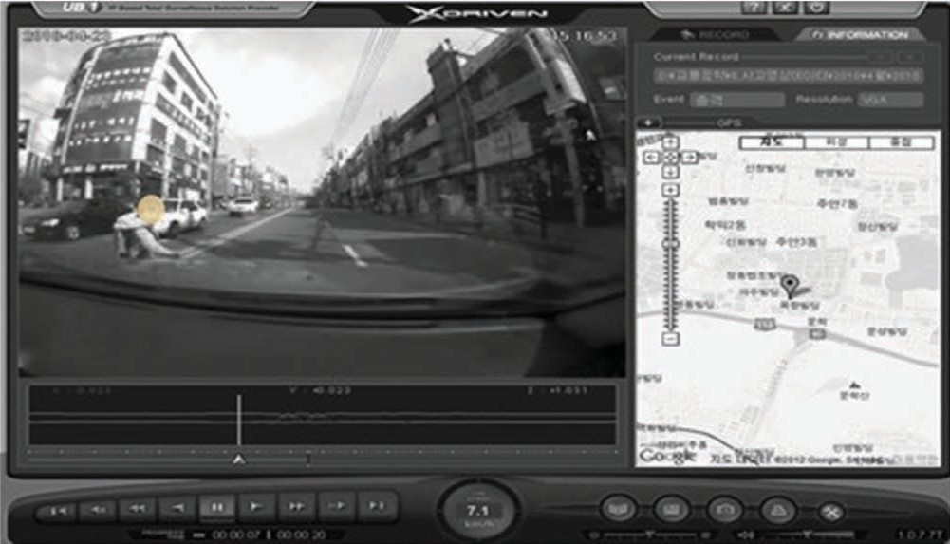

**FIGURE 1 Continuous frame of pedestrian crash on X-Driven program.**

system, how they are slightly different from the most advanced EDR, and data combination processing for two heterogeneous crash data sources (i.e., police-recorded data and black box-recorded data) (*28*).

## variable selection

Both dependent and independent variables were defined and extracted through analysis of the black box video data. As for the dependent variables, the crashes were categorized by four levels of crash sever- ity: death (within 30 days of the crash), incapacitating injury (requir- ing hospitalization of 3 weeks or more), visible injury (requiring hospitalization from 5 days to 3 weeks), and claim pain (requiring hospitalization of less than 5 days). In addition, the pedestrian’s impairment level, indicating whether the pedestrian could stand up without assistance, which was observed through the video recordings, was used as a dependent variable. Therefore, two dependent variables were used to develop the crash severity model.

For the independent variables, there are four categories: pedes- trian characteristics, driver characteristics, crash condition, and time period. Detailed variables for each independent variable category are presented, with mean and standard deviation of the collected data, in Table 1. A data reduction process was conducted to include only valid crash data and exclude exceptions, such as the crashes with unknown factors caused by poor video quality or limited range of the black box. For example, the data were excluded in the following cases: pedestrians went out of the vision of the black box after a crash or pedestrians are unseen because the video is not bright enough (e.g., at night or in shadow) or is of low quality.

## study hypotheses

New variables that could account for crash severity were extracted, as presented in Table 1. These variables explain the possible con- tributing factors before and after a crash. Specifically, a pedestrian’s level of impairment and a vehicle’s failure to stop can build on the assumption that a pedestrian who experiences a crash was not appro- priately walking or running, and the driver also may not immediately stop the vehicle if the crash results in a severe condition. Additional hypotheses were made as follows:

* Pedestrian behavior on injury severity. Injury severity would increase if the pedestrian

– Could not check if a vehicle was approaching,

– Was running (instead of walking),

– Was jaywalking (illegally crossing midblock),

– Was younger than 14 years old, or

– Was older than 65 years old.

* Vehicle maneuvers on injury severity. Injury severity would increase if

– The vehicle’s speed was higher or

–A vehicle failed to immediately stop after a crash.

* Driver behavior on injury severity. Injury severity would increase if

– The vehicle ran a red light (red light running violation),

– The driver could not see a pedestrian crossing because of limited vision, or

– The crash occurred at night.

With these hypotheses in mind, the behaviors of both pedestrians and drivers were thoroughly observed by the authors.

**TABLE 1 Description of Variables**

|  |  |  |
| --- | --- | --- |
| Variable | Variable Name | Description |
| Severity | Injury level | Claim pain (1): 45% |
|  |  | Visible injury (2): 24% |
|  |  | Incapacitating injury (3): 25% |
|  |  | Death (4): 6% |
|  | Pedestrian impairment level | Not standing after crash (1): 71% |
|  |  | Otherwise (0): 29% |
| Pedestrian characteristics | Failure to watch for vehicles | Not watching vehicle (1): 66% |
|  |  | Otherwise (0): 34% |
|  | Running or walking | Running before a crash (1): 27% |
|  |  | Otherwise (0): 73% |
|  | Jaywalking | Illegal jaywalking during crash (1): 48% |
|  |  | Otherwise (0): 52% |
|  | Age 1 | Age  14 (1): 9% |
|  |  | Otherwise (0): 91% |
|  | Age 2 | 14 < age  20 (1): 11% |
|  |  | Otherwise (0): 89% |
|  | Age 3 | 20 < age  65 (1): 57% |
|  |  | Otherwise (0): 43% |
|  | Age 4 (elderly) | Age > 65 (1): 23% |
|  |  | Otherwise (0): 77% |
| Crash characteristics | Initial speed | Speed when crashed (km/h): |
|  |  | Speed  30 km/h (1): 60%  30 km/h < speed  60 km/h (2): 28%  Speed > 60 km/h (3): 12% |
|  | Maneuver | Turning (1): 25% |
|  |  | Otherwise (0): 75% |
| Driver characteristics | Violation | Red-light running (1): 56% |
|  |  | Otherwise (0): 44% |
|  | Failure of vehicle to stop | Failure to stop after crash (1): 27% |
|  |  | Otherwise (0): 73% |
|  | Area of vision | Not enough vision for pedestrians (1): 46% |
|  |  | Otherwise (0): 54% |
| Others | Day–night | Night (1): 56% |
|  |  | Otherwise (0): 44: |

## resuLts

**Model specification**

A MIMIC model was used to identify the relationship between taxi- to-pedestrian injury severity and its causal factors. The MIMIC model is a special case of structural equation model and consists of a measurement model and structural model. A measurement model

 *x*   *y*  ☹  where

  vector of latent endogenous variables,

*y*  vector of indicators,

(1)

(2)

defines the relationships between a latent variable and its indicators, as shown in Figure 2.

However, a structural model specifies the causal relationships among latent variables and explains the causal effect (*29*). The MIMIC model leads to the following equations:

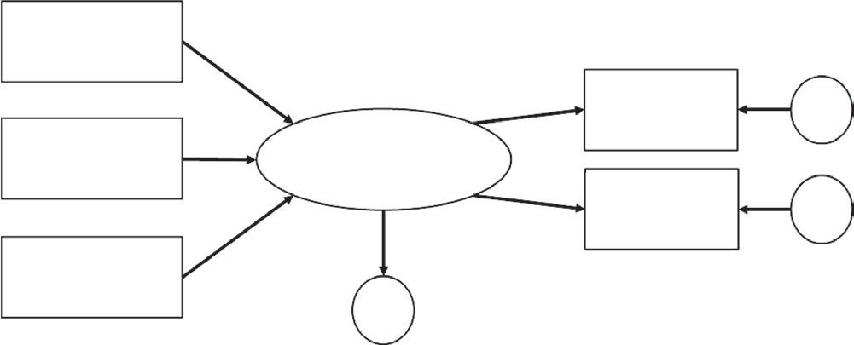

Explanatory variable *x*1

Indicator *y*1

**d**2

Explanatory variable *x*2

Latent **g**

variable

Indicator *y*2

**d**3

Explanatory variable *x*3

**w**1

**FIGURE 2 Concept of MIMIC model.**

*x*  vector of observed exogenous variables that cause ,

 and ☹  matrices of unknown parameters to be estimated, and

 and   error terms of *y* and .

In the transportation field, various studies have been conducted using a structural equation model or its parts, such as path analysis and MIMIC model. The studies include driver behavior modeling, mode choice modeling, and public acceptability analysis of new traf- fic policies (*29–32*). When it comes to applying a MIMIC model, assessing goodness of fit and the estimation of parameters of the hypothesized model are fundamental. Comparative fit index, root mean square error of approximation, goodness-of-fit index, and 2 test can be used with the conventional cutoff criteria suggested by some studies (*30–32*). Although no standards exist, the studies have some universally known rules of thumb for goodness of fit indexes in an acceptable model: root mean square error of approximation of less than 0.06, goodness of fit and comparative fit index of more than 0.9, adjusted goodness of fit index of above 0.85, and 2/df of between 2 and 5.



Night

.103

(.02)

Driver’s limited vision

.085

(.02)

Vehicle’s failure to stop

.166

(.02)

.554

(.00)

Initial speed

.436

(.00)

.418

(.00)

.54

(*)

Injury level

Jaywalking

.140

(.04)

Severity

.52

(.01)

Elderly

.147

(.02)

Pedestrian’s impairment level

Pedestrian’s failure to watch vehicle approaching

.155

(.01)

**FIGURE 3 Final MIMIC model (standardized estimates).**

## resulting MiMiC Model

The MIMIC model, accounting for the relationship between the pos- sible causal factors of the crash and the crash severity, was developed, as shown in Figure 3. The numbers on the arrows in this figure are parameters estimated at the 95% significant level, and the numbers in parentheses indicate *p*-value (the asterisk means fixed parameter to identify the scale of error term). The resulting MIMIC model showed that the vehicle’s failure to stop, the vehicle’s initial speed, the pedes- trian’s illegal jaywalking, the pedestrian being elderly, and the pedes- trian failing to watch for the vehicle approaching statistically and significantly affected crash severity, represented by the pedestrian’s injury and impairment levels. Also, the driver’s vision being limited and the crash occurring at period also had a relationship as indirect variables with the crash severity, even though the strength was not as high as the other variables. This developed MIMIC model performed well, according to the following goodness-of-fit test results: 2/df  2.754, root mean square error of approximation  0.04, goodness- of-fit index  0.984, adjusted goodness-of-fit index  0.965, and comparative fit index  0.957.

## disCussion of resuLts

On the basis of the MIMIC model, the results were interpreted as follows:

* + Dependent variables. Two dependent variables (i.e., injury and impairment levels) are correlated in crash severity (latent variable) with almost identical coefficients (0.54 and 0.52). Both coefficients account for crash severity at the 95% confidence level.
* Independent variables (all). There was a significant relation- ship between crash severity and the selected explanatory variables, including a pedestrian’s failure to watch a vehicle approaching, a pedestrian’s jaywalking, the elderly (older than 65 years old), a vehicle’s excessive speed (more than 60 km/h), a driver’s failure to immediately stop, limited vision for drivers, and nighttime, with different relationship strengths.
* Independent variables (pedestrian and crash characteristics).

Elderly (0.147 coefficient) and jaywalking (0.140 coefficient) were the major factors affecting crash severity, as expected.

* Independent variables (driver characteristics). The vehicle’s

failure to immediately stop significantly affected crash severity, with a coefficient of 0.17.

The important findings from the results of the MIMIC model are as follows:

* Jaywalking was significantly correlated with the vehicle’s ini- tial speed, indicating that the crash severity level would increase if a vehicle traveling at a high speed collided with the pedestrian.
* Because factors relating to the pedestrian (being elderly, jay-

walking, failing to watch a vehicle) significantly affected crash sever- ity, traffic safety education for pedestrians or appropriate road facility designs for elderly people would be beneficial in reducing the number of pedestrian-related crashes and their severity.

* The vehicle’s failure to immediately stop is correlated with the

nighttime variable and the driver’s limited vision, which is logical because a driver would not have enough time to respond to a danger if a driver’s vision is limited during the night.

* The initial speed variable had the highest relationship with

crash severity, indicating that reducing speed will be effective in

100.0

80.0

60.0

**Percentage**

40.0

20.0

80.0

60.0

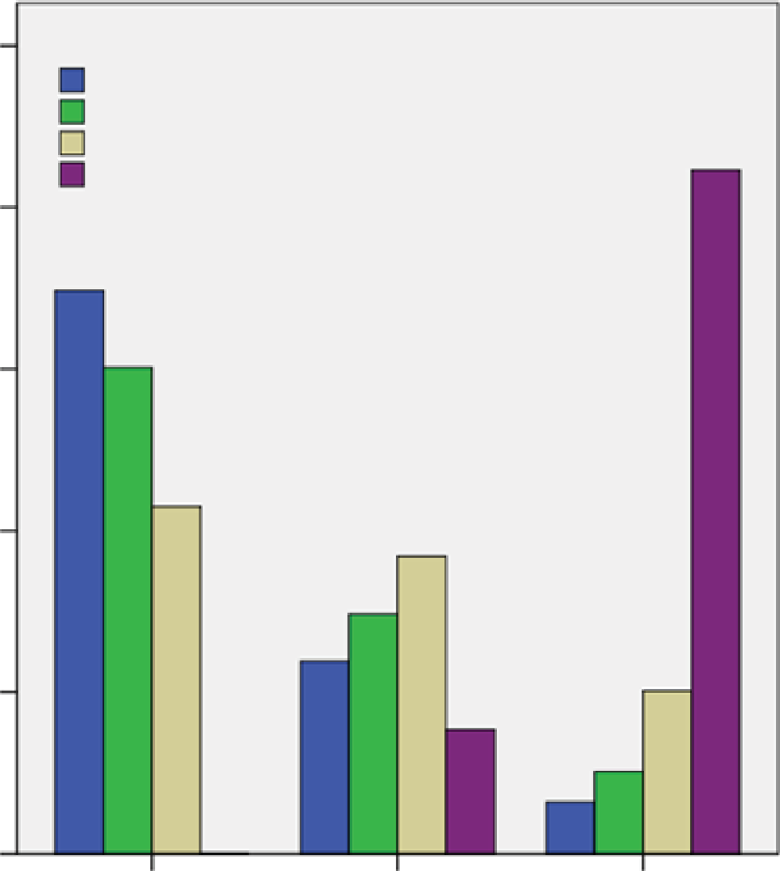

Injury Level

Complaint of pain Visible injury Incapacitating injury Death

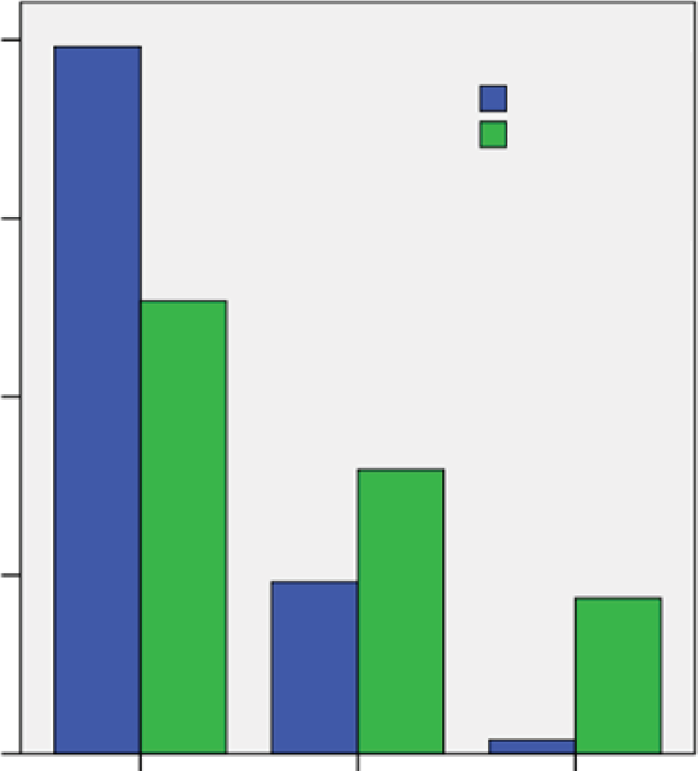

Impairment Level

Stand No stand

40.0

**Percentage**

20.0

.0

<30

31–60

**Speed (km/h)**

>61

.0

<30

31–60

**Speed (km/h)**

>61

**(a) (b)**

**FIGURE 4 Crash injury severity by speed measure: percentage of speeds on severity level of (*a*) injury and (*b*) impairment.**

mitigating crash severity. This result can be seen in Figure 4, which shows that speed of more than 60 km/h negatively affected the injury and impairment levels. In detail, more than 80% of deaths happened (Figure 4*a*) and the pedestrian’s standing capability sig- nificantly dropped (Figure 4*b*), when a vehicle’s speed was more than 60 km/h.

## ConCLusions

This study investigated factors that significantly affect the severity level of taxi–pedestrian crashes by extracting explanatory variables from black box recording data. Black box devices are generally mounted on the front window of the vehicle, and they record the traffic situations before and after a crash. This feature of the video recording data leads to the reconstruction of crash situations and the extraction of additional explanatory variables that could not be retrieved from police reports. Specifically, the data provide addi- tional information such as traffic violations of drivers or pedestrians, pedestrian behavior before a crash, and vehicle speed when a crash occurs. Because the black box video recording data provide live crash situations and enable safety analysts to reconstruct the crash situation, this analysis method is promising for traffic safety studies.

The independent variables extracted from the video data were used to model the relationship between potential causal factors and crash severity using a MIMIC model. The MIMIC model showed that the following factors resulted in more serious crash severity: failure by the pedestrian to watch a vehicle approaching, jaywalking by the pedestrian, the pedestrian being elderly (older than 65 years old), excessive speed by the vehicle (more than 60 km/h), failure by the driver to immediately stop, the driver having limited vision, and the crash occurring at night. Because vehicle speed of more than 60 km/h

had the highest relationship with crash severity, road facility design to calm speed is recommended. In addition, relevant education to prevent traffic violations by pedestrians, and the implementation of road facility design for elderly persons is expected to mitigate crash severity because the pedestrian-related variables (i.e., being elderly, jaywalking, failure to watch a vehicle) considered in this study sig- nificantly affected crash severity. These findings mostly confirm the study hypotheses, but the pedestrian behavioral factor (i.e., walk- ing and running) and young age (i.e., younger than 14 years old) did not significantly affect crash severity as did the other factors that were hypothesized beforehand.

An in-car black box has potential as a new data source in the analysis of crashes by revealing the situation inside a vehicle. The result could be crash analysis that is more comprehensive because it is based on multiple data sources, including existing sources (e.g., crash reports and closed-circuit television recordings) and a new data source (i.e., in-vehicle black box video recordings). Crashes could be investigated through inside and outside views of vehicles. In addition, this study emphasizes that the driver’s view and potential (expected) behaviors should be taken into consider- ation when road infrastructure and traffic controls are designed and installed because a driver’s vision and the brightness of the scene (day or night) significantly affect injury severity.

## reCoMMendations for future researCh

Some aspects might be of great interest for future research to improve and validate the proposed crash severity model. Additional study needs to be conducted on the basis of black box video data from pas- senger vehicles. Taxi drivers cannot represent all driver behaviors, and additional research efforts with different vehicle types will lead

to more comprehensive analysis, which can also be beneficial for identifying more reasonable factors under common traffic situations. In addition, the vision of black box video data is limited to the front view of vehicles. With this limitation in mind, an integration of black box video data with a geographic information system, which would include geometric information about the crash location, would be helpful in a thorough analysis of factors that affect crash severity. In addition, many crashes that involve pedestrians are attributed to jaywalking. Therefore, the traffic flow condition factors, such as vol- ume and level of service, that would have an impact on the pedestri- ans’ illegal behavior should also be considered in vehicle–pedestrian crash severity studies.

## aCknowLedgMents

The authors acknowledge and thank Incheon Taxi Mutual Aid Asso- ciation for its assistance and support. Special thanks go to Jaehoon Chung for his work on crash data analysis.

## referenCes

1. Peden, M. *World Report on Road Traffic Injury Prevention.* World Health Organization, Geneva, 2004.
2. KoROAD. Central Analysis Center for Traffic Accidents. 2015. http:// [www.koroad.or.kr/en_web/view/safeBiz3.do.](http://www.koroad.or.kr/en_web/view/safeBiz3.do)
3. Posey, C., T. L. Roberts, P. Benjamin, and R. J. Bennet. Multiple Indi- cators and Multiple Causes (MIMIC) Models as a Mixed-Modelling Technique: A Tutorial and an Annotated Example. *Communications of the Association for Information Systems,* Vol. 36, Article 11, 2015.
4. Haleem, K., P. Alluri, and A. Gan. Analyzing Pedestrian Crash Injury Severity at Signalized and Non-Signalized Locations. *Accident Analy- sis and Prevention,* Vol. 81, 2015, pp. 14–23. https://doi.org/10.1016

/j.aap.2015.04.025.

1. Koopmans, J. M., L. Friedman, S. Kwon, and K. Sheehan. Urban Crash- Related Child Pedestrian Injury Incidence and Characteristics Associ- ated with Injury Severity. *Accident Analysis and Prevention,* Vol. 77, 2015, pp. 127–136. https://doi.org/10.1016/j.aap.2015.02.005.
2. Niebuhr, T., M. Junge, and E. Rosen. Pedestrian Injury Risk and the Effect of Age. *Accident Analysis and Prevention,* Vol. 86, 2016, pp. 121–128. https://doi.org/10.1016/j.aap.2015.10.026.
3. Fontaine, H., and Y. Gourlet. Fatal Pedestrian Accidents in France: A Typological Analysis. *Accident Analysis and Prevention,* Vol. 29, No. 3, 1997, pp. 303–312. https://doi.org/10.1016/S0001-4575(96)00084-X.
4. Kim, J.-K., G. F. Ulfarsson, V. N. Shankar, and F. L. Mannering. A Note on Modeling Pedestrian-Injury Severity in Motor-Vehicle Crashes with the Mixed Logit Model. *Accident Analysis and Prevention,* Vol. 42, No. 6, 2010, pp. 1751–1758. https://doi.org/10.1016/j.aap.2010.04.016.
5. Zegeer, C. V., J. C. Stutts, H. Huang, M. Zhou, and E. Rodgman. Analysis of Elderly Pedestrian Accidents and Recommended Countermeasures. *Transportation Research Record,* No. 1405, 1993, pp. 56–63.
6. Zhang, G., K. K. Yau, and X. Zhang. Analyzing Fault and Severity in Pedestrian–Motor Vehicle Accidents in China. *Accident Analysis and Prevention,* Vol. 73, 2014, pp. 141–150. https://doi.org/10.1016/j.aap

.2014.08.018.

1. Aziz, H. M.A., S. V. Ukkusuri, and S. Hasan. Exploring the Determi- nants of Pedestrian–Vehicle Crash Severity in New York City. *Acci- dent Analysis and Prevention,* Vol. 50, 2013, pp. 1298–1309. https:// doi.org/10.1016/j.aap.2012.09.034.
2. Al-Ghamdi, A. S. Pedestrian–Vehicle Crashes and Analytical Tech- niques for Stratified Contingency Tables. *Accident Analysis and Pre- vention,* Vol. 34, No. 2, 2002, pp. 205–214. https://doi.org/10.1016

/S0001-4575(01)00015-X.

1. Zajac, S. S., and J. N. Ivan. Factors Influencing Injury Severity of Motor Vehicle–Crossing Pedestrian Crashes in Rural Connecticut. *Accident Analysis and Prevention,* Vol. 35, No. 3, 2003, pp. 369–379. https:// doi.org/10.1016/S0001-4575(02)00013-1.
2. *Coding Manual: Motor Vehicle and Traffic Collision Analysis on Connecticut Streets and Highways.* Connecticut Department of Transportation, Newington, 1986.
3. Zhang, J., J. Lindsay, K. Clarke, G. Robbins, and Y. Mao. Factors Affect- ing the Severity of Motor Vehicle Traffic Crashes Involving Elderly Drivers in Ontario. *Accident Analysis and Prevention,* Vol. 32, No. 1, 2000, pp. 117–125. https://doi.org/10.1016/S0001-4575(99)00039-1.
4. Shankar, V. N., G. F. Ulfarsson, R. M. Pendyala, and M. L. B. Nebergall. Modeling Crashes Involving Pedestrians and Motorized Traffic. *Safety Science,* Vol. 41, No. 7, 2003, pp. 627–640. https://doi.org/10.1016

/S0925-7535(02)00017-6.

1. Chang, L.-Y., and H.-W. Wang. Analysis of Traffic Injury Severity: An Application of Non-Parametric Classification Tree Techniques. *Acci- dent Analysis and Prevention,* Vol. 38, No. 5, 2006, pp. 1019–1027. https://doi.org/10.1016/j.aap.2006.04.009.
2. Kim, J.-K., G. F. Ulfarsson, V. N. Shankar, and S. Kim. Age and Pedes- trian Injury Severity in Motor-Vehicle Crashes: A Heteroskedastic Logit Analysis. *Accident Analysis and Prevention,* Vol. 40, No. 5, 2008, pp. 1695–1702. https://doi.org/10.1016/j.aap.2008.06.005.
3. Choi, J.-S., S.-Y. Kim, K.-S. Hwang, and S.-Y. Baik. Severity Analysis of the Pedestrian Crash Patterns Based on the Ordered Logit Model. *International Journal of Highway Engineering,* Vol. 11, No. 1, 2009, pp. 153–164.
4. Niehoff, P., H. C. Gabler, J. Brophy, C. Chidester, J. Hinch, and

C. Ragland. Evaluation of Event Data Recorders in Full Systems Crash Tests. In *Proceedings of the 19th International Technical Conference on the Enhanced Safety of Vehicles,* NHTSA, U.S. Department of Transportation, 2005.

1. Boon, R. Post-Accident Analysis of Digital Sources for Traffic Acci- dents. University of Twente, Enschede, Netherlands, 2014.
2. Gabler, H., C. Hampton, and T.A. Roston. Estimating Crash Severity: Can Event Data Recorders Replace Crash Reconstruction? In *Proceed- ings of the 18th International Technical Conference on the Enhanced Safety of Vehicles,* NHTSA, U.S. Department of Transportation, 2003.
3. Wu, B.-F., Y.-H. Chen, and C.-H. Yeh. Driving Behaviour-Based Event Data Recorder. *IET Intelligent Transport Systems,* Vol. 8, No. 4, 2014, pp. 361–367. https://doi.org/10.1049/iet-its.2013.0009.
4. Young, C.-P., B. R. Chang, and T.-Y. Wei. Highway Vehicle Acci- dent Reconstruction Using Cooperative Collision Warning Based Motor Vehicle Event Data Recorder. In *2009 IEEE Intelligent Vehi- cles Symposium,* IEEE, New York, 2009. https://doi.org/10.1109

/IVS.2009.5164441.

1. German, A., J.-L. Comeau, B. Monk, K. J. McClafferty, P. F. Tiessen, and J. Chan. The Use of Event Data Recorders in the Analysis of Real- World Crashes. In *Proceedings of the Canadian Multidisciplinary Road Safety Conference 12,* 2001, pp. 10–13.
2. Ismail, K., T. Sayed, and N. Saunier. Automated Analysis of Pedestrian– Vehicle Conflicts: Context for Before-and-After Studies. *Transporta- tion Research Record: Journal of the Transportation Research Board,* No. 2198, 2010, pp. 52–64. https://doi.org/10.3141/2198-07.
3. Twaddle, H., T. Schendzielorz, O. Fakler, and S. Amini. Use of Auto- mated Video Analysis for the Evaluation of Bicycle Movement and Interaction. *IS&T/SPIE Electronic Imaging,* 2014.
4. Chung, Y., and I. Chang. How Accurate Is Accident Data in Road Safety Research? An Application of Vehicle Black Box Data Regarding Pedestrian-to-Taxi Accidents in Korea. *Accident Analysis and Preven- tion,* Vol. 84, 2015, pp. 1–8. https://doi.org/10.1016/j.aap.2015.08.001.
5. X-DRIVEN: The Ultimate Driving Recording System for Your Vehicle. Bosch, 2010. <http://www.zonetechnology.co.nz/site/zone/files/X-Driven>

_Bosch_Brochure_LR[1].pdf.

1. Vlahogianni, E. I., M. G. Karlaftis, N. Papageorgiou, and D. I. Tselentis. Factors Influencing Freeway Traffic Upstream of an Incident. *Advances in Transportation Studies,* Vol. 1, 2014, pp. 17–36.
2. Di Ciommo, F., A. Monzon, and A. Fernandez-Heredia. Improving the Analysis of Road Pricing Acceptability Surveys by Using Hybrid Mod- els. *Transportation Research Part A: Policy and Practice,* Vol. 49, 2013, pp. 302–316.
3. Hu, L., and P. M. Bentler. Cutoff Criteria for Fit Indexes in Covariance Structure Analysis: Conventional Criteria Versus New Alternatives. *Structural Equation Modeling,* Vol. 6, No. 1, 1999, pp. 1–55. https:// doi.org/10.1080/10705519909540118.

*The Standing Committee on Safety Data, Analysis, and Evaluation peer-reviewed this paper.*