Using computers to understand cancer metabolism

Cancer changes many key components of the cell behaviour. This includes changes to how the cell grows and communicates with its environment, but also alters how the cell works on a molecular level. Included in these changes is alterations to the cell’s **metabolism**- that is, how the cell digests sugars and other nutrients and converts them to energy. Today we are going to look at how you can use computers to simulate the effects of mutations to metabolism on the cell behaviour. Computational biologists use these techniques to look for proteins that might be good drug targets in the future, and to suggest where we are missing information (and where to do the next experiments!).

# BioModelAnalyzer

http://biomodelanalyzer.research.microsoft.com/

To use computers to understand cell behaviour we need to build a **model**- a mathematical representation that describes how proteins talk to one another and change over time. Here we have used a web based tool called the BioModelAnalyzer to build this model. This allows you to draw the proteins, genes, metabolites and cells on a blank canvas and then give each a function to describe how it changes over time. Once you have a model, you can then analyse it using the buttons on the right hand side of the screen. Try to make a small model in the interface!



Today we will use **stability analysis** to see how the model behaves. Stability analysis tells you how **all possible** simulations end- if you can prove your model is stable then it means that all simulations end with one set of values. We will use this to analyse our models to see what effect mutations have.

# Metabolism Model

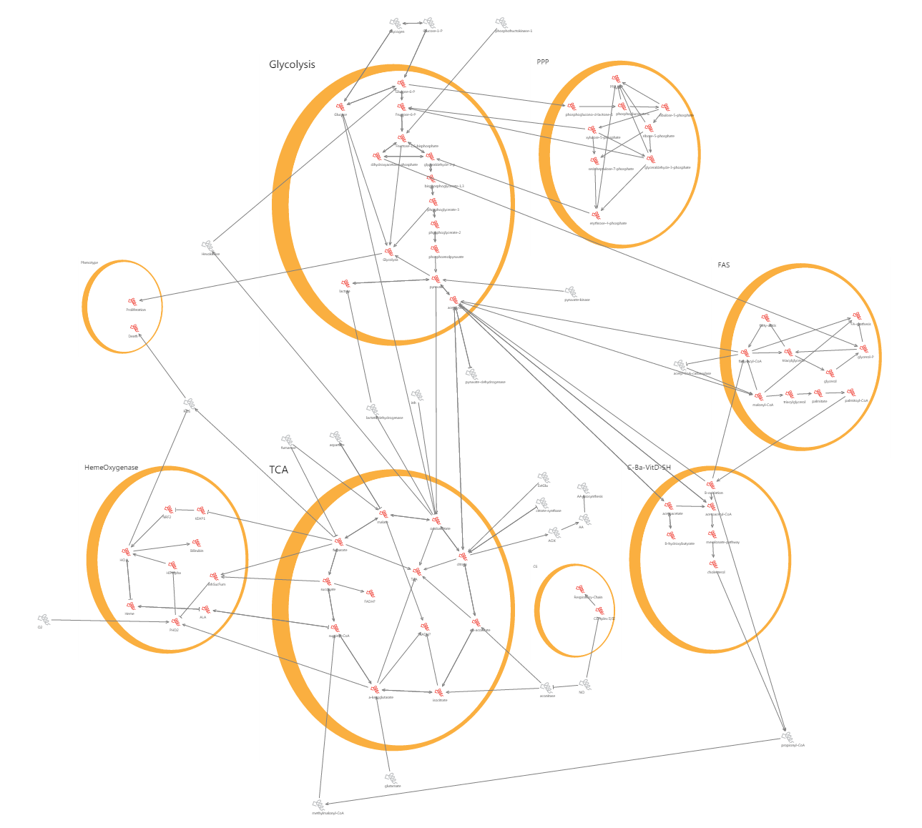

In metabolism sugar (glucose) is converted by a number of different processes into energy. In this model we have separated them with different cells. For example, **glycolysis**, the first stage of sugar metabolism, is represented by a large cell at the top of the model. Inside the glycolysis “cell” are the metabolites and proteins that carry out that conversion.

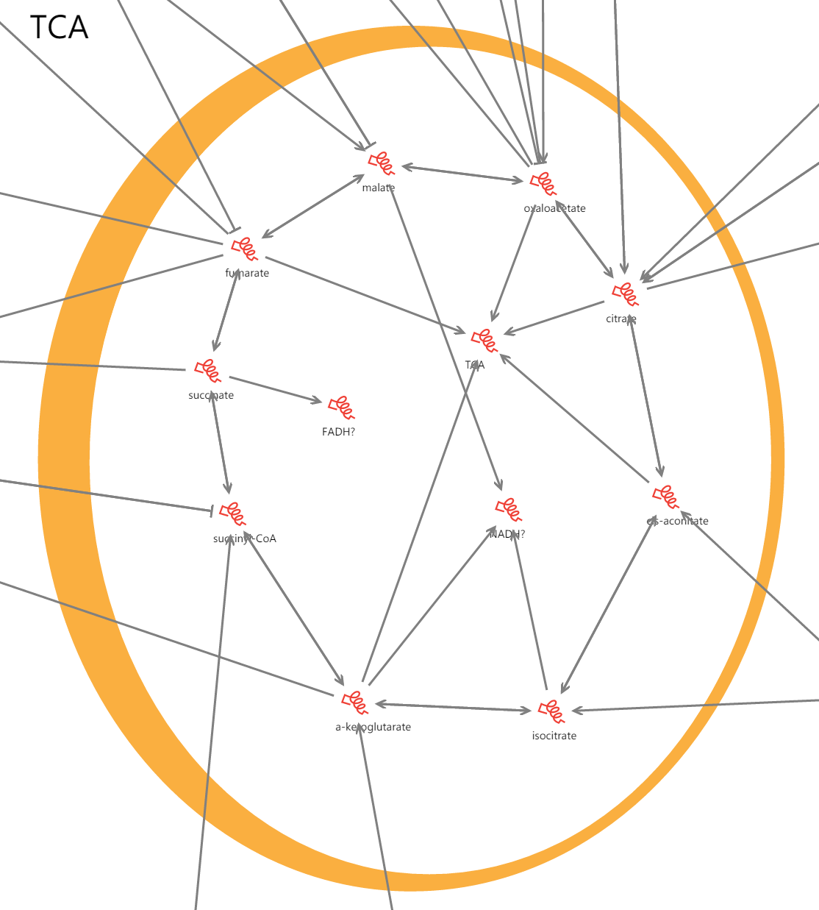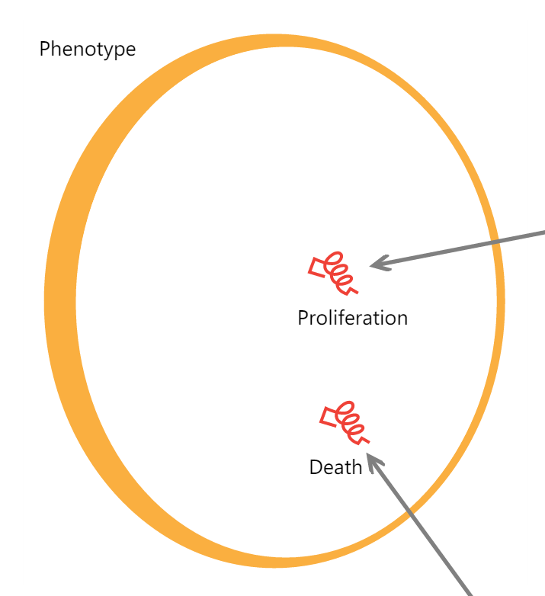

The two processes we will look at are **TCA** and **Phenotype**. The first is an important stage that follows glycolysis, and in which there are proteins that are mutated in cancer. The second describes how the whole cell behaves in response to any mutations; for example, **proliferation** indicates how much we expect the cell to grow and **death** indicates that the cell is likely to die. Most metabolites are represented by numbers from 0 to 4. These represent distinct ranges of concentrations that can be understood as No activity, low, medium, medium-high, and high activities.

If we perform a stability analysis we can see what the normal state of the cell is like. It shows that the model is stable, and that most proteins and metabolites have a value in the middle of their ranges. Looking specifically at the metabolites **succinate**, **fumarate**, and **malate** (in **TCA**) we can see that it normally has a value of 2 (medium activity), and the protein **HO** (in **HemeOxygenase**) has a level of 1.

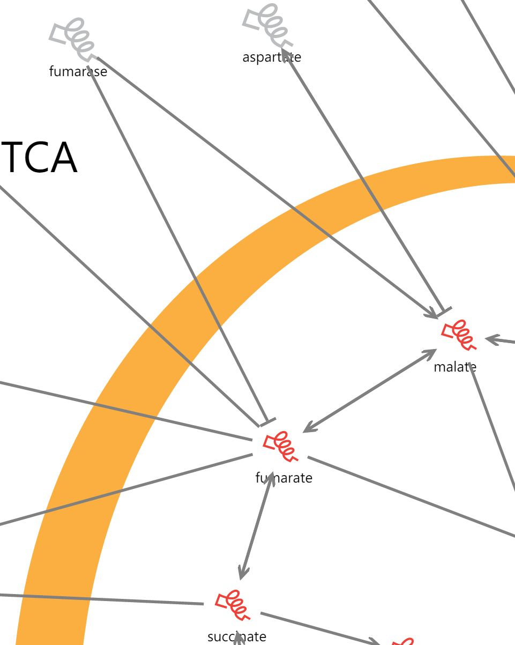

The protein **fumarase** converts **fumarate** to **malate**, and is lost in some cancers. We can simulate this by right clicking fumarase, selecting edit, and setting its target function from 1 to 0 (i.e. no activity). When we perform the stability analysis again, we can see how the cell has changed; there is no longer any malate in the model (shown by its value of 0), whilst fumarate has accumulated to high levels (its value is 4). **Succinate** has also accumulated, to a lesser extent. This causes other changes in the system- can you identify what has changed and has not? Why do you think they have changed?

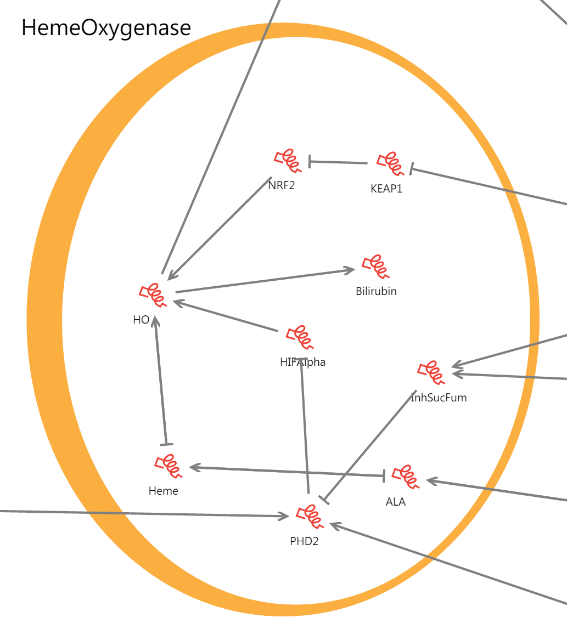

When fumarate accumulates to a high level, this can be toxic for a cell. Cancer cells avoid dying from an overdose of fumarate by removing it from the system. Can you see what is removing fumarate from the cell? One strategy to kill cancer cells is to stop them from removing fumarate, see what happens to a cancer cell (with a mutation in **fumarase**), and what happens to a normal cell when you stop them from removing fumarate.

The Frezza grouped discovered that a second mutation in **HO** causes cells to die. What happens when you mutate HO (change its value to 0)? What happens if you have a HO mutation but **fumarase** is active (set its value back to 1)?

# Modelling Common causes of Cancer

Whilst the metabolism model focuses on a specific mutation that appears to lead to cancer, many cancers are caused by a combination of mutations in “regulator genes”. These genes control broad cellular behaviours, like growth, or resistance to death, and many cancers can be traced to mutations in one of these genes. We have constructed a network of the common regulators EGFR, KRAS, PTEN, and P53, you may have heard of some of these.

Load the model into the BMA by opening up the side bar and pressing “import”, search for the model named “Cancer Regulators”, and load it into the BMA.

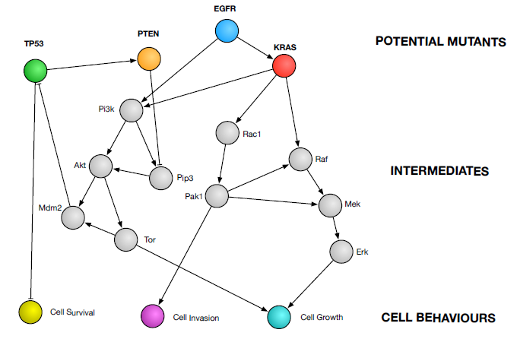

Here you can see how interconnected even simple networks of genes can get. At the bottom of the cell there are three behaviours that can indicate a cell is cancerous – Growth, Invasion, and Survival. This model is a lot simpler than the previous one, each node can only be a value of 1 (on), or 0 (off). We call this a binary system. There are nodes within the model that represent mutations in the key proteins, for example – EGFR_mutant. Activating these nodes (e.g. setting their value to 1), simulates the effect of having a mutation in this protein in a cell, i.e the protein does not function correctly.

Try activating some mutations and see what changes – notice how not all mutations cause the same behaviour changes in cells. In particular, P53 mutations only cause changes in cell survival, so cancers caused by mutations in this protein will need to be treated differently to others.

We have also included the effects of known drugs on the network. Can you think of reasons why none of the drugs directly work on the mutant proteins?

Notice how many drugs need to be applied together in order to change a behaviour, for example Trametinib and Rapamycin are often both required to lower the growth behaviour in some situations, particularly with an EGFR mutation.

Using these kinds of tools, we can predict which drug combinations might be most effective for a particular cancer, if we know what is causing it.