Cornell Note Taking
This method of note taking is useful because it enables you to keep track of questions or thoughts that occur to you while making notes. It also allows you to go back and add comments to a page of notes or connect ideas from one source to another.
The Cornell note taking method serves multiple purposes:
- Notes from the lecture or readings, so that you have a record of information you may have forgotten (Details section)
- Summary of what was covered in the lecture or reading which you can easily look through (Summary section)
- A set of key points and/or questions that serve as a mini study guide (Main Ideas section
Method
During class
- take down information in largest area of the page
- when instructor moves to new point, skip a few lines
After class
- complete phrases & sentences as much as possible
- for all significant information, write cue in left margin

After writing the notes in the main space, use the left-hand space to label each idea and detail with a key word or "cue“

An example of Cornell Note taking form is below – blank sample follows
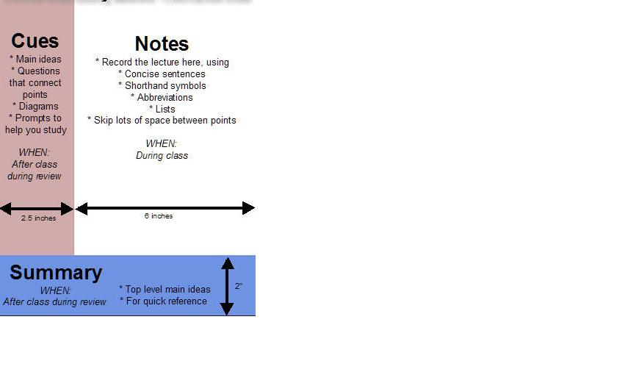
(Sever, 2013)
Main Ideas | Details
Summary
(Dees, 2010)

