Is There a Clash of Civilizations? Evidence from Patterns of International Conflict Involvement, 1946-1997

Appendix

GIACOMO CHIOZZA

Department of Political Science
Duke University

28 March 2002

The Dependent Variable
This study primarily relies upon the Kosimo data set, a collection of conflict data prepared by Pfetsch & Rohloff (2000) of the University of Heidelberg, Germany. This collection differs from previous, and widely used, data sets such as Brecher & Wilkenfeld’s (1997) ICB and Jones, Bremer & Singer’s (1996) MID data in two major ways. The first feature is its temporal span, covering a longer period in the post-Cold War era: data are available until 1999, even though the analysis in this study stops in 1997 because of limitations on data availability on the explanatory variables. The second feature is that the Kosimo collection also includes data on nonviolent and latent conflicts. The rationale underlying the choice of including nonviolent conflicts is that ‘All violent conflicts evolve from nonviolent crises. Also, most violent conflicts do not end in sudden peace, but are followed by periods of shaky consolidation and a sense of ongoing crisis’ (Kosimo online manual, www.kosimo.de). This broader focus allows analyzing state interactions in a more encompassing way that avoids equating absence of violence with peace.
Four types of conflict interactions are distinguished:
- Latent conflict: completely nonviolent ;
- Crisis: mostly nonviolent;
- Severe crisis: sporadic, irregular use of force, 'war-in-sight' crisis;
- War: systematic, collective use of force by regular troops (Kosimo online manual, www.kosimo.de).
The dependent variable for the models reported in Table I takes on a value of 1 whenever any of these four types of conflict occurs, while the Kosimo model reported in Table III excludes the latent conflicts, that is, only considers crises, severe crises, and wars. As a robustness check, the analysis was also replicated using the ICB and the MID data sets. Table IV offers a comparison of the conflict events listed in the three data sets.
____________

Table IV in here
____________
Table IV shows that the three data sets cover a fairly similar, but not equivalent, set of conflictual events. What counts as a conflict in the Kosimo data set is not necessarily coded likewise in the ICB and the MID data. For example, out of 459 ICB conflict events, 275 (60%) are also Kosimo conflicts, whereas out of 1890 MID conflict events, 845 (45%) are also Kosimo conflicts. The overlap between the ICB and MID data is more pronounced: out of 446 ICB events, 350 (78%) are also included in the MID data set.
A similar picture emerges if we exclude the latent crises from the set of Kosimo conflict cases. As Table V shows, of all the 459 ICB crises, 245 (53%) are also included in the Kosimo data set. Similarly, of all the 1890 ICB crises, 561 (30%) are listed in the Kosimo data. A comparison of the results in Table IV and Table V also shows that some Kosimo latent crises – i.e., completely non-violent interactions – are also coded as ICB or MID cases. As a matter of fact, the number of joint Kosimo and ICB events drops from 275 to 245 when the latent crises are excluded. Analogously, the number of joint Kosimo and MID events drops from 845 to 561 when the latent crises are excluded. This implies that there are 30 dyad-years that are simultaneously coded as latent Kosimo crises and as ICB crises, and that there are 284 dyad-years that are coded as latent crises in Kosimo and as MID conflicts.
____________

Table V in here
____________
This analysis shows that the category of international conflict can capture different events depending upon the focus, the breadth, and the specificity of the definitions employed. Testing the CofC thesis on alternative specifications of the dependent variable, therefore, offers a powerful test of external validity. The fact that the CofC thesis finds little support even when considering alternative characterizations of states’ conflictual interactions further reduces the empirical viability of the argument.

Civilization
This study codes the civilizational status of a dyad using the classification that Henderson & Tucker (1999, 2001) constructed on the basis of Huntington’s (1996: 26-27) civilizational map. As a robustness check, the analysis was also replicated using the alternative classification elaborated by Russett, Oneal & Cox (2000). While closely similar, the two classifications reach different conclusions on the civilization membership of a few countries. Moreover, Russett, Oneal & Cox (2000) do not create a residual category for countries of dubious civilizational status, as Henderson & Tucker (1999, 2001) did. They also place three countries, namely Ethiopia, Haiti, Japan, in the separate category of ‘Lone Countries,’ that is, countries that have their own civilization (Russett, Oneal & Cox, 2000: 592). Table VI offers a comparison of the two classifications.
____________

Table VI in here
____________
Table VI shows a cross-tabulation of the 42,844 dyads in the sample using the intercivilization dummy variables measured using Henderson & Tucker’s (1999, 2001) and Russett, Oneal & Cox’s (2000) lists, respectively. The two lists classify 41,107 (96%) of the dyads in the same way, which shows the high degree of overlap between the two coding schemes. The contradictory classification of 1,737 observations, on the other hand, directly speaks to the difficulties underlying the task of attributing a civilization to some countries. What remains to be seen is whether different results are obtained with different measures of civilization. Table VII addresses this question.
____________

Table VII in here
____________
Table VII replicates Model 2 in Table I. The estimates remain virtually unchanged. No matter which measure is used, dyads of different civilization are less likely to engage themselves in conflictual confrontations.

Modernization
Modernization is a multifaceted concept that covers a vast array of social, economic, and political dimensions that cannot be captured adequately with single-indicator variables (for an overview, see Przeworski & Limongi, 1997; Lipset, 1994). Therefore, in order to have a more comprehensive measure, a factor analysis model was estimated using four different indicators: the log of energy consumption per capita, the percentage of the total population living in cities, the percentage of students enrolled in primary schools, and the number of radio receivers per 10,000 inhabitants. All these four indicators capture important dimensions of modernization, namely economic activity, urbanization, education, and the degree of exposure to the mass media. The expectation is that a modern society should score high on all those dimensions.
Data were collected for all the country-years included in the population of cases – 6,288 observations – and a measurement model was estimated using principal factor extraction while retaining only one factor. Table I presents the factor loadings: all indicators are in the expected direction and three out of four – energy consumption per capita, urbanization, and the number of radio receivers – load heavily on an underlying latent construct. Education, on the other hand, is weakly associated with the latent factor. The proportion of variance accounted for by the common latent factor is about .405 (for this measure, see Kim & Mueller, 1976: 24).
The results of the factor analysis are then used to estimate factor scales, that is, estimates of the latent modernization construct for each observation. To this end, the regression method was used to compute the factor scores reported in Table VIII. From this, an operational measure of modernization was derived that varies from -2.024 to 3.688. To ease interpretation, this variable was rescaled so that its minimum is equal to 0 and its maximum is equal to 1.
____________

Table VIII in here
____________
The level of modernization in a dyad is again measured using the weak-link assumption. Given the hypotheses associated with the CofC thesis, what matters is the level of modernization of the less developed country in the dyad.
Data on the four indicator variables were taken from several sources: the COW capability data set from Bennett & Stam (2001), the OECD Statistical Compendium CD-Rom, the World Bank 2000 World Development Indicators CD-Rom, Mitchell’s (1998a,b,c) International Historical Statistics, Banks’ (1976) Cross-National Time-Series, and various issues of the United Nations Energy Statistical Yearbook, the United Nations Demographic Yearbook, the United Nations Statistical Yearbook, and the Unesco Statistical Yearbook.
This study measures modernization using a composite index of four indicators. The question remains whether the four indicators would have a different impact on the probability of conflict were they to be included separately in the regression models. Table X addresses this issue.
____________

Table IX in here
____________
Table IX shows that all indicators of modernization are positively associated with the probability of conflict. No matter how modernization is measured, the coefficients are positive and significant, consistently with the results obtained while using the aggregate modernization index in Table I. The coefficients on the interaction effects between the modernization indicators and civilization are far from statistical significance in three out of four cases, namely when modernization is measured by the log of energy consumption per capita, the levels of urbanization, and the numbers of radios receivers per 10,000 people. This means that there is no statistical difference in the effect of these indicators on the probability of conflict between dyads of same and different civilization. The exception is the interaction effect between education and civilization: that coefficient is negative and significant. It appears that the effect of educational attainments differs from that of the other indicators and that of the composite modernization index. The education variable was, after all, the one that had the most tenuous connection with the latent construct in the factor analysis model. A clearer assessment of the impact of these variables on conflict, however, can be obtained from Figure 3.
____________

Figure 3 in here
____________
Figure 3 plots the probability of conflict as the four modernization indicators move from the values associated with the 5th percentile to those associated with the 95th percentile. The four graphs show the close resemblance between the curves describing the effects for same and different civilization dyads. Even in the case of the education indicator, the curves move on practically parallel lines for most of the scale, and start to diverge as the indicator gets past the value of 14 (i.e., about the 85th percentile). The effect gets substantial only when the indicator reaches the level of 20, a very substantial value considering that the 95th percentile is about 17. While it appears that as enrollment in primary schools gets increasingly higher, same civilization dyads experience a greater risk of conflict involvement, these estimates should be considered with some caution. The data points on which they are based are few, and therefore, the reliability of the predicted probabilities at such unusual levels is limited and strongly contingent upon the characteristics of the model estimated (see King & Zeng, 2001c). In general, the results obtained using separate indicators are similar to those reported in Table I and Figure 2: as modernization increases, the probability of conflict increases, and different and same civilization dyads are not differently affected by this pattern.
Another robustness check was conducted on the modernization variable. It could be argued that the more modernized country in the dyad dictates the propensity for conflict, and that this condition might particularly be true for different-civilization dyads. To test this conjecture on a ‘strong link’ assumption for the modernization variable, a variable was created that measures the greater of the modernization scores of the countries in a dyad, and its interaction effect with civilization was computed. Table X reports the results.
____________

Table X in here
____________
The findings obtained using the ‘strong link’ assumption are very similar to those previously obtained: the coefficient on the composite modernization index is positive and significant, while that on the interaction term is also positive, but non significant. The magnitude of the coefficients also remains practically unchanged.

Prior Correction
This study uses a case-control research design in which all the conflict observations are analyzed along a sample of the non-conflict cases. Two methods exist to correct for the bias introduced by subsampling the zero cases: prior correction and weighting. The weighting option was used because this approach is more robust against model misspecification (King & Zeng, 2001a: 145). The results were also replicated using the alternative prior correction method, with no substantive difference. Table XI reports the results.
____________

Table XI in here
____________
Table IV. Comparison of KOSIMO, ICB, and MID Conflict Data

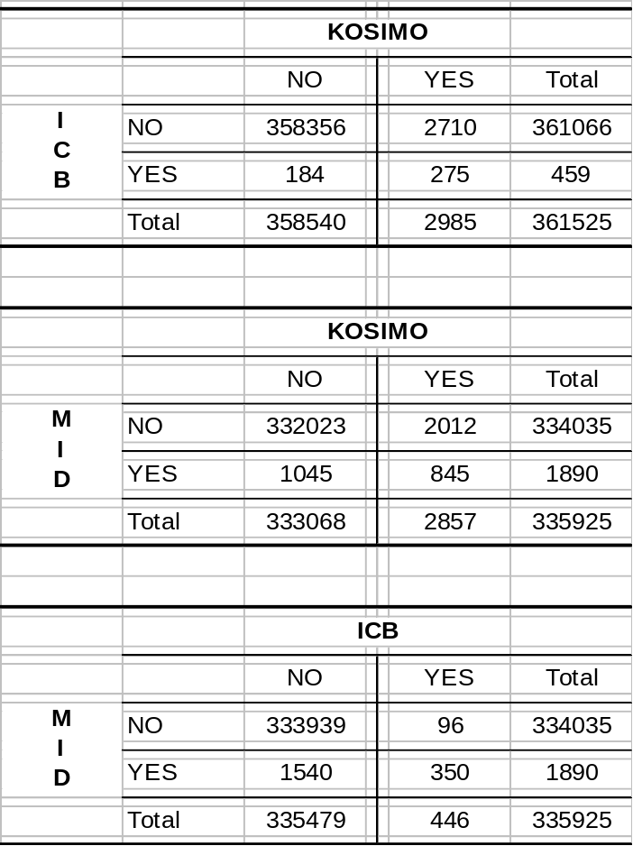
Table V. Comparison of KOSIMO, ICB, and MID Conflict Data:
Excluding KOSIMO Latent Crises

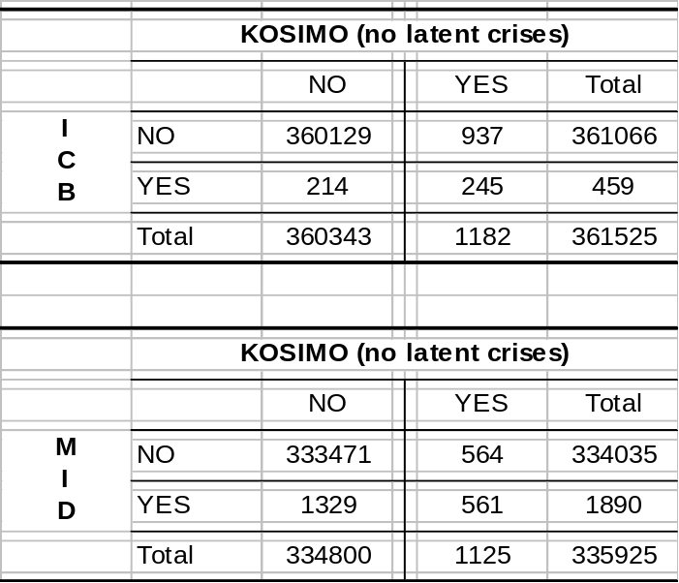
Table VI. Comparison of Alternative Measures of
the Intercivilization Dyad Variable

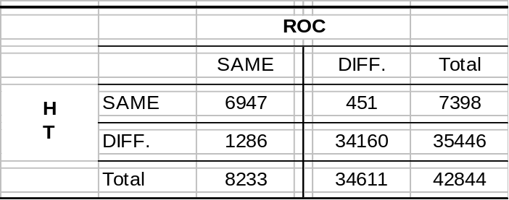
HT stands for Henderson & Tucker; ROC stands for Russett, Oneal & Cox

Table VII. Rare Events Logit Analysis
Predicting Involvement in International Conflict:
Alternative Measure for the Intercivilization Dyad Variable

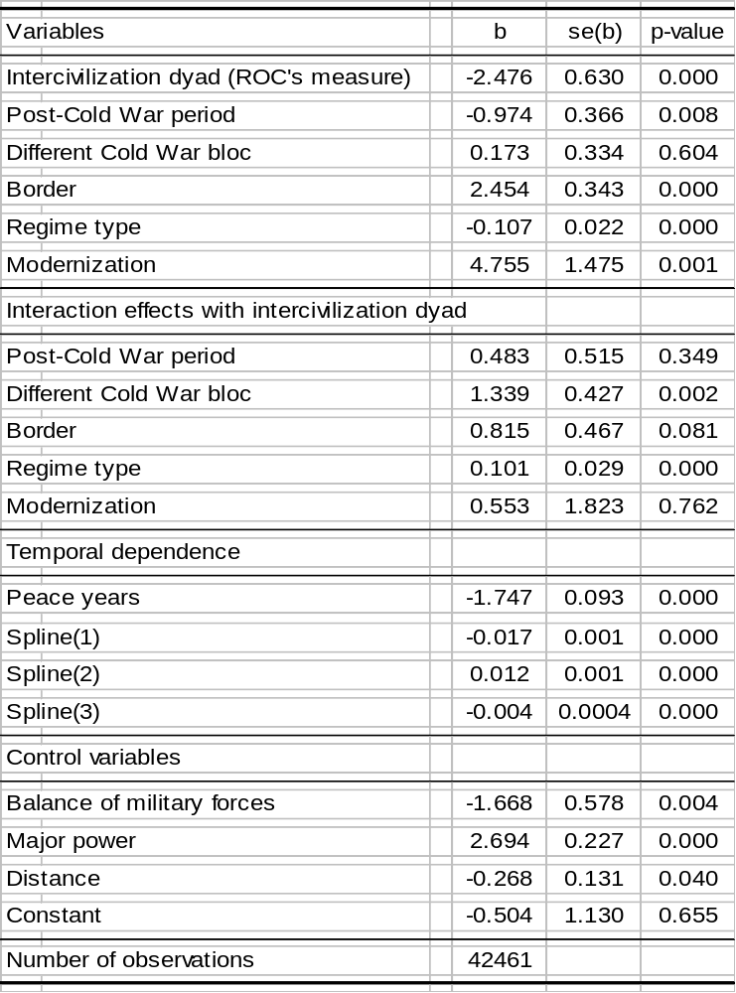
Parameters estimated using King & Zeng's (2001a,b) Relogit program. Weighting option used with robust standard errors and clustering by dyad. All tests are two-tailed. ROC stands for Russett, Oneal & Cox (2000)

Table VIII. Factor Analysis Model of Modernization

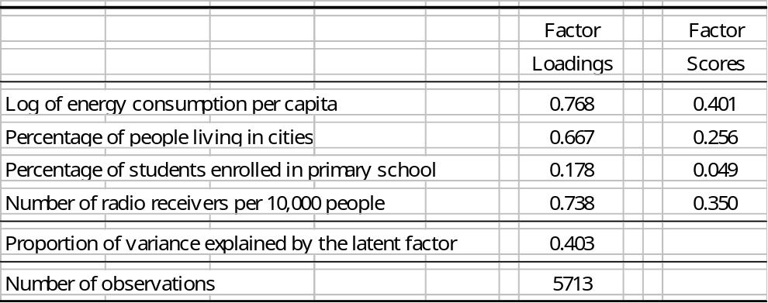

Table IX. Rare Events Logit Analysis
Predicting Involvement in International Conflict:
Single Modernization Indicators
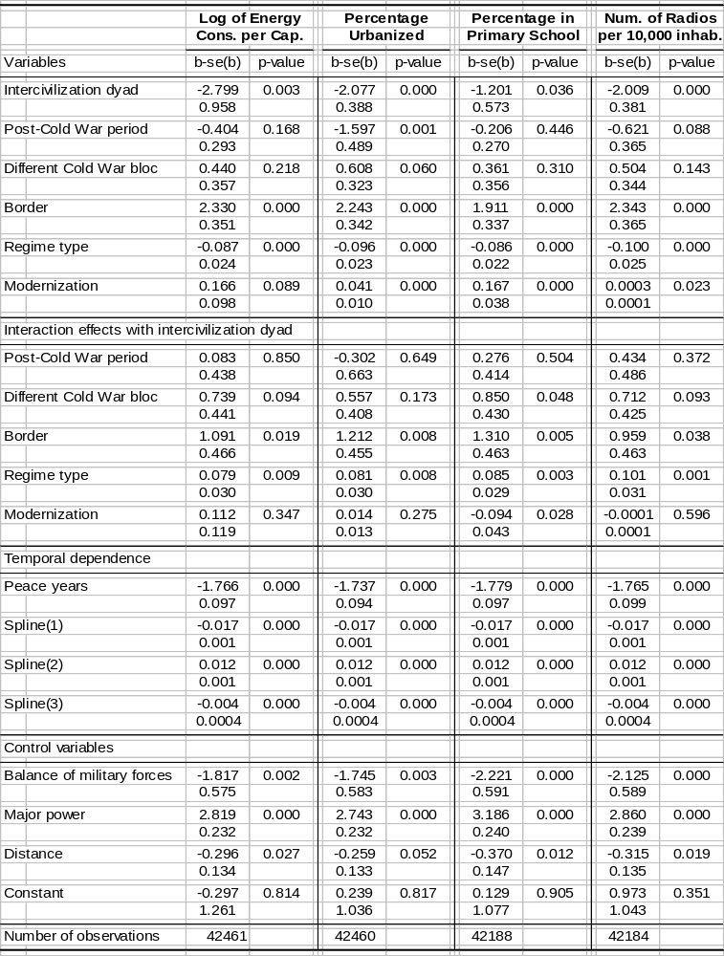
Parameters estimated using King & Zeng's (2001a,b) Relogit program. Weighting option used with robust standard errors and clustering by dyad. All tests are two-tailed.
Table X. Rare Events Logit Analysis
Predicting Involvement in International Conflict:
‘Strong Link’ Assumption on the Modernization Variable

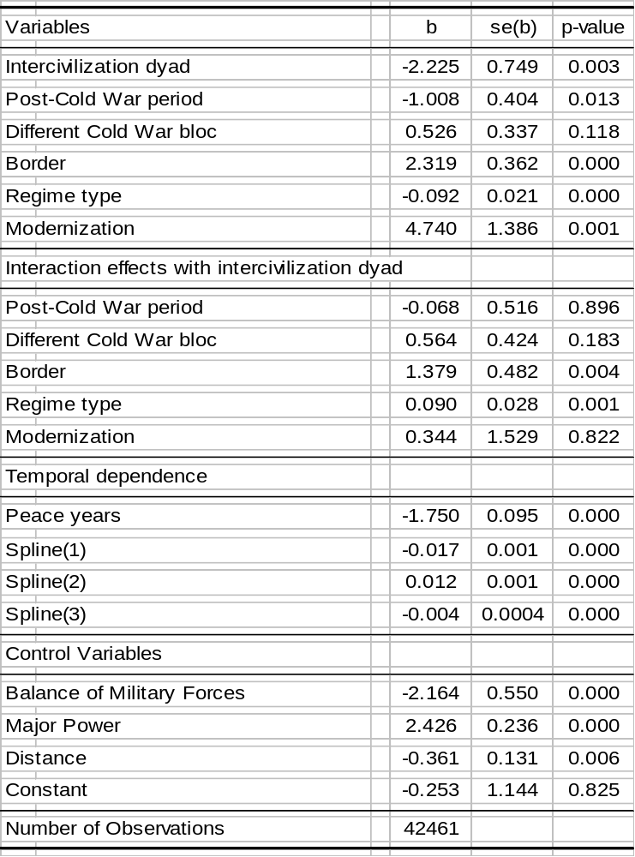
Parameters estimated using King & Zeng's (2001a,b) Relogit program. Weighting option used with robust standard errors and clustering by dyad. All tests are two-tailed.
Table XI. Rare Events Logit Analysis
Predicting Involvement in International Conflict:
Prior Correction

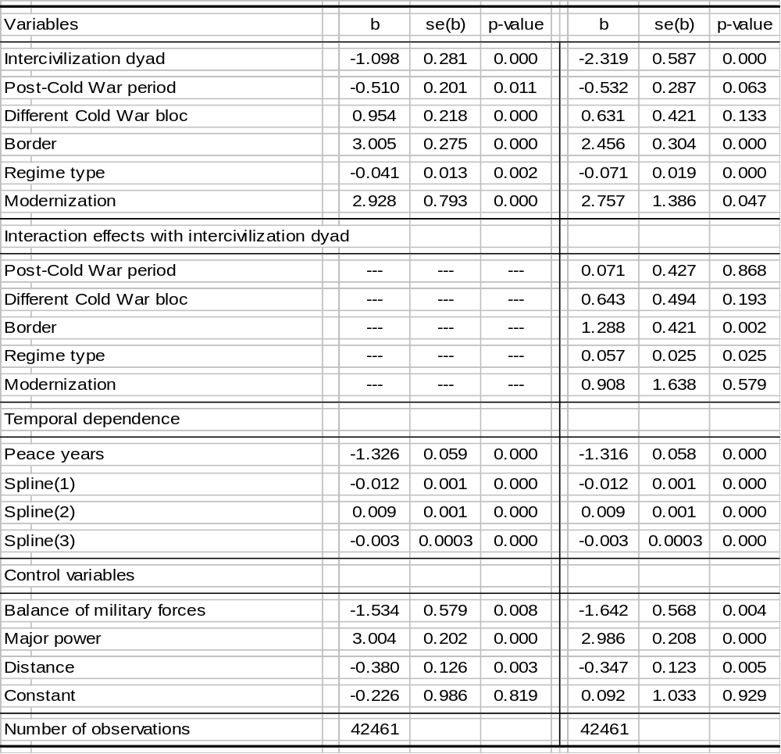
Parameters estimated using King & Zeng's (2001a,b) Relogit program. Prior correction option used with robust standard errors and clustering by dyad. All tests are two-tailed.

Figure 3. Modernization and Conflict Involvement: Single Indicator Measures

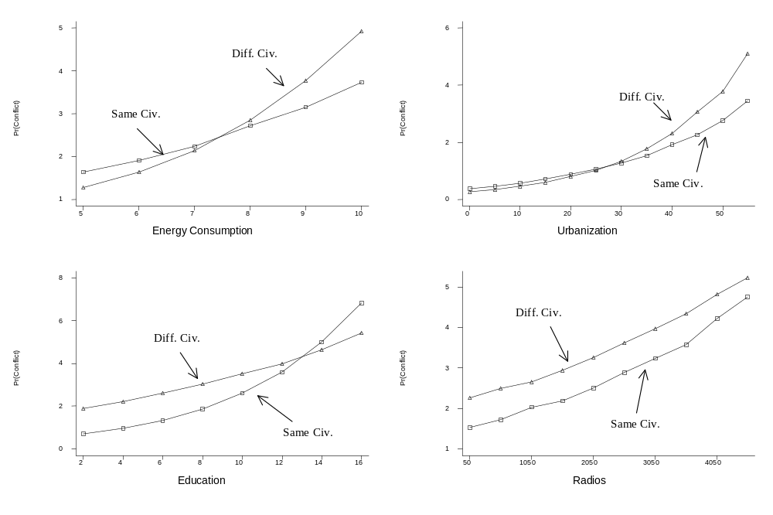
References
Banks, Arthur S., 1976. Cross-National Time Series, 1815-1973 [Computer file]. ICPSR Study 7412. Ann Arbor, MI: Inter-university Consortium for Political and Social Research.
Bennett, D. Scott & Allan C. Stam, 2001. EUGene: Expected Utility Generation and Data Management Program. Version 2.013. http://eugenesoftware.org
Brecher, Michael & Jonathan Wilkenfeld, 1997. A Study of Crisis. Ann Arbor: University of Michigan Press.
Jones, Daniel M.; Stuart A. Bremer & David Singer, 1996. ‘Militarized Interstate Disputes, 1816-1992: Rationale, Coding Rules, and Empirical Patterns’, Conflict Management and Peace Science 15(2): 163-213.
Henderson, Errol A. & Richard Tucker, 1999. The Clash of Civilizations Data Project. Version 2.0. http://www.vanderbilt.edu/~rtucker/data/clash/member.html
Henderson, Errol A. & Richard Tucker, 2001. ‘Clear and Present Strangers: The Clash of Civilizations and International Conflict’, International Studies Quarterly 45(2): 317-338.
Huntington, Samuel P., 1996. The Clash of Civilizations and the Remaking of World Order. New York: Simon & Schuster.
Kim, Jae-On & Charles W. Mueller, 1976. Introduction to Factor Analysis: What It is and How To Do It. Sage University Paper Series on Quantitative Applications in the Social Sciences, 07-013. Newbury Park, CA: Sage.
King, Gary & Langche Zeng, 2001a. ‘Logistic Regression in Rare Events Data’, Political Analysis 9(2): 137-163.
King, Gary & Langche Zeng, 2001b. ‘Explaining Rare Events in International Relations’, International Organization 55(3): 693-715.
King, Gary & Langche Zeng, 2001c. ‘How Factual is Your Counterfactual?’ Working Paper, 2 August 2001, available at http://gking.harvard.edu.
Lipset, Seymour Martin, 1994. ‘The Social Requisites of Democracy Revisited’, American Sociological Review 59(1): 1-22.
Mansfield, Edward D., 1988. ‘The Distribution of Wars over Time’, World Politics 41(1): 21-51.
Mitchell, B.R., 1998a. International Historical Statistics: Africa, Asia & Oceania, 1750-1993. London: Macmillan.
Mitchell, B.R., 1998b. International Historical Statistics: The Americas, 1750-1993. London: Macmillan.
Mitchell, B.R., 1998c. International Historical Statistics: Europe, 1750-1993. London: Macmillan.
Pfetsch, Frank R. & Christoph Rohloff, 2000. ‘KOSIMO: A Databank on Political Conflict’, Journal of Peace Research 37(3): 379-389.
Przeworski, Adam & Fernando Limongi, 1997. ‘Modernization: Theory and Facts’, World Politics 49(2): 155-183.
Russett, Bruce; John R. Oneal & Michaelene Cox, 2000. ‘Clash of Civilizations, or Realism and Liberalism Déjà Vu? Some Evidence’, Journal of Peace Research 37(5): 583-608.

NOTES

An additional feature of the Kosimo data is the coding of domestic conflict. This data were not used in the present study, given its focus on interstate interactions.
Mansfield (1988) reports a similar finding with respect to wars.
A few countries that are not included in the Russett, Oneal & Cox (2000) list are given the civilizational membership used by Henderson & Tucker (1999, 2001). This procedure affects the following countries: Armenia, Azerbaijan, Belarus, Bosnia-Herzegovina, Comoros, Croatia, Czech Republic, Eritrea, Estonia, Fiji, Georgia, Guyana, Kazakhstan, Kyrgyz Republic, Latvia, Lithuania, Macedonia, Moldova, Slovakia, Slovenia, Tajikistan, Turkmenistan, Ukraine, and Uzbekistan.
To avoid having negative values on the energy consumption per capita variable, the levels of energy per capita are multiplied by 10,000 before taking the log. The UN Energy Yearbook aggregates the energy data for South Africa, Botswana, Lesotho, Namibia, and Swaziland in a unique measure, namely that for the South Africa Customs Union. Analogously, the energy data for Eritrea are included in those for Ethiopia in the period 1994-1997. Therefore, these numbers were disaggregated into their basic components using the relative size of their economies as measured by GDP. Data on GDP are taken from the UNACTD, Handbook of Statistics CD-Rom.
Only one eigenvalue of the correlation matrix was greater than 1 (λ=1.61).
Missing values on the modernization variable were filled in using best-subset regression imputation as implemented by Stata 7’s Impute command. This procedure affected 575 (9.14%) observations.
Dyads with missing values on either country were treated as if the unique value available were the minimum. This affected 14 observations.

