Lab 6: Correlations and data reduction techniques

## Instructions

Follow the assignment step-by-step. Create a Microsoft Word document and name your $.doc(x)$ file in a following format: $your_surname_lab5.rmd$. For example,

sichinava_lab6.doc(x)

In this document you will copy the results of your analysis.

## Correlations

In this assignment we are going to examine how correlations might be done in SPSS. Also we are going to do some fun factor analysis on national resilience scale developed by Kimhi et al, 2016.

### Prepare data for the first set of analysis

In the first part of the assignment we are going to analyze voting data from Georgia’s presidential and parliamentary elections. Specifically, we will examine whether district-level votes for the United National Movement are correlated with different variables. Download the geoelections.csv file from this link: <https://goo.gl/a3gWjZ> . Read it into SPSS and attach corresponding variable labels to variables. Change variable Elections into numeric.

|  |  |
| --- | --- |
| Variable | Label |
| TurnoutProp | Total turnout |
| UNMProp | Vote share for the UNM and its candidates |
| Urban | Proportion of urban population |
| Georgian | Proportion of ethnic Georgians |
| Orthodox | Proportion of orthodox population |
| HiEd | Proportion of higher education holders |
| WHC | Proportion of white-collar workers |
| District | District code |
| Elections | Elections |

### Analysis of election data

Now let’s examine correlation between UNMProp and TurnoutProp. Make sure that both variables are numeric. In order to examine the relationship, go to Analyze>Corrlate>Bivariate and drag and drop variables of interest into corresponding menu.

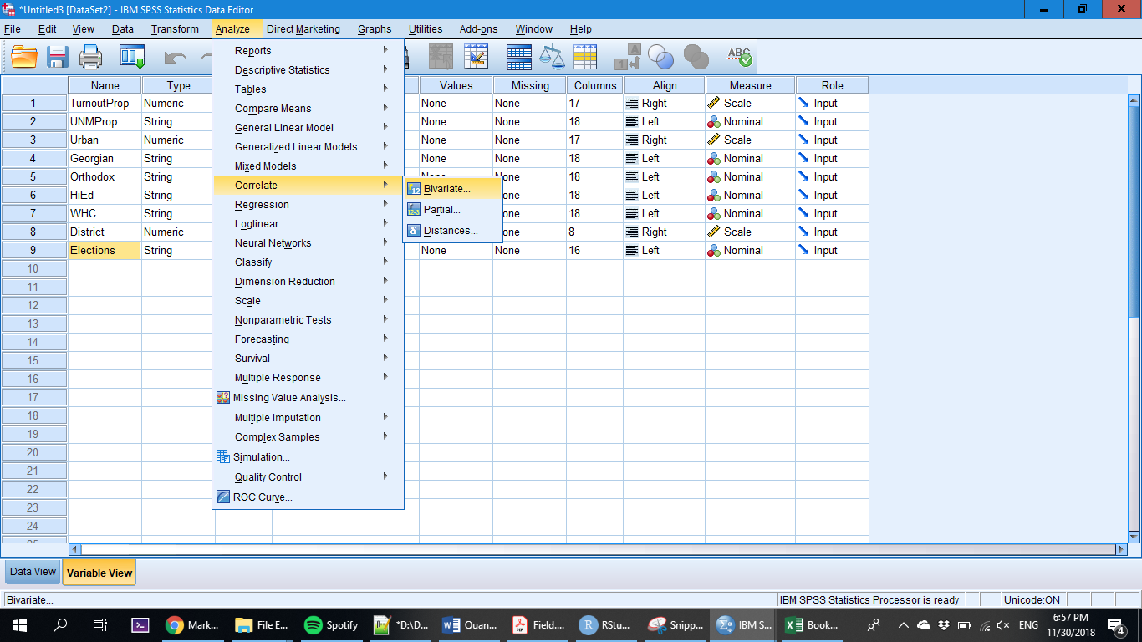

What kind of relationship is between vote share of the UNM and turnout? Is it positive or negative?

In order to check whether you used correct measure of correlation you might want to check the distribution of your variables. If they are *approximately normally distributed*, then go ahead with Pearson’s correlation. Otherwise use Spearman’s rho.

As you might have noticed, each case in our dataset is a combination of election year and district. In order to assess the moderating effect of election year, use partial correlation from the same Correlate menu. Use numeric version of Elections variable as a moderating variable. How would you assess the effect?

Excellent - now you might want to run partial correlations between UNM votes and different demographic measurements such as education level, proportion of Georgians and orthodox. How are each of these variables related with each other?

### Examining Georgians’ national resilience

CRRC-Georgia administered a 13-item resilience scale based on the work of Kimhi et. al. [2017](https://www.researchgate.net/profile/Shaul_Kimhi/publication/320681318_Individual_Community_and_National_Resilience_in_Peace_Time_and_in_the_Face_of_Terror_A_Longitudinal_Study/links/5a2f94380f7e9bfe8170582a/Individual-Community-and-National-Resilience-in-Peace-Time-and-in-the-Face-of-Terror-A-Longitudinal-Study.pdf). National resilience implies whether people are willing to follow the footsteps of the national government in times of crises. In order to measure resilience, respondents were asked a battery of questions. On a six-point scale where 1 corresponds to “Do not agree at all” and 6 “Completely agree” respondents were presented a battery of questions with following items:

* I believe that my government will make the right decision during a time of crisis
* During a national crisis society in my country will back up government decisions and those of the prime minister
* I have full confidence in the ability of the security forces of my country to protect our population
* My country is my home and I don’t intend to leave it
* My society has coped well with past crises and will cope well with future crises
* I am optimistic about the future of my country
* Social relations between the different groups in my country are good.
* In my society there is a high level of social solidarity (mutual assistance and concern for one another)
* The expression ‘man is wolf to man’ is characteristic of my society
* In my society there is a reasonable level of social justice.

Additionally, using a six-point scale respondents were asked to assess whether they trust or distrust parliament, education system, and police.

Download questionnaire and dataset from this [link](https://www.dropbox.com/s/9qt6xxg56el4ii1/dataset.rar?dl=0). Our goal is to calculate latent variables lying behind the above-mentioned scale. These new variables will be components of national resilience. Resilience questions are saved under following names: NSBELGOV, NSBACGOV, NSBELFOR, NSHOME, NSCRPF, NSOPTFU, NSSOREGO, NSHISOL, NSWOLF, NSSOCJUST, TRUSTPAR, TRUSTEDSYST, TRUSTPOLICE. Assign negative values to missing values. Now go to Dimension reduction>>Factor analysis and drag and drop the mentioned variables to the menu. Click Rotation and check Varimax. Also you might want to save factor scores to separate variables.

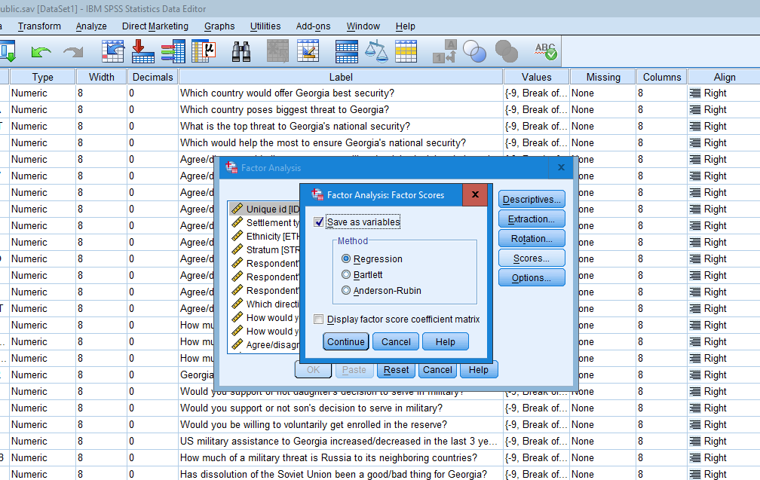

Now let’s make sense what our factors mean. Look at the variables to which each factor is positively or negatively correlated. Take 0.4 (or -0.4) as a threshold. Come up with meaningful names for your factors and substantiate your choice.

Now let’s go further and analyze how our factor scores differ by group. In your opinion, for each factor, do Georgians differ in terms of gender?

## Submission of the assignment

Submit your file to [this link](https://www.dropbox.com/request/UCNOlVaXNuUbLpZIZjHy) before the start of our next meeting. Or if it’s not working, send it via email: [david.sichinava@tsu.ge](mailto:david.sichinava@tsu.ge)