CSI THOOTHUKUDI-NAZARETH DIOCESE

DR.G.U.POPE COLLEGE OF ENGINEERING

POPE NAGAR SAWYERPURAM-628 251



Register No :

**Certified that this is the bonafide record of work done by**

**Selvan/Selvi ……………………………………………………………………… of ……….**

**Semester ……….. branch for the lab ……………………………………………………**

**During the year…………………**

**Staff In-charge H. O.D**

**Submitted for the university practical Examination held on …………..**

**Internal Examiner External Examiner**

|  |  |  |  |  |  |
| --- | --- | --- | --- | --- | --- |
| **S.NO** | **DATE** | **TITLE** | **PAGE** | **MARK** | **SIGN** |
| 1 |  |  | 3 |  |  |
| 2 |  |  | 5 |  |  |
| 3 |  |  | 7 |  |  |
| 4 |  |  | 13 |  |  |
| 5 |  |  | 16 |  |  |
| 6 |  |  | 19 |  |  |
| 7 |  |  | 22 |  |  |
| 8 |  |  | 25 |  |  |
| 9 |  |  | 28 |  |  |
| 10 |  |  | 31 |  |  |
| 11 |  |  | 34 |  |  |

|  |  |
| --- | --- |
| EX NO: 1 | MAKE STUDY USING COMMANDS LIKE TCPDUMP,NETSTAT,IFCONFIG,NSLOOKUP,TRACEROUTE |
| DATE: |

**Aim** : To use commands like tcpdump,netstat,ifconfig,nslookup,traceroute,using a network protocol analyzer.

**Algorithm :**

1. Use the linux for the commands fast executon.
2. Open terminal & switch to root user.
3. Install the required tools to work.
4. Use traffic analyzer commands & observe the executions.

**Commands :**

sudo -i

apt install net-tools

ifconfig

tcpdump -d

tcpdump -i

netstat -a

netstat -l

netstat -s

netstat -i

netstat -r

nslookup 8.8.8.8

nslookup google.com 8.8.8.8

apt install inetutils-traceroute

traceroute google.com

apt install wireshark

wireshark

**Output :**

**Result:**

Thus to use commands like tcpdump,netstat,ifconfig,nslookup,traceroute,using a network protocol analyzer have been analyzed successfully.

|  |  |
| --- | --- |
| EX NO: 2 | WRITE AN HTTPS WEB CLIENT PROGRAM TO DOWNLOAD A WEB PAGE USING TCP SOCKETS. |
| DATE: |

**Aim :**  To write an HTTPS web client program to download a web page using TCP sockets.

**Algorithm:**

1. Import the necessary packages.
2. Initialize URI & URL.
3. Create a bufferreader object to read the URL stream.
4. Create a bufferreader object to write data into it.
5. Console the program & data lines
6. Observe the executed output.

**Program :**

import java.io.BufferedReader;

import java.io.BufferedWriter;

import java.io.FileWriter;

import java.io.InputStreamReader;

import java.net.URI;

import java.net.URL;

public class WebScraper {

public static void main(String[] args) throws Exception {

URI uri = new URI("https://www.instagram.com");

URL url = uri.toURL();

BufferedReader reader = new BufferedReader(new InputStreamReader(url.openStream()));

BufferedWriter writer = new BufferedWriter(new FileWriter("data.html"));

String line;

while ((line = reader.readLine()) != null) {

System.out.println(line);

writer.write(line);

writer.newLine();

}

reader.close();

writer.close();

}

}

**Output :**

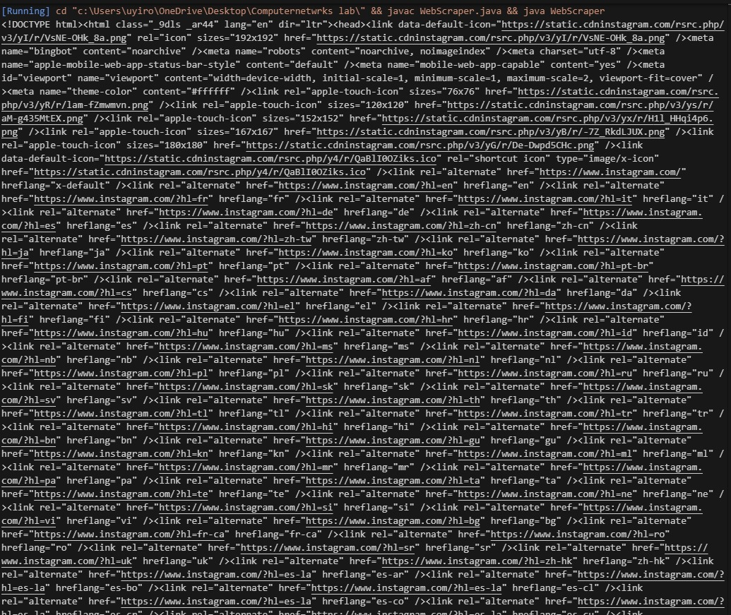

**Result :** Thus to write an https web client program to download a web page using tcp sockets has been executed successfully.

|  |  |
| --- | --- |
| EX NO: 3 | CREATE & RUN ECHOSERVER, ECHOCLIENT, FILETRANSFERSERVER, FILETRANSFERCLIENT USING TCP SOCKETS. |
| DATE: |

**Aim :** To create & run echoserver,echoclient,filetransferserver,filetransferclient using TCP sockets.

.

**Algorithm[ES]:**

1. Import the necessary packages.
2. Set the port numbers.
3. Initialize the server sockets.
4. Enter sn infinite loop to hsndle incoming clients.
5. Setup inut & output streams.
6. Process client messages.

**Algorithm[EC]:**

1. Import the necessary packages.
2. Set the host and port.
3. Establish the connection to server.
4. Setup I/O stream.
5. Display connection success messages.
6. Read the user inpt.
7. Close the connection when done.

**Algorithm[FTS]:**

1. Import the necessary packages.
2. Set the port number.
3. Initialize the server socket.
4. Setup I/O file stream.
5. Transfer data from client to server.
6. Close resources after transaction.

**Algorithm[FTC]:**

1. import the necessary packages.
2. Set the host, port, filepath.
3. Establish a connection to server.
4. Setup I/O stream.
5. Transfer the file data.
6. Close resources after transaction.
7. Display success message.

**BioData :**

Name : DavidJones

Father’s Name : Nicholas

Ph No : 9488209176

Mail ID : [jesustheimmaculatta@gmail.com](mailto:jesustheimmaculatta@gmail.com)

DOB : 20.06.2005

Gender : Male

Marital Status : Unmarried

Qualification : Diploma in Computer Applications

Experience : 0 yrs

Address :5B/403, Coats Nagar, Vallinayagapuram, tuty

**Program :**

1. **EchoServer**

import java.io.*;

import java.net.*;

public class EchoServer {

public static void main(String[] args) {

int port = _ _ _ _ _;

try (ServerSocket serverSocket = new ServerSocket(port)) {

System.out.println("Echo Server started on port " + port);

while (true) {

try (Socket clientSocket = serverSocket.accept();

BufferedReader in = new BufferedReader(new InputStreamReader(clientSocket.getInputStream()));

PrintWriter out = new PrintWriter(clientSocket.getOutputStream(), true)) {

String message;

while ((message = in.readLine()) != null) {

System.out.println("Received: " + message);

out.println("Echo: " + message);

}

}

}

} catch (IOException e) {

e.printStackTrace();

}

}

}

**Output :**

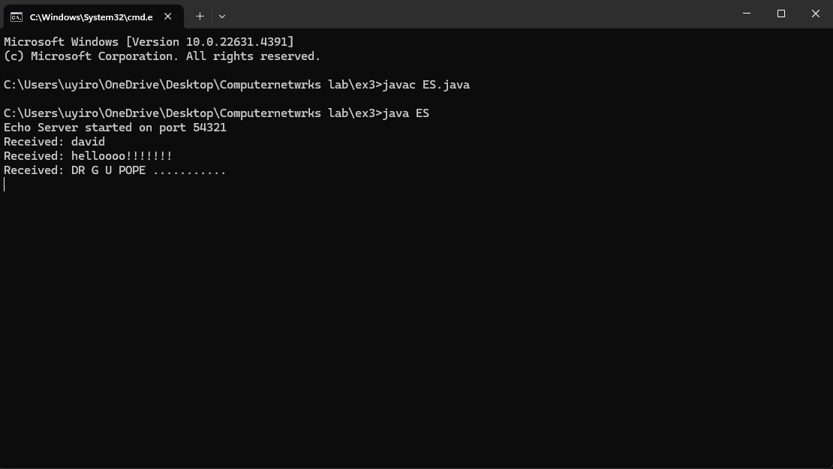

1. **EchoClient**

import java.io.*;

import java.net.*;

public class EchoClient {

public static void main(String[] args) {

String host = "localhost";

int port = _ _ _ _ _;

try (Socket socket = new Socket(host, port);

BufferedReader in = new BufferedReader(new InputStreamReader(socket.getInputStream()));

PrintWriter out = new PrintWriter(socket.getOutputStream(), true);

BufferedReader consoleIn = new BufferedReader(new InputStreamReader(System.in))) {

System.out.println("Connected to echo server on " + host + ":" + port);

String userInput;

while ((userInput = consoleIn.readLine()) != null) {

out.println(userInput);

System.out.println("Server replied: " + in.readLine());

}

} catch (IOException e) {

e.printStackTrace();

}

}

}

**Output :**

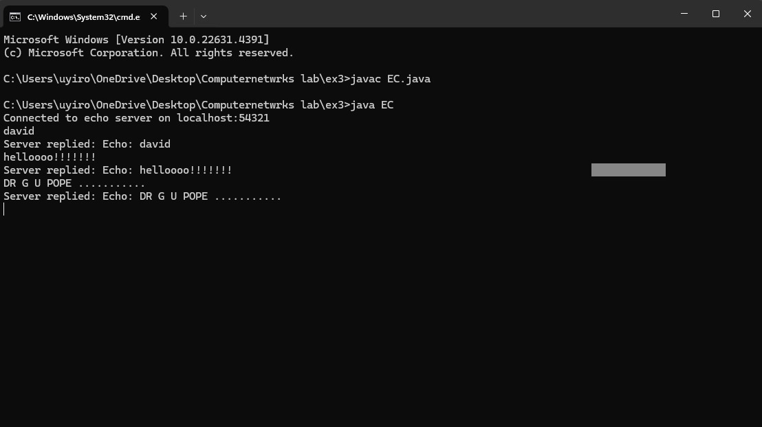

1. **FileTransferServer**

import java.io.*;

import java.net.*;

public class FileTransferServer {

public static void main(String[] args) {

int port = _ _ _ _ _;

try (ServerSocket serverSocket = new ServerSocket(port)) {

System.out.println("File Transfer Server started on port " + port);

while (true) {

try (Socket clientSocket = serverSocket.accept();

InputStream in = clientSocket.getInputStream();

FileOutputStream fileOut = new FileOutputStream("received_ ")) {

byte[] buffer = new byte[4096];

int bytesRead;

while ((bytesRead = in.read(buffer)) != -1) {

fileOut.write(buffer, 0, bytesRead);

}

System.out.println("File received and saved as 'received_file.txt'");

}

}

} catch (IOException e) {

e.printStackTrace();

}

}

}

1. **FileTransferClient**

import java.io.*;

import java.net.*;

public class FileTransferClient {

public static void main(String[] args) {

String host = "localhost";

int port = _ _ _ _ _;

String filePath = " "; // Update with correct path

try (Socket socket = new Socket(host, port);

FileInputStream fileIn = new FileInputStream(filePath);

OutputStream out = socket.getOutputStream()) {

byte[] buffer = new byte[4096];

int bytesRead;

while ((bytesRead = fileIn.read(buffer)) != -1) {

out.write(buffer, 0, bytesRead);

}

System.out.println("File sent successfully.");

} catch (IOException e) {

e.printStackTrace();

}

}

}

**Output :**

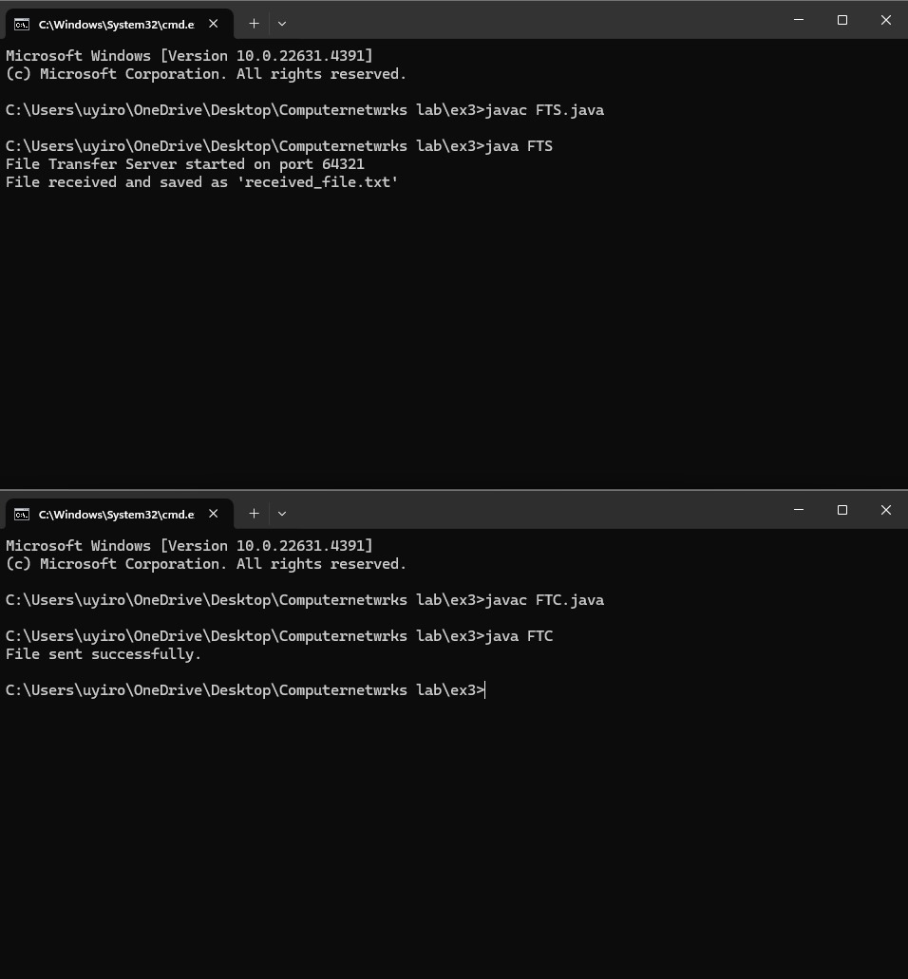

**Result :** Thus to create & run echoserver,echoclient,filetransferserver,filetransferclient using TCP sockets has been recorded successfully.

|  |  |
| --- | --- |
| EX NO: 4 | WRITE CODES TO STUDY THE BASIC SIMULATION OF DNS USING UDP SOCKETS. |
| DATE: |

**Aim**: To write codes to study the basic simulation of DNS using UDP sockets.

**Algorithm:**

1. Import the necessary packages.
2. Assign the doamin address.
3. Ensure your connection with server.
4. Request for datapackets and record the responses.
5. Catchout the occurred exceptions and relay it.
6. Note down the output for further verification.

**Program:**

import java.net.DatagramPacket;

import java.net.DatagramSocket;

import java.net.InetAddress;

public class SimpleDNSClient {

public static void main(String[] args) {

try {

String domain = "www.Cloudflare.com";

InetAddress dnsServer = InetAddress.getByName("1.1.1.1");

byte[] dnsQuery = buildDnsQuery(domain);

DatagramSocket socket = new DatagramSocket();

DatagramPacket requestPacket = new DatagramPacket(dnsQuery, dnsQuery.length, dnsServer, 53);

socket.send(requestPacket);

byte[] buffer = new byte[512];

DatagramPacket responsePacket = new DatagramPacket(buffer, buffer.length);

socket.receive(responsePacket);

socket.close();

System.out.println("Raw DNS response: ");

for (int i = 0; i < responsePacket.getLength(); i++) {

System.out.print(String.format("%02X ", buffer[i]));

}

System.out.println();

} catch (Exception e) {

e.printStackTrace();

}

}

private static byte[] buildDnsQuery(String domain) throws Exception {

byte[] header = {

(byte) 0xAA, (byte) 0xAA,

(byte) 0x01, (byte) 0x00,

(byte) 0x00, (byte) 0x01,

(byte) 0x00, (byte) 0x00,

(byte) 0x00, (byte) 0x00,

(byte) 0x00, (byte) 0x00

};

byte[] question = new byte[domain.length() + 2 + 4];

String[] labels = domain.split("\\.");

int pos = 0;

for (String label : labels) {

question[pos++] = (byte) label.length();

for (char c : label.toCharArray()) {

question[pos++] = (byte) c;

}

}

question[pos++] = 0x00;

question[pos++] = 0x00; question[pos++] = 0x01;

question[pos++] = 0x00; question[pos++] = 0x01;

byte[] dnsRequest = new byte[header.length + question.length];

System.arraycopy(header, 0, dnsRequest, 0, header.length);

System.arraycopy(question, 0, dnsRequest, header.length, question.length);

return dnsRequest;

}

}

**Output :**

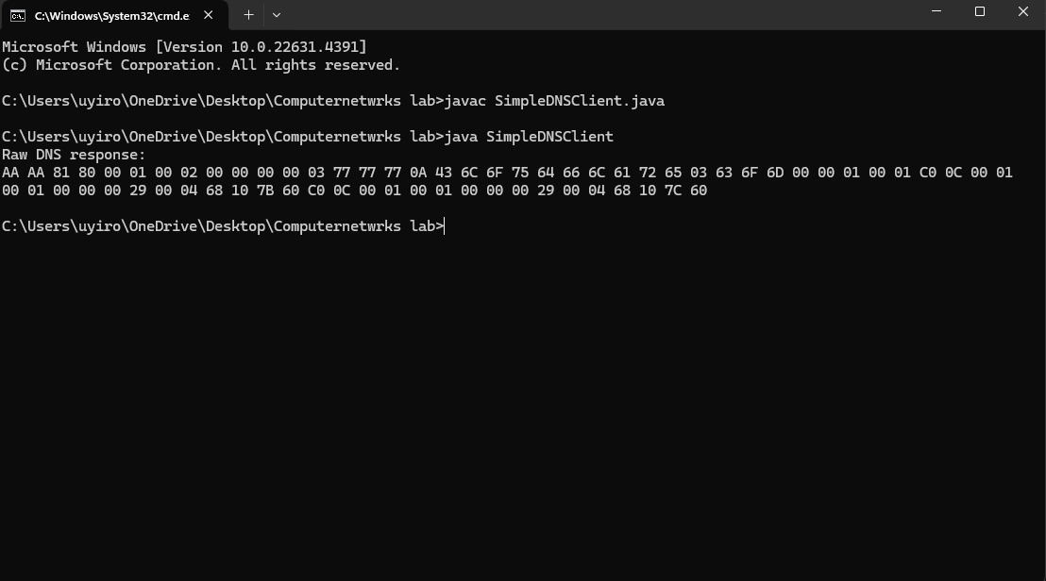

**Result :** Thus to write codes to study the basic simulation of DNS using UDP sockets has been initiated successfully.

|  |  |
| --- | --- |
| EX NO: 5 | WRITE CODES TO STIMULATE ARP/RARP PROTOCOLS. |
| DATE: |

**Aim**: To write codes to stimulate ARP/RARP protocols.

**Algorithm:**

1. Import the necessary java packages.
2. Recognize the mapping co-ordinates.
3. Record the request and response.
4. Reamplify the protocol addresses.
5. Observe the output and cross examine the codes.

**Program:**

import java.util.HashMap;

import java.util.Map;

public class ARPSimulation {

private static Map<String, String> arpTable = new HashMap<>();

static {

arpTable.put("192.168.1.1", "00:14:22:01:23:45");

arpTable.put("192.168.1.2", "00:14:22:01:23:46");

arpTable.put("192.168.1.3", "00:14:22:01:23:47");

}

public static void main(String[] args) {

String ipToResolve = "192.168.1.1";

String macToResolve = "00:14:22:01:23:47";

String macAddress = arpRequest(ipToResolve);

if (macAddress != null) {

System.out.println("ARP Response: IP " + ipToResolve + " is at MAC " + macAddress);

} else {

System.out.println("ARP Response: IP " + ipToResolve + " is not found.");

}

String ipAddress = rarpRequest(macToResolve);

if (ipAddress != null) {

System.out.println("RARP Response: MAC " + macToResolve + " is at IP " + ipAddress);

} else {

System.out.println("RARP Response: MAC " + macToResolve + " is not found.");

}

}

private static String arpRequest(String ipAddress) {

return arpTable.get(ipAddress);

}

private static String rarpRequest(String macAddress) {

for (Map.Entry<String, String> entry : arpTable.entrySet()) {

if (entry.getValue().equals(macAddress)) {

return entry.getKey();

}

}

return null;

}

}

**OUTPUT :**

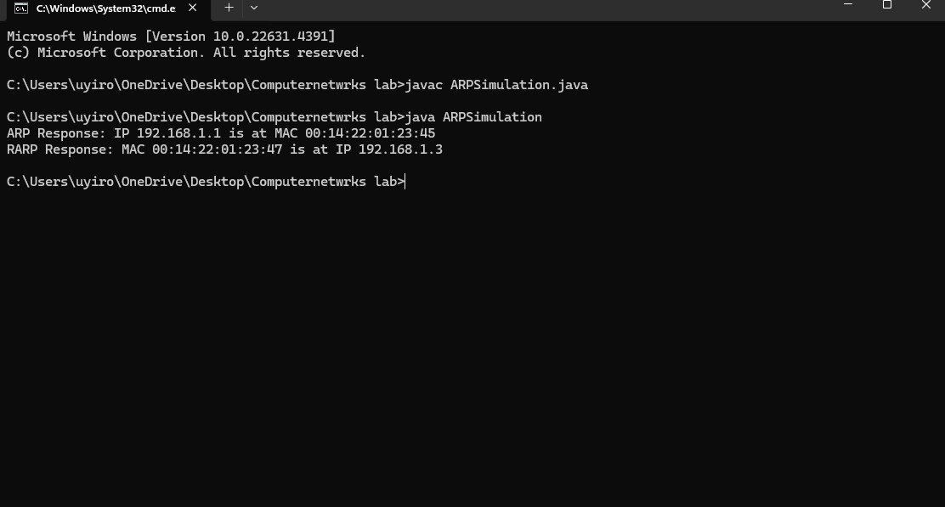

**Result :** Thus to write codes to stimulate ARP/RARP protocols has been done successfully.

|  |  |
| --- | --- |
| EX NO: 6 | STUDY OF NETWORK SIMULATORS AND CONGESTION CONTROL ALGORITHM |
| DATE: |

**Aim :** To Study Of Network Simulators And Congestion Control Algorithm.

**Algorithm:**

1. Ns runs in both Windows, Linux .Highly preferred for easy control is linux(ubuntu).
2. Open the terminal on linux update the system , also install libraries , packages for firther execution.
3. Open up the text editor and start the coding with .tcl extension.
4. Compile and run the code which generates the trace file with .tr Extension.
5. Create a new graph file and feed your code , then save it with .gp extension.
6. Run the code the to view the graphical structure as your output.

**Commands :**

sudo apt update

sudo apt install ns2 nam gnuplot

gedit cs.tcl

ns cs.tcl

ls

gedit cs.tr

grep -e '^\+' -e '^-|^-^r' cs.tr > filtered_LS

LS

tr.tr

ls

cat filtered_tr.tr | head -n 20

gedit ps.gp

gnuplot ps.gp

ls

eog pf.png

**Program :**

**Extension : .tcl**

set ns [new Simulator]

set tracefile [open CCS.tr w]

$ns trace-all $tracefile

set n0 [$ns node]

set n1 [$ns node]

set n2 [$ns node]

set n3 [$ns node]

$ns duplex-link $n0 $n1 1Mb 10ms DropTail

$ns duplex-link $n1 $n2 1Mb 10ms DropTail

$ns duplex-link $n2 $n3 1Mb 10ms DropTail

set tcp [new Agent/TCP]

$ns attach-agent $n0 $tcp

set sink [new Agent/TCPSink]

$ns attach-agent $n3 $sink

$ns connect $tcp $sink

set ftp [new Application/FTP]

$ftp attach-agent $tcp

$ns at 0.0 "$ftp start"

$ns at 4.5 "$ftp stop"

$ns at 5.0 "finish"

proc finish {} {

global ns tracefile

$ns flush-trace

close $tracefile

exit 0

}

$ns run

**Extension : .gp**

set terminal pngcairo

set output 'packet_flow.png'

set title 'Packet Flow Over Time'

set xlabel 'Time (s)'

set ylabel 'Packet Flow'

set xrange [0:*]

set yrange [0:*]

plot "valid_data.tr" using ($2):($4) with lines title 'Packet Flow (Sent)' linecolor rgb 'blue', \

"valid_data.tr" using ($2):($4) with lines title 'Packet Flow (Received)' linecolor rgb 'red'

**Output :**

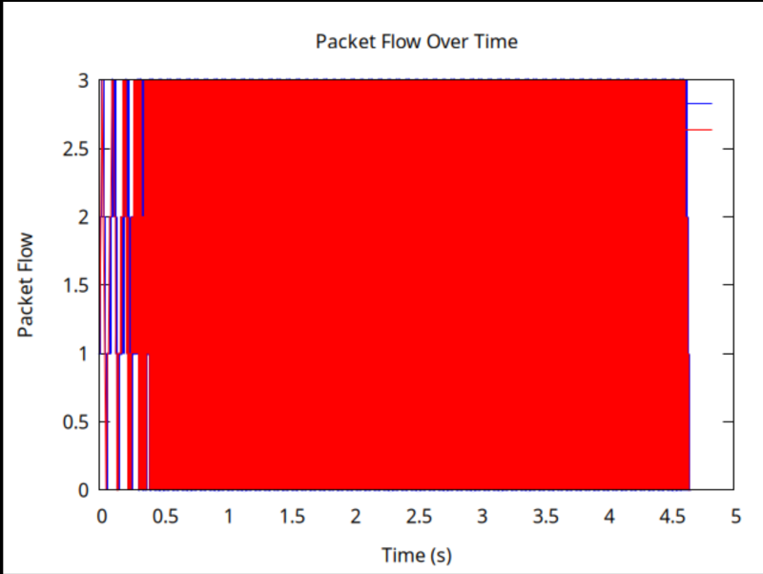

**Result :** Thus the study of network simulators and congestion control algorithm has been executed successfully.

.

|  |  |
| --- | --- |
| EX NO: 7 | STUDY OF TCP/UDP PERFORMANCE USING SIMULATION TOOL |
| DATE: |

**Aim :** To study the tcp/udp performance using simulation tools using ns2.

**Algorithm:**

1. Ns runs in both Windows, Linux .Highly preferred for easy control is linux(ubuntu).
2. Open the terminal on linux update the system , also install libraries , packages for firther execution.
3. Open up the text editor and start the coding with .tcl extension.
4. Compile and run the code which generates the trace file with .tr Extension &.awk extension.
5. Create a new graph file and feed your code , then save it with .gp extension.
6. Run the code the to view the graphical structure as your output.

**Commands :**

Gedit ex7tcp_udp.tcl

Ns ex7tcp_udp.tcl

Ls

Gedit trace.awk

Awk -f analyze_trace.awk congestion_simulation.tr > analyzed_trace.txt

Gedit trace.gp

Gnuplot trace.gp

Eog traffic_flow.png

**Program :**

**Extension : .tcl**

set ns [new Simulator]

set tracefile [open congestion_simulation.tr w]

$ns trace-all $tracefile

set n0 [$ns node]

set n1 [$ns node]

set n2 [$ns node]

$ns duplex-link $n0 $n1 1Mb 10ms DropTail

$ns duplex-link $n1 $n2 1Mb 10ms DropTail

set tcp [new Agent/TCP]

$ns attach-agent $n0 $tcp

set udp [new Agent/UDP]

$ns attach-agent $n0 $udp

set sink [new Agent/TCPSink]

$ns attach-agent $n2 $sink

set udpsink [new Agent/Null]

$ns attach-agent $n2 $udpsink

$ns connect $tcp $sink

$ns connect $udp $udpsink

set ftp [new Application/FTP]

$ftp attach-agent $tcp

$ns at 0.5 "$ftp start"

$ns at 4.5 "$ftp stop"

set cbr [new Application/Traffic/CBR]

$cbr attach-agent $udp

$cbr set packetSize_ 1000

$cbr set interval_ 0.1

$ns at 1.0 "$cbr start"

$ns at 4.0 "$cbr stop"

$ns at 10.0 "finish"

proc finish {} {

global ns tracefile

$ns flush-trace

close $tracefile

exit 0

}

$ns run

**Extension : .awk**

BEGIN {

print "Time\tSource\tDest\tType\tSize"

}

{

if ($1 == "+" || $1 == "-") {

printf("%s\t%s\t%s\t%s\t%s\n", $2, $3, $4, $7, $8)

}

}

**Extension : .gp**

c

**Output :**

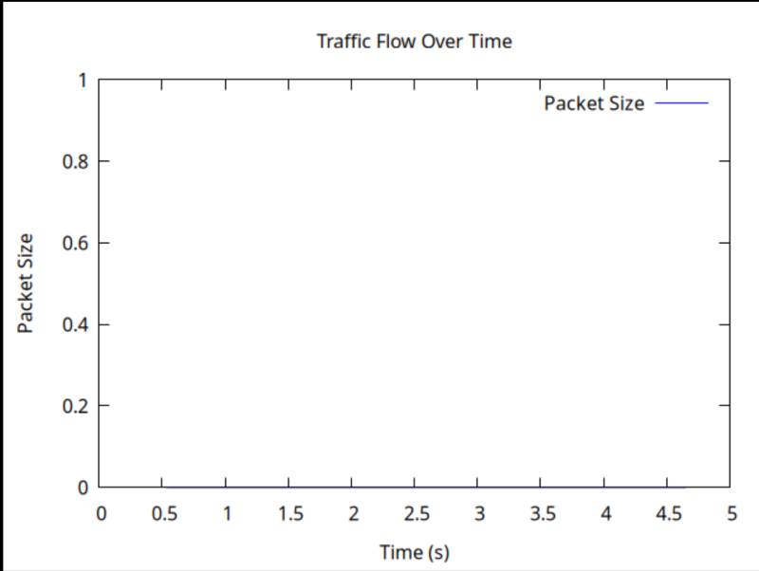

**Result :** Thus to study the tcp/udp performance using simulation tools using ns2 has been done successfully

|  |  |
| --- | --- |
| EX NO: 8a | SIMULATION OF LINK STATE ROUTING ALGORITHM |
| DATE: |

**Aim :** To write codes to simulate LSR.

**Algorithm:**

1. Ns runs in both Windows, Linux .Highly preferred for easy control is linux(ubuntu).
2. Open the terminal on linux update the system , also install libraries , packages for firther execution.
3. Open up the text editor and start the coding with .tcl extension.
4. Compile and run the code which generates the trace file with .tr Extension &.awk extension.
5. Create a new graph file and feed your code , then save it with .gp extension.
6. Run the code the to view the graphical structure as your output.

**Commands :**

gedit lsr.tcl

ns lsr.tcl

ls

gedit lsr.awk

awk -f lsr.awk dijkstra_trace.tr > lsr traced.txt

gedi# Create a simulator instance

lsr.gp

gnuplot lsr.gp

**Program :**

**Extension : .tcl**

set ns [new Simulator]

set tracefile [open dijkstra_trace.tr w]

$ns trace-all $tracefile

set n0 [$ns node]

set n1 [$ns node]

set n2 [$ns node]

set n3 [$ns node]

set n4 [$ns node]

$ns duplex-link $n0 $n1 2Mb 10ms DropTail

$ns duplex-link $n1 $n2 2Mb 5ms DropTail

$ns duplex-link $n2 $n3 2Mb 5ms DropTail

$ns duplex-link $n3 $n4 2Mb 10ms DropTail

$ns duplex-link $n0 $n4 2Mb 20ms DropTail

$ns duplex-link $n2 $n4 2Mb 5ms DropTail

set udp0 [new Agent/UDP]

$ns attach-agent $n0 $udp0

set null0 [new Agent/Null]

$ns attach-agent $n4 $null0

$ns connect $udp0 $null0

set cbr [new Application/Traffic/CBR]

$cbr set packetSize_ 512

$cbr set interval_ 0.2

$cbr attach-agent $udp0

$ns at 1.0 "$cbr start"

$ns at 4.0 "$cbr stop"

$ns at 5.0 "finish"

proc finish {} {

global ns tracefile

$ns flush-trace

close $tracefile

exit 0

}

$ns run

**Extension : .awk**

BEGIN {

print "Time\tSource\tDest\tType\tSize"

}

{

if ($1 == "+" || $1 == "-") {

printf("%s\t%s\t%s\t%s\t%s\n", $2, $3, $4, $7, $8)

}

}

**Extension : .gp**

set terminal pngcairo

set output 'LSR.png'

set title 'Link State Traffic Flow Over Time'

set xlabel 'Time (s)'

set ylabel 'Packet Size'

set xrange [0:*]

set yrange [0:1000]

plot "LSRtraced.txt" using 1:5 with lines title 'Packet Size' linecolor rgb 'blue'

**Output :**

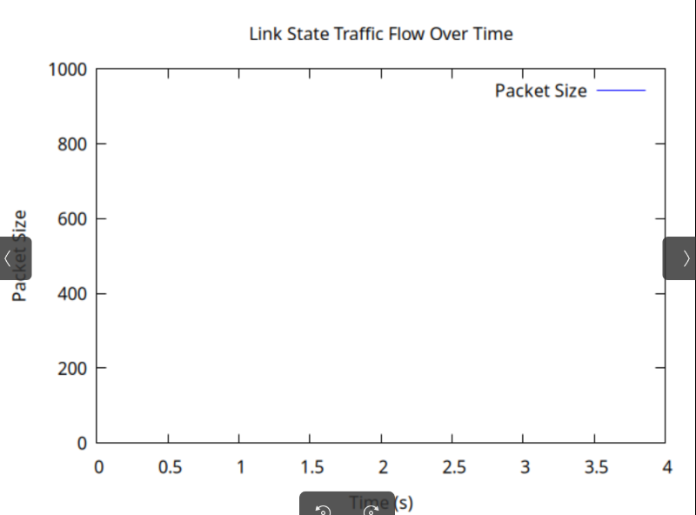

**Result :** Thus to write codes to simulate LSR has been executed successfully.

|  |  |
| --- | --- |
| EX NO: 8b | SIMULATION OF DISTANCE VECTOR ROUTING ALGORITHMS |
| DATE: |

**Aim :** To write codes to simulate DVR.

**Algorithm:**

1. Ns runs in both Windows, Linux .Highly preferred for easy control is linux(ubuntu).
2. Open the terminal on linux update the system , also install libraries , packages for firther execution.
3. Open up the text editor and start the coding with .tcl extension.
4. Compile and run the code which generates the trace file with .tr Extension &.awk extension.
5. Create a new graph file and feed your code , then save it with .gp extension.
6. Run the code the to view the graphical structure as your output.

**Commands :**

gedit dvr.tcl

ns dvr.tcl

ls

gedit 8btrace.awk

awk -f 8btrace.awk dvr_trace.tr > 8btraced.txt

gedit 8btrace.gp

gnuplot 8btrace.gp

eog dvr.png

**Program :**

**Extension : .tcl**

set ns [new Simulator]

set tracefile [open dvr_trace.tr w]

$ns trace-all $tracefile

set n0 [$ns node]

set n1 [$ns node]

set n2 [$ns node]

set n3 [$ns node]

set n4 [$ns node]

$ns duplex-link $n0 $n1 2Mb 10ms DropTail

$ns duplex-link $n1 $n2 2Mb 10ms DropTail

$ns duplex-link $n2 $n3 2Mb 10ms DropTail

$ns duplex-link $n3 $n4 2Mb 10ms DropTail

set udp0 [new Agent/UDP]

$ns attach-agent $n0 $udp0

set null0 [new Agent/Null]

$ns attach-agent $n4 $null0

$ns connect $udp0 $null0

set cbr [new Application/Traffic/CBR]

$cbr set packetSize_ 512

$cbr set interval_ 0.2

$cbr attach-agent $udp0

$ns at 1.0 "$cbr start"

$ns at 4.0 "$cbr stop"

$ns at 5.0 "finish"

proc finish {} {

global ns tracefile

$ns flush-trace

close $tracefile

exit 0

}

$ns run

[[

**Extension : .awk**

BEGIN {

print "Time\tSource\tDest\tType\tSize"

}

{

if ($1 == "+" || $1 == "-") {

printf("%s\t%s\t%s\t%s\t%s\n", $2, $3, $4, $6, $8)

}

}

**Extension : .gp**

set terminal pngcairo

set output 'DVR.png'

set title 'Traffic Flow Over Time'

set xlabel 'Time (s)'

set ylabel 'Packet Size'

set xrange [0:*]

set yrange [0:1000]

plot "analyzed_trace.txt" using 1:5 with lines title 'Packet Size' linecolor rgb 'blue'

**Output :**

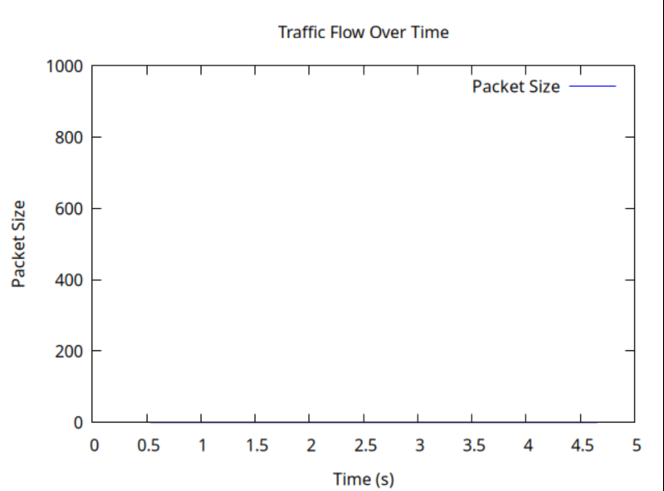

**Result :** Thus to write codes to simulate DVR has been executed successfully.

|  |  |
| --- | --- |
| EX NO: 9 | UNICAST ROUTING PROTOCOL |
| DATE: |

**Aim :** To write codes to simulate unicast routing protocol.

**Algorithm:**

1. Ns runs in both Windows, Linux .Highly preferred for easy control is linux(ubuntu).
2. Open the terminal on linux update the system , also install libraries , packages for firther execution.
3. Open up the text editor and start the coding with .tcl extension.
4. Compile and run the code which generates the trace file with .tr Extension &.awk extension.
5. Create a new graph file and feed your code , then save it with .gp extension.
6. Run the code the to view the graphical structure as your output.

**Commands :**

gedit ex9.tcl

ns ex9.tcl

Less unicast_trace.tr

q

**Program :**

set ns [new Simulator]

set tracefile [open unicast_trace.tr w]

$ns trace-all $tracefile

set n0 [$ns node]

set n1 [$ns node]

set n2 [$ns node]

set n3 [$ns node]

set n4 [$ns node]

$ns duplex-link $n0 $n1 2Mb 10ms DropTail

$ns duplex-link $n1 $n2 2Mb 10ms DropTail

$ns duplex-link $n2 $n3 2Mb 10ms DropTail

$ns duplex-link $n3 $n4 2Mb 10ms DropTail

set udp0 [new Agent/UDP]

$ns attach-agent $n0 $udp0

set null0 [new Agent/Null]

$ns attach-agent $n4 $null0

$ns connect $udp0 $null0

set cbr [new Application/Traffic/CBR]

$cbr set packetSize_ 512

$cbr set interval_ 0.2

$cbr attach-agent $udp0

$ns at 1.0 "$cbr start"

$ns at 4.0 "$cbr stop"

$ns at 5.0 "finish"

proc finish {} {

global ns tracefile

$ns flush-trace

close $tracefile

exit 0

}

$ns run

**Output :**

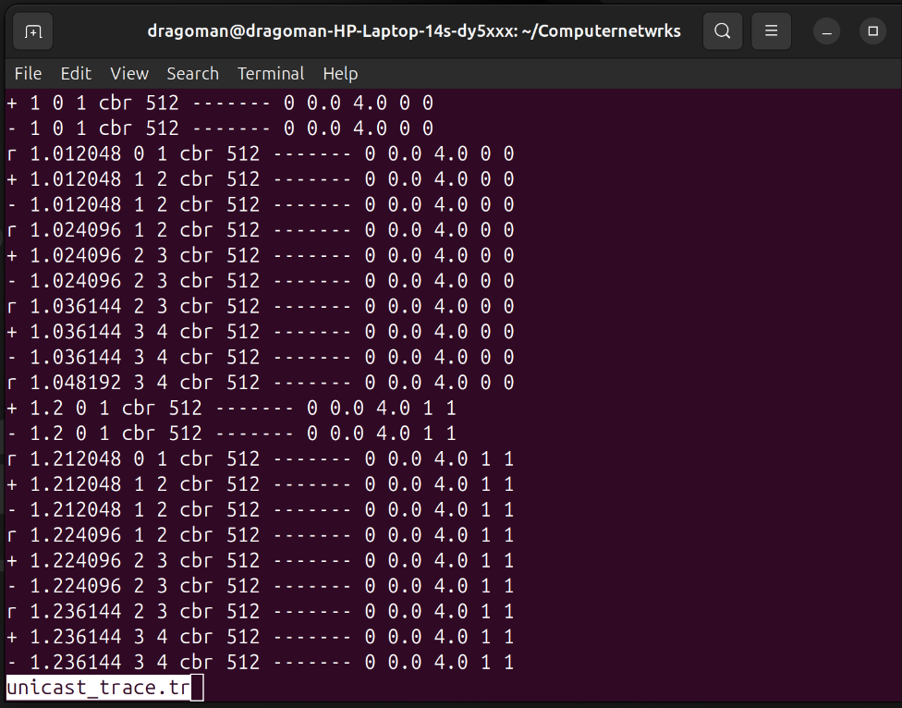

**Result :** Thus to write codes to simulate UCR has been executed successfully.

|  |  |
| --- | --- |
| EX NO: 10 | SIMULATION OF ERROR CORRECTION CODE (CRC) |
| DATE: |

**Aim :** To write codes to simulate error correction codes like CRC.

**Algorithm:**

1. Import necessary java utils.
2. By using notepad, vsc you can structure up the codes .
3. Feed the datasets to codes.
4. Execute it using java commands.
5. Further data updates lead to the great study of ECC.
6. Compile and run the code to observe the outputs.

**Program :**

import java.util.Arrays;

public class CRC {

public static void main(String[] args) {

String[] dataSet = {"1101011011", "1011101", "111000111", "1101011010", "0111110101"};

String generator = "10011";

System.out.println("CRC Error Detection Simulation\n");

System.out.println("Generator Polynomial: " + generator + "\n");

for (String data : dataSet) {

String encodedData = encodeData(data, generator);

System.out.println("Original Data: " + data);

System.out.println("Encoded Data: " + encodedData + "\n");

}

}

// Function to perform XOR operation

static String xor(String a, String b) {

StringBuilder result = new StringBuilder();

for (int i = 1; i < b.length(); i++) {

if (a.charAt(i) == b.charAt(i))

result.append("0");

else

result.append("1");

}

return result.toString();

}

// Function to perform Modulo-2 division

static String mod2div(String dividend, String divisor) {

int pick = divisor.length();

String tmp = dividend.substring(0, pick);

int n = dividend.length();

while (pick < n) {

if (tmp.charAt(0) == '1')

tmp = xor(divisor, tmp) + dividend.charAt(pick);

else

tmp = xor("0".repeat(pick), tmp) + dividend.charAt(pick);

pick += 1;

}

if (tmp.charAt(0) == '1')

tmp = xor(divisor, tmp);

else

tmp = xor("0".repeat(pick), tmp);

return tmp;

}

// Function to encode data using CRC

static String encodeData(String data, String generator) {

int dataLen = data.length();

int generatorLen = generator.length();

String appendedData = data + "0".repeat(generatorLen - 1);

String remainder = mod2div(appendedData, generator);

return data + remainder;

}

}

**Output :**

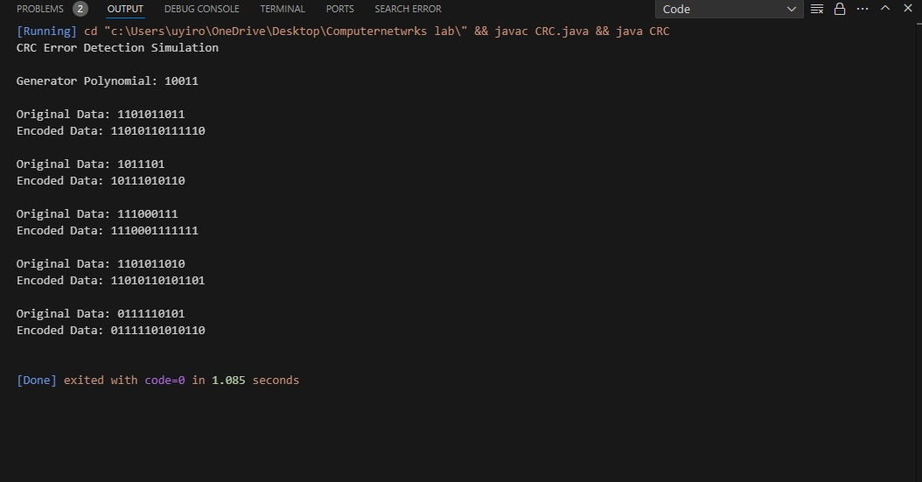

**Result :** Thus to write codes to simulate ECC has been executed successfully.