Student ID:102831215

Name:Dawei Li

# Setup Screenshot

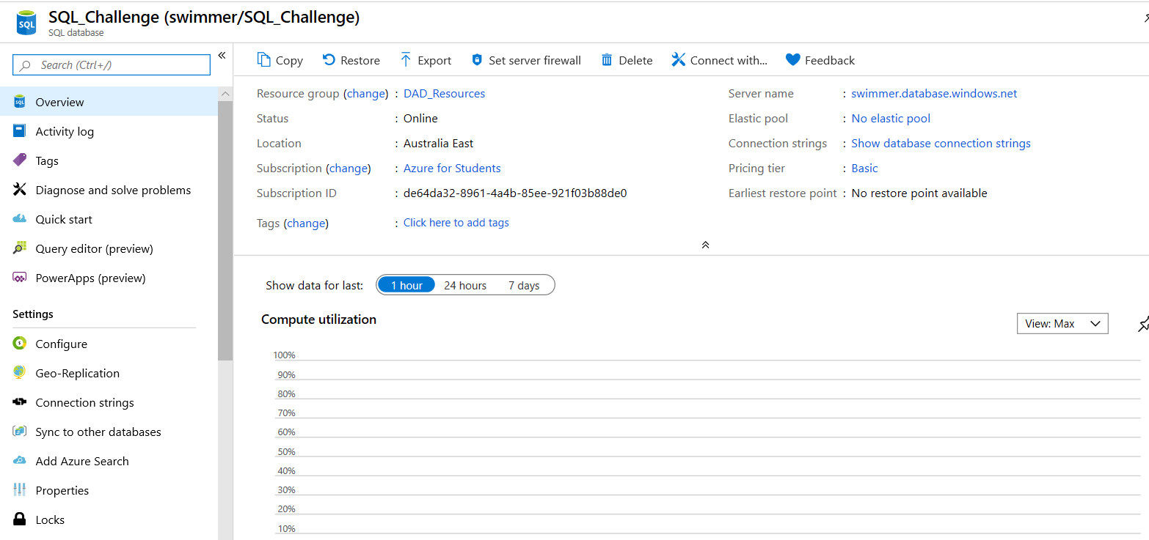

# Task 2 Screenshot

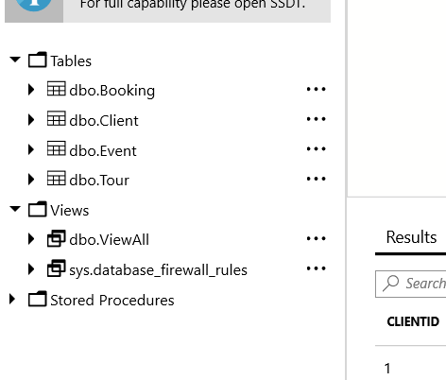

# Task 3 Screenshot

