Student ID:102831215

Name:Dawei Li

# Setup Screenshot

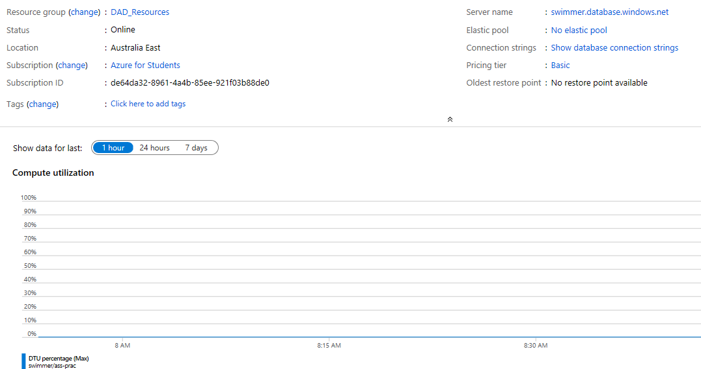

# Task1

Subject(SubjCode, Description)

Tacher(StaffID, Surname, GivenName)

SubjectOffering(Year, Semester, Fee, SubjCode, StaffID)

Foreign Key (SubjCode) References Subject

Foreign Key (StaffID) References Teacher

Student(StudentID, Surname, GivenName, Gender)

Enrolment(DateEnrolled, Grade, Year, Semester, StudentID)

Foreign Key (Year, Semester) References SubjectOffering

Foreign Key (StudentID) References Student

# Task 2 Screenshot

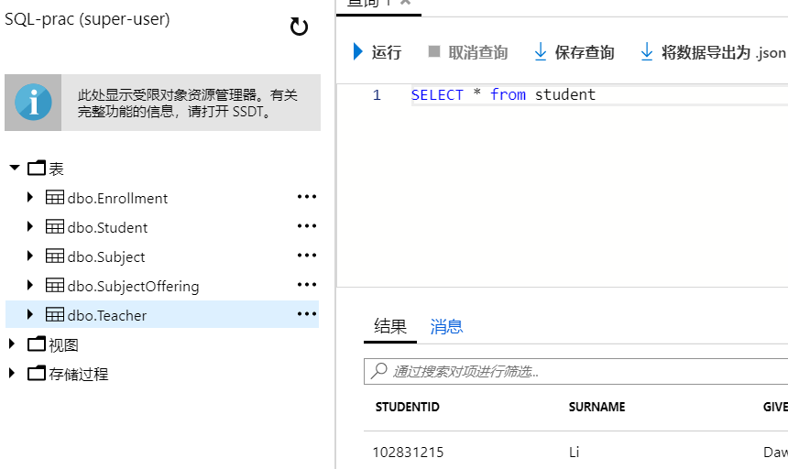

# Task 3 Screenshot

