MULTIMEDIA UNIVERSITY OF KENYA
CCS 2226 - Foundations of Artificial Intelligence
Task Three - Prolog Family Tree
Name: David Osoro Solomon | Reg No: CIT-223-089/2023 | Lecturer: P. Mokodir
Step 1 - Loading the Files
Load both files into SWI-Prolog in this exact order:
?- consult('C:/Users/Admin/family.pl').

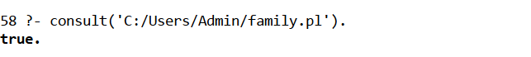

?- consult('C:/Users/Admin/lab2rels.pl').

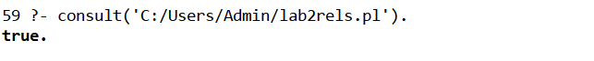

Step 2 - Father and Mother
?- father(X, tom).

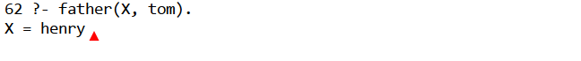

?- mother(X, tom).

Step 3 - Grandparent and Grandchild
Press ; after each answer to get more results.
?- grandparent(X, peter).
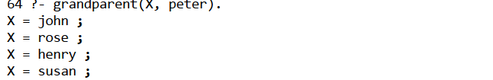

?- grandchild(X, george).

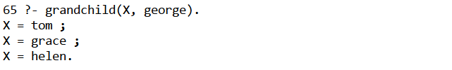

Step 4 - Siblings
?- sibling(X, tom).

?- brother(X, grace).

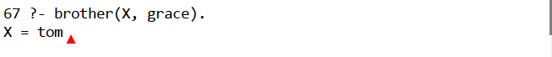

?- sister(X, tom).

Step 5 - Uncle and Aunt
?- uncle(X, peter).

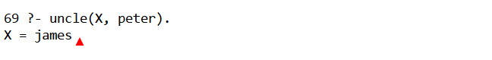

?- aunt(X, peter).

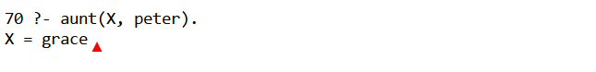

Step 6 - Cousins
?- cousin_list(peter, L).

Step 7 - List Queries Using setof
?- sister_list(tom, L).

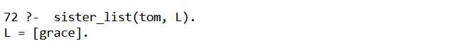

?- brother_list(peter, L).
Expected: L = [david]
[Screenshot here]

?- grandparent_list(peter, L).

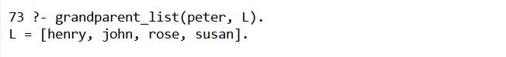

Step 8 - Ancestor and Descendant
?- ancestor(george, peter).

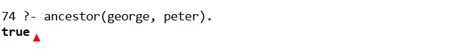

?- descendant(peter, george).

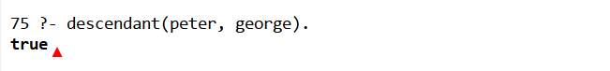

Step 9 - Operator Experiments
?- a = a.

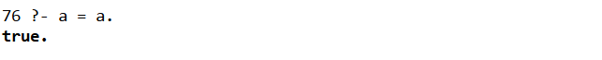

?- X = a.

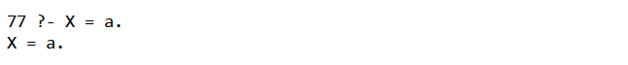

?- a == a.

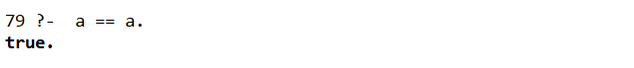

?- a \== b.

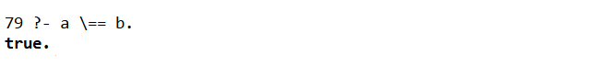

?- diff(a, b).

