8th Mar 2024

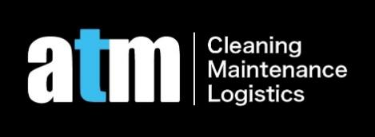

**To: [1202/157 A'Beckett St, Melbourne VIC 3000 Property Agent or Landlord](https://www.realestate.com.au/property/unit-202-609-burwood-rd-hawthorn-vic-3122)**

This is confirmed we received $700 from the renter of above property. The cleaning was conducted in a professional way.

It has included

1. Steam clean of the carpet
2. Steam clean of the mattress
3. Steam clean of the sofa
4. Vacuum clean of carpet
5. Floor boards/Floor tiles mopping
6. Bedroom
7. Bathroom
8. Kitchen(cook top, range hood, sink, floor & cabinet)
9. Microwave
10. Oven
11. Dishwasher
12. Refrigerator
13. Washing machine
14. Dryer
15. Air conditioner
16. Skirting board/Window frame/Wardrobe
17. Blinds
18. Window glasses (single side clean)
19. Balcony with sliding door windows (double sides clean)
20. Wall marks removal
21. Pet hair removal
22. Rubbish removal
23. Mould removal
24. 自定义

It has excluded

1. Steam clean of the carpet
2. Steam clean of the mattress
3. Steam clean of the sofa
4. Vacuum clean of carpet
5. Floor boards/Floor tiles mopping
6. Bedroom
7. Bathroom
8. Kitchen(cook top, range hood, sink, floor & cabinet)
9. Microwave
10. Oven
11. Dishwasher
12. Refrigerator
13. Washing machine
14. Dryer
15. Air conditioner
16. Skirting board/Window frame/Wardrobe
17. Blinds
18. Window glasses (single side clean)
19. Balcony with sliding door windows (double sides clean)
20. Wall marks removal
21. Pet hair removal
22. Rubbish removal
23. Mould removal
24. 自定义

If you have any queries, please do not hesitate to contact us on 0480 025 891

ATM Cleaning

Managing Director Alex Mu