$date$

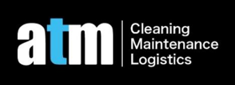

**To: $address$ Property Agent or Landlord**

This is confirmed we received $$amount$ from the renter of above property. The cleaning was conducted in a professional way. It has included$basic_service$ $electrical_appliances$, $other_services$, $rooms$$awa$ $awa_services$.

($excluded_ele$ are excluded).

If you have any queries, please do not hesitate to contact us on 0480 025 891.

ATM Cleaning

Managing Director Alex Mu