**Find-A-Group**

**Software Requirements Specification**

**CEN 3031 Fall 2019**

**Modification history:**

|  |  |  |  |
| --- | --- | --- | --- |
| Version | Date | Who | Comment |
| v1.0 | 10/3/2019 | Cameron, David, Nicholas, Jackson, Darian | Initial Version. Completed section 1. |
| V1.1 | 10/8/2019 | Cameron, David, Nicholas, Jackson | Completed section 2 and 3. |
| V1.2a | 10/10/2019 | Cameron, David, Nicholas, Jackson, Darian | Refined and tested shall statements. Removed vague terms from introduction. |
| V1.3 | 10/24/19 | Cameron, David, Nicholas, Jackson, Darian | Added new use case to UCD.  Added new shall statements 18-20.  Removed unnecessary core statements. |
| V1.4b | 10/31/19 | Cameron, David, Nicholas, Jackson, Darian | Added two new use cases to UCD and reorganized them. |
| V1.5 | 11/7/2019 | Cameron, David, Nicholas, Jackson, Darian | Added new use case to UCD. |
| V2.0 | 11/27/19 | David | Shall statements that described how data was saved were rewritten to show data is stored in text files. |

**Team Name:** 2sday

**Team Members:**

* David Rose, dsrose3626@eagle.fgcu.edu
* Cameron Brien, cbrien0661@eagle.fgcu.edu
* Nicholas Hansen, [nchansen7678@eagle.fgcu.edu](mailto:nchansen7678@eagle.fgcu.edu)
* Jackson Turner, [jbturner6375@eagle.fgcu.edu](mailto:jbturner6375@eagle.fgcu.edu)
* Darian Colon, Dcolon8953@eagle.fgcu.edu

**Contents of this Document**

Introduction

* Software to be Produced
* Definition, Acronyms, and Abbreviations

Product Overview

* Assumptions
* Use Case Diagram
* Use Case Descriptions

Specific Requirements

**SECTION 1: Introduction**

Software to be Produced:

* Our software allows users to find social groups of users with similar interests, and create groups of their own. Users can create profiles with a username and a password. After creating a profile, users can search for groups to join using tags. A user who creates a group will be assigned the role of group leader. The group leader can assign and remove tags to the group they created for users to search and join. The group leader can add group meetings. All group members can view group meetings.

Definitions, Acronyms, and Abbreviations:

* Profile – An object representing the user’s unique identity in the program, containing their ID, username, and password.
* Group - A collection containing many users, tags, and meetings. The group is managed by a group leader.
* Tag – A premade attribute used to represent a hobby or activity that a user may like.
* Group leader – A user who has the authority to add or remove tags and add meetings for the group.
* Group meeting – A location and time where the group members can assemble.
* Group member – A user who has joined a group.

**SECTION 2:** **Product Overview**

Assumptions:

* This program will be run by the Java Virtual Machine.
* The user has both a mouse and keyboard.

Use Case Diagram:

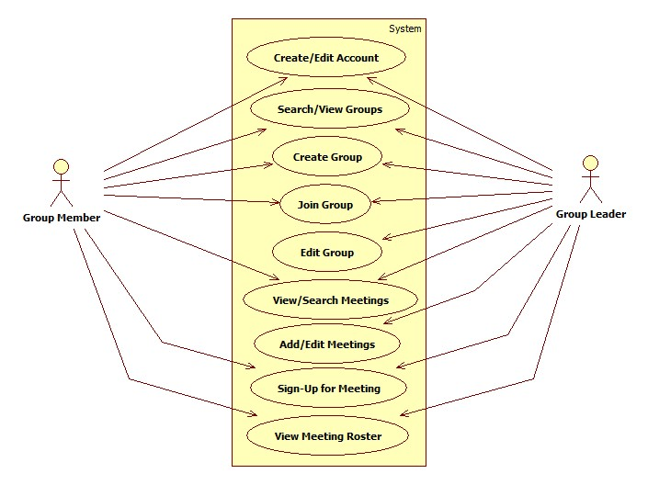

Use Case Descriptions:

* Create/Edit Account – The user will be able to create an account with a username and password.
* Search/View Groups – The user will be able to specify tags to find groups that have those tags and will be able to view those groups in the software.
* Create Group – The user will be able to create a new group object and makes the user who created it the group leader for that group.
* Join Group – The user will be able to join a group after conducting a group search.
* Edit Groups – The group leader will be able to add or remove tags for the group.
* Search/View Meetings – The group member will be able to search for meetings associated with a group, and view selected meeting details.
* Add/Edit meetings – The group leader will be able to create new meetings for a group or changes time or location of an existing meeting.
* Sign-Up for Meeting – The group member will be able to sign-up for meeting attendance.
* View Meeting Roster – The group member will be able to view the roster of attendees of a selected meeting within the leader’s group.

**SECTION 3: Specific Requirements**

|  |
| --- |
| **No:** 1 |
| **Statement:** The system shall create profiles containing a username and password. |
| **No:** 2 |
| **Statement:** The system shall create groups containing system provided tags. |
| **No:** 3 |
| **Statement:** The system shall save usernames, passwords, tags, groups, and profiles using a text file. |
| **No:** 4 |
| **Statement:** The system shall provide the user with a list of preset tags. |
| **No:** 5 |
| **Statement:** The system shall search for groups based on group tags. |
| **No:** 6 |
| **Statement:** The system shall display meetings that take place at a specific time or place. |
| **No:** 7 |
| **Statement:** The system shall designate a user that creates a group as the new group’s leader. |
| **No:** 8 |
| **Statement:** The system shall allow group leaders to edit their group’s meeting dates, times, and locations. |
| **No:** 9 |
| **Statement:** The system shall allow users to log into their profile using their username and password. |
| **No:** 10 |
| **Statement:** The system shall allow group leaders to create meetings. |
| **No:** 11 |
| **Statement:** The system shall save meeting dates, times, and locations using text files. |
| **No:** 12 |
| **Statement:** The system shall allow the user to view the description of the meeting, which is the meeting’s date, time of day, location, host group name and attendees. |
| **No:** 13 |
| **Statement:** The system shall automatically make the group leader who creates a meeting an attendee. |
| **No:** 14 |
| **Statement:** The system shall allow group members to attend a meeting. |
| **No:** 15 |
| **Statement:** The system shall allow group members to cancel attendance to an attending meeting. |
| **No:** 16 |
| **Statement:** The system shall direct the user from the login page to the profile page. |
| **No:** 17 |
| **Statement:** The system shall allow the user to toggle between their profile and group pages. |
| **No:** 18 |
| **Statement:** The system shall categorize group members into two roles: member and leader. |
| **No:** 19 |
| **Statement:** The system shall require the username and password to be composed of at least seven alphanumeric characters. |
| **No:** 20 |
| **Statement:** The system shall allow the group to have a maximum of four tags. |

Template created by G. Walton ([GWalton@mail.ucf.edu](mailto:GWalton@mail.ucf.edu)) on Aug 30, 1999 and last updated Aug 15, 2000; updated by A. Koufakou, Aug 2014

This page last modified by D. Rose ([dsrose3626@eagle.fgcu.edu](mailto:dsrose3626@eagle.fgcu.edu)) on November 27, 2019