**Game of Warstone**

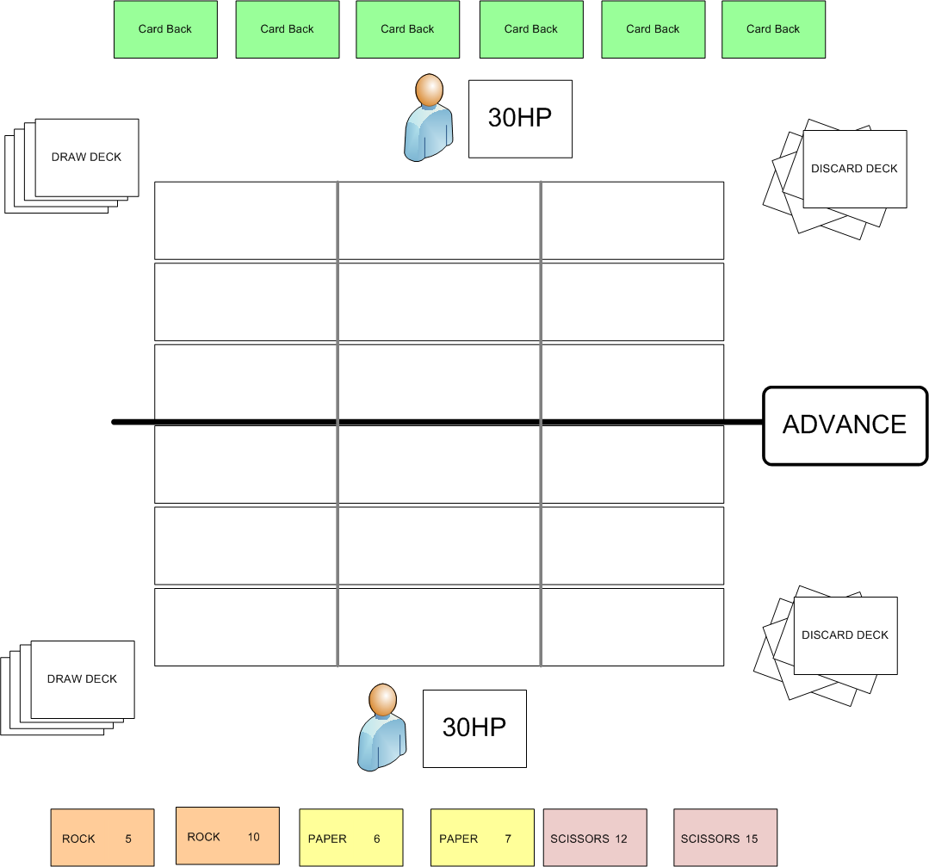

**Each player has a Deck of 33 cards:**

3 suits

* + Rock
  + Paper
  + Scissors

11 Cards in each suit have ranks 5, 6, 7, 8, 9, 10, 11, 12, 13, 14, 15

Spells

* Skip Turn
* Destroy Card
* Double Move (Move a card again after moving it on your turn)
* Shove push one opponent card back one space if there is an empty space behind it

Deck is shuffled.

Each player Draws 6 cards to hand.

**Board:**

* 3 lanes. Left, Center, Right.
* Each lane has 6 cells. 3 on my side 3 on opponent side.
* A thick line in the middle to denote territory
* Advance button
* Each Player has a Health pool (30 hp)

**Player turn:**

* Draw a card
* Place a card from hand in any empty space in your territory (Optional)
* Move any or each of my cards one space **Left, Right or Back** (in any order)
  + Cant move it forward in this action (done later)
  + **Only allowed if there is a free space to move into**
  + Can move even if in enemy territory
* Play a Spell (Optional)
* Trigger Advance (Ends Turn)

**On your turn show which cards can still be moved**

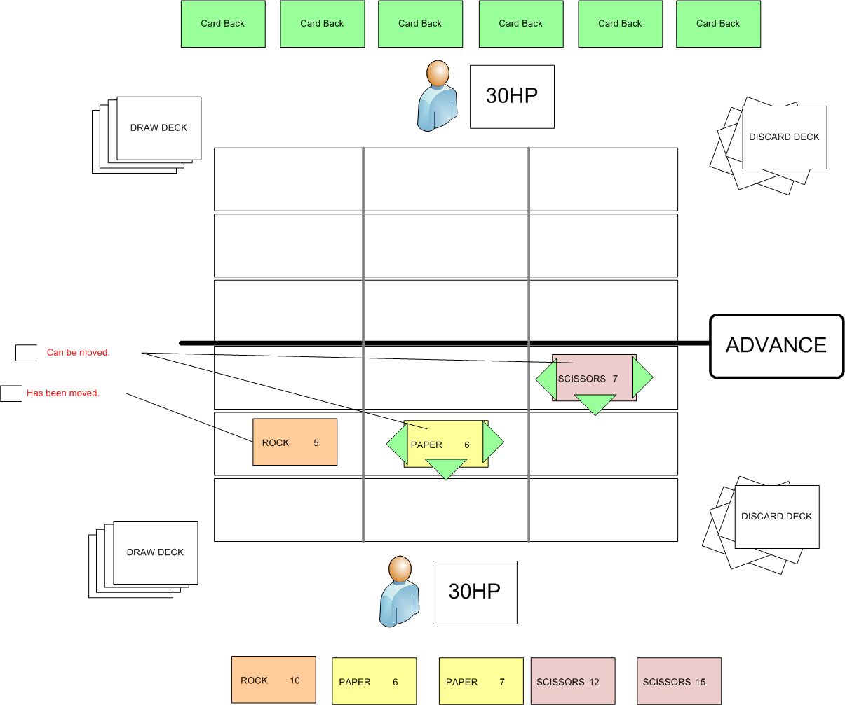

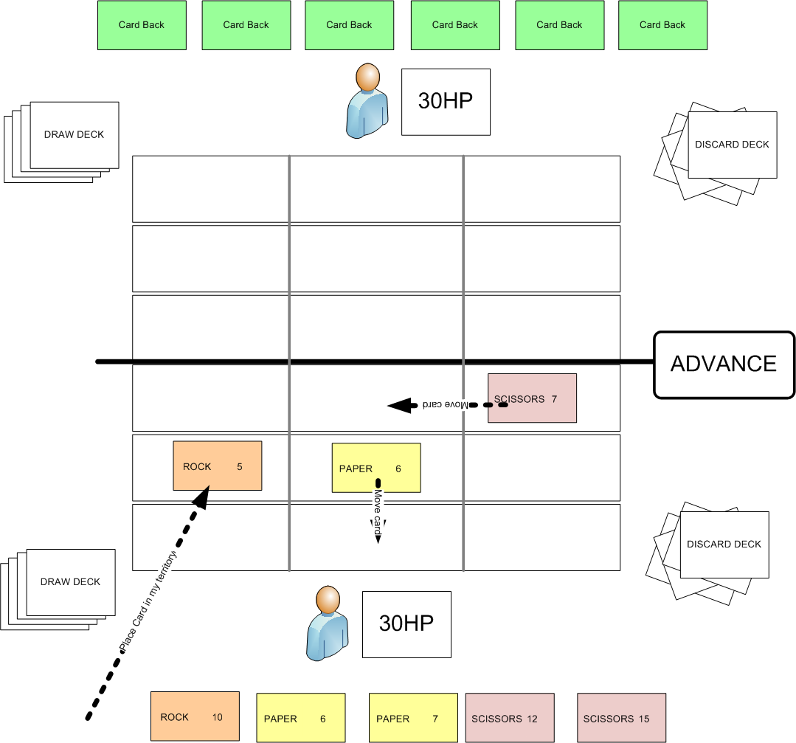

**ADVANCE & Triggering combat:**



When the player presses ADVANCE, starting from the cards closest to the opposing avatar, all of the **attacker’s** cards attempt to move one space forward.

If they cannot move forward, they do combat to opposing creature, or deal damage to the opponent.

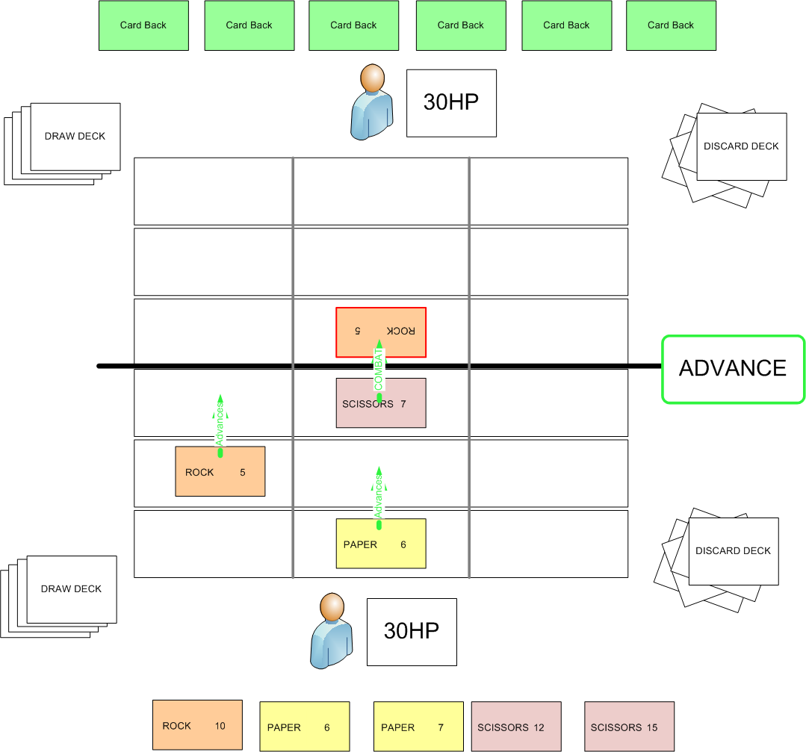

**Combat:**

Creatures of the same Suit deal damage to each other based on their rank.

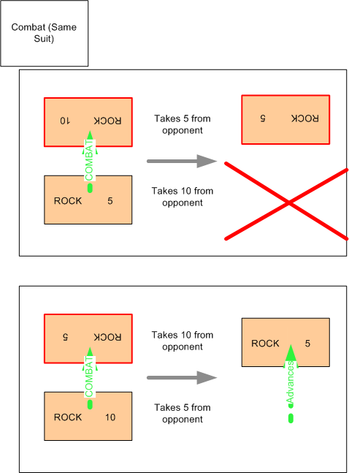

This reduces its rank. When a creature has no hp left, move it to the owner’s discard deck.

**Combat (Mismatched Suits)**

* Paper deals 2x value to Rock, ½ to Scissors
* Rock deals 2x value to Scissors, ½ to Paper
* Scissors deals 2x value to Paper, ½ to to Rock

When ½ points damage, ROUNDUP

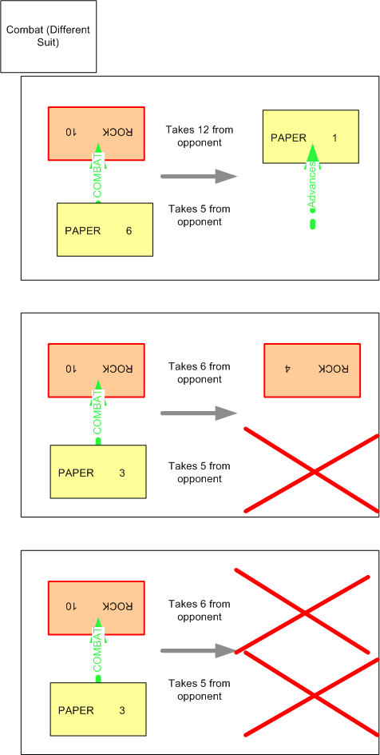

**Combat (Enemy Player)**

If the card attempts to advance into the enemy player, it deals damage to the opponents HP and is sent to the attackers discard deck.

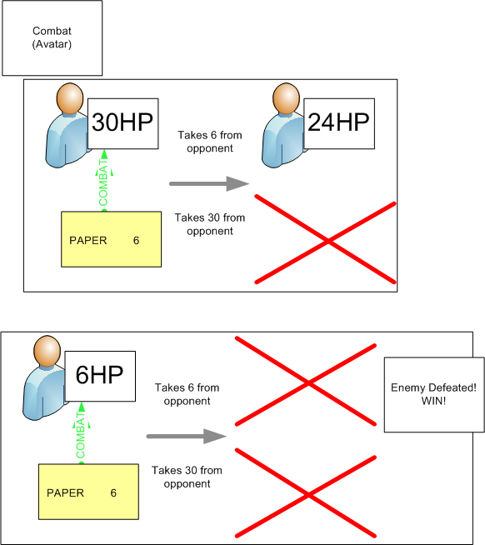

If the opponent reaches 0 HP you win.

After drawing the last card in your deck, reshuffle the discard deck and move it to the Draw Pile.

Play continues until one player wins.