查找

二维有序数组查找定值
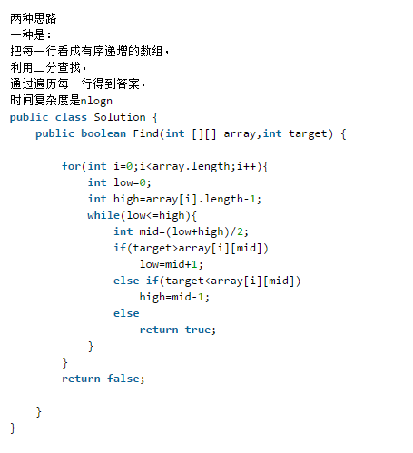
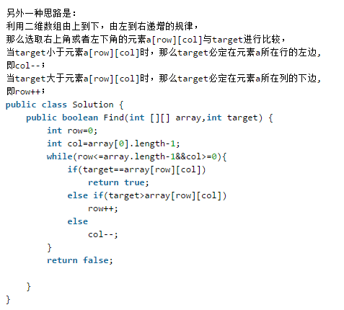

调整奇数偶数顺序
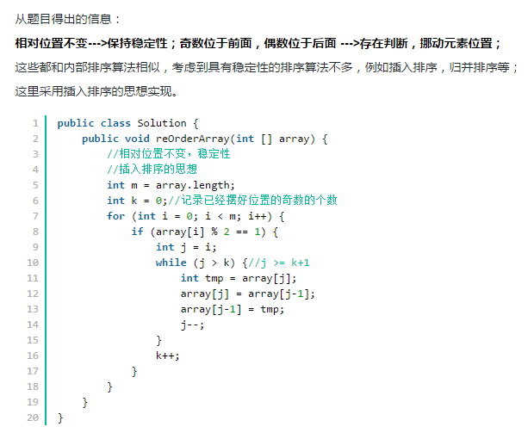

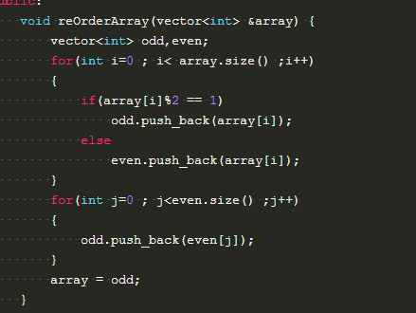

链表

输入一个链表，输出该链表中倒数第k个结点。
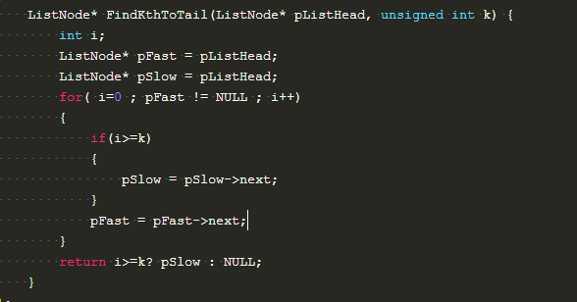

输入一个链表，反转链表后，输出新链表的表头。
迭代：
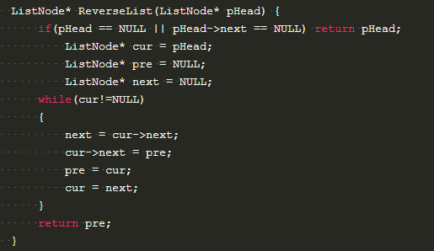

递归
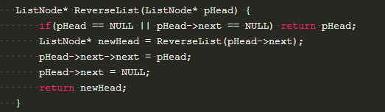

复杂链表的复制

/*
struct RandomListNode {
int label;
struct RandomListNode *next, *random;
RandomListNode(int x) :
label(x), next(NULL), random(NULL) {
}
};
*/
class Solution {
public:
RandomListNode* Clone(RandomListNode* pHead)
{
if(pHead == NULL) return NULL;
RandomListNode* p1 = pHead;
//复制
while(p1 != NULL)
{
RandomListNode* tmp = new RandomListNode(p1->label);
RandomListNode* next = p1->next;
p1->next = tmp;
tmp->next = next;
p1 = next;
}
// RandomListNode* p2 = pHead;
p1 = pHead;
//链接
while(p1!=NULL)
{
if(p1->random != NULL) p1->next->random = p1->random->next;
else p1->next->random =NULL;
p1 = p1->next->next;
}
//拆分
// RandomListNode* p3 = pHead;
p1 = pHead;
RandomListNode* p4 = pHead->next;
while(p1!=NULL)
{
RandomListNode* clone = p1->next;
p1->next = clone->next;
if(clone->next != NULL)
{
clone->next = clone->next->next;
}
else
{
clone->next = NULL;
}
// clone->next = clone->next==NULL? NULL : clone->next->next;
p1 = p1->next;
}
return p4;
}
};

