全排列（含重复字符）
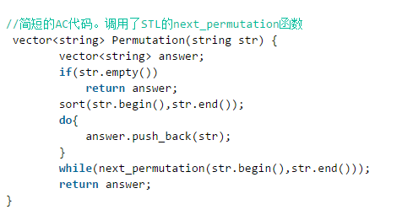
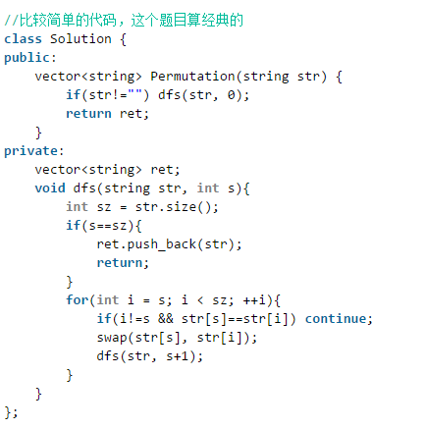

class Solution {
public:
int step;
int len;
int *visit;
vector<string> res;
string str_tmp;
map<string,int> mp;
void dfs(string str,int step)
{
if(step == len)
{
mp[str_tmp]++;
if(mp[str_tmp] == 1)
res.push_back(str_tmp);
}
for(int i=0 ;i<len ; i++)
{
if(visit[i]==0)
{
visit[i] = 1;
str_tmp += str[i];
dfs(str,step+1);
str_tmp.pop_back();
visit[i] = 0;
}
}
}
vector<string> Permutation(string str) {
vector<string> vec;
len = str.length();
if(len<=0) return vec;
visit = new int[len];
memset(visit,0,sizeof(int)*len);
dfs(str,0);
return res;
}
};

把数组排成最小的数

class Solution {
public:
string PrintMinNumber(vector<int> numbers) {
string resstr;
vector<string> num;
string s;
for(int i=0 ; i<numbers.size() ; i++)
{
s = to_string(numbers[i]);
num.push_back(s);
}
sort(num.begin(),num.end(),[](string s1,string s2){return s1+s2 < s2+s1;});
for(int j=0 ; j<num.size() ; j++)
{
resstr += num[j];
}
return resstr;
}
};

