Structure Discussion

Assumption
The Shape interface has been implemented a lot of concrete classes. This part has been developed and reused for long time. Now we need develop some new functions for it, for example getting the type of shapes or some other mathematics functions. However Shape interface do not handle any case which related with mathematics at this moment.

Solutions
According to the assumption I develop new interface hierarchy MathAPI and apply adapter pattern as a bridge to combine them. MathTriangle class is responsible to join the functionalities of those two independent interfaces. If we apply this structure, we need add mathTriangle property inside Triangle class.
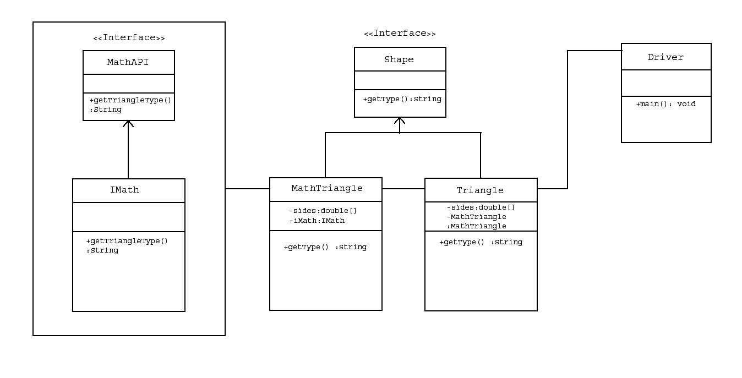

As alternative solution I implement decorator pattern also. TriangleDecorator class wraps the original class and provides new functions. This solution allows us to add new functions without changing the existing structure and classes. If we want to use TriangleDecorator class to access the existing methods, we need to create new method on it and intact existing functions.
