Development Description

Thanks for giving me the opportunity to work on this assignment. Here I would like to give a brief discussion of my design, implementation and testing of the program.

1, Question analysis

This program should be able to determine the type of a triangle. The input is the lengths of the triangle's three sides.

I need to consider this program could be used into larger and more complex problem domains. I assume in the future this program should be able dealing with many different shapes for example square, circle and others. The input could come from many different places, for example web services, cloud servers or Databases. So I think the structure of the program should be extended, at the same time it should be simple, clearly and readable.

2, Program design

2.1 According to the assignment this program will only include one task as follow.

Task 1: Determine triangle type
Start: user input the lengths of the triangle's three sides.
End: get the type of triangle

2.2 Use case

1 Get triangle type
User | Program
input the lengths of sides
(error input: incorrect character and incorrect figure )
Return the type of triangle
(allow user input again)

2.2 UML

To meet the demands of this assignment, I define Shape interface and implement Triangle class. In this way the program could be easily extended to handle many different shapes. When we create a new shape class, we do not need to change the other parts of this program.

I use very simple way to create Driver class, so the program keeps very clearly structure. If the situation becomes more complex in the future, this part could easily be modified.

The program has been separated into Shaper, Loader and Driver three parts. In this way it becomes easier to test.

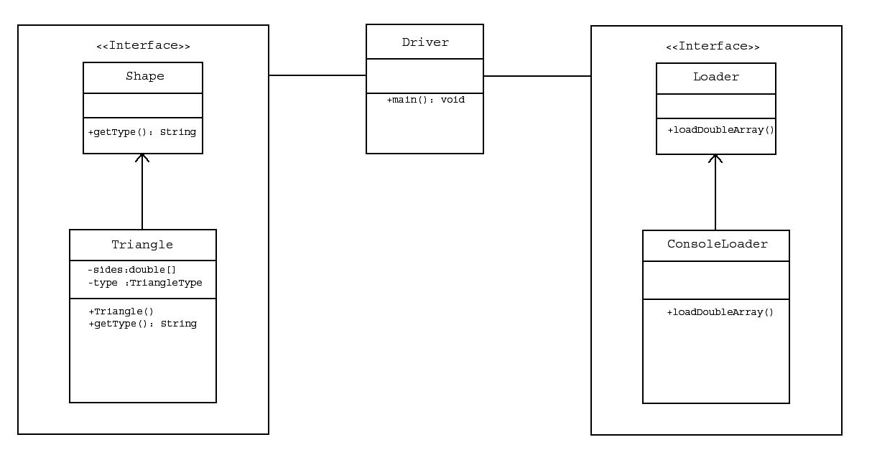

3, Implementation

Triangle type determination is very important during program implementation. After user give positive lengths of three sides, the program should find out whether the triangle is legal. If it is a legal triangle, the program needs to find out if the triangle is equilateral. If it is not, the program should determine it is either isosceles, or scalene.

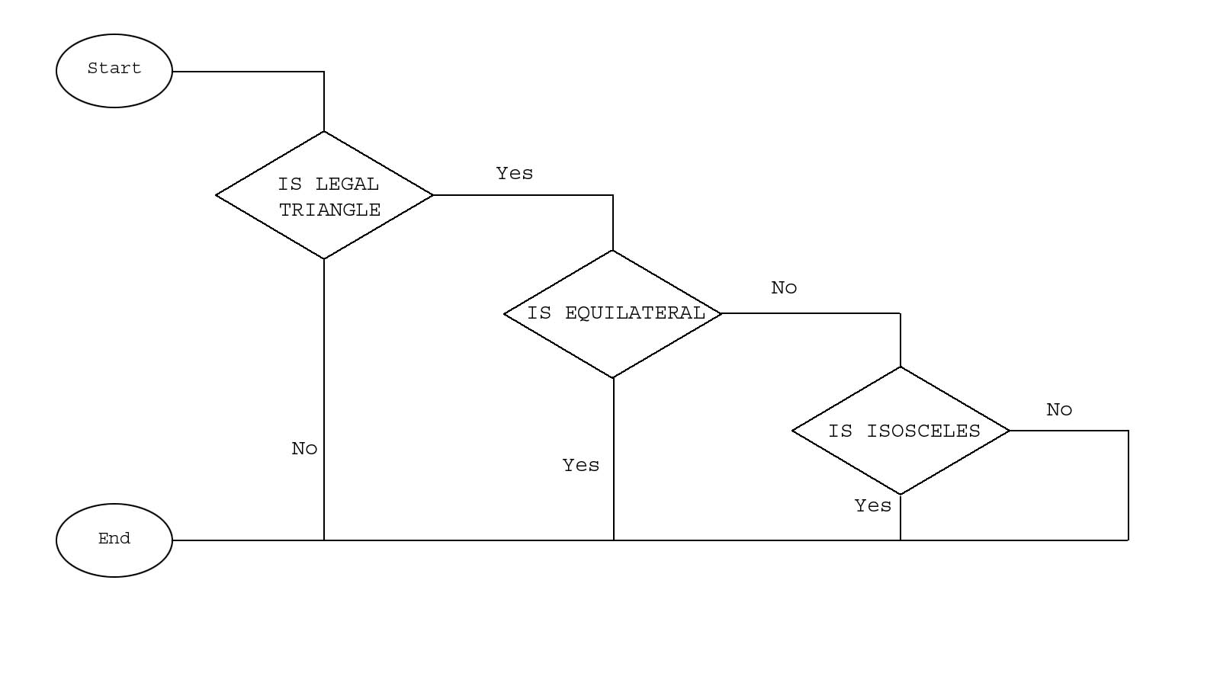

4, Test

Both black-box and white-box testing has been applied in this project.

First I use white-box testing method to test Triangle Type Determination part. It exercises the implementation determineType() method which located in Triangle class. The test cases cause every path to be executed. I have putted the code of unite test in test folder.

The black-box testing has been applied on Loader part, after white-box testing. I review design and define two test cases.

. Input of sides’ lengths with incorrect characters (56cm, 5u, 56)
. Input of sides’ lengths is incorrect figures (-56, 0, 65)

During black-box testing, the input value comes from console, program give correct feedback.

