Unit 4: Selecting Defrules on the Basis of Their

Utilities and Learning these Utilities

Now we will examine how utilities for defrules are computed and used in their selection. We will also look at how these utilities are learned.

4.1 The Theory

Each defrule has a utility associated with it. The utility at the start for a defrule can be set using :INITIAL-UTILITY parameter. For example:

(defrule add (arg1 arg2) :INITIAL-UTILITY 5.0 (+ arg1 arg2))

Utilities for a group of defrules can be assigned using the *iu* parameter. In this unit we will describe how those utilities can be learned from experience. Like activations, utilities have noise added to them. The noise is controlled by the utility noise parameter s which is set with the parameter *egs*. The noise is distributed according to a logistic distribution with a mean of 0 and a variance of

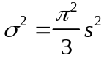

If there are a number of defrules competing with expected utility values Uj the probability of choosing defrule i is described by the formula

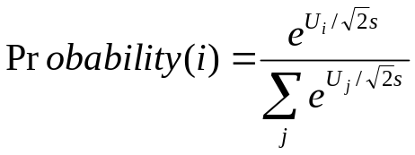

where the summation is over all the defrules which are currently able to run. Note however that the equation only serves to describe the selection process for a defrule. It is not actually computed by the system. The defrule with the highest utility (after noise is added) will be the one chosen to run.

4.2 Building Sticks Example

We will illustrate these ideas with an example from problem solving. Lovett (1998) looked at participants solving the building-sticks problem illustrated in the figure below. This is an isomorph of Luchins waterjug problem that has a number of experimental advantages. Participants are given an unlimited supply of building sticks of three lengths and are told that their objective is to create a target stick of a particular length. There are two basic strategies they can select – they can either start with a stick smaller than the desired length and add sticks (like the addition strategy in Luchins waterjugs) or they can start with a stick that is too long and “saw off” lengths equal to various sticks until they reach the desired length (like the subtraction strategy). The first is called the undershoot strategy and the second is called the overshoot strategy. Subjects show a strong tendency to hillclimb and choose as their first stick a stick that will get them closest to the target stick.
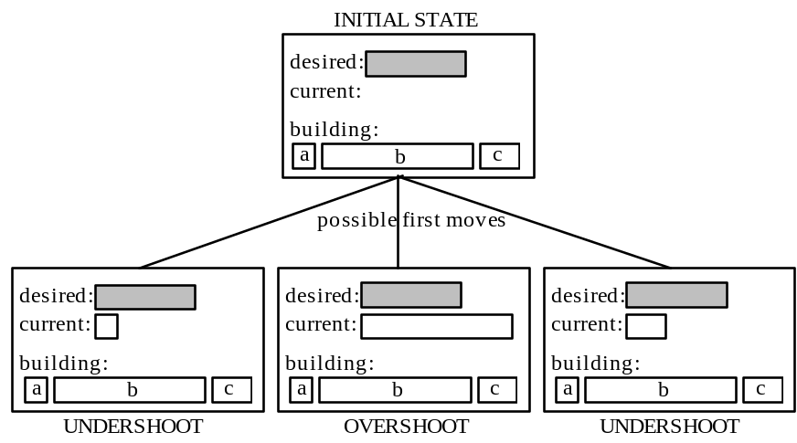

You can go through a run of this by loading the model sticks. By calling the command (do-set) you will run through a set of problems once and it will return a list of two items indicating which strategy, overshoot or undershoot, that you chose first. The output for the run would like the following –

? (do-set)
(OVER OVER OVER OVER OVER OVER OVER UNDER UNDER OVER OVER UNDER OVER OVER OVER)

The behavior of the model is controlled by four defrules that make the decision to apply the overshoot or undershoot strategy.

(defrule decide-over (current A B C G)
:group (choose-strategy-over)
(setq *strategy* 'over)
(if (= current 0)
(setq current B))
(loop while (> current G) do
(cond
((= (- (- current G) C) 0)
(setq current (- current C)))
((= (- (- current G) A) 0)
(setq current (- current A)))
((> (- (- current G) A) (- (- current G) C))
(setq current (- current C)))
((< (- (- current G) A) (- (- current G) C))
(setq current (- current A)))))
current)

(defrule decide-under (current A B C G)
:group (choose-strategy-under)
(setq *strategy* 'under)
(if (= current 0)
(setq current C))
(loop while (< current G) do
(cond
((= (- (- G current) C) 0)
(setq current (+ current C)))
((= (- (- G current) A) 0)
(setq current (+ current A)))
((> (- (abs(- current G)) A) (- (abs(- current G)) C))
(setq current (+ current C)))
((< (- (abs(- current G)) A) (- (abs(- current G)) C)) (setq current (+ current A)))))
current)

(defrule force-over (current A B C G)
:group (choose-strategy-over choose-strategy-under choose-strategy- force)
(setq *strategy* 'over)
(if (= current 0)
(setq current B))
(loop while (> current G) do
(cond
((= (- (- current G) C) 0)
(setq current (- current C)))
((= (- (- current G) A) 0)
(setq current (- current A)))
((> (- (- current G) A) (- (- current G) C))
(setq current (- current C)))
((< (- (- current G) A) (- (- current G) C))
(setq current (- current A)))))
current)

(defrule force-under (current A B C G)
:group (choose-strategy-over choose-strategy-under choose-strategy-force)
(setq *strategy* 'under)
(if (= current 0)
(setq current C))
(loop while (< current G) do
(cond
((= (- (- G current) C) 0)
(setq current (+ current C)))
((= (- (- G current) A) 0)
(setq current (+ current A)))
((> (- (abs(- current G)) A) (- (abs(- current G)) C))
(setq current (+ current C)))
((< (- (abs(- current G)) A) (- (abs(- current G)) C)) (setq current (+ current A)))))
current)

The key information is in the over and under variables which are encoded in the function bst. The over variable encodes the difference in length between stick b and the target stick, and the under variable encodes the difference in length between the target stick and stick c. If one of these differences appears to get the model much closer to the target (more than 25 units of length closer than the other) then the decide-under or decide-over defrules can fire to choose the strategy. In all situations, the other two defrules, force-under and force-over, can apply. Thus, if there is a clear difference in how close the two sticks are to the target stick there will be three defrules (one decide, two force) that can apply and if there is not then just the two force defrules can apply. The choice among the defrules is determined by their relative utilities which we can see by using the show-utilities command:

? (show-utilities)

(FORCE-UNDER . 6.3598742)
(FORCE-OVER . 17.675306)
(FORCE-UNDER . 6.3598742)
(FORCE-OVER . 17.675306)
(DECIDE-UNDER . 18.204895)
(FORCE-UNDER . 6.3598742)
(FORCE-OVER . 17.675306)
(DECIDE-OVER . 19.999996)
"Compiled rules not shown."
NIL

The initial utility values are set by the :initial-utility parameter in the model:

defrule decide-over (current A B C G) :initial-utility 13

defrule decide-under (current A B C G) :initial-utility 13

defrule force-over (current A B C G) :initial-utility 10

defrule force-under (current A B C G) :initial-utility 10

The :initial-utility parameter for the force defrules are set to 10 while they are set to a more optimistic 13 for the decide defrules. The (show-utilities) command shows the last computed utility values for the defrules in the event of a selection and includes the effect of utility noise. Thus, we see that even though the true utility for decide-over is 13 it had a utility of 19.999 the last time it was ready to be selected for running. Unless a defrule is explicitly assigned a value for its initial utility, it is given a default value of 0. Therefore, the above four defrules are the only ones in the model with non-zero values.

Let us consider how these defrules apply in the model. Suppose the difference between the under and over differences is 35 units of length, there will be one decide and two force defrules that will match in that scenario. Let us consider the probability of choosing each defrule according to the equation.

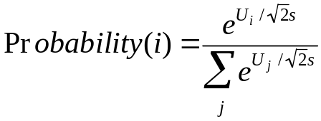

In the model, the parameter s is set at 3. First, consider the probability of the decide defrule:

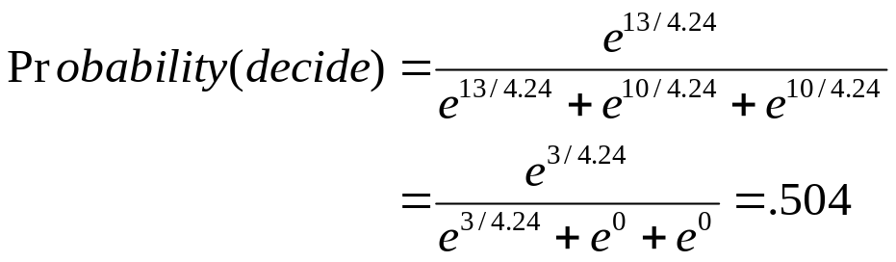

Similarly, the probability of the two force defrules can be shown to be .248. Thus, there is a .248 probability that a force defrule will fire that has the model try to solve the problem in the direction other than it appears.

4.3 Utility Learning

So far we have only considered the situation where the defrule parameters are static. The utilities of rules (defrules) can also be learned as the model runs based on rewards that are received by the model. Utility learning is updated according to a simple integrator model (e.g. see Bush & Mosteller, 1955).. If U_{i}(n-1) is the utility of a rule i after its n-1st application and R_{i}(n) is the reward the rule receives for its nth application, then its utility U_{i}(n) after its nth application will be

Difference Learning Equation

where α is the learning rate and is typically set at .2 (this can be changed by adjusting the *alpha* parameter with the setq command). This is also basically the Rescorla-Wagner learning rule (Rescorla & Wagner, 1972). According to this equation the utility of a rule will be gradually adjusted until it matches the average reward that the rule receives.

There are a couple of interesting issues about the reward itself. Rewards occur at various times not necessarily associated with any rule -- for instance, in the case of a monkey it may press a button and receive a squirt of juice a second later. A number of expressions may have been executed before the reward is delivered. The reward R_{i}(n) that rule i will receive will be the external reward received minus the time from the rule’s selection to the reward. This serves to give less reward to more distant rules.

4.4. Learning in the Building Sticks Task

The following are the percent choice of overshoot for each of the problems in the training set from an experiment with a building sticks task reported in Lovett & Anderson (1996):

Lovett, M. C., & Anderson, J. R. (1996). History of success and current context in problem solving: Combined influences on operator selection. Cognitive Psychology, 31, 168-217.

a b c Goal %OVERSHOOT
15 250 55 125 20
10 155 22 101 67
14 200 37 112 20
22 200 32 114 47
10 243 37 159 87
22 175 40 73 20
15 250 49 137 80
10 179 32 105 93
20 213 42 104 83
14 237 51 116 13
12 149 30 72 29
14 237 51 121 27
22 200 32 114 80
14 200 37 112 73
15 250 55 125 53

The majority of these problems look like they can be solved by undershoot and in some cases the unit difference in lengths is greater than 25. However, the majority of the problems can only be solved by overshoot. The first and last problems are interesting because they are identical and look strongly like they are undershoot problems. It is the only problem that can be solved either by overshoot or undershoot. Only 20% of the participants solve the first problem by overshoot but after the sequence of problems this rises to 53% for the last problem.

The model sticks is the one that simulates this experiment. The values of utilities for the defrules at the start of the experiment look like this:

? (show-utilities)

(FORCE-UNDER ACT-UP::RULE-IU 10)
(FORCE-OVER ACT-UP::RULE-IU 10)
(FORCE-UNDER ACT-UP::RULE-IU 10)
(FORCE-OVER ACT-UP::RULE-IU 10)
(DECIDE-UNDER ACT-UP::RULE-IU 13)
(FORCE-UNDER ACT-UP::RULE-IU 10)
(FORCE-OVER ACT-UP::RULE-IU 10)
(DECIDE-OVER ACT-UP::RULE-IU 13)
"Compiled rules not shown."

The following is the performance of the model on a 10000 simulation run:

? (collect-data 10000)
CORRELATION: 0.633
MEAN DEVIATION: 25.178

Trial 1 2 3 4 5 6 7 8 9 10
11 12 13 14 15
55.43 67.50 69.64 70.23 86.55 51.83 72.30 73.60 57.26 55.
84 51.57 49.14 64.17 65.74 52.90

NIL

If you print out the utility values for the defrules after the experimental run you will see that the two over defrules have increased utility while the under defrules have a drop off. On average, the force-over defrule has a slightly higher value than the decide-under defrule. It is this change in values that creates the increased tendency to choose the overshoot strategy.

4.5 Learning in a Probability Choice Experiment

Your assignment is to develop a model for a "probability matching" experiment run by Friedman et al (1964). The experiment to be implemented is very simple. The basic procedure, which is repeated for 48 trials, is:

1. The subject is to be presented with an option of choosing between heads and tails.
2. The subject selects heads or tails
3. A feedback as to what the correct answer, either "Heads" or "Tails", is given to the subject.

Friedman et al arranged it so that heads was the correct choice on 10%, 20%, 30%, 40%, 50%, 60%, 70%, 80%, and 90% of the trials (independent of what the participant had done). For your experiment you will only be concerned with the 90% condition. Thus, your experiment will be 48 trials and “Heads” will be the correct answer 90% of the time. We have averaged together the data from the 10% and 90% conditions (flipping responses) to get an average proportion of choice of the dominant answer in each block of 12 trials. These proportions are 0.66, 0.78, 0.82, and 0.84. This is the data that your model is to fit. Note, this is not the percentage of correct responses – the correctness of the response does not matter. Your model must begin with a 50% chance of saying heads, then rapidly adjust its probabilities so that it averages close to 66% over the first block of 12 trials, and increase to about 84% by the final block. You will run the model through the experiment many times (resetting before each experiment) and average the data of those runs for comparison. As an aspiration level, this is the performance of the model that we wrote, averaged over 100 runs:

? (collect-data 100)
CORRELATION: 0.930
MEAN DEVIATION: 0.027
Original Current
0.660 0.647
0.780 0.824
0.820 0.820
0.840 0.811
NIL

In achieving this, the parameters we worked with were the noise in the utilities (set by the *egs* parameter) and the rewards associated with successful and unsuccessful predictions.

