UML Class Diagrams
Class diagrams are the backbone of almost every object-oriented method including UML.
They describe the static structure of a system.
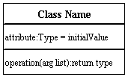 | 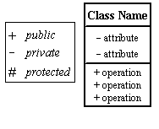
Association:  (Uni-directional, Bi-directional)  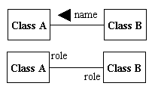 | 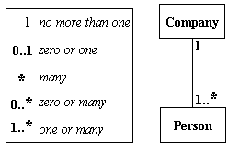
Composition: Aggregation:  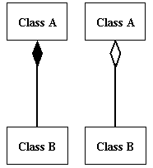 | Inheritance:  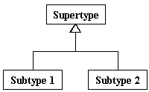

UML Package Diagrams
Package diagrams organize the elements of a system into related groups to minimize dependencies among them.
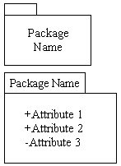 | 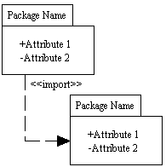

UML Use Case Diagrams
Use case diagrams model the functionality of a system using actors and use cases. Use cases are services or functions provided by the system to its users.

System  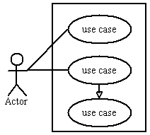 | Use Case Actor  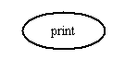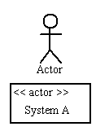
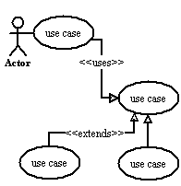 | Relationships  Illustrate relationships between an actor and a use case with a simple line. For relationships among use cases, use arrows labeled either "uses" or "extends." A "uses" relationship indicates that one use case is needed by another in order to perform a task. An "extends" relationship indicates alternative options under a certain use case.  Learn how to draw relationships.

