# Chrome Developer Tools

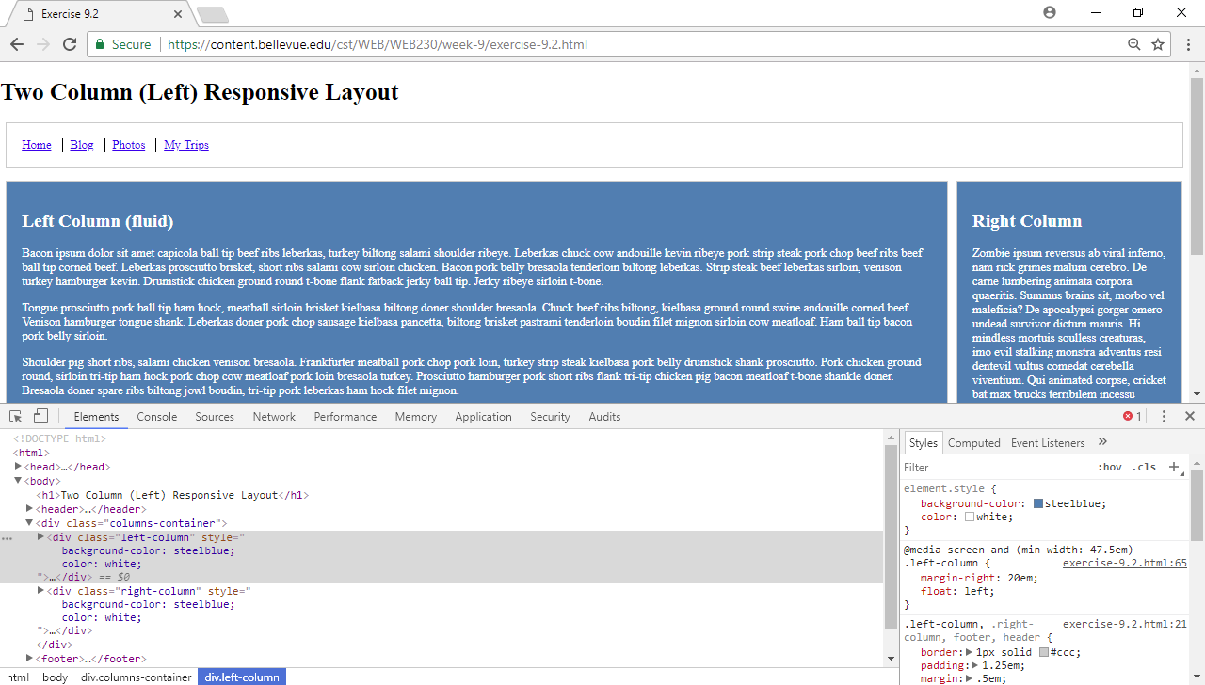

In order to change the elements of a webpage using the Chrome developer tool, you can press ‘f12’ at the top right side of the keyboard and the debugger console will appear. At the top left hand side of the console that opened you’ll see a tab labeled elements. If you are not on that tab, you should select it and select the button farthest to the left at the top of the debugger that has an arrow pointer on it. This button allows you to select an element of the page by clicking directly on it. Click on the section of the left column that makes the whole columns background get highlighted. On the right side of the debugger window, you will see the defined styles for the element that you clicked. Above those style is text that says ‘element.style{ }’. Click the mouse pointer in between the curly braces and you can type in your style definitions. In this case you can point your mouse to the right of the curly braces, and you should see three dots. If you hover over these dots, four icons will appear. If you click the icon that says ‘Add background-color’, your cursor will appear in the proper area waiting for you to define the background color. Do so, and repeat these steps for the ‘color’ of the left-column (icon that says ‘Add color’, and repeat all of the steps when styling the right column.