# Firefox Developer Tools

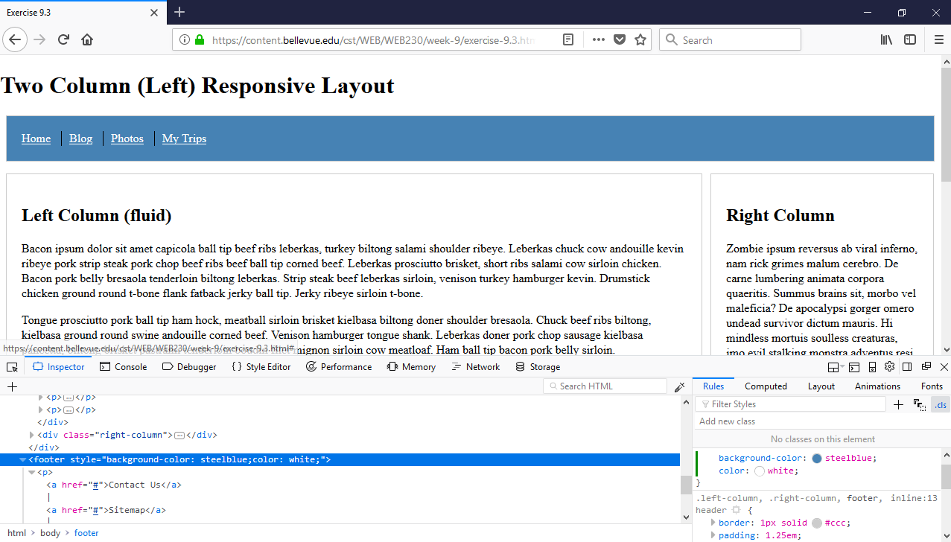

You can open a web page in Firefox and press the ‘f12’ button on the top right side of the keyboard to show the developer tool window. Once this window is visible, click on the tab labeled ‘Inspector’ that is located at the top left side of the developer tool window. Click the button to the left of the ‘Inspector’ tab that has a pointer arrow. Hover over the top navigation menu until the whole header container is highlighted and the tool tip says header. Once the header is highlighted, click on it and look to the bottom right side of the developer tool window for ‘element{ }’. Once located, click in between the curly braces and type ‘back’. Suggestions will appear under the entry box. Press the down arrow until ‘background-color’ is selected and press ‘Enter’. Your cursor will move to another input box in which you specify the color you desire (steelblue). Press ‘Enter’.

To modify the footer, you will repeat these steps starting with re-selecting the button on the top left side of the developer tool window that has the mouse pointer arrow. After you have changed the background color and pressed the ‘Enter’ button, your cursor will move down to another entry box in which you can specify another property (color), and after you press enter your cursor will move to the value box in which you can specify the color you desire (white).

Now we need to add a new rule for the ‘<a href>’ elements for our link font color. Click on the arrow to the left of the <footer> tag in the source code in the left window. Expand the <p> element by clicking the arrow next to the ‘<p>’ tag. Select the line that has ‘<a href=”#”>’. Below the ‘Animations’ tab at the top right side of the right window, there is a button that has the text ‘+’. Click that button to add a new rule. The cursor will appear in the right-side window again, in a input box with the letter ‘a’ highlighted. Press the tab button (or click the mouse pointer in between the curly braces again) and you will type the name of the property you want to change (‘color’). Press ‘Enter’ and the cursor will move to the right and it is there where you will specify the value (‘white’) to associate with the property you defined previously.