# Using Chrome Developer Tools

Step-by-step instructions on how one might set break points and "walk-through" a JavaScript application (include screen captures)

1. Open your application with the chrome browser.
2. Press the f12 button at the top of the keyboard.
3. Click on ‘sources’ located at the top of the window that appeared at the bottom of the screen as a result of pressing the f12 key.

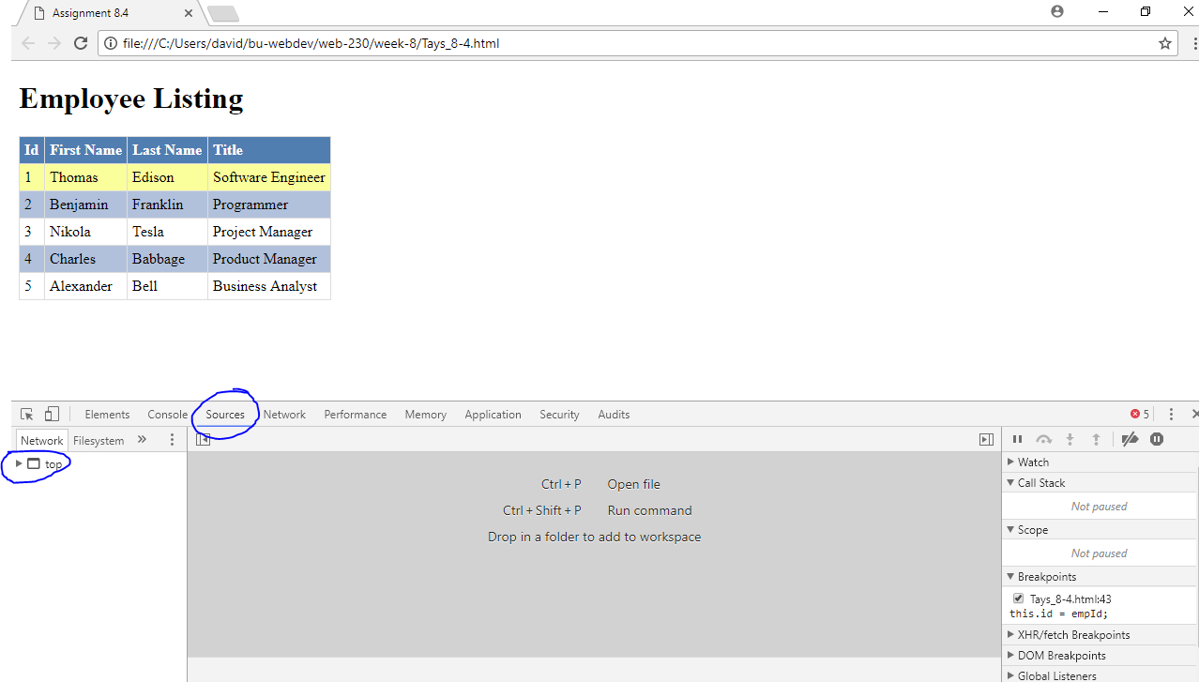

1. Find and select your file. On the left hand side of the developer window the filesystem is displayed, in which you can expand the folders and locate your html file that contains the javascript you would like to step through.

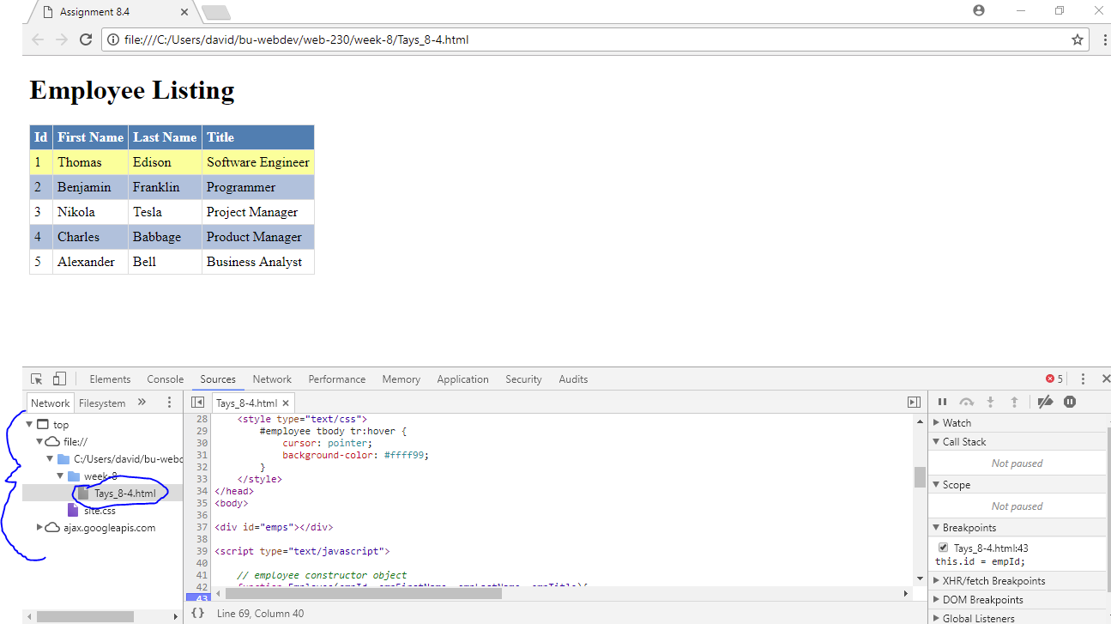

1. Locate the line of code you would like to break (pause) at and click on the line number that it is on.

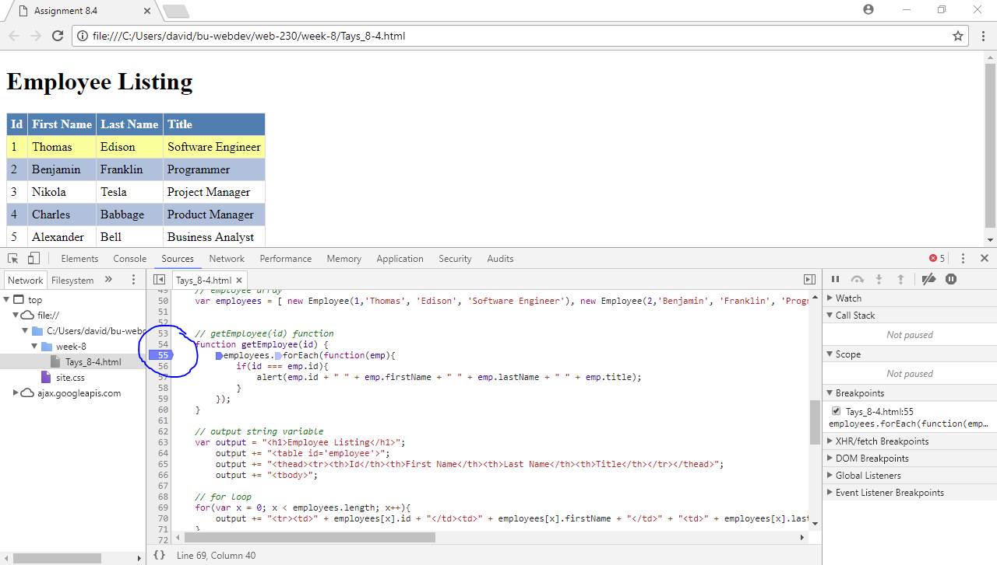

Step-by-step instructions on how one might log and read messages from the JavaScript console window (include screen captures)

1. Repeat the steps for setting a breakpoint at an area that has values being set to variables or object properties.
2. Click ‘console’ that is located to the left of ‘sources’ at the top of the developer window.
3. Type: console.log(‘hello world’);

Use the value inside the parentheses instead of ‘hello world’.

1. Press ‘enter’ on your keyboard to display the value

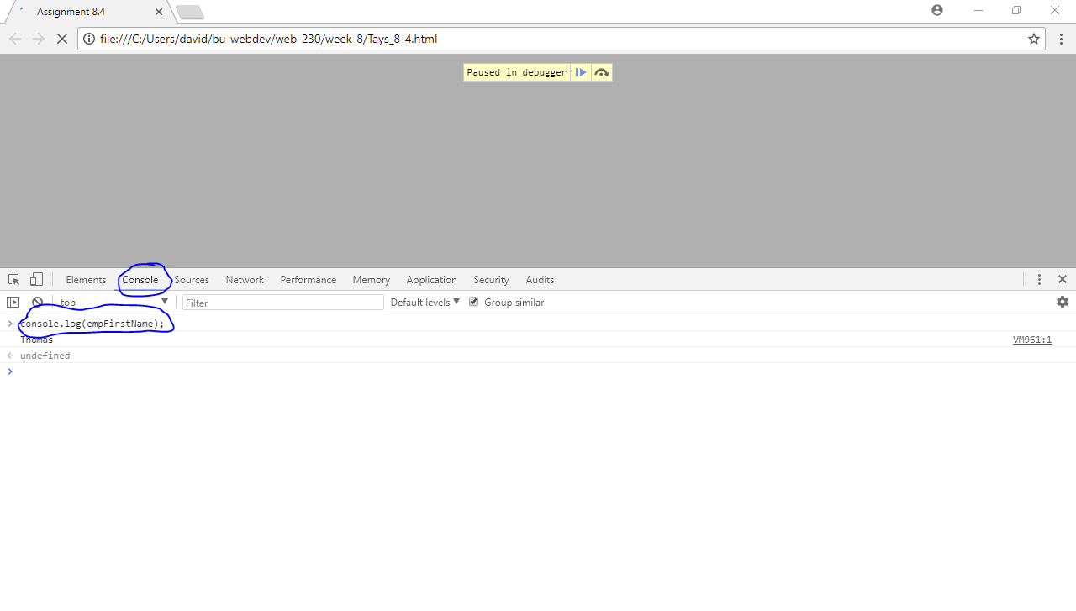

Step-by-step instructions on how one might select HTML elements in the JavaScript console window (include screen captures)

1. Click ‘console’ at the top of the developer window.
2. Type console.dir(document.getElementById(‘theID’).innerHTML);
3. Press ‘Enter’ on your keyboard to display the markup and values.

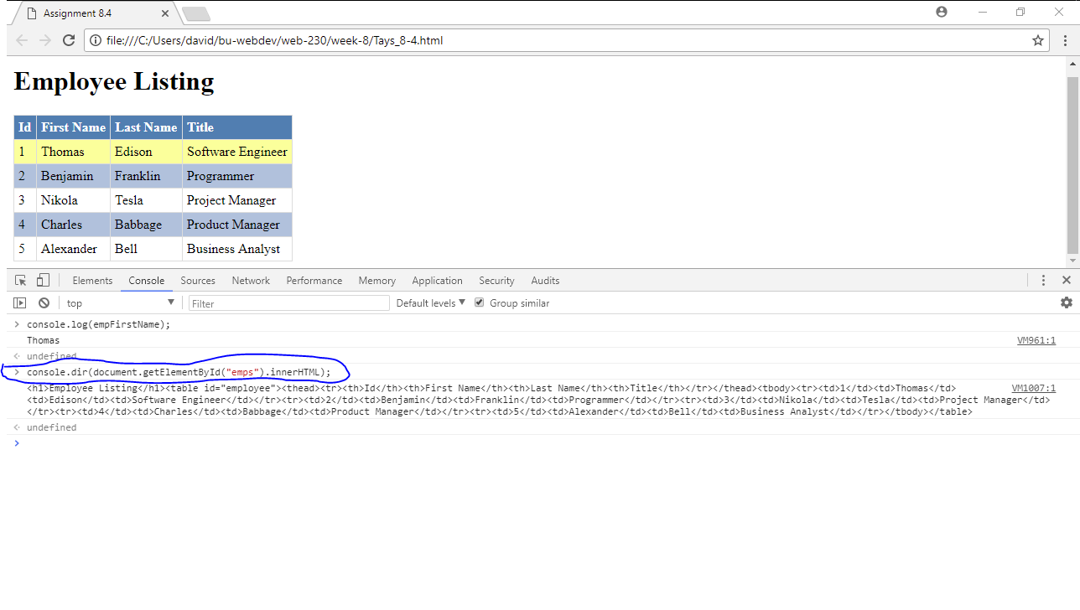

Step-by-step instructions on how one might simulate CSS states (hover, focus) on live HTML elements (include screen captures)

1. Open a webpage with the Chrome browser.
2. Press f12 on your keyboard
3. Click ‘elements’ at the top of the developer window that is now displayed
4. Right-click on the line of code that declares the element you want to force into a state

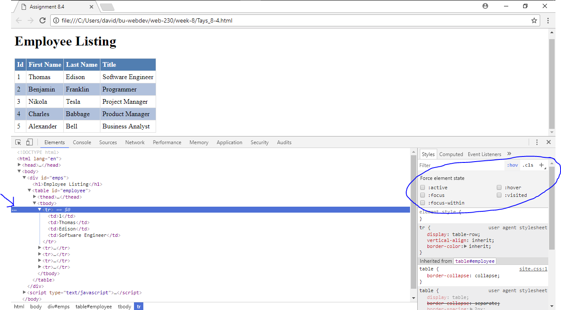

1. Hover over force state, and select the state that you desire.

