1. Introduction
   1. Purpose  
      A learning management system for internal employees. The system will present learning material to a user and quiz them over the material. The system provides individual quiz summaries and a cumulative summary.
   2. Terminology  
      I felt like this would be best completed after the TDD is mostly complete, as I have not included much terminology that needs explained yet.

1.3 User Personas

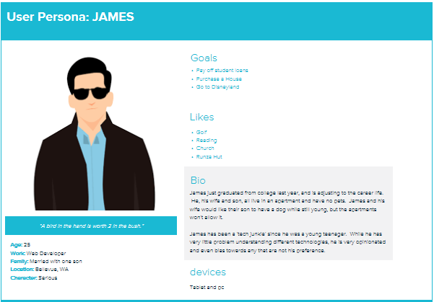

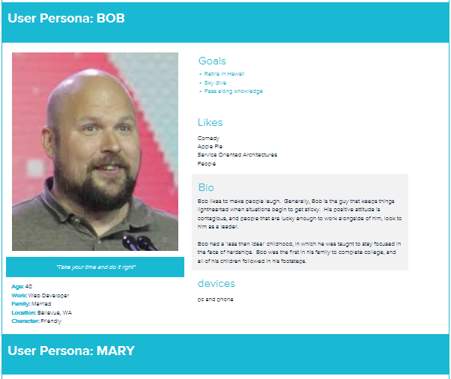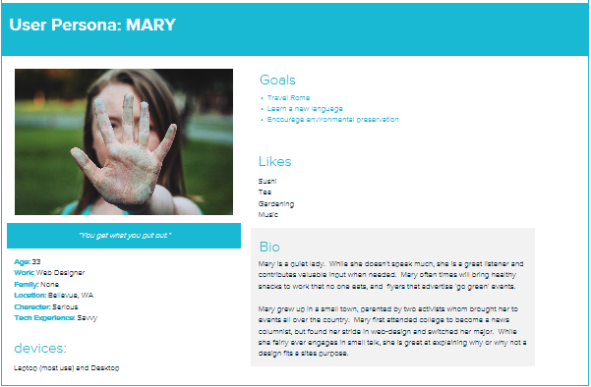

1.4 User Stories

1. Bob
   1. As an administrator, I want to access quiz scores per user, so that I can evaluate a user’s level of experience. (create a view that displays quizzes per user)
   2. As an administrator, I want to be able to add quizzes to application, so that I can rotate or integrate new quizzes. (create crud functionality)
   3. As an administrator, I want the application to be intuitive, so that I don’t have to do much training before subjecting employees to the quizzes. (Create home page toolbar)
   4. As an administrator, I want the application ran internally, so that I can use the company’s authentication service. (Create users model)
   5. As an administrator, I would like the application to look professional on any device, so that employees can take quizzes or check scores from phones, tablets or desktop devices. (integrate material design)
2. Mary
   1. As a user, I want to login before taking a quiz, so that I am credited for the quizzes that I’ve taken. (Create login view)
   2. As a user, I want the ability to logout, so that my scores are not available to passersby. (create logout view)
   3. As a user, I want a summary of accumulative quizzes, so that I can reflect on my progress. (filter quizzes by user id)
   4. As a user, I want text to be contrast to the backgrounds, so that I can easily read the content in different lighting. (Use industry standards e.g. Material design themes)
   5. As a user, I want to be able to view a presentation twice if needed, so that I can be prepared for the quiz. (Create presentations, create presentation view)
3. James
   1. As a user, I want to be able to view a single quiz from a previous date, so that I can pinpoint my own progress. (create view)
   2. As a user, I want my quiz scores to only be available to myself and bosses, so that my progress is private. (create admin privileges)
   3. As a user, I want to be able to go forward and backward in a quiz, so that I can skip a question and come back if needed. (create prev and next buttons)
   4. As a user, I would like notified if I forget to answer a question, so that I do not turn in incomplete quizzes. (create quiz validation)
   5. As a user, I would like the questions included in my quiz summary, so that I know what questions I got correct or incorrect. (Create quiz review and summary with summary)

1.5 Time Estimations

Cumulative summary view 3hrs  
 Create CRUD functionality 6hrs  
 Create Toolbar 1hr  
 Create Login view 2hrs  
 Create Login functionality 2hrs  
 Create Logout view 1hr  
 Create Logout functionality 2hrs  
 Create Summary view 3hrs  
 Create Summary filter 3hrs  
 Create presentations 2hrs  
 Create presentations view 2hrs  
 Create quiz validations 6hrs  
 Create database 3hrs  
 Create tests 3hrs

2. Process Design

2.1 Prototypes

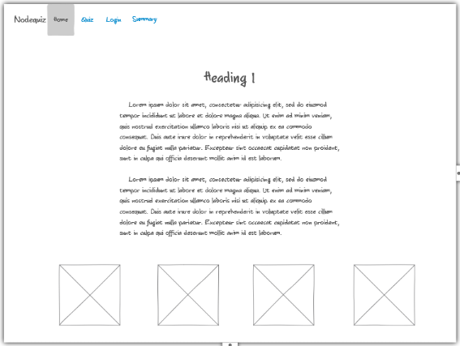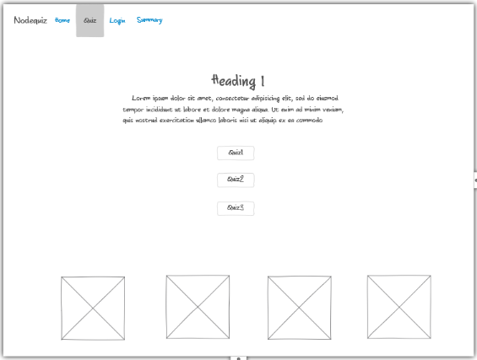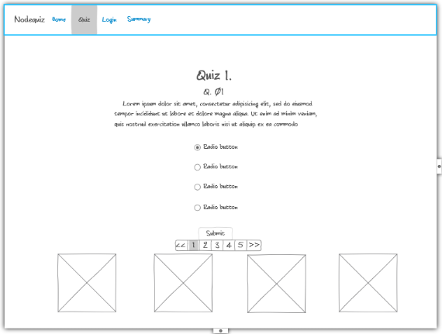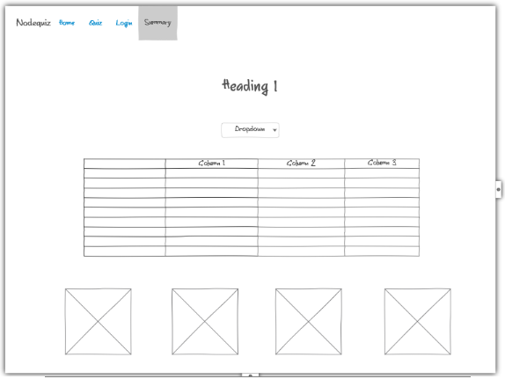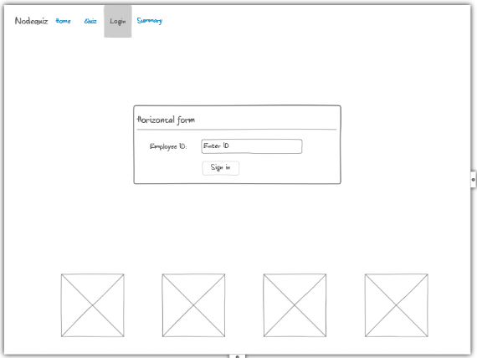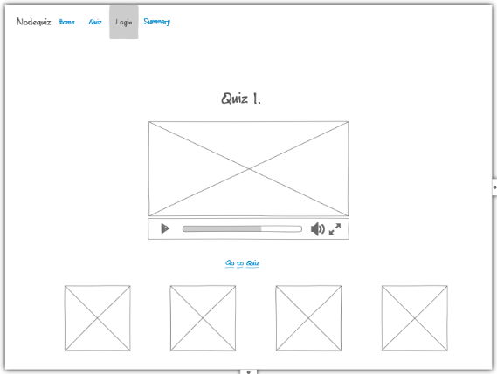

2.2 ORD (Object Relational Diagram(s)  
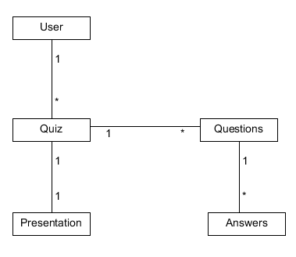

2.3 NoSQL Document Diagram

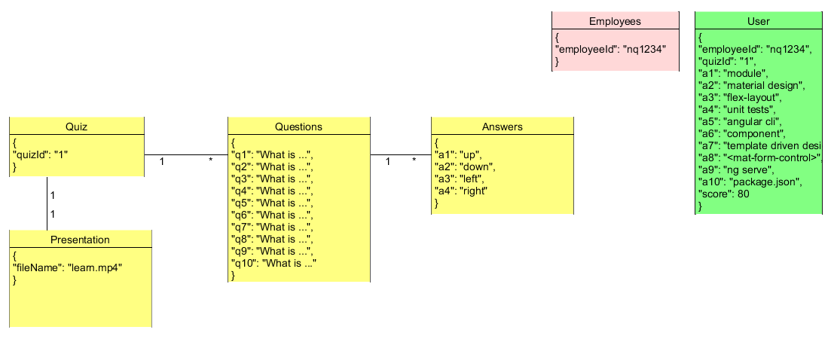

2.4 NoSQL data structure

{

"quizzes":[

{

"quizId": "1",

"title": "Two Pizza Team",

"questions": [

{"q1": "According to the presentation, how many pizzas should it take to feed the size team that is recommended?",

"answers": [

{"a1": "4"},

{"a2": "1"},

{"a3": "6"},

{"a4": "2"}]},

{"q2": "Individuals that may sit back or rely on the other members of the team to get things done are accused of :",

"answers": [

{"a1": "clowning around"},

{"a2": "over-achieving"},

{"a3": "being bossy"},

{"a4": "social loafing"}]},

{"q3": "Associated with participation in a large team, an individual may feel like there is a lack of support, this is referred to as:",

"answers": [

{"a1": "long-distance relationship"},

{"a2": "another day in paradise"},

{"a3": "relational loss"},

{"a4": "tragic"}]},

{"q4": "A solution to relational loss is friendly meetings, but they should be held very seldom.",

"answers": [

{"a1": "friendly meetings do not help"},

{"a2": "friendly meetings help, but should be held often"},

{"a3": "true"},

{"a4": "friendly meetings should be held once a year"}]},

{"q5": "Another solution is to personalize. The presentation lists three ways to do this. Select the answer that is not mentioned in the presentation.",

"answers": [

{"a1": "follow each other on social media"},

{"a2": "play games"},

{"a3": "host holiday parties"},

{"a4": "schedule work trips"}]},

{"q6": "Contributing is another way to battle relational loss.",

"answers": [

{"a1": "true"},

{"a2": "false"},

{"a3": "this is not mentioned"},

{"a4": "relational loss is good"}]},

{"q7": "Who coined the term two-pizza team, according to the presentation?",

"answers": [

{"a1": "Bill Gates"},

{"a2": "Nikola Tesla"},

{"a3": "Jeff Bezos"},

{"a4": "Fusajiro Yamauchi"}]},

{"q8": "Select the option that he does not claim. Bezos claims that small teams help to eliminate three things: ",

"answers": [

{"a1": "management struggles"},

{"a2": "misinterpretations"},

{"a3": "hidden costs"},

{"a4": "security breaches"}]},

{"q9": "1",

"answers": [

{"a1": "1"},

{"a2": "1"},

{"a3": "1"},

{"a4": "1"}]},

{"q10": "1",

"answers": [

{"a1": "1"},

{"a2": "1"},

{"a3": "1"},

{"a4": "1"}]}

],

"filename": "Two-Pizza Rule.mp4"

},

{ … }, { … }

]

}

//in employees

{

"employeeId": "nq1234"

}

{

"employeeId": "nq1235"

}

{

"employeeId": "nq1236"

}

{

"employeeId": "nq1237"

}

{

"employeeId": "nq1238"

}

//in user

{

"userId": "nq1234",

"quizzes": [

{"quizId": "1",

"a1": "module",

"a2": "material design",

"a3": "flex-layout",

"a4": "unit tests",

"a5": "angular cli",

"a6": "component",

"a7": "template driven design",

"a8": "<mat-form-control>",

"a9": "ng serve",

"a10": "package.json",

"score": 80},

{"quizId": "1",

"a1": "module",

"a2": "material design",

"a3": "flex-layout",

"a4": "jasmine",

"a5": "angular cli",

"a6": "component",

"a7": "template driven design",

"a8": "<mat-form-control>",

"a9": "ng serve",

"a10": "package.json",

"score": "90"

}]

}{“quizId”: “2”,

…

}

]

]

}

3. QA Testing

3.1 QA Test Plan

Purpose

**Detail**:

* Testing checks for components presence
* Testing checks for proper component content

Scope

This wiki details the testing that will be performed by the project team for the Nodequiz project. It defines the overall testing requirements and provides an integrated view of the project test activities. Its purpose is to document:

* What will be tested

Ownership

Testing summary

Scope of Testing

**In Scope**

The items in scope are form related. The tags and content of the components will be tested.

**Out of Scope**

Authentication is out of scope for these tests

3.2 Unit Tests