Lab 04 — Developer Productivity with Claude
Code walkthrough of 04_developer_productivity/ — Claude Agent SDK app that explores codebases with tools, MCP, subagents, hooks and a scratchpad.

1. What this lab builds
An interactive CLI agent (main.py) that answers questions about a sample Python e-commerce app located in storefront/. The agent is built on top of claude-agent-sdk and combines five orthogonal capabilities:
- Built-in tools: Read, Write, Edit, Grep, Glob — the primitives for exploring code.
- MCP server (docs): an in-process tool called lookup_docs that searches mock project documentation in data.py.
- Explore subagent: a read-only agent with an isolated context, used for multi-file analysis.
- Hooks: PreToolUse / PostToolUse log every tool call in real time.
- Scratchpad: scratch.md persists findings across runs so prior exploration is not wasted.

2. Architecture overview
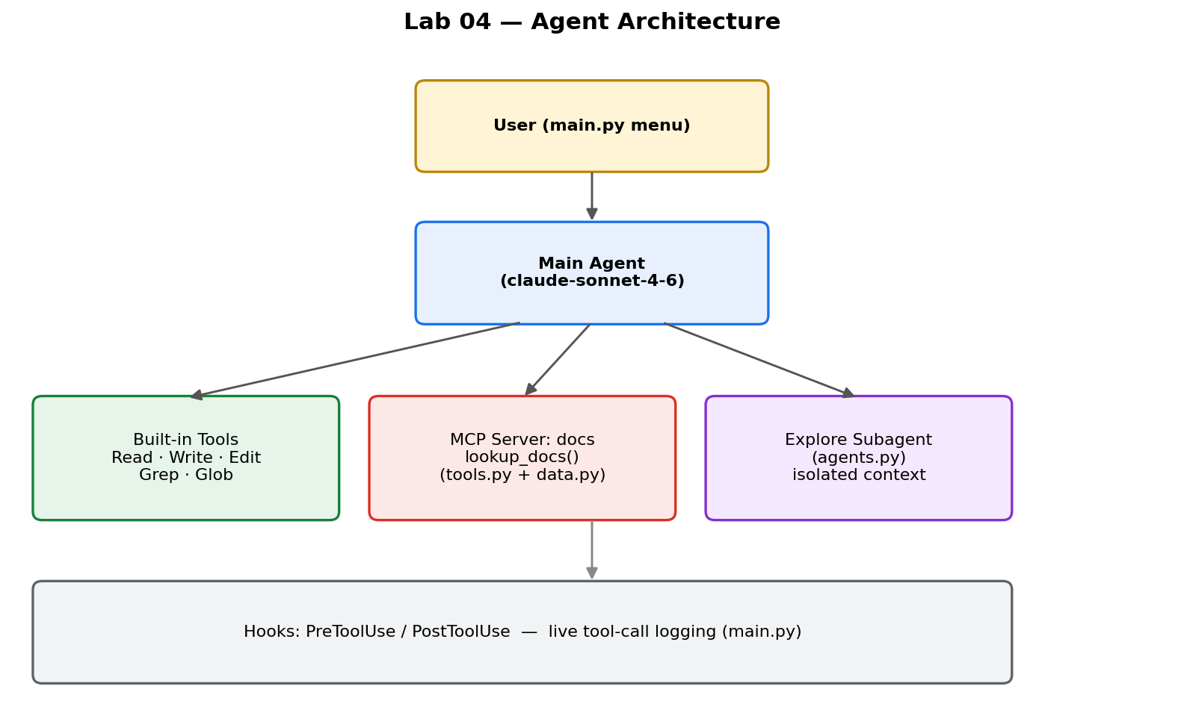
The main agent sits between the user and three specialised workers: built-in filesystem tools, the docs MCP server, and the explore subagent. Hooks wrap every tool call for observability.

3. Request lifecycle
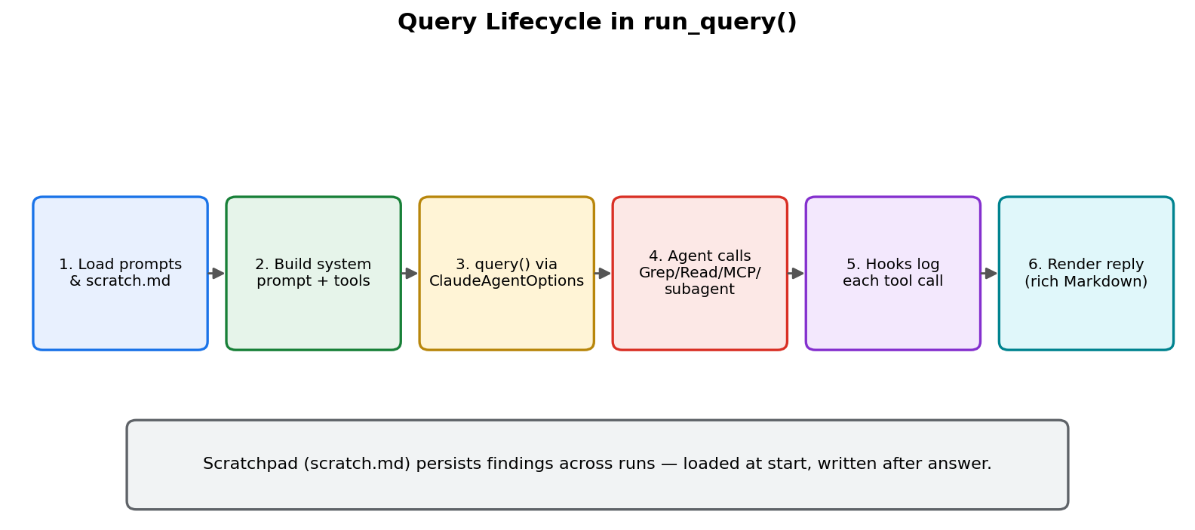
Every question flows through run_query() in main.py. The function assembles the system prompt, registers tools/hooks/subagents, then streams the agent reply through rich Markdown.

4. File-by-file walkthrough

main.py — orchestration
- load_prompt() reads prompts/system_prompt.txt and substitutes four placeholders: scratchpad content, scratchpad instructions, MCP-tool guidance, and explore-subagent guidance.
- on_pre_tool_use / on_post_tool_use are async hook callbacks. They print a coloured one-line summary for each call — spawning a subagent, invoking an MCP tool, or running Grep/Read/etc. They return {"continue_": True} to let the call proceed.
- display_message() renders assistant text with rich.Markdown and demotes API-error strings into a _last_api_error buffer so the CLI shows a friendly message instead of a stack trace.
- run_query() is the core loop. It builds ClaudeAgentOptions with model=claude-sonnet-4-6, allowed_tools, the docs MCP server, hooks, permission_mode="bypassPermissions", max_turns=10 and effort="low" — then iterates query(...) and pipes each message into display_message.
- The interactive main() prints a menu of six preset questions (find tests, trace validate_email, refactor middleware.py, etc.) and also accepts free-form questions.

agents.py — Explore subagent
Exposes build_explore_agent() which returns a dict {"explore": AgentDefinition(...)}. The description is what the main model reads to decide when to delegate; the prompt is loaded from prompts/explore_agent.txt. A TODO in the file asks you to restrict tools=["Read", "Grep", "Glob"] so the subagent cannot write or spawn sub-subagents.

tools.py — MCP documentation server
Defines a single SDK tool with the @tool decorator: lookup_docs(query). It scores each entry in DOCS by how many query words match the concatenated title+section+content, returns the top three as JSON, and is wrapped with create_sdk_mcp_server(name="docs", ...) in main.py. The tool description is deliberately detailed so the agent chooses it over Grep for documentation-style questions.

data.py — mock documentation corpus
A Python list of dicts with five docs: Architecture, API reference, Onboarding, Testing conventions, and Known tech debt. This is what lookup_docs searches.

storefront/ — the codebase under investigation
A small layered Python app: app.py (business logic), models.py (validate_email, format_currency), utils.py (re-exports from models), api/routes.py (endpoints), api/middleware.py (auth + rate-limit). The tests/ directory holds unit tests.

prompts/
- system_prompt.txt — the main system prompt. Uses four format placeholders and explicitly teaches tool selection and incremental exploration.
- explore_agent.txt — the subagent system prompt, which defines the investigation-report output format.

config.py, manage.py, _manage/
config.py holds ANSI colour codes. manage.py has two commands: restart resets files to _manage/starter/ (TODOs intact, scratch.md deleted), and solve copies _manage/solved/ on top (completed versions).

5. Lab progression (what the TODOs add)
- Step 4 — MCP docs server: enhance tool description, build create_sdk_mcp_server, register it in mcp_servers, add mcp__docs__lookup_docs to allowed_tools.
- Step 5 — Explore subagent: register AgentDefinition, restrict its tools, add Agent to allowed_tools, teach the main prompt when to delegate.
- Step 6 — Scratchpad: read scratch.md at start of run_query and instruct the agent to append findings after answering.
- Step 7 — .claude/commands/explore.md: package the whole flow as a reusable slash command with context:fork so it runs in an isolated scratch workspace.

6. Running it
python -m venv .venv
.venv\Scripts\activate
cp .env.example .env # add ANTHROPIC_API_KEY
pip install -r requirements.txt
python main.py
Pick a number from the menu or type a free-form question. Scratchpad findings accumulate in scratch.md. Use python manage.py restart to reset; python manage.py solve to apply the reference solution.

7. Rate-limit note
The default org rate limit for Opus is 30K input tokens/minute, which this lab can exceed on larger queries. main.py now pins the model to claude-sonnet-4-6 which has its own quota. Swap to claude-haiku-4-5-20251001 for the cheapest/fastest option.

Tip: to turn this file into a Google Doc, upload it to Google Drive and pick "Open with → Google Docs". All images and headings are preserved.

