Sentiment Analysis – Lightning talk – Data Science Cornwall - 28th March 2019

David Trethewey

Using NLTK in Python and visualisation in matplotlib

I focused on the game reviews.

sentiment of the words
The sentiment of a number of words is given in a lexicon in nltk.sentiment.vader.SentimentIntensityAnalyzer

Hutto, C.J. & Gilbert, E.E. (2014). VADER: A Parsimonious Rule-based Model for
Sentiment Analysis of Social Media Text. Eighth International Conference on
Weblogs and Social Media (ICWSM-14). Ann Arbor, MI, June 2014.

Checking the methodology
is a naive equivalance of more positive words = positive review accurate?
does it look different when you move from a global view to a per review view?

all lexicon words in each review

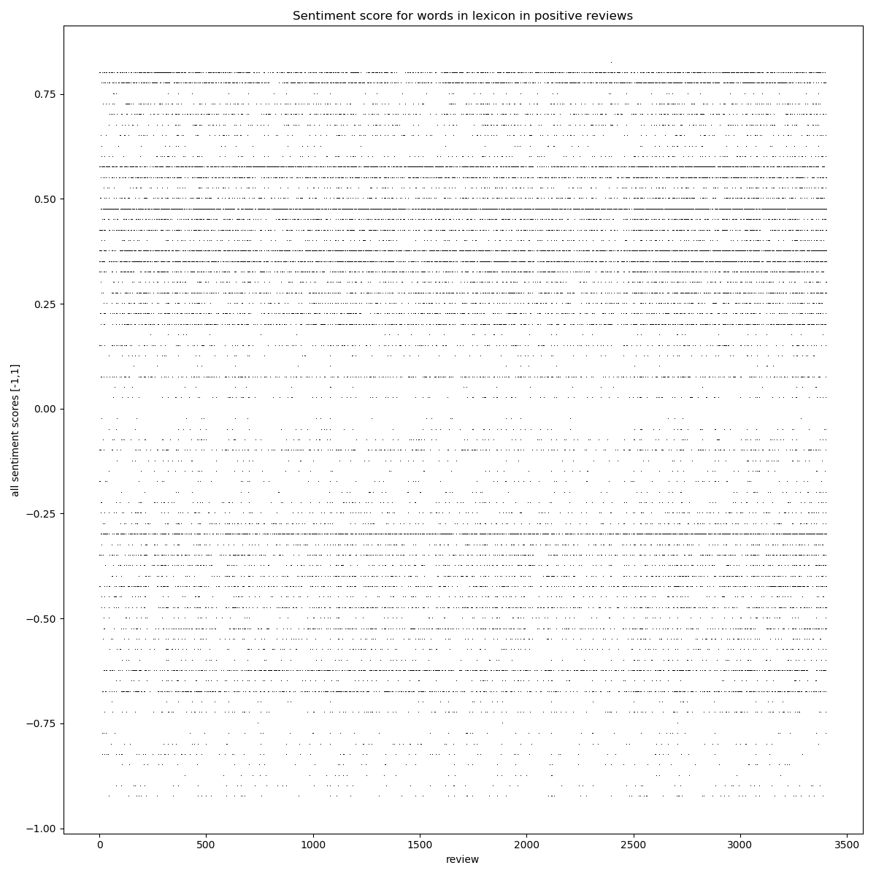

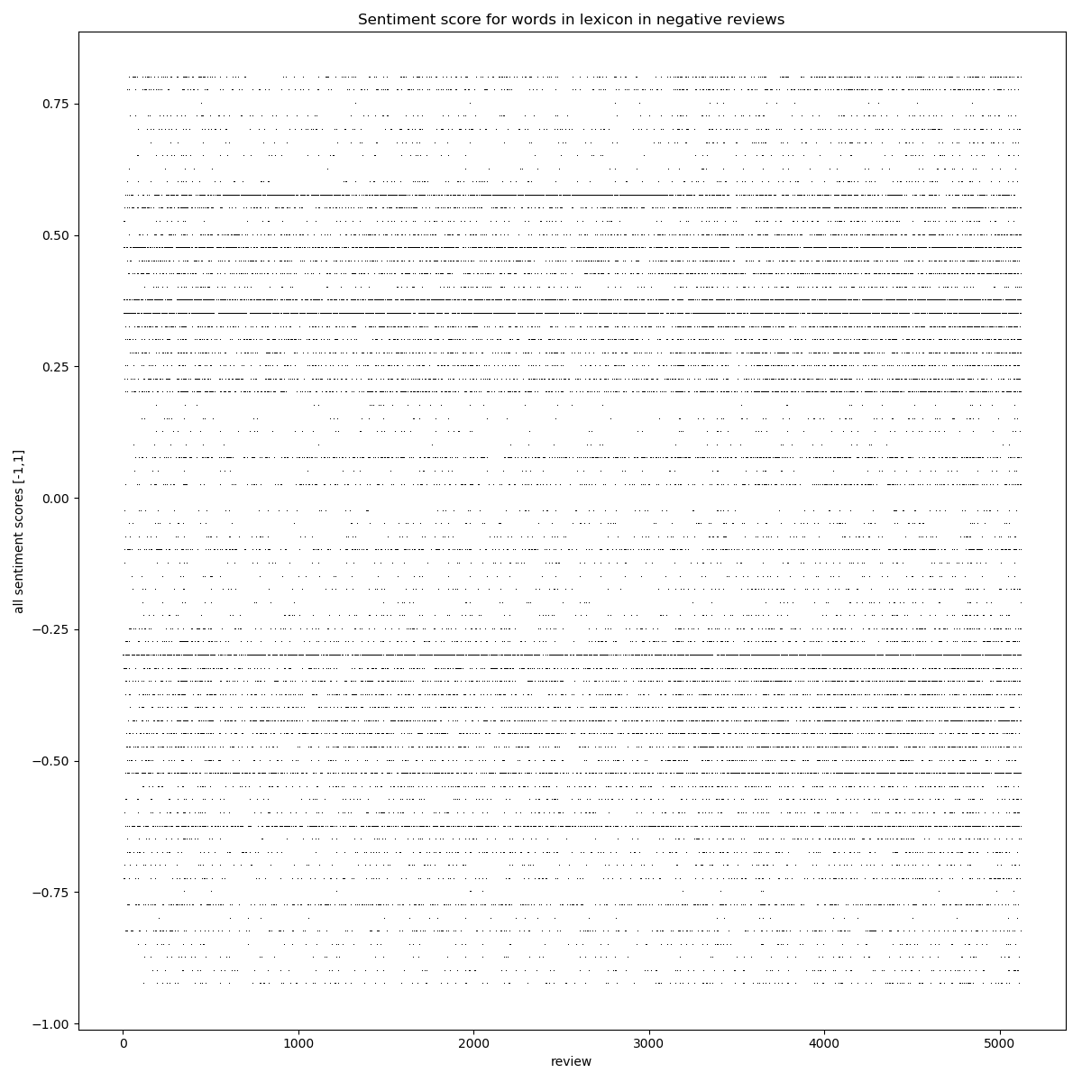
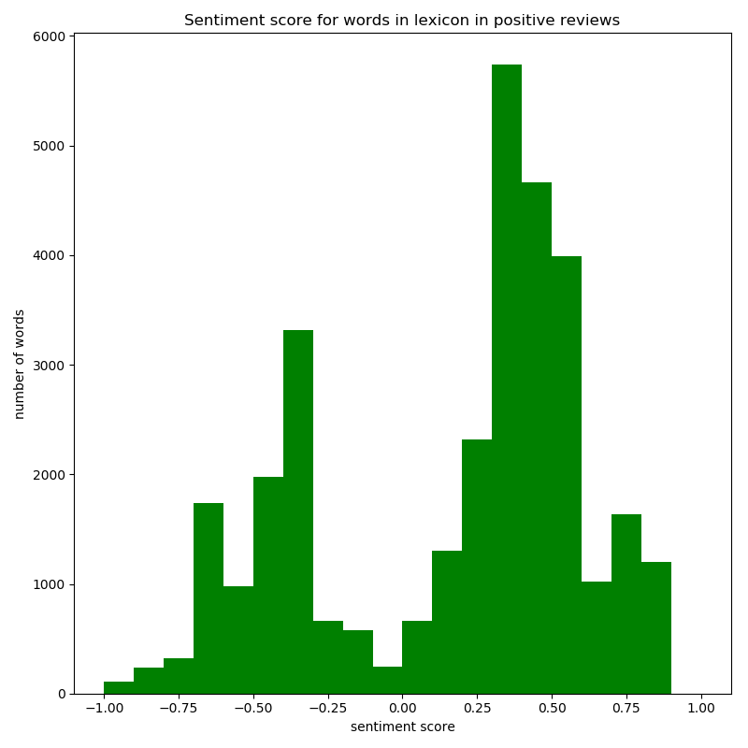
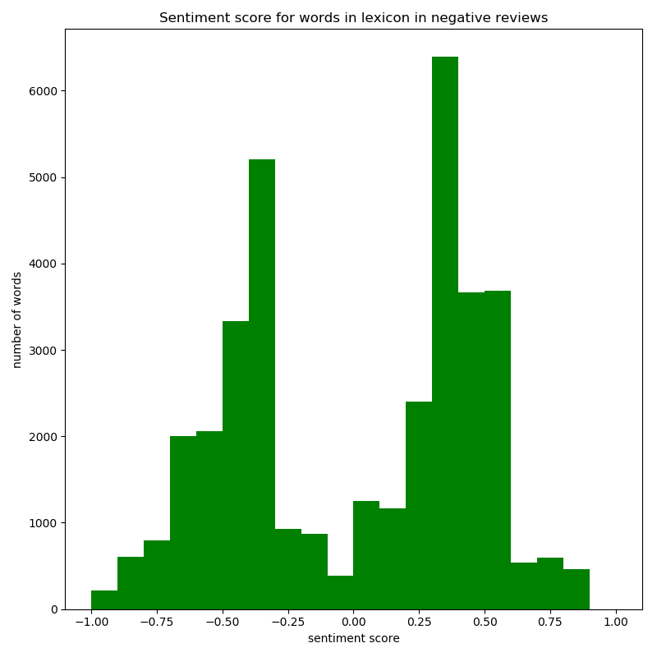

Note there are still quite a lot of positive words in negative reviews, but few very positive words with sentiment > 0.6 or so.
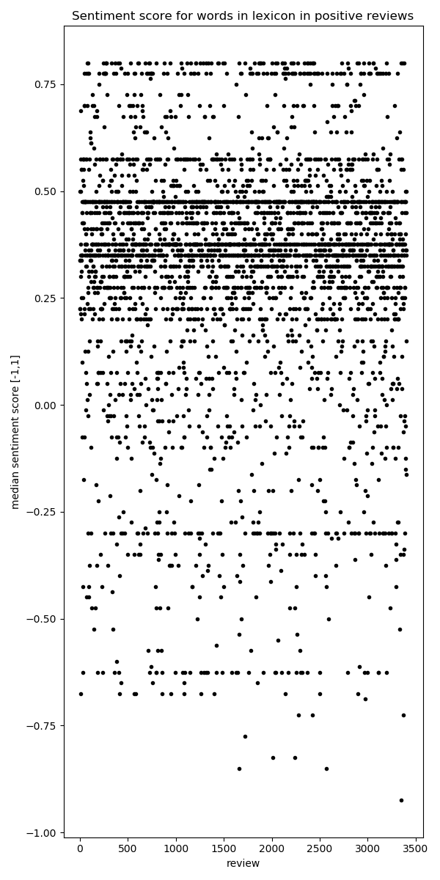
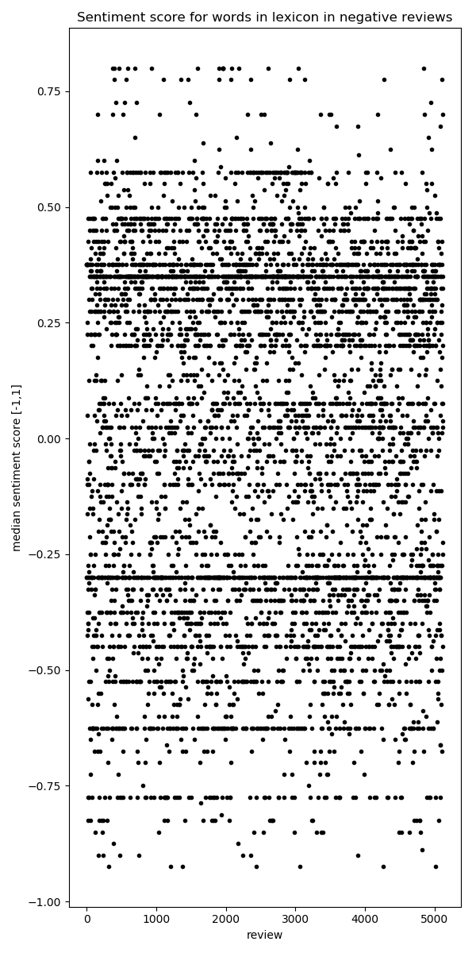
Looking at the median could help deal with outliers, but some positive reviews have a median sentiment score that is negative.
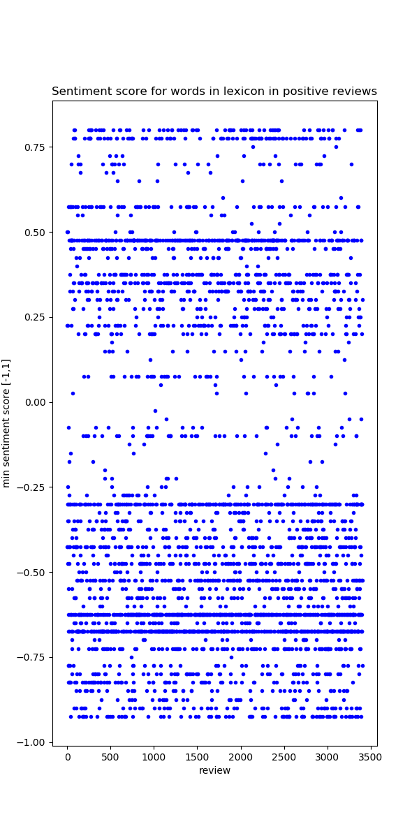
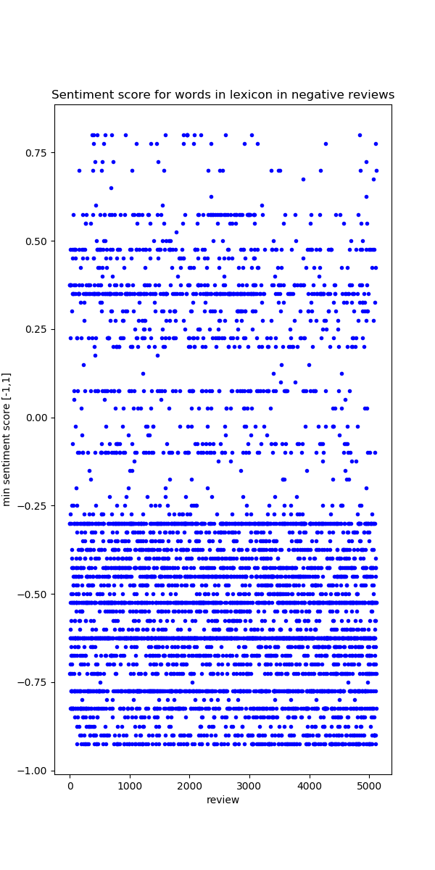
Some negative reviews have a minimum sentiment score well into positive territory
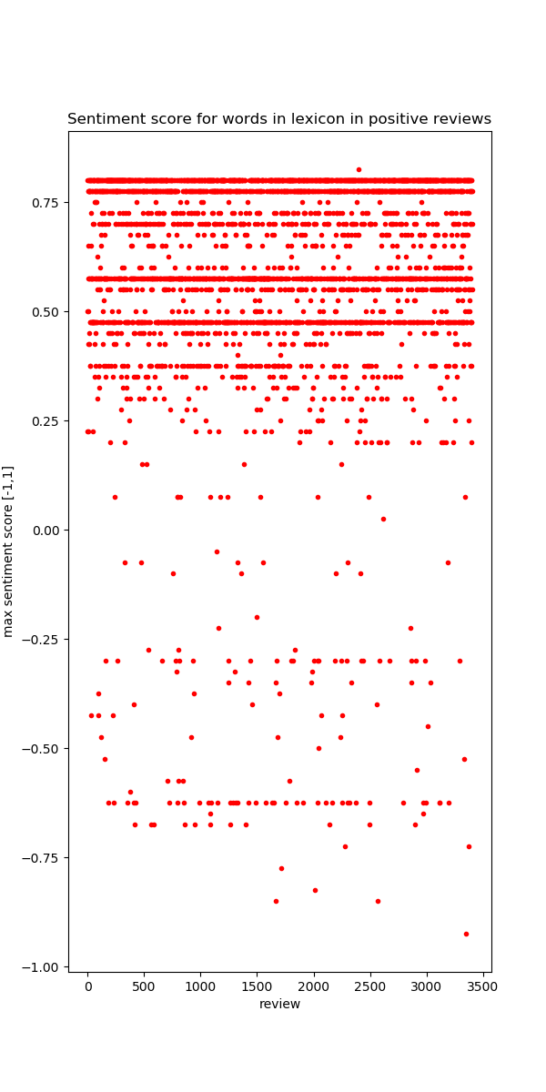
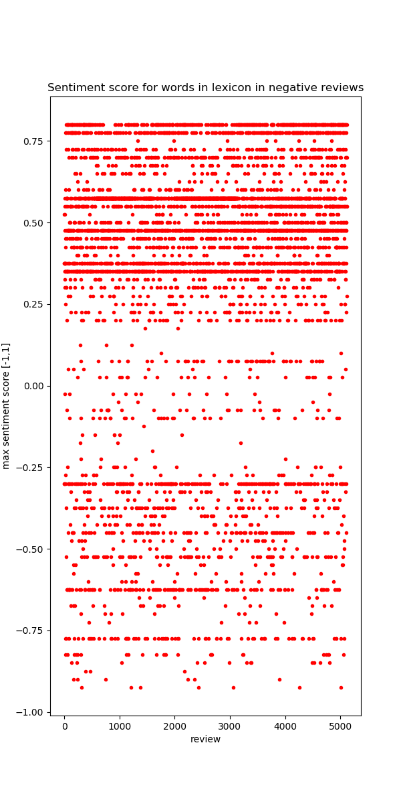
However very few positive reviews have only negative words

Hypotheses to test

does the length of a review affect the sentiment?

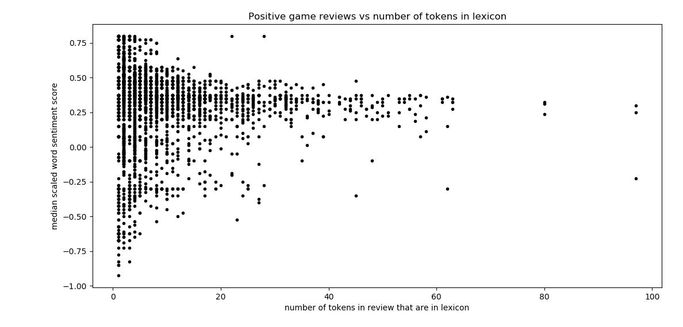
positive reviews made up of negative words tends to decline with the length of the review.
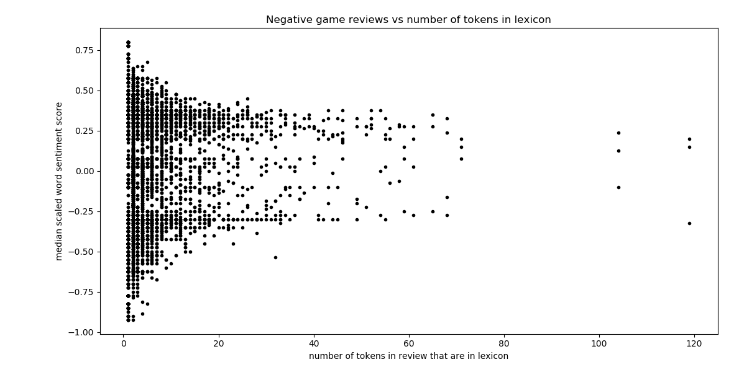
negative reviews seem to have a bimodal distribution which tends to be more the case for longer reviews, perhaps reviewers tend to either use negative words, or negated positive words consistently, and more so for longer than shorter reviews.

Rather than long rants full of negativity, the most negative reviews are short.

