Sample Document

## Header 1

This is an R Markdown document.

Use an asterisk mark to provide emphasis such as *italics* and **bold**.

Create lists with a dash:

* Item 1
* Item 2
* Item 3

You can write in-line code with a back-tick.

Code block display  
with fixed-width font

Blockquotes are offset

## R Code Chunks

With R Markdown, you can insert R code chunks including plots:

#quick summary and plot  
library(ggplot2)

## Warning: package 'ggplot2' was built under R version 3.0.3

summary(cars)

## speed dist   
## Min. : 4.0 Min. : 2.00   
## 1st Qu.:12.0 1st Qu.: 26.00   
## Median :15.0 Median : 36.00   
## Mean :15.4 Mean : 42.98   
## 3rd Qu.:19.0 3rd Qu.: 56.00   
## Max. :25.0 Max. :120.00

qplot(speed, dist, data=cars) +   
 geom_smooth()

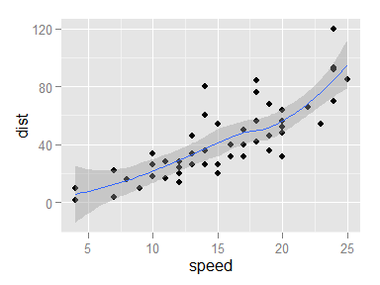

You can also show the results of code without the underlying code itself. You can also format tables.

## Warning: package 'knitr' was built under R version 3.0.3

|  |  |  |
| --- | --- | --- |
|  | speed | dist |
|  | Min. : 4.0 | Min. : 2.00 |
|  | 1st Qu.:12.0 | 1st Qu.: 26.00 |
|  | Median :15.0 | Median : 36.00 |
|  | Mean :15.4 | Mean : 42.98 |
|  | 3rd Qu.:19.0 | 3rd Qu.: 56.00 |
|  | Max. :25.0 | Max. :120.00 |



## More Tools

I counted 2 red trucks on the highway.

The arithmetic mean is equal to $\frac{1}{n}\sum_{i=i}^{n}{x_{i}}$, or the summation of n numbers divided by n.

You can create a notebook or html from an R script by passing it to render with `rmarkdown::render('file.R', 'html_document')

You can use the googleVis package to create interactive plots, as well as embed Shiny apps.

You can customize chunk options to tailor the evaluation.

You can cache chunks of code to save and reuse.

You can also embed links like this: <http:/rmarkdown.rstudio.com>.

# Say Hello to markdown

Markdown is an **easy to use** format for writing reports. It resembles what you naturally write every time you compose an email. In fact, you may have already used markdown *without realizing it*. These websites all rely on markdown formatting

* [Github](www.github.com)
* [StackOverflow](www.stackoverflow.com)
* [Reddit](www.reddit.com)