CPEN 3710 lab 11

David Tulis bqb428

Due 11/25/14

Two real, unequal roots

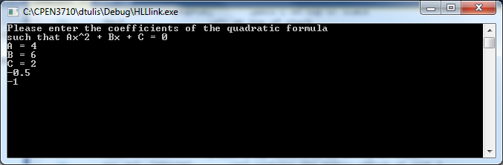

Two real, equal roots

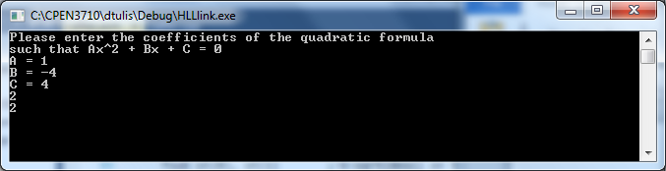

Complex roots

