David Tulis

CPEN3710 lab 2

1. Output of our ADDSUB.exe program  
   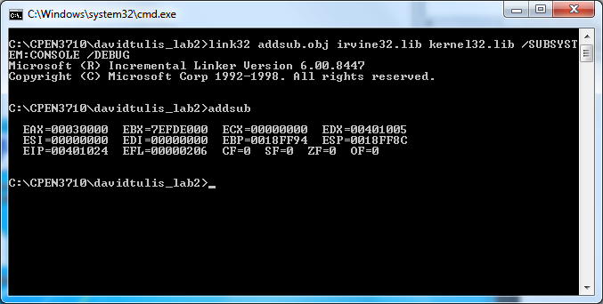
2. Output of addsub2.exe program  
   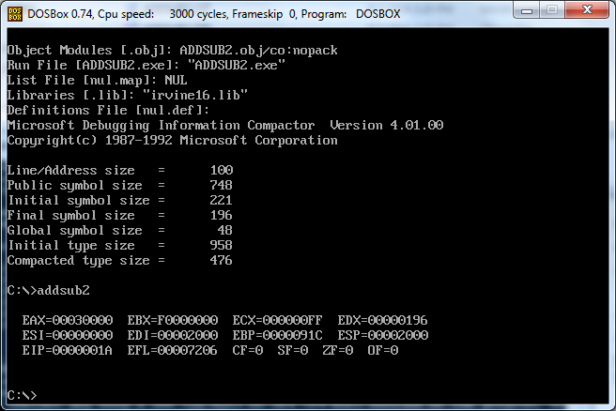
3. Output of our modified program  
   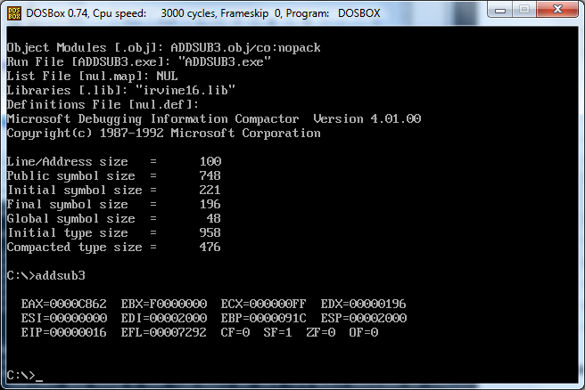

Question 1: Explain in your own words the differences between the first and second programs (ADDSUB and ADDSUB2). Consider both the differences in structure between protected and real mode code and the differences in how the task itself was accomplished

Answer 1: The first program is running in protected mode. We can run it directly from the command prompt because the OS has put restrictions in place on what memory it is allowed to access

The second program is running in real mode, and must be run from an emulated DOS environment. The reason being: there are no restrictions on the range of memory we are allowed to access all memory. Memory is segmented in real mode.

The task was accomplished in both protected mode and real mode. In real mode, we assigned the values to names, and referred to the names instead of the values. If we want to use labels, we have to declare segments in our code (data segment, code segment). The protected mode does not segment memory.

Question 2: Repeat question 1 for the third program (ADDTHREE) with respect to the second (ADDSUB2). This time, since both programs are written for real mode execution, the differences you are explaining should only be in terms of the data definition directives and the code itself.

Answer 2: Since both of these programs are running in real mode, the only differences are the amount of memory we are allocated for our variables and the amount of memory we are allocated for our results. Program 2 allocates more memory than Program 3 does.