David Toledo

CIS17B-48941

Texas Hold Em Documentation

Classes: Main, Deck, Players, GameWindow.

Deck: create deck by using Qvector which will hold all 52 poker cards(Qpixmap)

Functions: Shuffle(), getCardImage()

Shuffle is used to shuffle the deck(Qvector), this is achived by:

std::srand(unsigned (std::time(0)));

std::random_shuffle(cardTextRepresentation.begin(),cardTextRepresentation.end());

getCardImage is used to deal cards in order, from first card until the 9th card

total of 9 dealt cards are needed for texas hold em. This returns the card image to the caller(gamewindow). Each time this function is called it increments the decks index to insure that the same card is not dealt more than once. The index is reset everytime the deck Is shuffled.

Players: create 2 players, the dealer and the user(player).

Functions: setName();

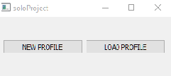

When the game runs the user must create a new profile to begin playing, this will

Initilize the cash amount of both dealer and player to: 10000 dealer, and 1000 player. If

The player has already played before and saved his profile, he has the option to load it.

Upon clicking on new Profile or load profile a dialog window will open and prompt the

User for his a new username, or ask to select his previously saved profile

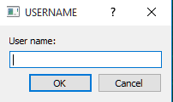

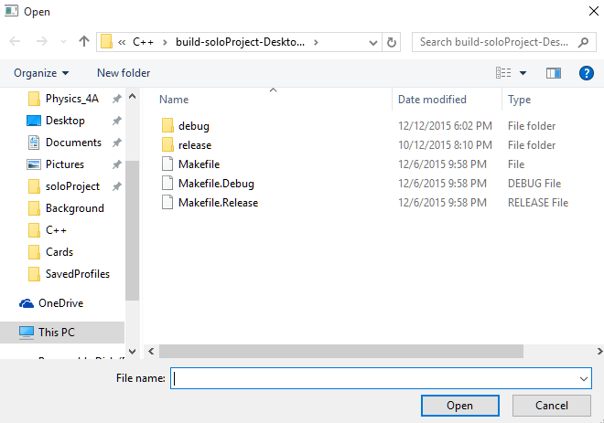

GameWindow: Inherits from Qwidget

Functions: setDefaultBacksideCard(),allInReveal(),dealTableCards(),analyzeDealerHand(),analyzePlayerHand(),determineWinnerHand(),dealHandCards(),foldHand(),callCheckHand(),raiseHand(),aiAutomate(),resetCards(),allInTimeReveal(),resetCash(),handLabelHide(),dealerRaiseConfirm(),foldConfirmTimed(),dealerGamerCashReset(),helpMenuWindow(),newProfileDialog(),saveFileDialog(),loadFileDialog().

The gamewindow is set to have fixed size so the user cannot change it.

The gameWindow consists of a menubar, with submenus:

MenuBar: File, and Help. Submenus: new, load, save, profiles. Close game

Help: consists of a window specifying the possible hands and their ranking.

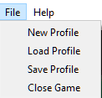

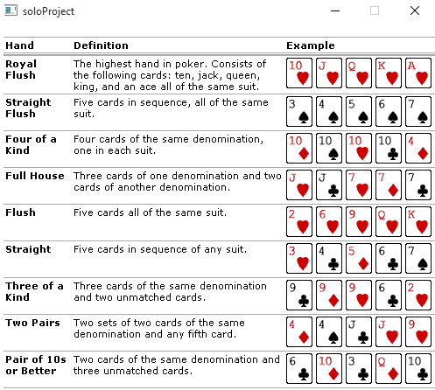

GameWindow consists of a main GridLayout which holds in place other layout (button layout, textLabelsLayout, cardsImagesLayout).

Each Button:**Play,Fold,Call/Check, Raise** are the main way to play the game, the user analyzes his hand and determines what button to press.

Each Button is connected to SLOTS so that the appropriate action is performed upon pressing them.

Play : this performs a shuffle on the deck, initializes all necessary variables to their default value

This is the only button that is initially enabled to press, only upon pressing play will the first cards

Be dealt and the rest of the buttons enabled. This play button will be disabled.

Fold: this performs exactly what the button specifies, you forfeit the game and the dealer gets the amount of cash you played, all buttons are disabled except for play.

Call/Check: used to either pass on betting or betting the amount of cash the dealer has raised.

Raise/Confirm: This button enables the user to increase his bet. This is achieved by raising the slider, or entering the cash value into the dialog box. He will then need to confirm his bet by pressing confirm. If the player bets all of his cash, all of the cards will be revealed and the winner will be determined.

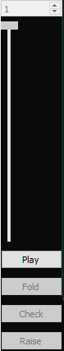

**Determining the winner:**

2 ways to win:

1. The user fold, forfeiting the game and making the dealer the winner.
   1. The dealer may also fold, making the user the winner.
2. All cards are revealed and both hands are analyzed, the player will the highest score is the winner
   1. A label will let the players know who won, and what hand was achieved by the winner.

**Game Hand Algorithm:**

Each card is assigned a score value as followed:

A = 2600 if not in a low straight consisting of 2,3,4,5. If low straight is attained then its value is just 1.

(2 = 2), (3 = 3), (4 = 4), (5 = 5), (6 = 14), (7 = 26), (8 = 49), (9 = 94), (10 = 183), (J = 352), (Q = 680), (K=1322).

Each hand is also assigned a score value:

(pair = 5049), (2 pair = 12605), (3 of a kind = 21130), (straight = 30933), (flush = 36071),(fullhouse = 41120)

(4 of a kind = 51565), (straight flush = 63288)

Each hand is analyzed by adding the total card score + hand score, this will be the player total score which is

Then compared to the opponents score. Whoever has the highest score is the winner.

How to analyze each players hand:

Each player can have 10 possible hand combinations (these combinations are put on a Qvector)

Each hand combination is analyzed and compared to the other combos in the vector, which ever has the

Highest score is the one that the player will keep and use to play against the opponent.

A 2 dimensional array (cardOcurrence[a][b]) is built consisting of 10 rows (hand combination) and 13 columns(each column represents the cards from A-K. for every card occurrence, a 1 is added to the corresponding card(column), if there is a 2, 3, 4, then the hand contains a pair, 3 of a kind, or 4 of kind. This table is also used to find a straight hand, which would contain 11111 in column sequence. Another 2 dimensional array (suite[a][b]) is built of 10 rows and 5 columns, 10 rows representing 10 hand combinations and 5 columns for each card suite in each hand.

EXAMPLE: hand 1011010000001 = A, 3, 4, 6, K, with corresponding hhcsc = Heart, Heart, Club, Spade, Club

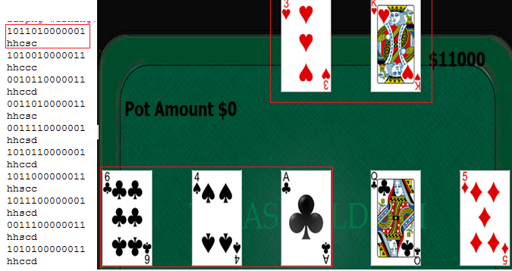

Final Game:

