**Video challenge game project progress summary**

**Date: 8/11/2019(12pm-5pm)**

* Fixed the cause of bugs
  + Cannot use safari on mac to talk with someone on google chrome.
  + Notice everyone: only use google chrome on any OS.
* Had a meeting with Grace
  + Discussed the restructure of implementation code.

**Date: 11/11/2019(12pm-5pm)**

* Had a meeting with Grace and Tom
  + confirmed to proper structure for implementation code (class and function definition and line limitation).
  + confirmed to use cloud real-time database (firebase) for the next design.
* Followed up the new design for implementation code

**Date: 12/11/2019(11am-5pm)**

* Implemented for confirmed code structure
  + amended the file structure and the code.

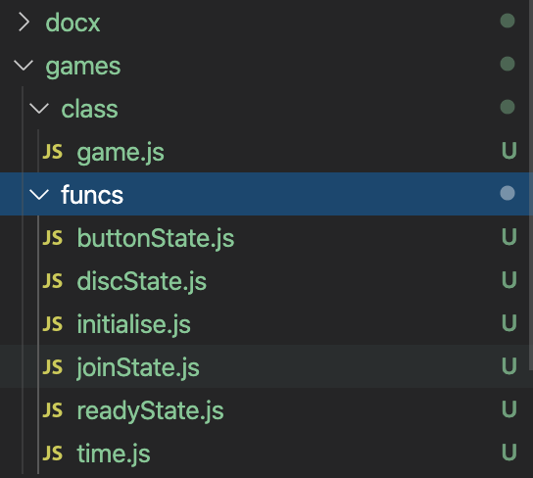 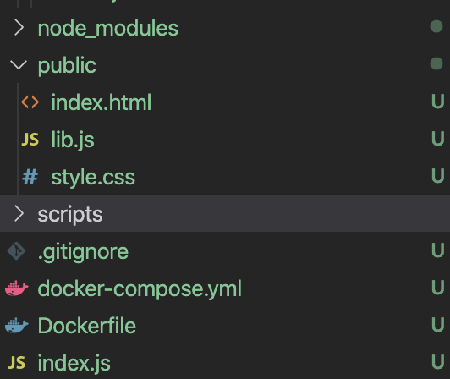

**Date: 13/11/2019(11pm-4pm)**

* Changed the game interaction rules
  + Players can click ready button when they join the game.
  + Players are not affected by the disconnection from other players.
  + Added colour representation for all players UI after the game starts.
  + Changed the UI for all players before game starts

**To do in the following weeks**

* Change the UI for all players after the game starts.
* Test the new design prototype.
* Develop multiple chain game.
* Develop the shuffle room game.
* Switch to firebase API.
* Develop Dialog flow chatbot.
* Develop the chatbot on Facebook messenger.
* Link chatbot with prototype.
* Synchronise the game with both chatbot and webpage.

**Date: 18/11/2019(12pm-5pm)**

* Change the partial UI for all players after the game starts
* Change the interface of head and tail player in the chain

**Date: 20/11/2019(10:30pm-5pm)**

* Add some function in the first player interface for game start
* Testing all players working in simultaneously.

**Date: 21/11/2019(10pm-5pm)**