**Video challenge game**

**Weblink**: <https://www.vcchallengegame.com/>

**Initial game Instruction:**

* Game setting:

1. Only one chain in the game.
2. Maximum number of players in one chain is 5.
3. Maximum ready time for the player is 30 seconds.

* Start the game:
  + - 1. A player joins the game

1. Enter the weblink above.
2. The player is assigned in first available position of the chain.

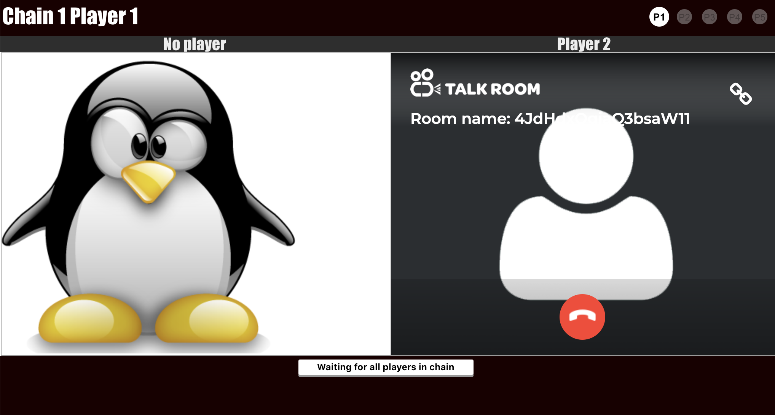

Figure 1: The first online player in the game,

left corner panel is shown the chain and player information,

right corner panel is shown all players online information,

bottom is shown the waiting message to the player.

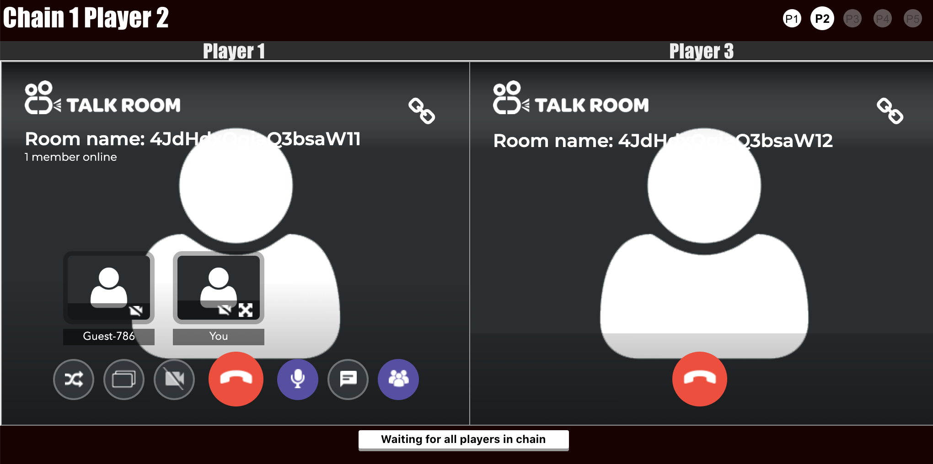

Figure 2: The second online player in the game,

Two white circles on right corner panel are shown two players are online.

1. Ready button shows when all players in the chain

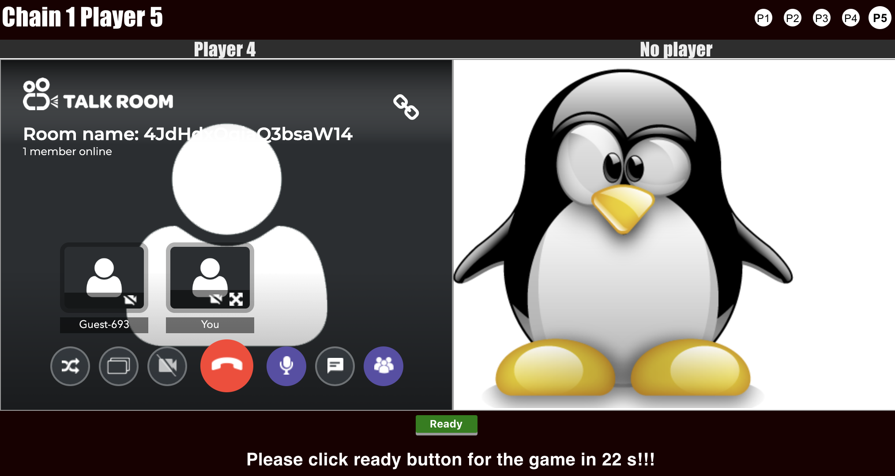

Figure 3: The last online player in the game,

the green Ready button pops out when all five players in the chain game,

only 30 seconds for all players to ready for the game.

1. The green circle on right corner panel shows the player clicked the ready button for the game, and the player can cancel the game by clicking the button again if they are not ready.

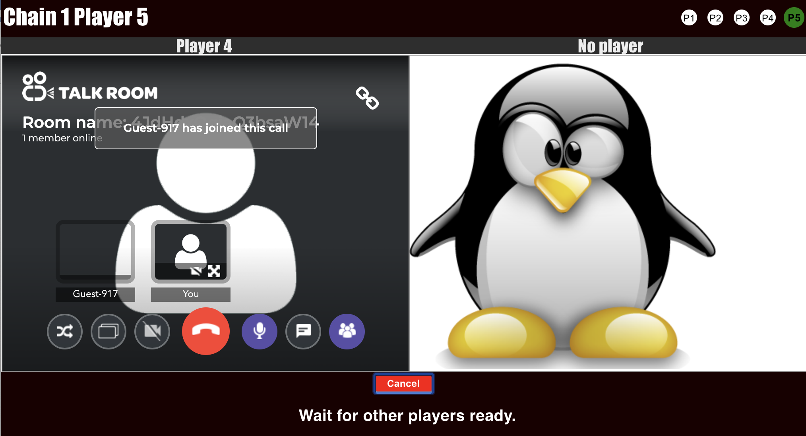

Figure 4: The last online player in the game,

the green circle shows the player is ready and waiting for the game,

the red Cancel button pops out when the player clicked the ready button before.

1. Once all players are ready by clicking the ready button, the game starts and records the time for completing the challenge through the video chain game.

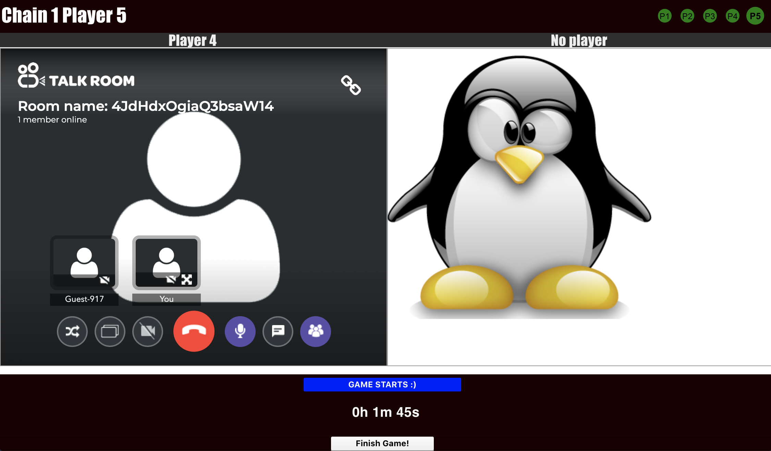

Figure 5: The last online player in the game,

the green circle shows all players are ready,

the bottom blue message and time counter pops out when the game starts,

only the last player has extra button to finish the challenge and the record the complete time for the team in a chain.

* End the game
  + - 1. The last player clicks on the finish game button.

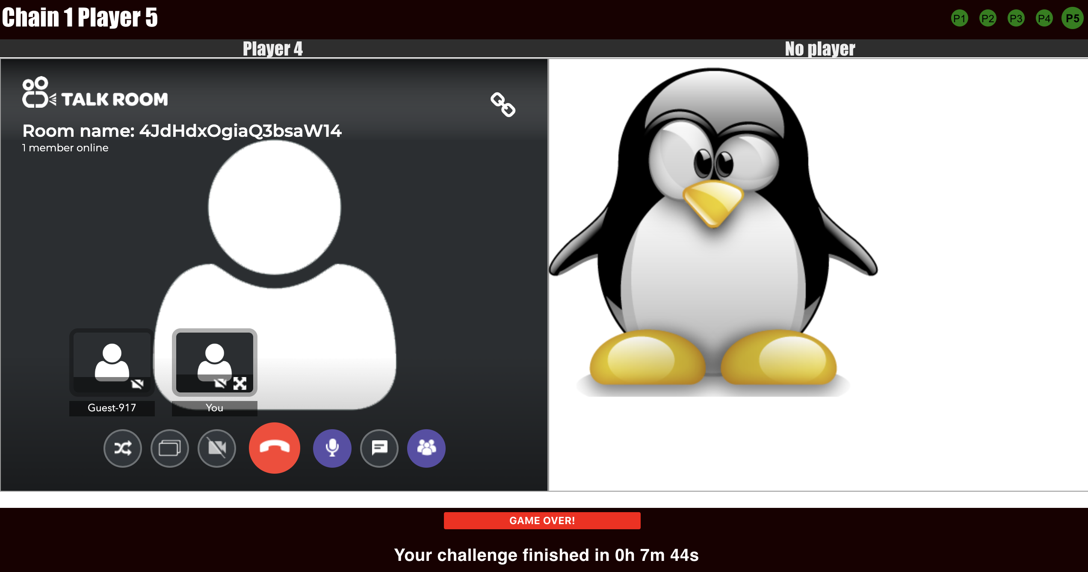

Figure 6: The last online player in the game,

the green circle shows all players are ready,

the bottom red message pops out when the game finishes,

the total used time shows when the game finishes by clicking the finish button.