Forecast-Aware Rolling-Horizon Optimization for Hybrid Wind-Storage Dispatch
David Valenta, North Carolina State University
Chris Qin, Washington State University
dvalent2@ncsu.edu

Abstract
Hybrid wind farms with energy storage must decide when to send wind energy directly to the grid, when to charge storage, and when to release stored energy. These decisions are difficult because both wind generation and electricity price change hour by hour. This work studies a forecast-aware dispatch pipeline for a West Texas Pyron wind-farm case using historical wind generation and ERCOT locational marginal price data. The current primary benchmark is the 100-MW Constant-Output Baseload Benchmark, a rule-based wind-storage case that tries to maintain 100 MW of grid output with a 100 MW / 10 h compressed-air energy storage system. Wind-only operation is kept as a secondary reference only. The experimental ladder first compares forecast methods, then tests deterministic rolling-horizon Gurobi dispatch, then adds uncertainty-aware scenario dispatch, and finally compares with a perfect-information oracle ceiling. The causal lag/ridge forecast had the lowest power RMSE at 21.24 MW. Deterministic 48-hour rolling-horizon dispatch improved COVE by 20.63% compared with the 100-MW benchmark. The strongest deployable case used three forecast scenarios and achieved a 67.16% revenue gain and a 40.18% COVE gain relative to the 100-MW benchmark. The perfect-information daily oracle reached 40.87% COVE gain, showing the remaining value of better future information. The results show that storage value depends on forecast quality, planning horizon, replanning logic, uncertainty handling, and physically consistent storage constraints.
Index Terms—hybrid wind farm, compressed-air energy storage, CAES, rolling horizon, mixed-integer linear programming, Gurobi, forecast uncertainty, ERCOT, COVE.
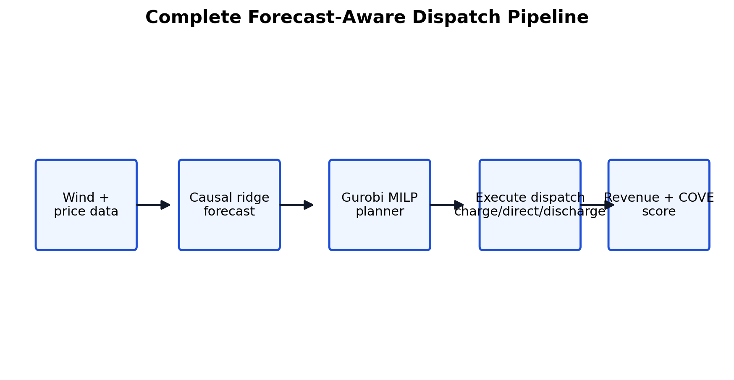
Fig. 1. Overall pipeline from forecasts to dispatch and realized scoring.

I. Introduction
Wind farms are variable power plants. A wind farm may produce a large amount of energy during a low-price hour and very little energy during a high-price hour. Storage can help by moving energy across time, but storage is not automatically beneficial. It has power limits, energy limits, efficiency losses, grid export limits, and state-of-charge constraints.
The main question is therefore whether a forecast-driven controller can move energy at the right time while obeying the real storage constraints. A dispatch policy that uses impossible battery behavior or perfect future information can look excellent but would not be deployable. This paper separates realistic controllers from upper-bound cases.
The revised comparison structure uses the 100-MW Constant-Output Baseload Benchmark as the main benchmark. This is a rule-based storage case, not a Gurobi revenue optimizer. It tries to deliver 100 MW when possible using actual wind and the same CAES device. Wind-only is still shown because it is an important no-storage reference, but it is no longer the headline comparison.
- Compare causal forecast models and select the lowest-error input for dispatch.
- Evaluate deterministic rolling-horizon Gurobi dispatch against the 100-MW benchmark.
- Test scenario-based dispatch to reduce dependence on one exact forecast.
- Compare deployable methods with perfect-information oracle cases to show remaining headroom.

II. Data and Benchmarks
The experiments use the Pyron wind-farm case with historical wind generation and ERCOT locational marginal price data. The long-period dispatch comparison covers 2014-2023 and uses 87,432 hourly records in the primary benchmark window. The final incomplete look-ahead window is excluded so each rolling-horizon solve has valid future data.
The 100-MW benchmark produced a normalized revenue metric of 5,981,942.95, raw realized revenue of $211,515,621.83, delivered energy of 5,911,506 MWh, and final SoC of 980.22 MWh. Its normalized COVE is 8.595322. Wind-only is shown below the main results as a no-storage secondary reference.
Item | Current setting | Reason
Target benchmark output | 100 MW | constant-output storage reference
Storage power | 100 MW charge / discharge | same CAES rating in each case
Storage capacity | 1,000 MWh | 100 MW times 10 hours
SoC bounds | 200-1,000 MWh | 20%-100% usable range
Initial SoC | 600 MWh | mid-range starting point
Efficiency | 0.55 discharge side | PNNL CAES assumption
Grid export cap | 249 MW | interconnection limit
Grid charging | not allowed | storage charges from wind only
Table I. Fixed storage and benchmark configuration.
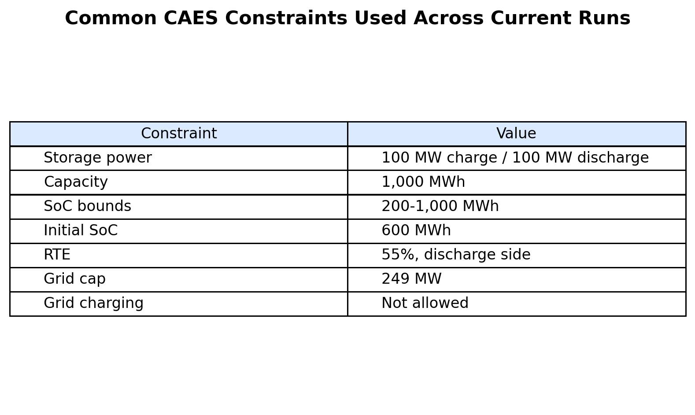
Fig. 2. Physical constraints enforced in the storage dispatch model.
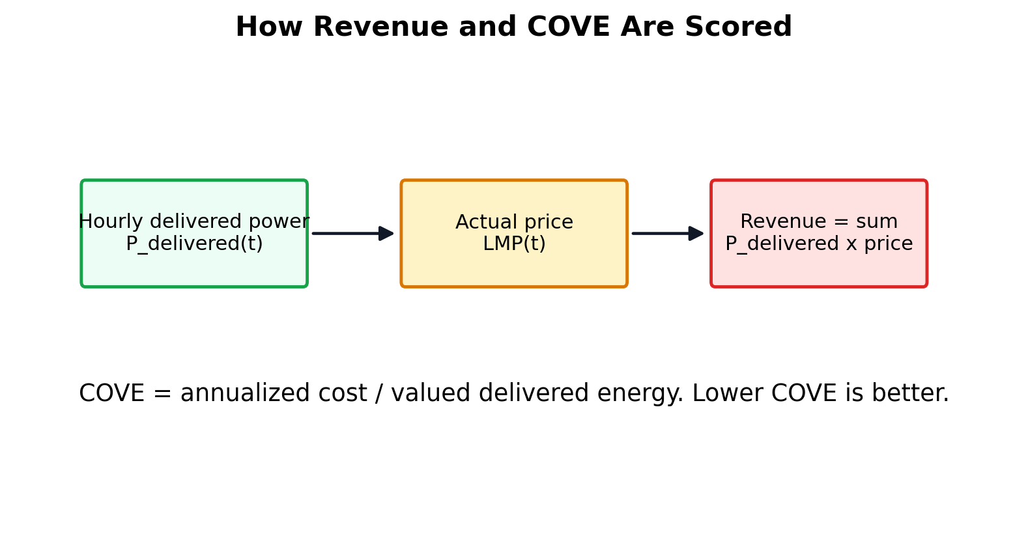
Fig. 3. Revenue and COVE calculation logic used to score realized operation.

III. Forecasting
The forecast stage predicts wind power before the optimizer acts. The selected method is a causal lag/ridge forecast. Causal means it uses only information already available at the prediction time. Lag means it uses recent historical values. Ridge means the fitted linear model is regularized so it stays stable instead of overreacting to noisy data.
Forecast accuracy is important because Gurobi can only optimize the information it receives. A poor forecast can cause the controller to store energy for a price spike that does not happen or release energy before a better price arrives.
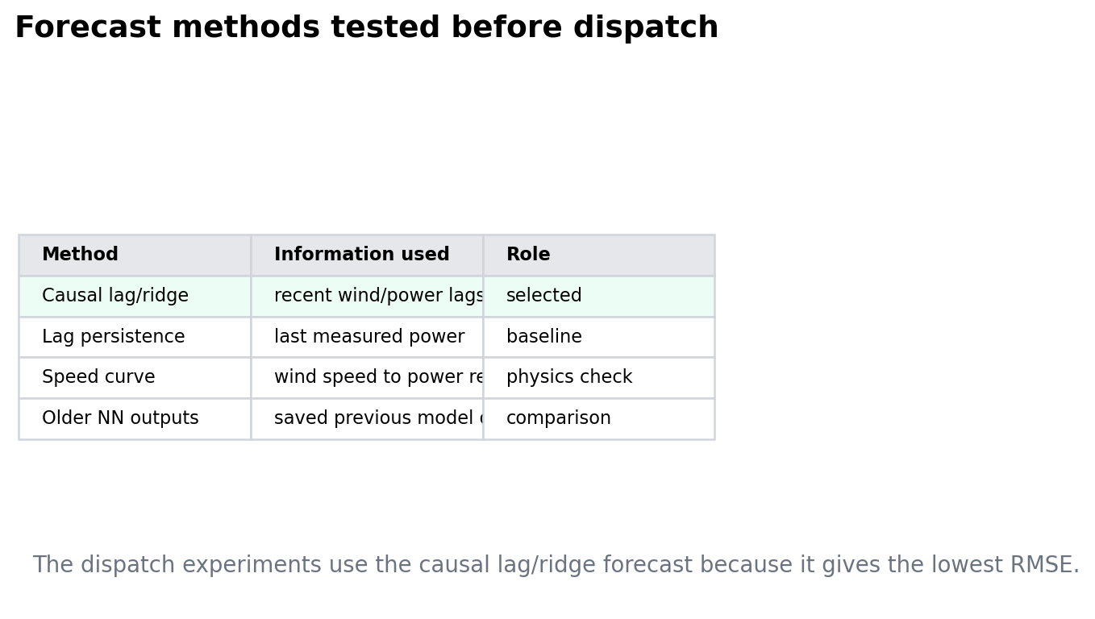
Fig. 4. Forecast methods compared before dispatch.
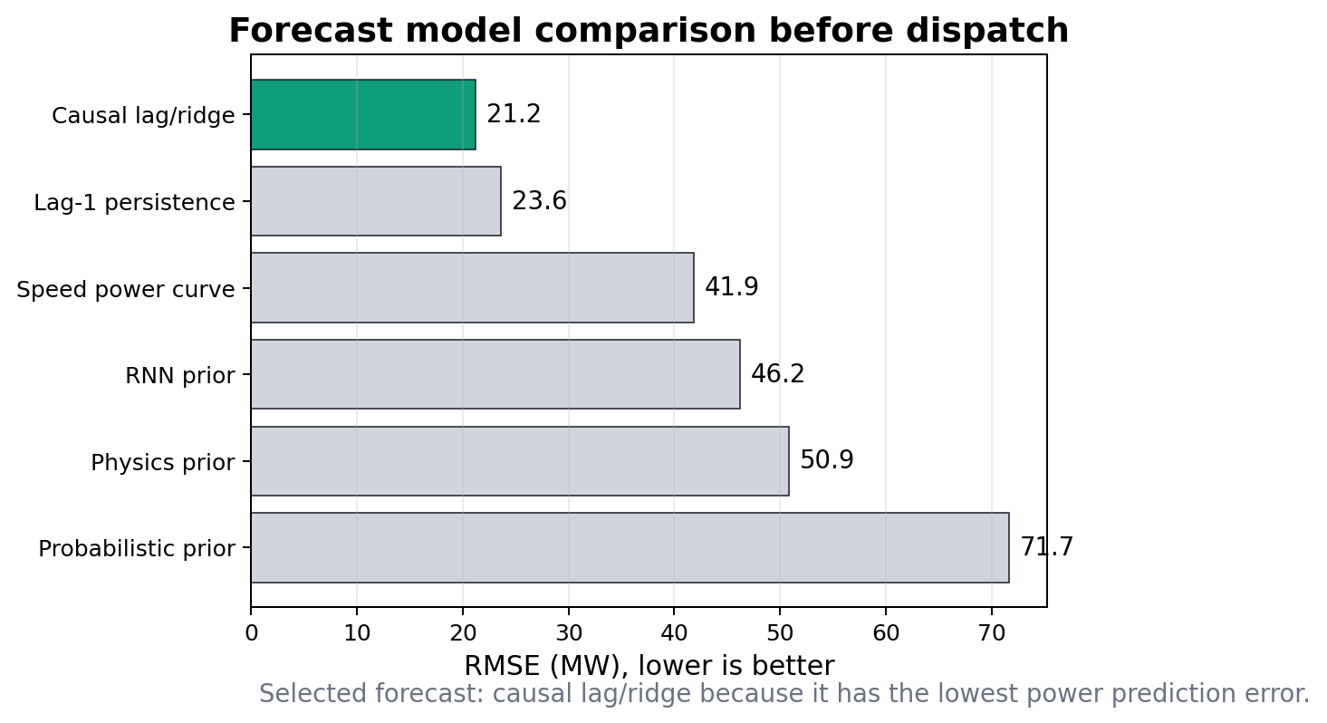
Fig. 5. Forecast RMSE comparison. Causal lag/ridge is selected with RMSE = 21.24 MW.
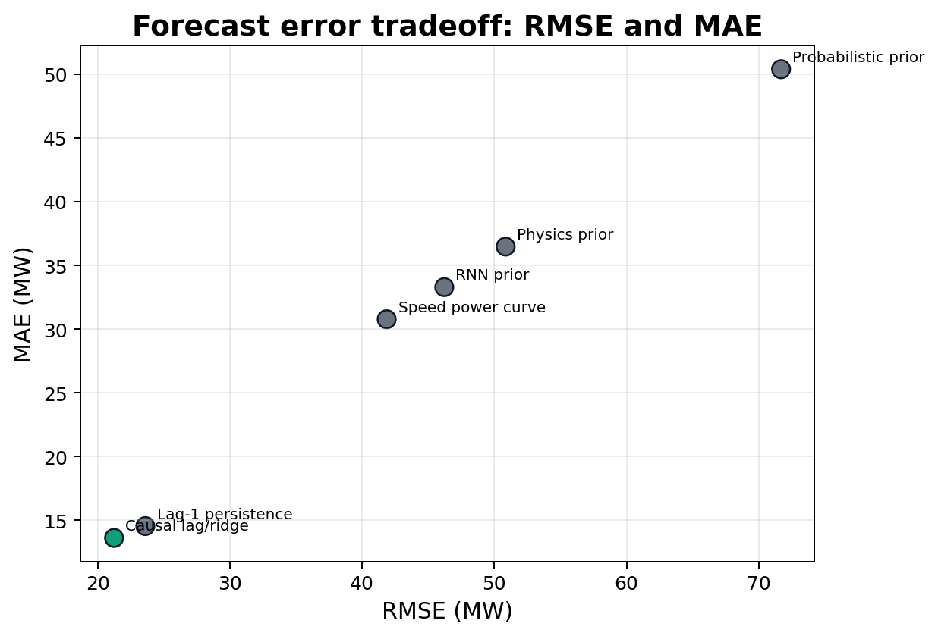
Fig. 6. RMSE and MAE comparison across forecast methods.
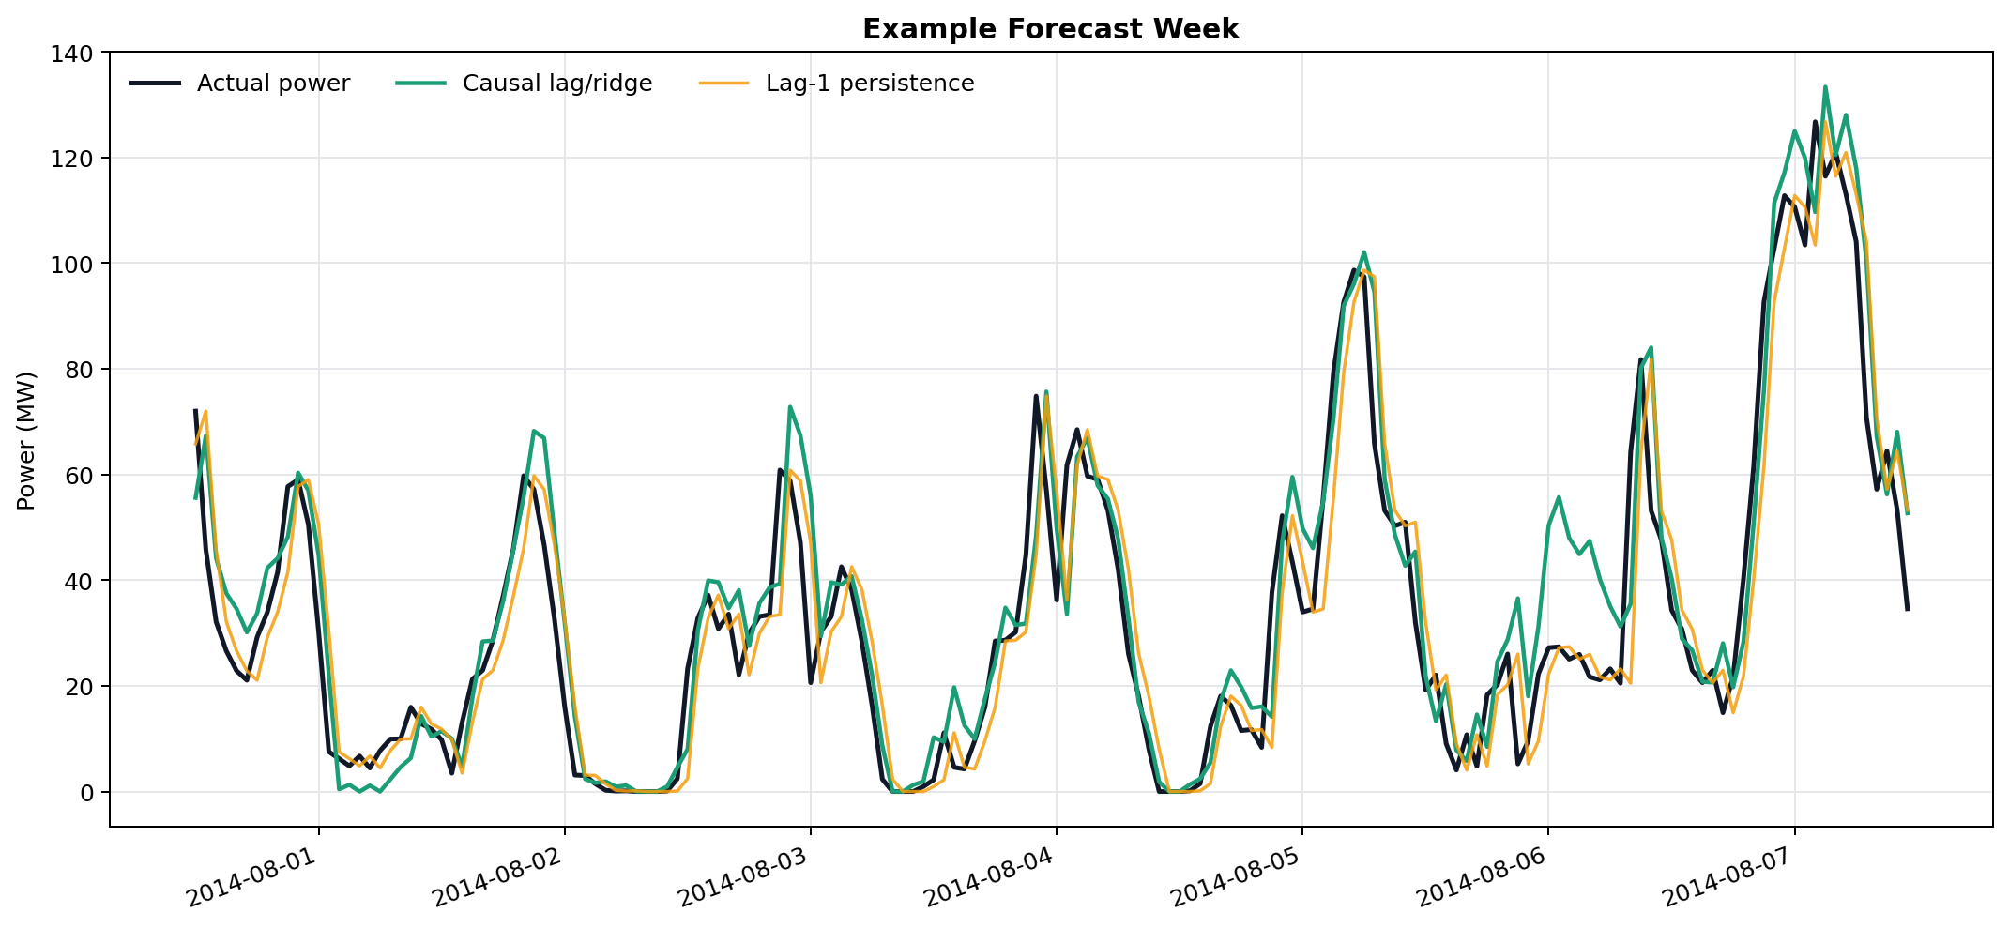
Fig. 7. Example week showing actual power and causal forecasts.

IV. MILP Dispatch Formulation
The dispatch problem is solved as a mixed-integer linear program. The main decision variables are direct wind delivered to the grid, charging power, discharging power, state of charge, delivered power, and curtailment. A binary mode variable prevents storage from charging and discharging at the same time.
Constraint | Plain meaning
200 <= SoC(t) <= 1000 | storage stays inside allowed range
0 <= P_ch(t) <= 100 | charging cannot exceed CAES power rating
0 <= P_dis(t) <= 100 | discharging cannot exceed CAES power rating
P_delivered(t) <= 249 | grid export cap
P_ch(t) uses wind only | no grid charging
SoC(t+1)=SoC(t)+P_ch-P_dis/0.55 | chronological storage update
P_delivered=P_direct+P_dis | delivery equals direct wind plus release
Table II. Main dispatch constraints in words.
A rolling-horizon controller repeatedly solves a future planning problem, executes the allowed near-term action, updates the real battery state, and solves again. This is more realistic than committing to one long schedule because the controller can respond as new information arrives.
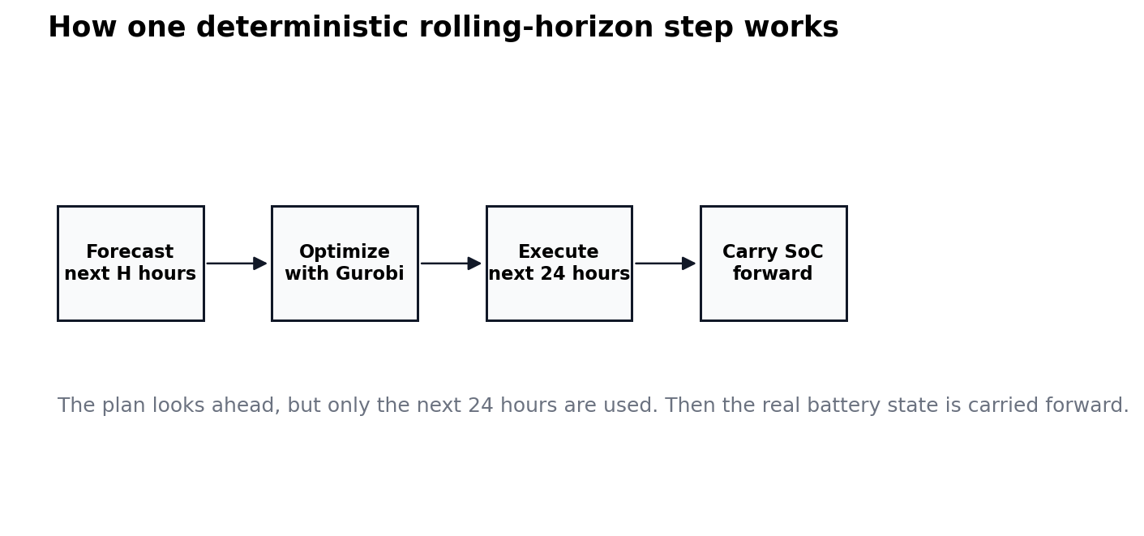
Fig. 8. Rolling-horizon operation: forecast, optimize, execute, carry SoC forward, and replan.

V. Deterministic Rolling-Horizon Results
The deterministic case feeds one causal forecast into Gurobi. Horizons of 24, 48, 72, and 168 hours were compared. The 48-hour horizon was best: it produced COVE 6.822045, revenue metric 7,536,849.56, raw revenue gain 26.08%, and COVE gain 20.63% versus the 100-MW benchmark.
The reason 48 hours performs best is that it gives the optimizer enough look-ahead to use storage, but not so much look-ahead that weak longer-range forecasts dominate the plan. The 72-hour and 168-hour deterministic plans remain close, but the extra look-ahead does not create additional value in this deployable forecast case.
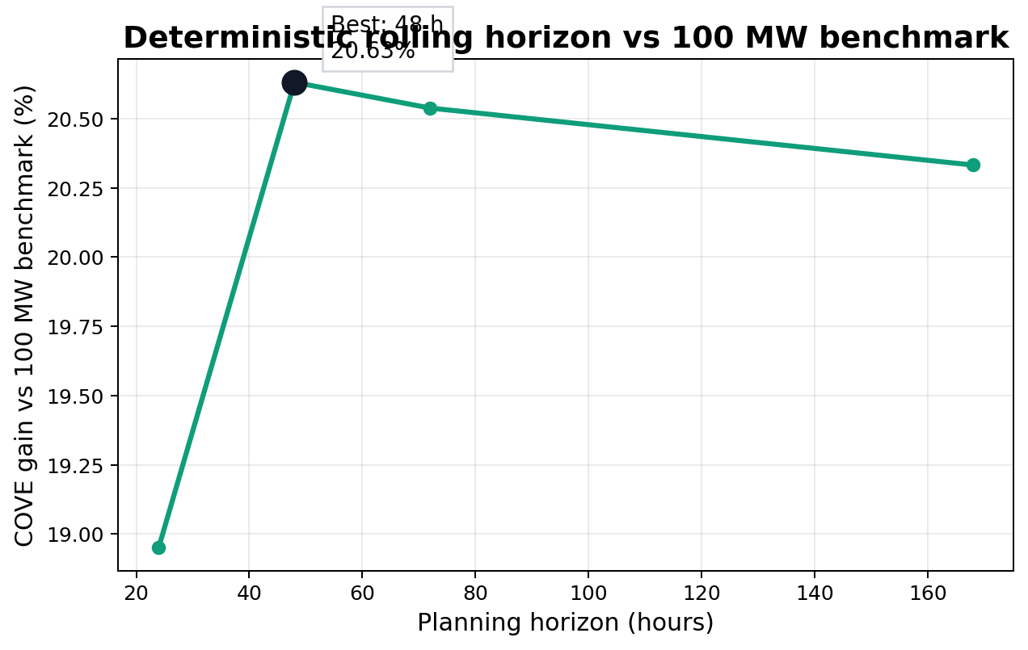
Fig. 9. Deterministic horizon sweep using the 100-MW benchmark as the primary comparison.
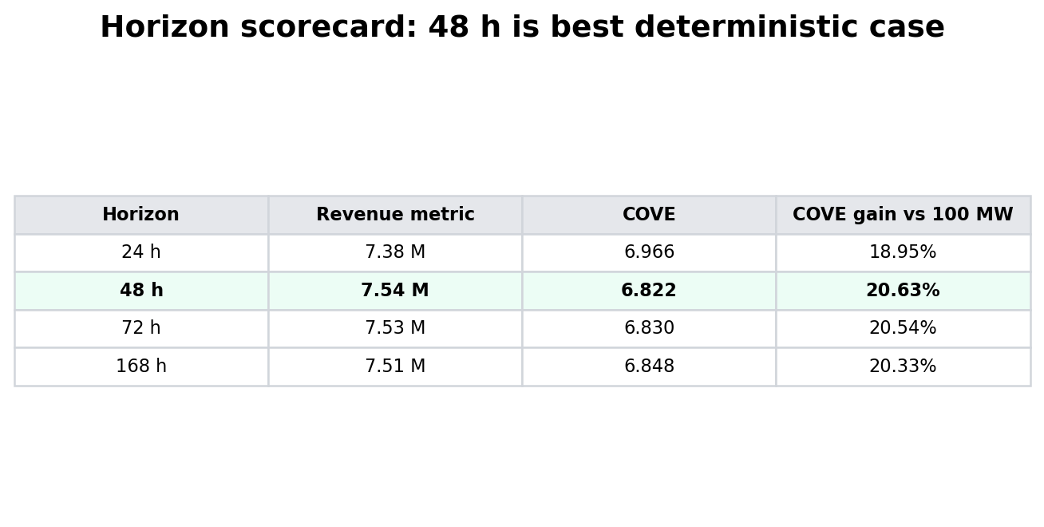
Fig. 10. Deterministic horizon scorecard.
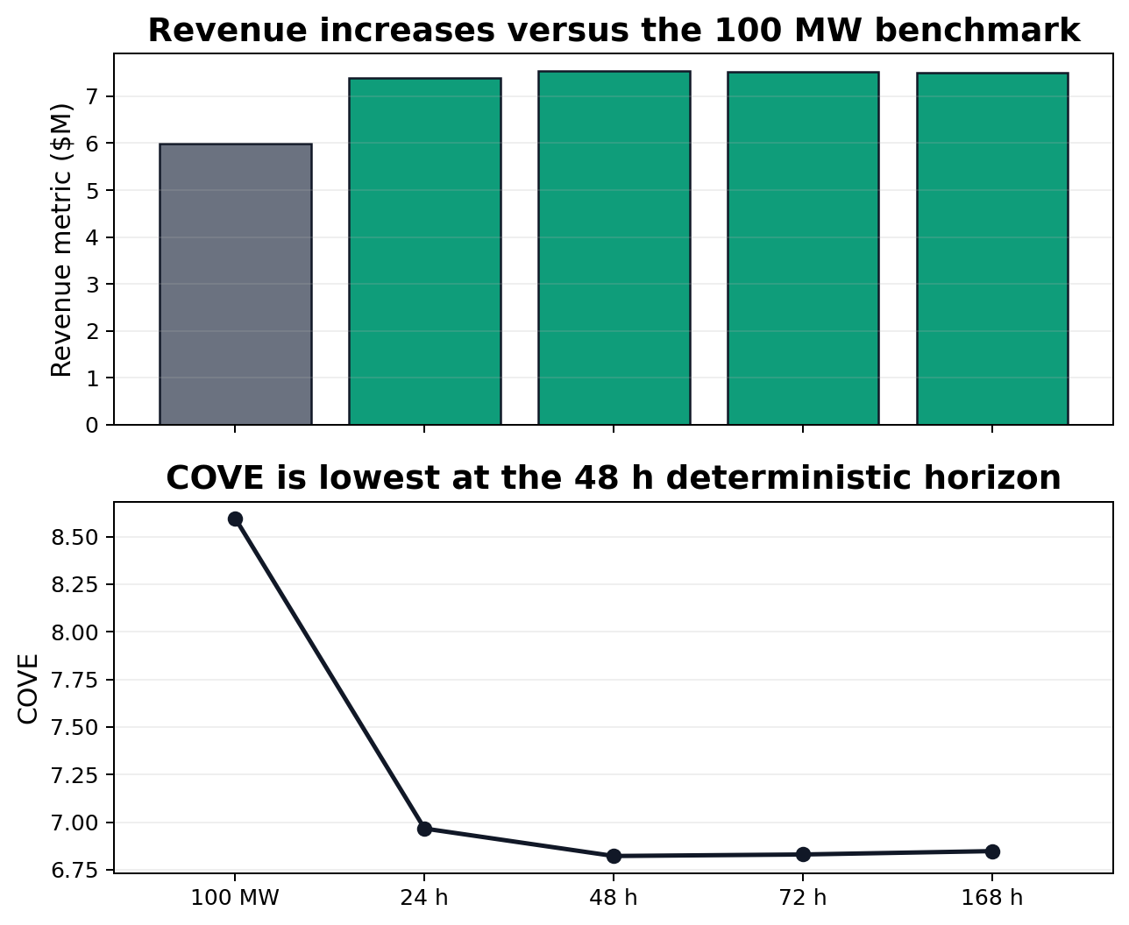
Fig. 11. Deterministic revenue and COVE by horizon.

VI. Scenario-Based Dispatch
The scenario controller uses the same forecast foundation but does not trust one future exactly. Instead, it creates several plausible forecast futures from forecast residual behavior. Gurobi then chooses a dispatch action that performs well across the scenario set. This is useful because wind and price uncertainty directly decide whether charging or discharging is profitable.
The best deployable scenario case used three forecast futures. It achieved dispatch revenue $353,949,333.45, revenue gain 67.16%, COVE 0.165716, and COVE gain 40.18% versus the 100-MW benchmark. Five and seven scenarios were close, while ten scenarios became more conservative and performed worse.
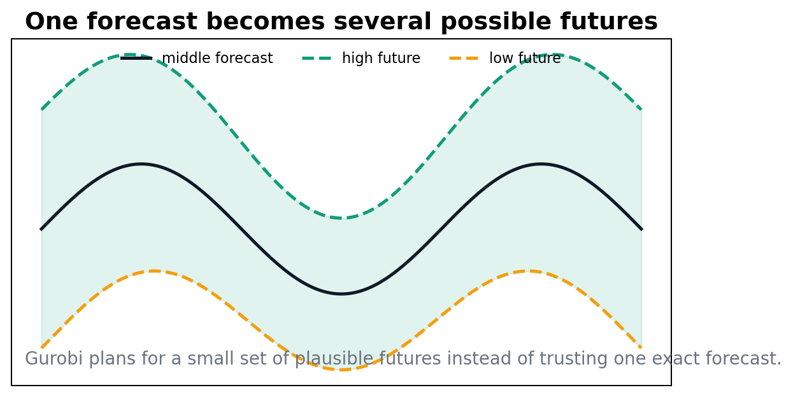
Fig. 12. Scenario idea: one forecast is expanded into several plausible futures.
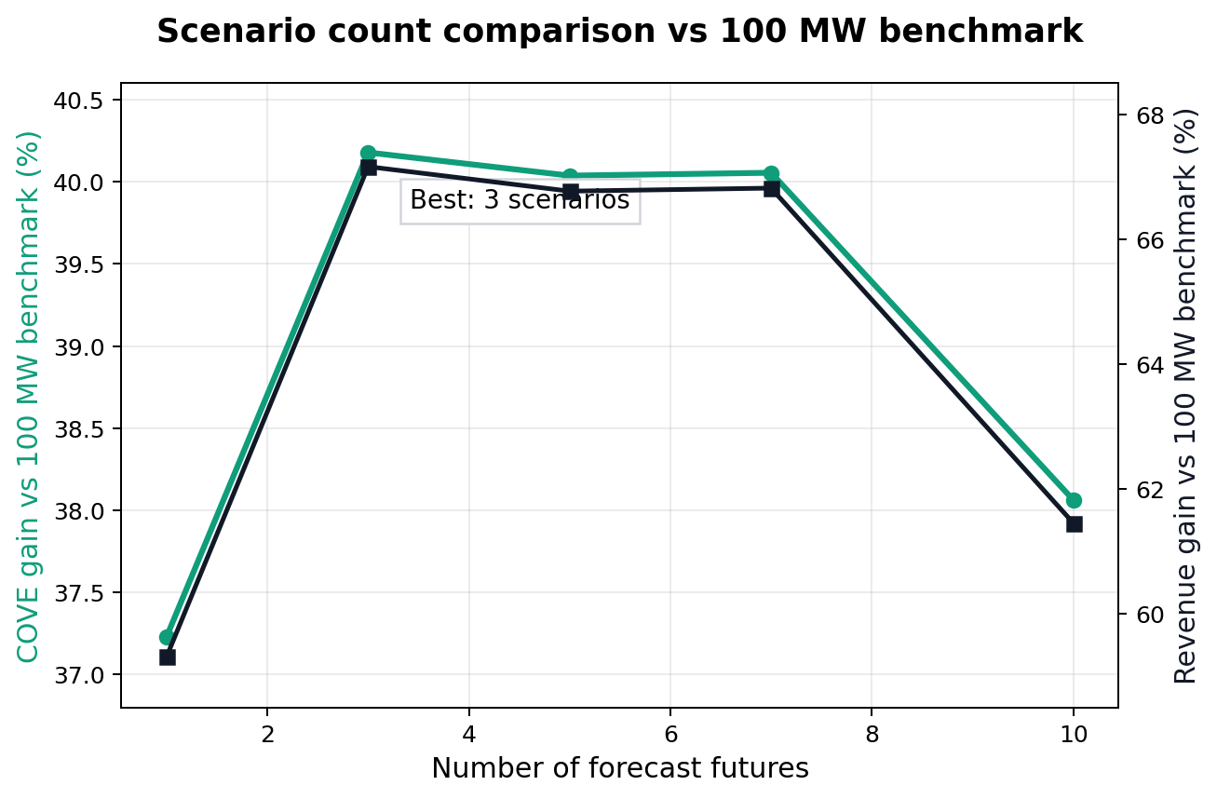
Fig. 13. Scenario count comparison against the 100-MW benchmark.
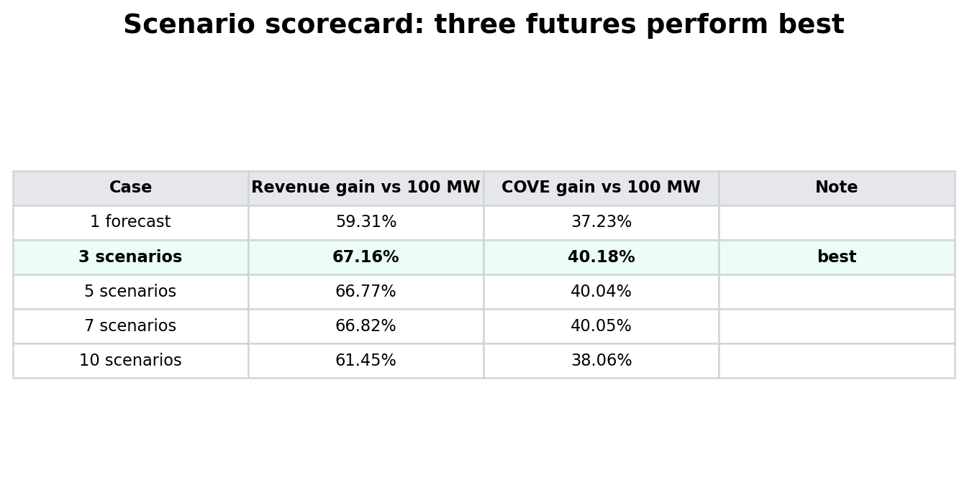
Fig. 14. Scenario scorecard. Three scenarios are the strongest deployable result.
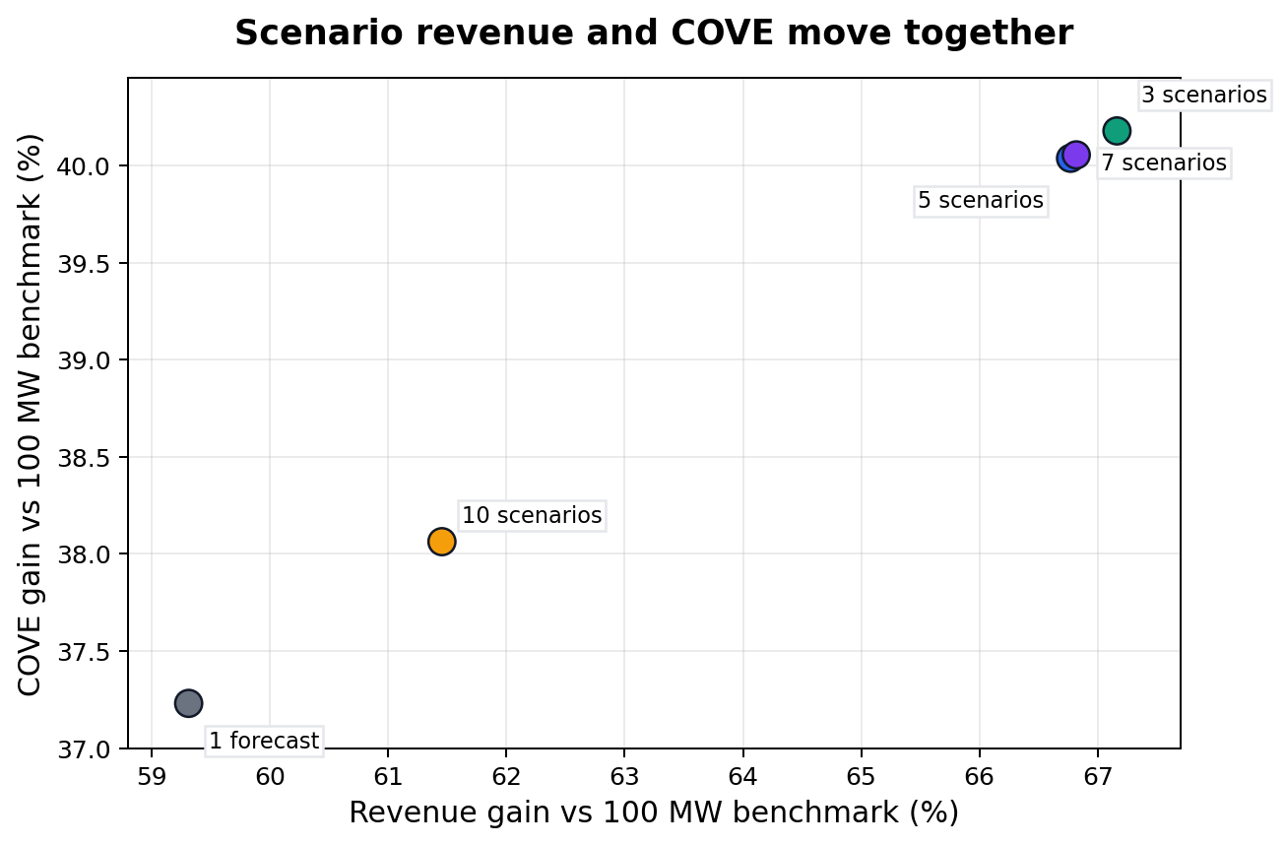
Fig. 15. Revenue and COVE gains move together for the stronger scenario cases.
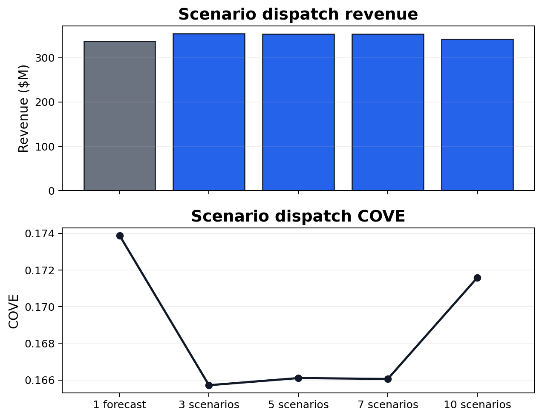
Fig. 16. Scenario revenue and COVE values.
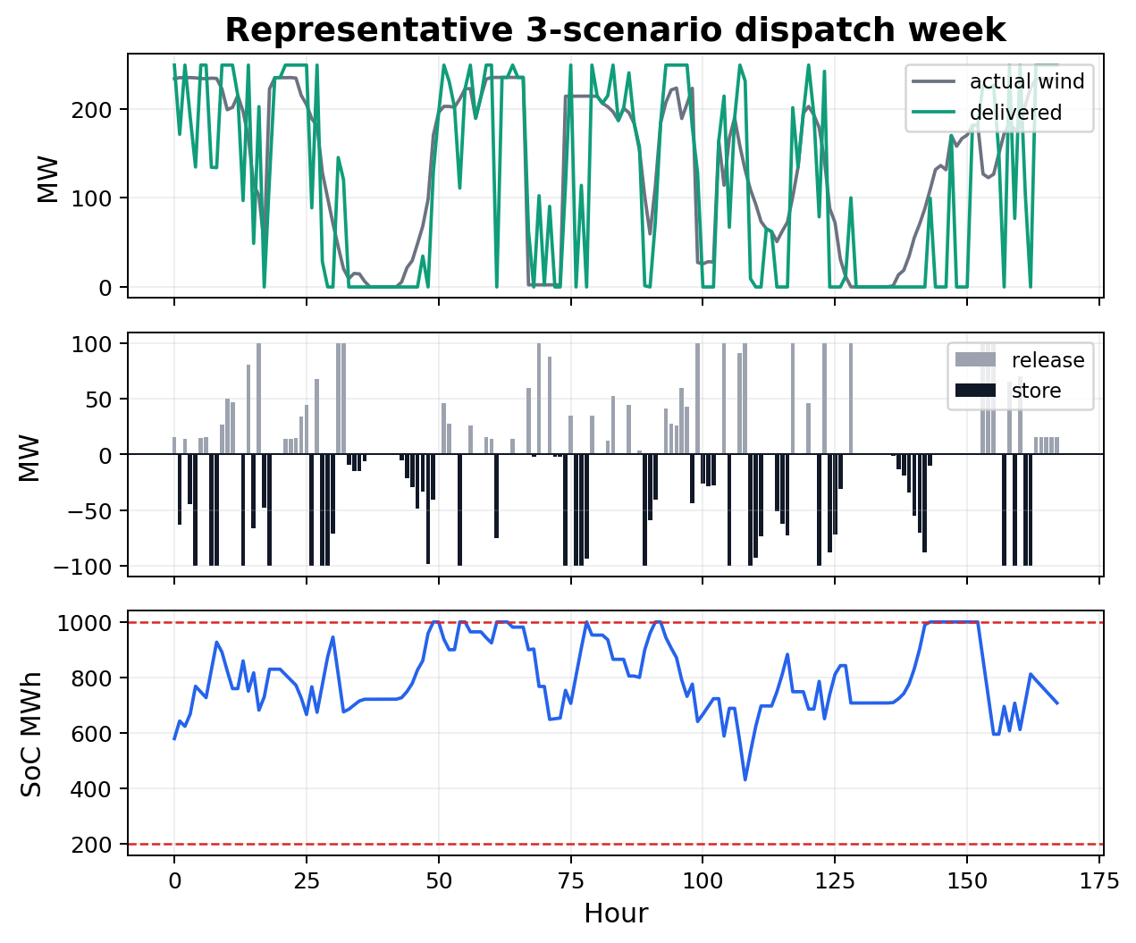
Fig. 17. Representative week for the three-scenario dispatch case.

VII. Oracle Upper Bound
The oracle is not a real controller because it receives the actual future wind and price before deciding. It is included to show the best possible value under the same storage constraints. This creates an upper bound: realistic forecast methods should be judged by how much of this value they can recover without using future information.
The best daily-replanning oracle used a 168-hour horizon and achieved COVE gain 40.87% versus the 100-MW benchmark. This is only slightly above the three-scenario deployable case, which suggests that scenario dispatch captures a large part of the storage value under the current benchmark.
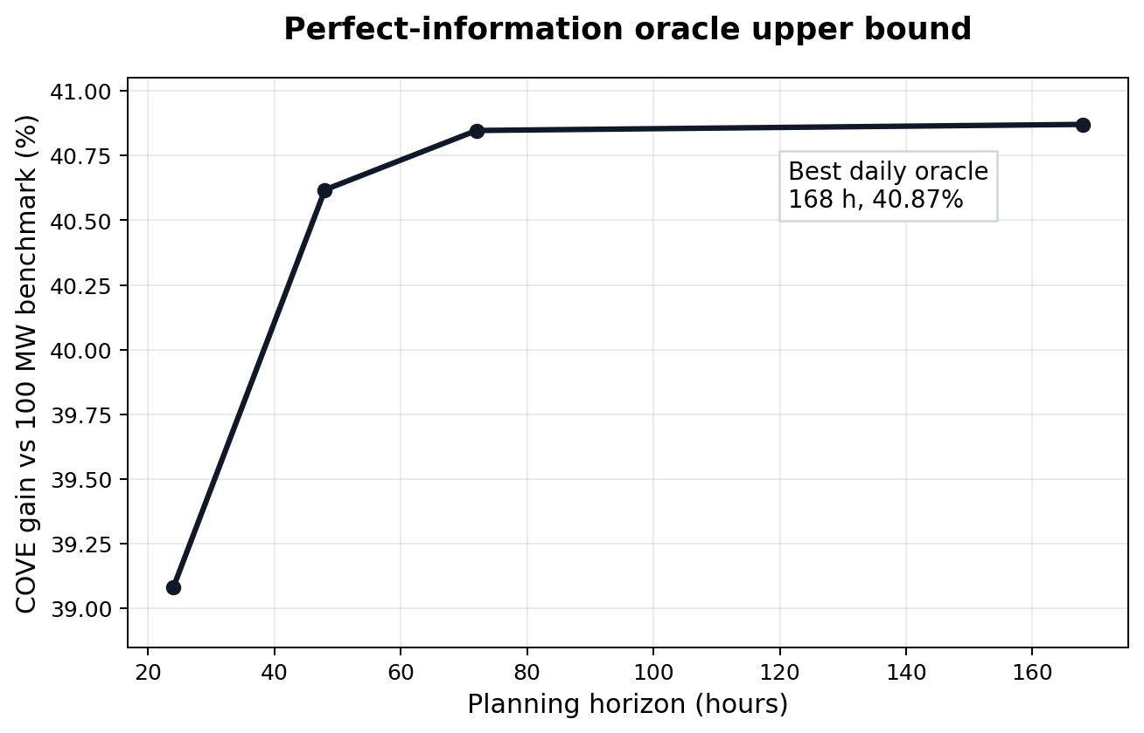
Fig. 18. Perfect-information daily oracle upper bound.
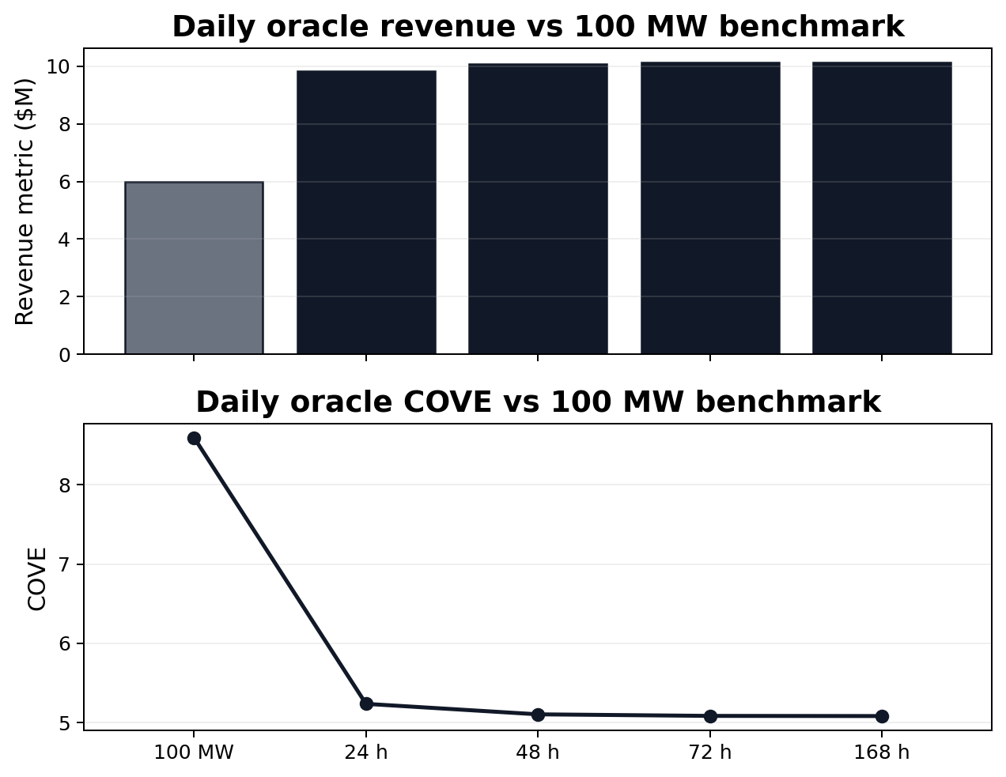
Fig. 19. Oracle revenue and COVE compared with the 100-MW benchmark.
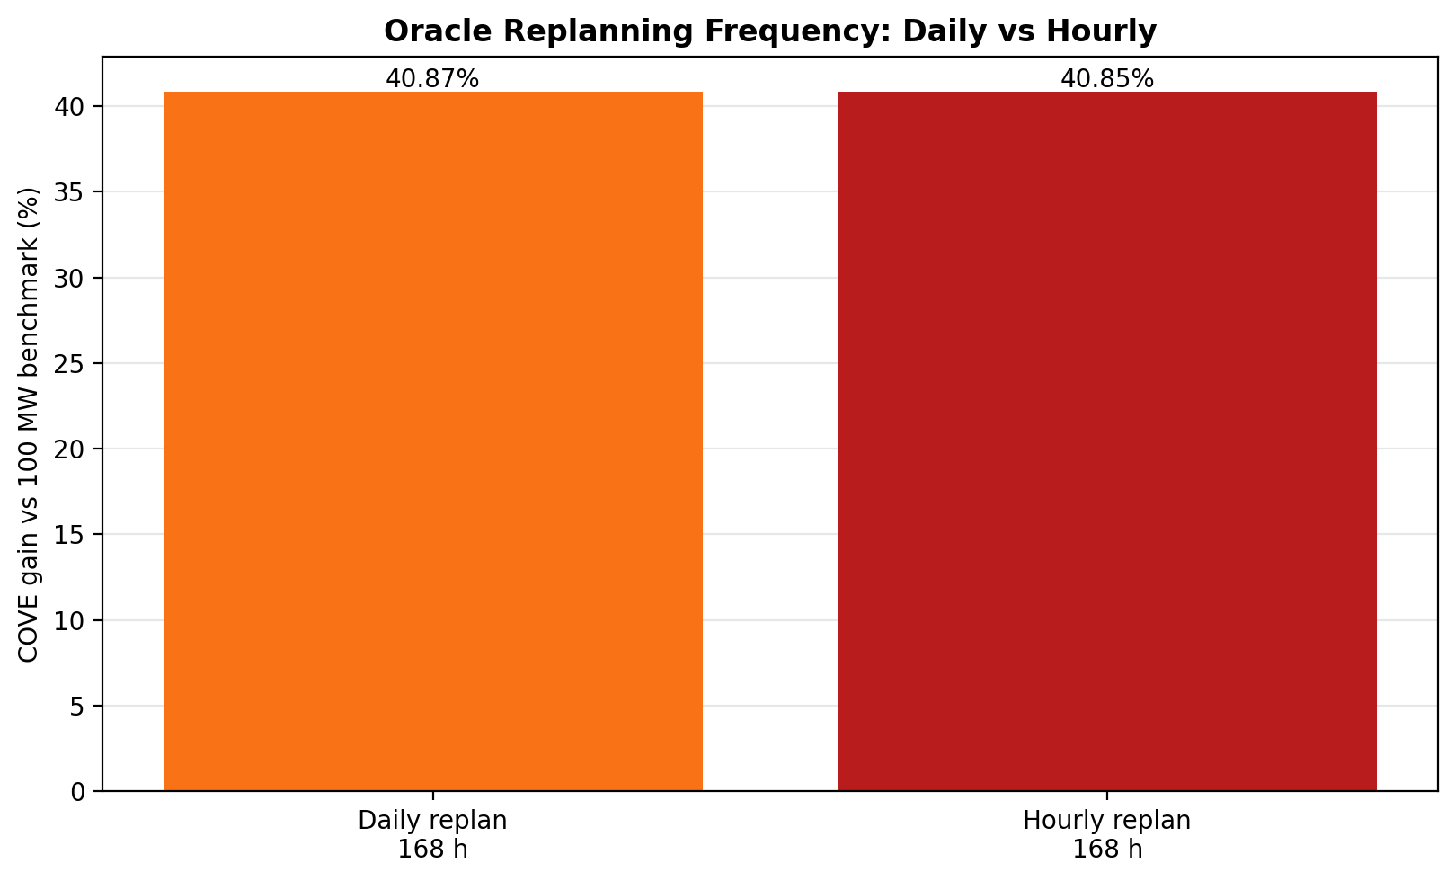
Fig. 20. Daily-replanning oracle and hourly oracle ceiling are reported separately.

VIII. Discussion
The current results change the paper story. The main comparison is no longer wind-only. The main comparison is the 100-MW Constant-Output Baseload Benchmark because it is a storage benchmark using the same CAES device. Wind-only remains useful, but it answers a different question: what happens if the wind farm uses no storage at all?
The deterministic controller improves over the 100-MW benchmark, but it is still fragile because it trusts one forecast. The scenario controller improves the result because it plans for a small set of possible futures. This does not make the forecast perfect; it makes the dispatch less dependent on a single forecast path.
Constraint integrity was audited after rerunning the current outputs. The audit checked 16 hourly output files, and all 16 passed the common 100 MW / 10 h configuration checks. This matters because a storage dispatch result is only meaningful if it does not create energy, violate SoC bounds, exceed power ratings, or exceed the grid export cap.
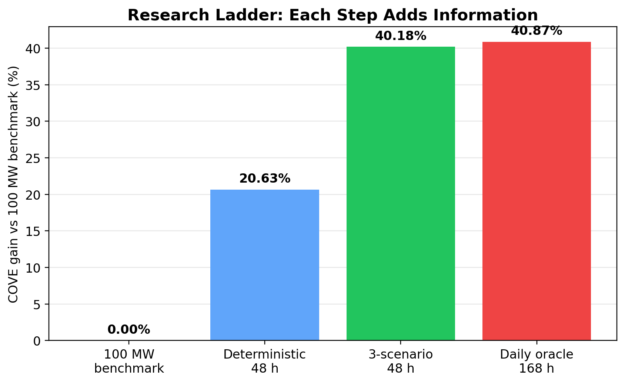
Fig. 21. Final experimental ladder with the 100-MW benchmark as the primary comparison.
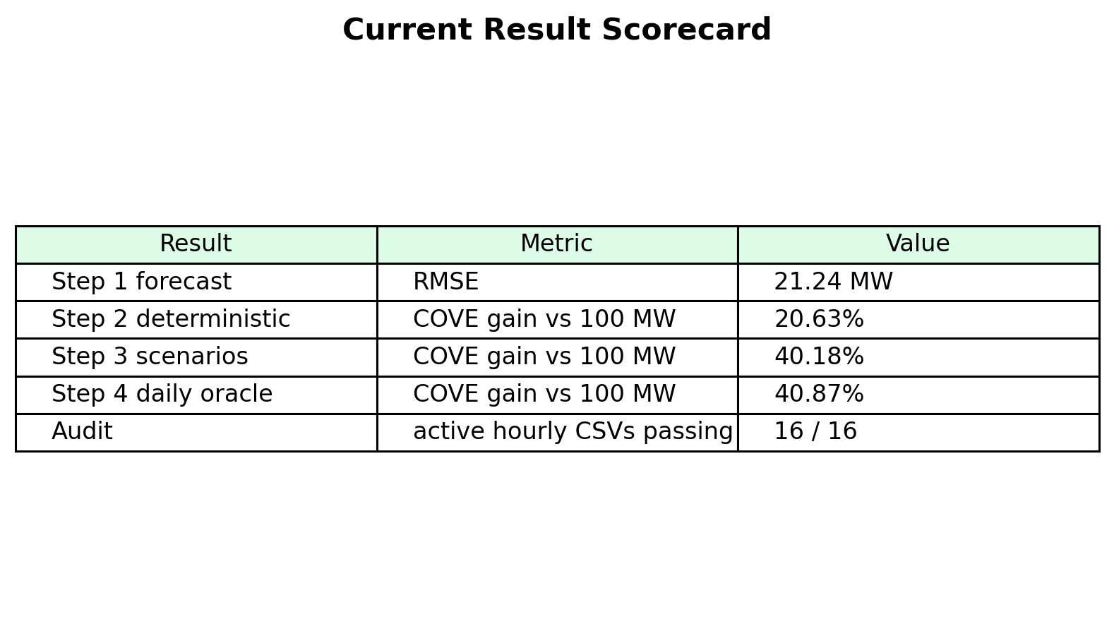
Fig. 22. Current paper-ready scorecard.

IX. Conclusion
This project developed a forecast-aware rolling-horizon dispatch pipeline for a hybrid wind-storage system. The final revised comparison uses a physically meaningful 100-MW constant-output storage benchmark as the main reference. The deterministic 48-hour controller improves over this benchmark, and the three-scenario controller improves further.
The main research takeaway is that better wind-storage dispatch is not only a storage-sizing problem. It is an information problem: forecast quality, planning horizon, scenario construction, and chronological SoC accounting jointly determine whether storage creates value. Future work should focus on stronger probabilistic forecasting, formal scenario calibration, additional storage technologies, and updated external validation data.

References
[1] Z. Lawrence and J. Yao, prior deep wind model dispatch project materials and repository.
[2] N. Hosseiniimeni, storage dispatch formulation and MILP guidance for hybrid renewable-energy storage.
[3] Pacific Northwest National Laboratory, Energy Storage Grand Challenge Cost and Performance Database.
[4] Electric Reliability Council of Texas, ERCOT market data and locational marginal price definitions.
[5] Gurobi Optimization, Gurobi Optimizer Reference Manual.
[6] T. Hastie, R. Tibshirani, and J. Friedman, The Elements of Statistical Learning.
[7] A. J. Conejo, M. Carrión, and J. M. Morales, Decision Making Under Uncertainty in Electricity Markets.

