Chapter 3 The Enhanced E-R Model and Business Rules

Chapter Overview

The purpose of this chapter is to present some important extensions to the E-R model (described in Chapter 2) that are useful in capturing additional business meaning. In particular, we describe two types of extensions to the E-R model. First, the enhanced entity-relationship (EER) model includes constructs for supertype/subtype relationships. Second, the inclusion of new notation for business rules allows the designer to capture a broader range of constraints on the data model than were previously available.

Chapter Objectives

Specific student objectives are included in the beginning of the chapter. From an instructor’s point of view, the objectives of this chapter are to:

1. Introduce the concept of supertype/subtype relationships, and prepare the student to recognize when to use these relationships in data modeling.
2. Describe the use of specialization (top-down perspective) and generalization (bottom-up perspective) as complementary techniques for defining supertype/subtype relationships.
3. Introduce notation for specifying both completeness constraints and disjointness constraints when modeling supertype/subtype relationships.
4. Help students gain sufficient perspective so that they recognize when to use (and when not to use) supertype/subtype relationships in realistic business situations.
5. Describe the basic premises of a business rules paradigm.
6. Discuss the universal data model and its use in packaged data models.

Key Terms

Attribute inheritance | Generalization | Subtype discriminator
Completeness constraint | Overlap rule | Supertype
Disjoint rule | Partial Specialization rule | Supertype/subtype hierarchy
Disjointness constraint | Specialization | Total specialization rule
Enhanced entity-relationship (EER) model | Subtype | Universal data model
Entity cluster

Classroom Ideas

1. Introduce the concept of supertypes and subtypes with a familiar example, such as VEHICLE (subtypes are CAR, TRUCK, SUV, etc.).
2. Introduce the basic notation for supertype/subtype relationships (Figure 3-1). Use this notation to represent the example you introduced in (1). Introduce your students to all three types of notation.
3. Discuss the EMPLOYEE example with subtypes (Figure 3-2). Use this figure to introduce the example of attribute inheritance.
4. Use Figure 3-3 to discuss the two major reasons for introducing supertype/subtype relationships: unique attributes among subtypes, and unique subtype relationships.
5. Contrast generalization and specialization using Figures 3-4 and 3-5. Have your students suggest other examples that use each of these techniques.
6. Introduce the completeness constraint using Figure 3-6. Give other examples where either the total specialization rule or the partial specialization rule is more appropriate.
7. Discuss the disjointness constraint and related notation using Figure 3-7. For reinforcement, have the students work Problem 8 or 9 (Problems and Exercises) in class.
8. Introduce notation for a subtype discriminator (Figures 3-8 and 3-9). Discuss why a different notation is required for the two cases shown in these figures.
9. Discuss entity clustering and illustrate with Figures 3-13 and 3-14.
- Review the extended example of a supertype/subtype hierarchy shown in Figure 3-10. For reinforcement, ask the students to work Problem 2 (Problems and Exercises) in class.
- Review universal data models and discuss how these are being used more widely today. Consider inviting an industry guest speaker to discuss how these universal data models are utilized in his/her company. If your students have access to computers during your class session, break the students into small groups and have them complete Review Question 16 then report back to the large class with their findings.
- Ask your students for examples of other business rules they have encountered recently in their work, school, or home experience that could be modeled with supertype/subtype hierarchies. See if they can diagram these rules using the notation provided in this chapter.

Answers to Review Questions

1. Define each of the following terms:
- Supertype. A generic entity type that has a relationship with one or more subtypes
- Subtype. A subgrouping of the entities in an entity type that is meaningful to the organization
- Specialization. The process of defining one or more subtypes of the supertype, and forming supertype/subtype relationships
- Entity cluster. A set of one or more entity types and associated relationships grouped into a single abstract entity type
- Completeness constraint. A type of constraint that addresses the question whether an instance of a supertype must also be a member of at least one subtype. The completeness constraint has two possible rules: total specialization and partial specialization
- Enhanced entity-relationship (EER) model. The model that has resulted from extending the original E-R model with new modeling constructs such as supertypes and subtypes
- Subtype discriminator. An attribute of the supertype whose values determine the target supertype or subtypes
- Total specialization rule. Specifies that each entity instance of the supertype must be a member of some subtype in the relationship
- Generalization. The process of defining a generalized entity type from a set of more specialized entity types
- Disjoint rule. Specifies that if an entity instance (of the supertype) is a member of one subtype, it cannot simultaneously be a member of two (or more) subtypes
- Overlap rule. Specifies that an entity instance can simultaneously be a member of two (or more) subtypes
- Partial specialization rule. Specifies that an entity instance of the supertype is allowed not to belong to any subtype
- Universal data model. A generic or template data model that can be reused as a starting point for a data modeling project

2. Match the following terms and definitions:
d supertype
f entity cluster
a subtype
e specialization
g subtype discriminator
c attribute inheritance
b overlap rule

3. Contrast the following terms:
- Supertype; subtype. A supertype is a generalized entity type that has one or more subtypes, while a subtype is a subgrouping of the entities in a supertype.
- Generalization; specialization. Generalization is the process of defining a generalized entity type from a set of more specialized entity types, while specialization is the process of defining one or more subtypes of the supertype.
- Disjoint rule; overlap rule. With the disjoint rule an instance of a supertype must be a member of only one subtype at a given time. With the overlap rule an instance of a supertype may simultaneously be a member of two or more subtypes.
- Total specialization rule; partial specialization rule. With the total specialization rule, each instance of the supertype must be a member of some subtype in the relationship. With the partial specialization rule, an instance of the supertype is allowed not to belong to any subtype.
- PARTY;PARTY ROLE. In a universal data model, PARTY represents persons and organizations independent of the roles they play whereas PARTY ROLE contains information about a party for an associated role.
- Entity; entity cluster. An entity is a person, place, object, event, or concept in the user environment about which the organization wishes to maintain data. An entity cluster is a set of one or more entity types and associated relationships grouped into a single abstract entity type.

4. Two conditions that indicate a designer should consider using supertype/subtype relationships:
- There are attributes that apply to some (but not all) of the instances of an entity type.
- There are relationships that apply to some (but not all) of the instances of an entity type.

- The reasons for using an entity clustering approach in presenting a data model include:
  - Simplifying the presentation of a complex enterprise-wide E-R diagram.
  - Enabling a hierarchical decomposition of a macro-level data model into finer and finer views of the data.
  - Desiring to focus part of the model on an area of interest to a community of users.
  - Creating several different entity cluster segments each with a different focus, such as departments, information system applications, business processes, or corporate divisions.

6. An example of a supertype/subtype relationship:
The supertype PERSON has many possible subtypes: MALE, FEMALE, INFANT, TEENAGER, etc, assuming these different types of persons have somewhat different attributes or participate in different relationships. In an organizational context, PERSON may have subtypes of EMPLOYEE, CONTRACTOR, CUSTOMER, VENDOR, MANAGER, etc.

7. Attribute inheritance is the property that subtype entities inherit values of all attributes of their supertype(s). This property is important because it makes it unnecessary to include supertype attributes redundantly with subtypes.

8. Give examples of:
- Supertype/subtype relationship where the disjoint rule applies: PERSON has subtypes MALE and FEMALE.
- Supertype/subtype relationship where the overlap rule applies: PERSON has subtypes INSTRUCTOR and STUDENT.

9. The types of business rules that are normally captured in an EER diagram include terms, relationship constraints, and supertype/subtype relationships (see Figure 3-11).

- The purpose of a subtype discriminator is to determine the target subtype (or subtypes) for each instance of a supertype.

- A packaged data model is most useful when one can easily customize it to the specific business (that is, the organization is very similar to other organizations for the same industry or purpose or the functional area is roughly the same as that functional area in other organizations). As long as the packaged data model is for the type of business or functional area, then it can generally be customized. The amount of customization depends upon the types of specialized business rules in place for the organization.

- A packaged data model provides the metadata of a standardized, industry-vetted data model usually built with a structured data modeling tool (i.e., ERWin from Computer Associates or Oracle Designer from Oracle Corporation). A data modeling project that starts with a packaged data model is different from one that would develop a model from scratch along the following dimensions:

  - The project would begin by identifying the parts of the packaged data model that apply to your specific project’s data modeling situation, rather than beginning to draw model elements.
  - The identified data elements from the packaged data model would be renamed to terms local to the organization.
  - Data in the packaged data model would be mapped to data in current organization databases, with the intent of developing migration plans for converting organizational data.
    - Understand that some of the data will not be able to be mapped (e.g., data elements in the package won’t be in the current systems, and likewise). Determine that each non-mapped item is essential and unique, as well as whether these requirements are necessary now or in the future.
    - Recognize that a purchased data model will have business rules to cover all possible circumstances where your specific local situation may need less flexibility and complexity.
    - The purchased data model can be used to “seed” questions for coverage with the end users of the new system and database, allowing for earlier and more in-depth participation of system users and managers in the data modeling project.
    - The comprehensive nature of the purchased data model will likely force the project to prioritize the staging of systems requirements related to customization of the overall data model.

- Data profiling is a way to statistically analyze data to uncover hidden patterns and flaws. Profiling can find outliers, see shifts in data distribution over time, and identify other phenomenon. Each perturbation of the distribution of data may tell a story, such as showing when major application system changes occurred, or when business rules changed. Often these patterns suggest poorly designed databases (e.g., data for separate entities combined to improve processing speed for a special set of queries but the better structure was never restored). Data profiling can also be used to assess how accurate current data are and anticipate the clean-up effort that will be needed to populate the purchased data model with high-quality data.

- A data modeling project using a packaged data model requires at least the same amount of skill as a project not using a packaged data model, and in some cases, may require more skill. The primary reason is that when a data modeling project uses a packaged data model, the data modeler must customize the packaged data model to meet local organizational needs and constraints. Thus, a successful data modeler using a packaged data model needs advanced skills and knowledge about the organization’s business rules, complex data modeling formalisms, and the structured data modeling tool used to specify the packaged data model.

- A packaged data model provides the metadata of a standardized, industry-vetted data model usually built with a structured data modeling tool (i.e., ERWin from Computer Associates or Oracle Designer from Oracle Corporation). The packaged data model contains a fully populated description of the data model and the structured data modeling tool that permits customization of the data model and printing of several reports from the model. The structured data modeling tool often includes the ability to produce SQL commands for database definition in a variety of database management systems.

- A subtype/supertype hierarchy is useful when you have several subtypes that are also supertypes. An example would be for bank accounts. At the first level, you can have savings, checking and loans. Underneath loans, there are several subtypes, including personal, auto, home, etc.

- A member of a supertype is always a member of at least one subtype when the rule of total specialization applies to an EERD.

Solutions to Problems and Exercises

- An example listing follows for a GRADUATE STUDENT:

Attribute Name | Data Value
SSN | 736-94-1802
Name | Jessica James
Address | 25 Lake Dr. Medford OR 95106
Gender | female
Date_of_Birth | Oct. 23, 1967
Major_Dept | Computer Science
Test_Score | 986

2.
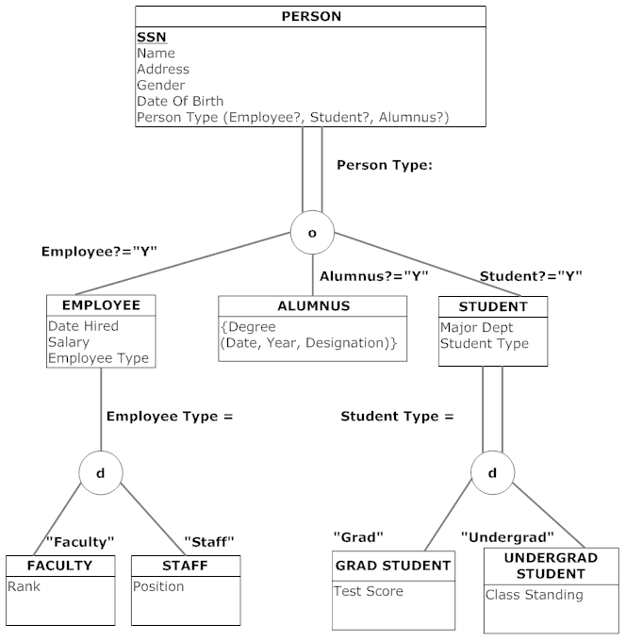
3.
a.

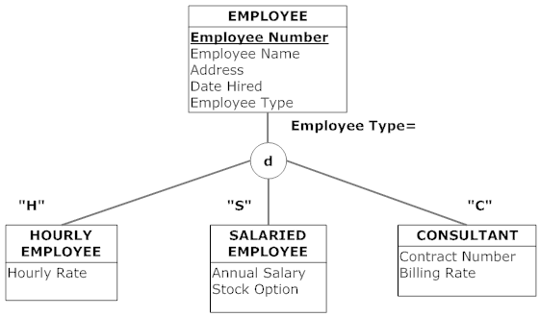

b.
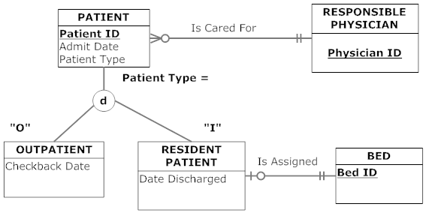

c.
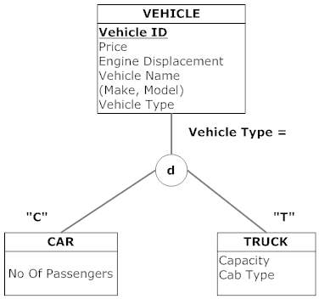

d.
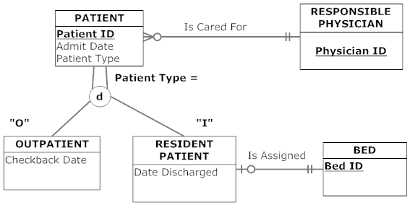

e.
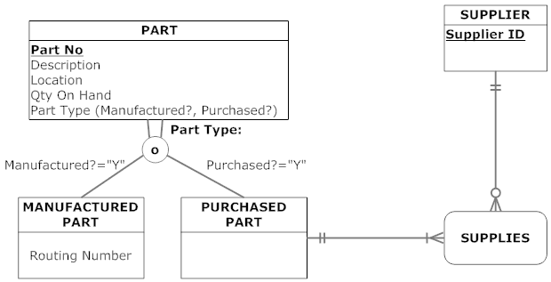

4. Sample definitions:
EMPLOYEE: a person who has signed an employment agreement or contract with the company.
HOURLY EMPLOYEE: an employee whose pay is based on number of hours worked.
SALARIED EMPLOYEE: an employee who receives a fixed salary each pay period.
CONSULTANT: an employee who has signed an employment contract and whose pay is based on an agreed billing rate.
Employee Number: an employee’s social security number.
Employee Name: an employee’s name consisting of first name, middle initial, and last name.
Address: an employee’s home address, consisting of street address, city, state, and zip code.
Date Hired: the date when an employee signed an employment agreement or contract.
Hourly Rate: the pay rate ($/hour) for an hourly employee.
Annual Salary: the base annual salary for a salaried employee.
Stock Option: the annual compensation (shares/year) of company stock for a salaried employee.
Contract Number: the number on the employment contract signed by a consultant.
Billing Rate: the compensation ($/hour or other stated period) on the employment contract signed by a consultant.

5. Sample definitions:
PATIENT: a person who has been admitted to the hospital, or to a treatment program administered by the hospital.
OUTPATIENT: a person who has been admitted to a program of treatment administered by the hospital.
RESIDENT PATIENT: a person who has been admitted for a stay in the hospital and assigned to a bed location.
RESPONSIBLE PHYSICIAN: a physician who has formally admitted patient to the hospital.
BED: a hospital bed located within a room in the hospital.
Is Cared For: the relationship between a physician and a patient admitted to the hospital by that physician.
Is Assigned: the relationship between a resident patient and the hospital bed to which that patient is assigned.
Patient ID: a patient’s social security number.
Patient Name: a patient’s first and last name.
Admit Date: the date when a patient was most recently admitted to the hospital or to a treatment program.
Checkback Date: the date when an outpatient is scheduled for a return visit.
Date Discharged: the date when a resident patient was discharged following the most recent stay in the hospital.
Physician ID: a unique identification number for an admitting physician.
Bed ID: a unique identification number for each hospital bed.

6.
a. Because only regular customers (as opposed to national customers) do business in a sales territory, then not all instances of the customer entity cluster do business in a selling unit. However, because all sales territories do business with at least one regular customer, then all sales territories do business with at least one instance of a customer entity cluster.

b. The attributes of item would be the attributes of PRODUCT and PRODUCT LINE from Figure 2-22: Product ID, Product Description, Product Finish, Product Standard Price, Product Line ID, Product Line Name.

c. The attributes of material would be the attributes of RAW MATERIAL, SUPPLIES, SUPPLIER, and VENDOR from Figure 2-22: Vendor ID, Vendor Name, Vendor Address, Supply Unit Price, Material ID, Unit Of Measure, Material Name, Material Standard Cost.

7. No, none of the vehicle classifications has a unique attribute or a unique relationship. Instead, Vehicle Category should be an attribute of the Vehicle entity type.

8a.

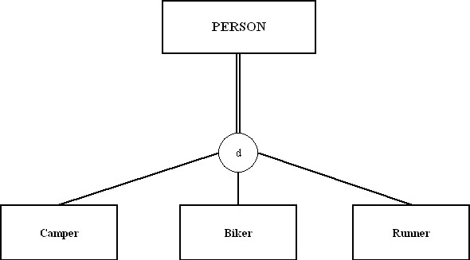

8b.
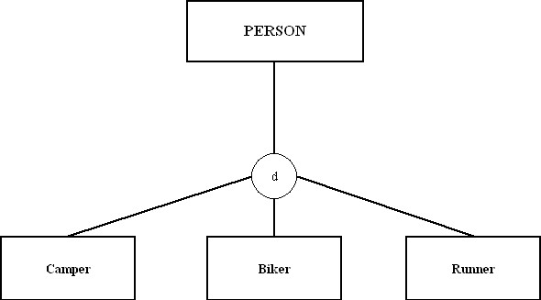

8c.

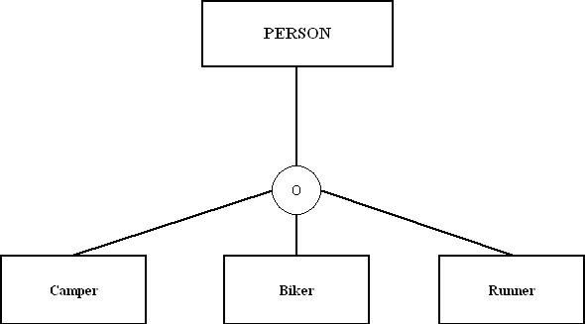

8d.
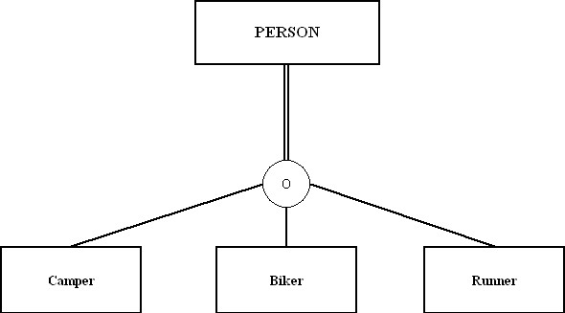

9. Standard EER Notation:

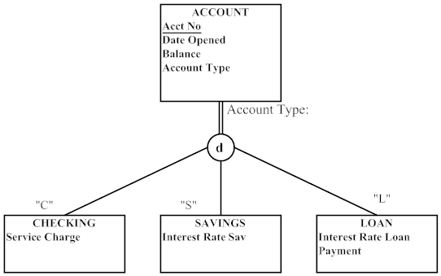

9) Visio Notation:

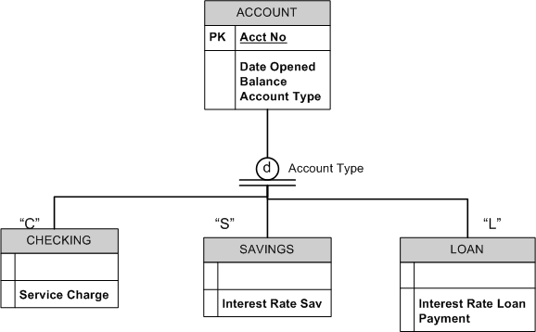

9) Subtype in Supertype Notation:

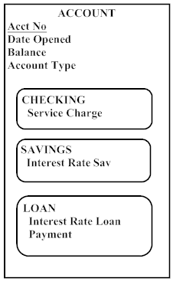

10. E-R Diagram from Chapter 2 Problem 20 with Entity Clusters:

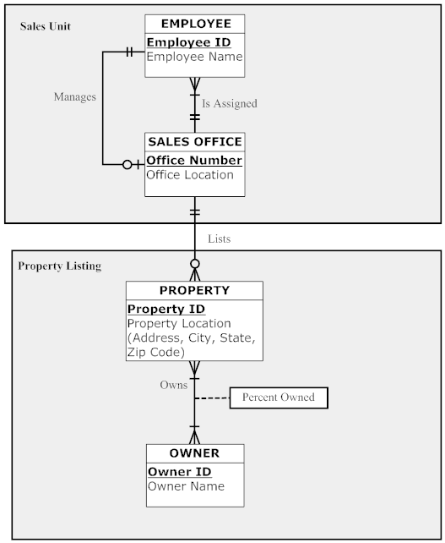

10 (continued)

The Sales Unit cluster can be used by people only interested in how the business is managed, without concern for the properties listed.
The Property Listing cluster can be used by people who are interested in property that is currently listed or who owns that property.



11. E-R Diagram from Chapter 2, Problem 23 with Entity Clusters:

There are three entity clusters: Project Detail, Employee Detail, and Dept Detail.
Project Detail contains the set of entities that would be used by one interested in the project without concern for the specific employees on the project. An assumption is that the only concern from the project side is to track employee skills and location, not individual employees.

The Employee Detail cluster would be of most value to the user who was interested in what skills specific employees have as well as location. Other details are available in this cluster, such as marriage. This cluster was chosen since one can then isolate employee information without looking at project information.

The Dept Detail cluster was chosen since one might not be concerned about vendors, however one might want to know what department a given employee works for. In the same way, one might want specifics about vendors without needing information about employees or projects.

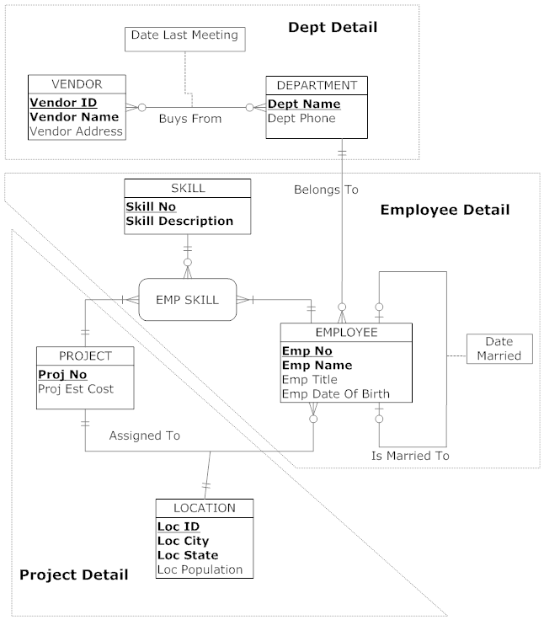

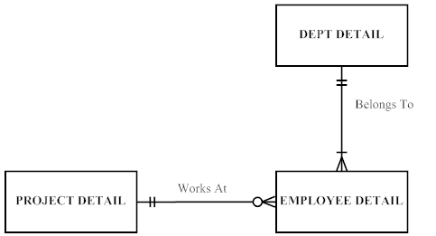
12. Please note that the problem does not explicitly state that Skill is a multivalued attribute. Given the fact that examples in the text have skill as a multivalued attribute, we have made this assumption here also.

EER Notation:
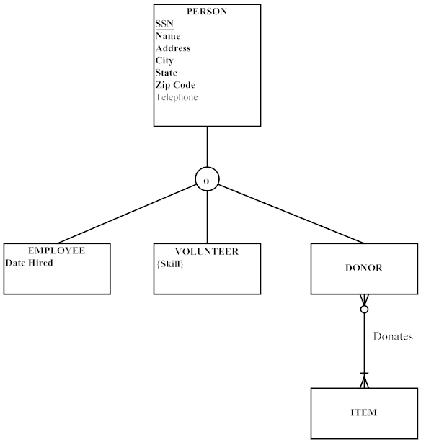

12) Visio Notation:
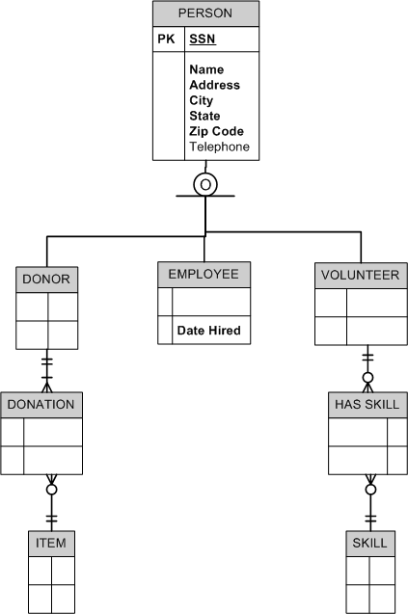
12) Subtypes inside Supertypes Notation
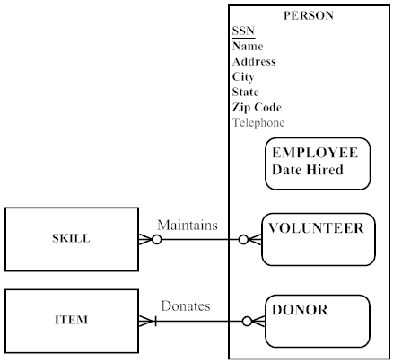

13. Note: Again, we have assumed that Skill is a multivalued attribute.

Standard EER Notation:
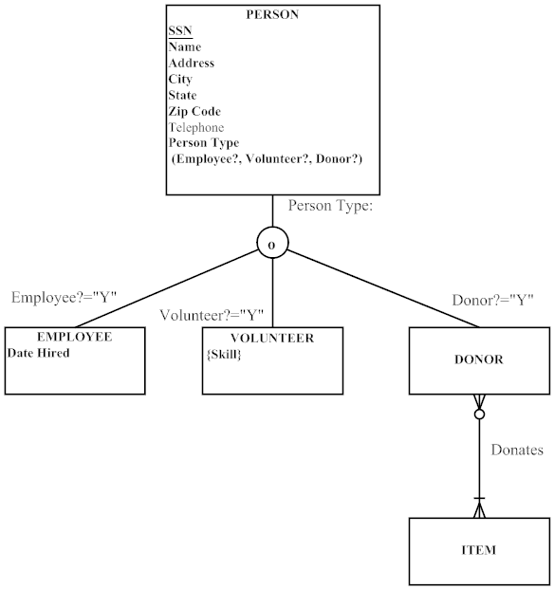
13) Visio Notation:
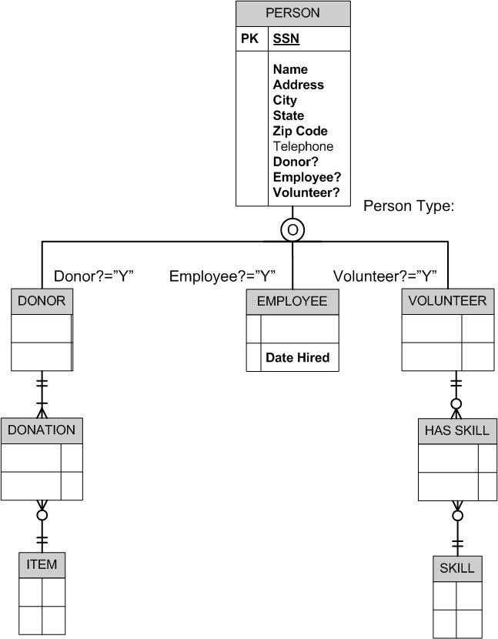
13) Subtypes inside Supertypes Notation:
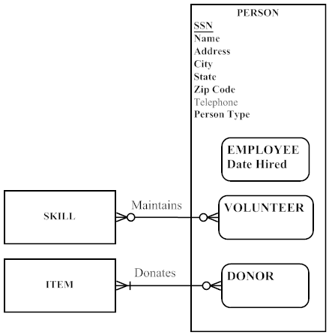

14. Notes to instructor: Student answers may vary depending upon their interpretation of the exercise situation. The solutions presented here are representative of possible answers, given certain assumptions. These notes are presented here for your reference:

a) An alternative solution could be to set ORGANIZATION as a supertype with INTERNAL and EXTERNAL subtypes. However, the exercise does not indicate unique attributes or special relationships between the proposed subtypes and any other entities, thus no supertype-subtype hierarchy is shown in these solutions. More questions would need to be asked of the end users to determine the appropriate model for this situation.

b) Another possible solution to this exercise would be to create a supertype of PARTY with subtypes of PERSON and ORGANIZATION. There is significant overlap of attributes between these two entity types that could suggest such a solution.

EER Notation:

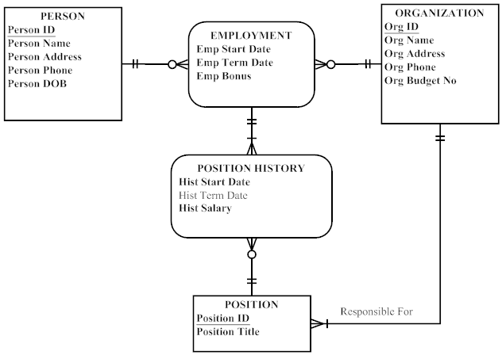
14) Visio Notation:

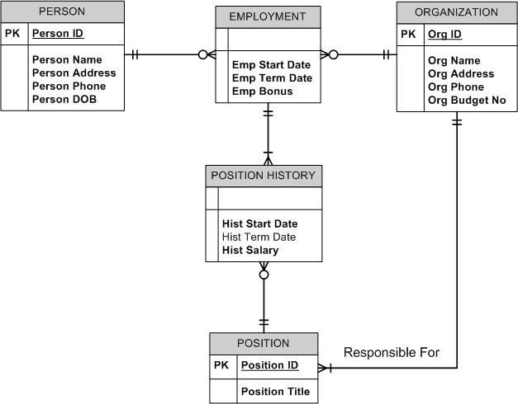

14) Subtypes within Supertypes Notation:

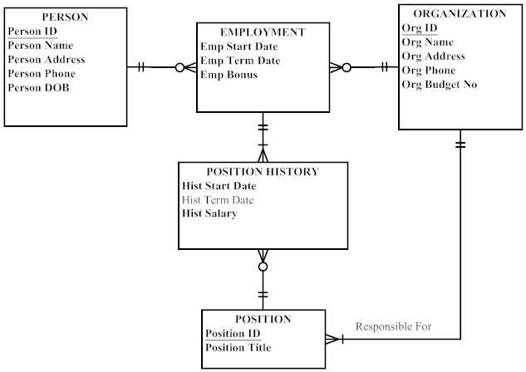

15. Note to instructor: This Problem & Exercise has a different written scenario than a similar one in Chapter 2. The plural “requested judgment characteristics” in Chapter 2 is semantically different from this exercise’s “requested judgment characteristic” which results in the alternate model solution shown below. This may be useful to point out to students regarding the importance of paying attention to fine details while modeling data.

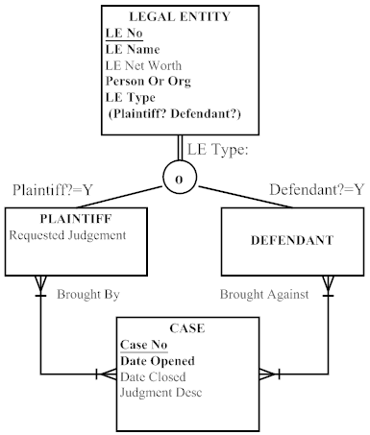

Notes:
1) Person Or Org attribute denotes Person or Organization type of Legal Entity. There is no reason to show Person and Organization as subtypes of Legal Entity, as there are no special attributes or relationships identified in the scenario.
2) The same legal entity cannot be both a Plaintiff and Defendant in the same Case.
3) Although DEFENDANT has no other unique attributes, it is required as a subtype to show the parties involved in a CASE. Further, the DEFENDANT subtype is necessary to show the Brought Against role that is necessary to defining the parties in a CASE.

16. EER Notation

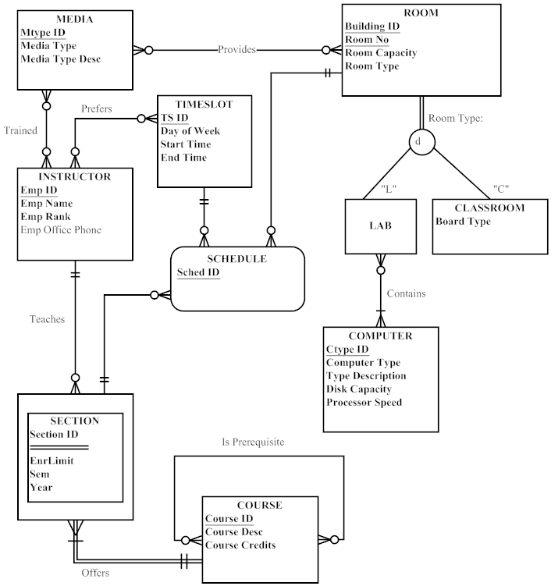
16) Visio Notation:

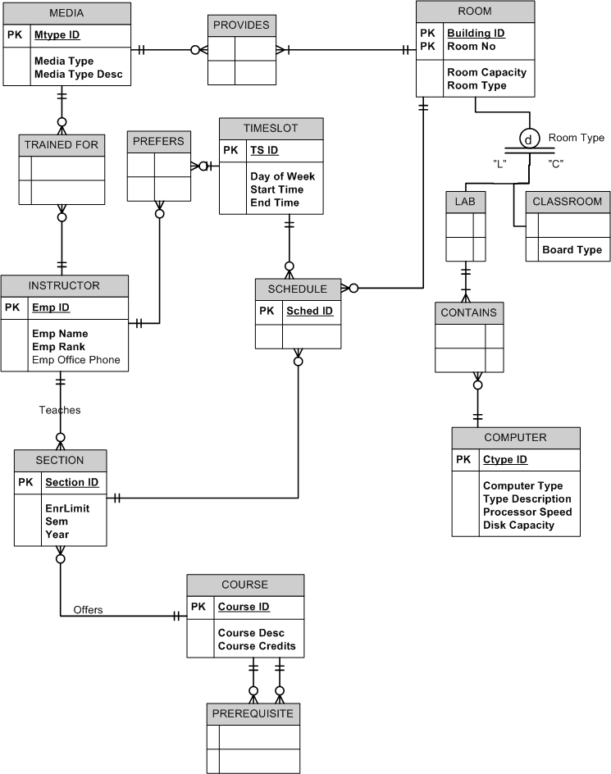
16) Subtype within Supertype Notation:
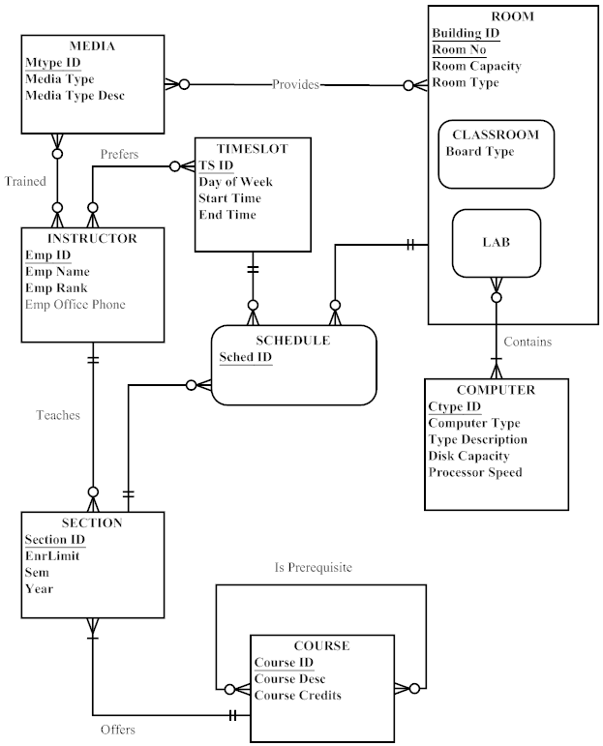
17. EER Notes (for all notations):
a) A CONSULTANT is either a Business or Technical consultant, not both.

EER Notation:

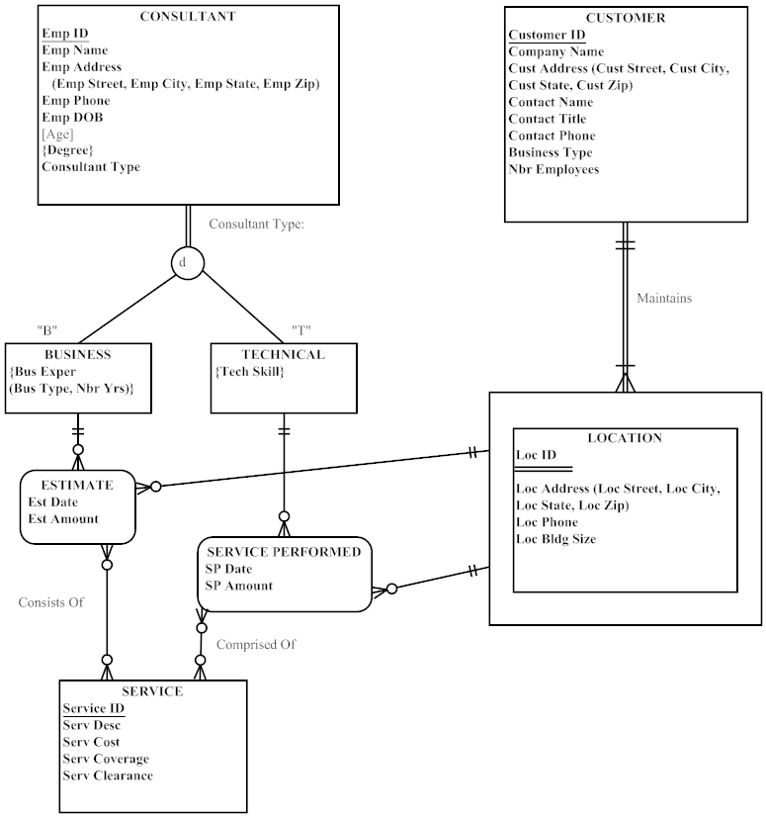
17) Visio notation:

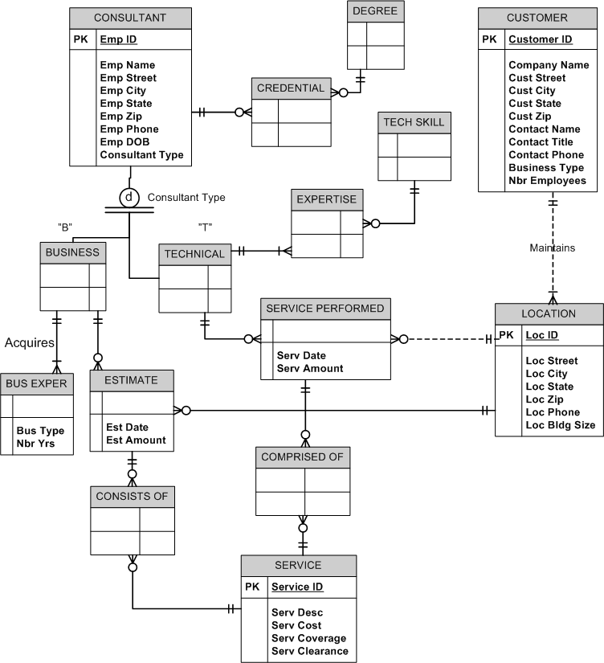
17) Subtype within Supertype Notation:

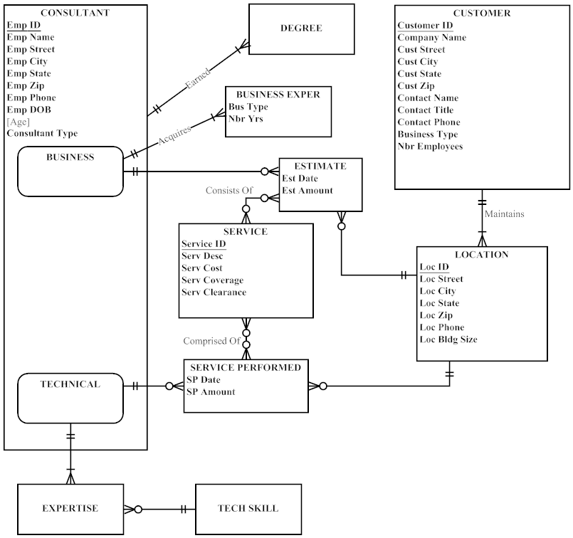

18. Selected Sample Definitions
CONSULTANT: a person who has signed an employment agreement or contract with the company, and who is on the company payroll.
BUSINESS CONSULTANT: a consultant who provides an estimate to a
customer.
TECHNICAL CONSULTANT: a consultant who provides security services to a
customer.
CUSTOMER: a business that requires security services.
LOCATION: one or more places of business for a customer.
SERVICE: a security service that can be performed.
ESTIMATE: A written estimate prepared by a business consultant for a location.
SERVICE PERFORMED: actual services performed by a technical consultant for a location.
Emp ID: a consultant’s employee id.
Degree: a consultant’s academic credential.
Business Experience: a business consultant’s business experience.
Tech Skills: a technical consultant’s technical expertise
Coverage: how much of an area a service covers for a given location.

19.

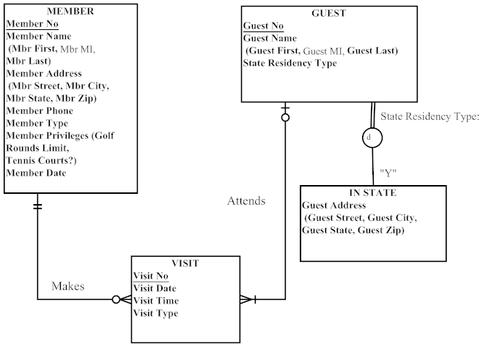

Notes for EERD:
1) Member Type values are Golf or Non-Golf.
2) Social and Tennis members are considered Non-Golf members. A Social member has a Golf Rounds Limit of 2 and Tennis Courts? = N. A Tennis member has a Golf Rounds Limit of 4 and Tennis Courts?=Y. A Golf member has a Golf Rounds Limit of 999 and Tennis Courts?=Y.
3) Golf members’ visits are tracked only if they bring a guest.
4) If a Guest becomes a Member, then Guest records are archived out of the database.
5) Member Date tracks the membership date of the Member.

20.
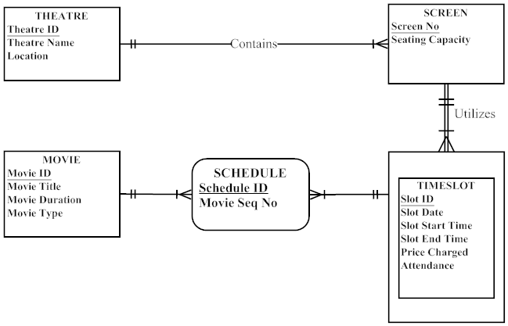

Notes for EERD:
1) Owners wish to know the attendance and Price Charged for each TIMESLOT (i.e., there is a charge with an attendance to see everything shown on a SCREEN in the same TIMESLOT).
2) Movie Seq No tracks the sequence in which movies are shown in the TIMESLOT (e.g., in a timeslot there might be two trailers, followed by two commercials, followed by a feature film, and closed with a commercial).

21.

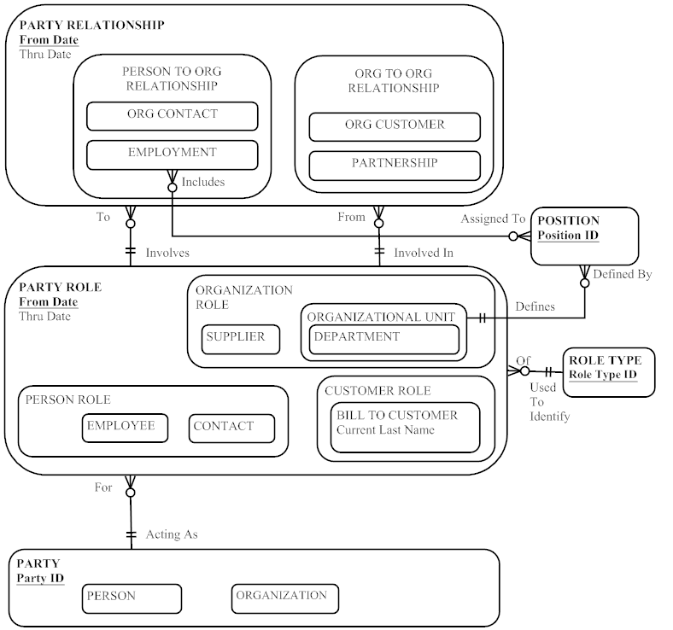

Notes:
1) A PERSON, in his/her EMPLOYMENT, may hold multiple POSITIONs or not yet have an assigned POSITION (this is shown with the 0:M cardinality near POSITION from EMPLOYMENT).
2) A POSITION might initially be unfilled, or over time, may be filled with multiple EMPLOYMENT instances of PERSONs (this is shown by the 0:M cardinality near EMPLOYMENT from POSITION).

Suggestions for Field Exercises

- Common examples of supertype/subtype constructs may be easy for student interviewees to identify. Ask your students to try to find an example of each of the rules described in the chapter: disjoint, overlapping, partial specialization, and total specialization. Also, for each example, have your students identify a candidate subtype discriminator. Ask your students to justify the use of supertype/subtype relationships for each of these examples, using the guidelines stated in the chapter.

- We suggest that you use this exercise as a continuation of Field Exercise 2 in Chapter 2. Ask your students to determine whether supertype/subtype relationships are formally modeled in the corporate E-R diagrams. Also, ask your students to determine how business rules are stated and enforced by each organization.

- We suggest you assign this exercise in conjunction with Field Exercise 4 in Chapter 2.

- Following are several questions that can be used to structure this report:
- How are business rules defined?
- Why are business rules important to an organization?
- What are alternative methods for capturing and expressing business rules?
- What advantages can an organization realize by formally capturing business rules?

- The availability of websites that provide information on this topic changes rapidly. This might be an excellent exercise to bring in an industry guest speaker to address your students. Possible sites that students may find information about this topic include:
  - www.universaldatamodels.com (note: site will point to Embarcadero ER/Win product for more information on what the models include, but the images may not be fully readable)
  - www.inmoncif.com (note: under the “Corporate Information Factory” section, there are sample models available to view, however, visitors must register an email address to access the materials)

Project Case

Case Questions

1. Yes, the ability to model supertype/subtype relationships is likely to be very important for a hospital. A modern hospital is a triumph of specialization. Many hospital entities are likely to have subtypes, for example:
ITEM: possible subtypes are Supply, Item, and Prescription Item
PATIENT: possible subtypes are Inpatient and Outpatient
TEST: possible subtypes are Scan and Blood test
PROCEDURE: possible subtypes are Biopsy and Surgical

3. Yes, the entity VISIT (scheduled for outpatients) is a weak entity as it does not have an independent business meaning to the hospital without the OUTPATIENT entity in the EERD. BED is also a weak entity for RESIDENT and CARE CENTER entities. Multivalued attributes include Volunteer Reference Information (business rules indicate at least 2 references are necessary), MVCH Service Information, Volunteer Experience Information, Volunteer Language, Volunteer Skill, Volunteer Interest, and Volunteer Preference Information.

- Student answers will vary based upon their understanding of business rules and their life experiences. Instructors should look at responses for student understanding of the business rules concept, and how these are represented using data modeling formalisms shown in the textbook. A more advanced example is presented below, for possible discussion with students in your classroom presentations and discussions.

A hospital has many business rules. Two examples are the following:
- A patient cannot be admitted to the hospital without a referral from a responsible physician.
- A nurse can be reassigned to a different care center only by permission of the nurse in charge of the care center where the nurse is presently assigned.
These sample business rules are not easy to model using the data modeling formalisms introduced in this version of the textbook, as these business rules require advanced data modeling formalisms using action assertion representations. The action assertion representations are more fully described and specified in the GUIDE Business Rules Project (GUIDE, Final Report, revision 1.2, October 1997).

4. A universal data model for Mountain View Community Hospital would work out well, since hospital applications are quite common. Of course, there would still need to be customization. One justification would be to look at the cost versus the cost savings from developing a database application completely from scratch.

Case Exercises
1. Note to instructor: When assigning this exercise to students, be sure to allow a sufficient amount of time for completion. The case scenario is fairly complex and will encourage students to do a lot of thinking and experimenting prior to developing a workable diagram. Due to the large size of the diagram, and the necessary notes to the diagram, this solution is presented in three parts: notes, diagram (without attributes displayed), and a “diagram” of the entities with all attributes displayed.

Business Rules/Notes for EERD (diagram on next page):
1. Only one entry for the Patient’s Emergency Contact Information is stored in the database.
2. Only the primary insurance information for the Patient is stored in the database. Secondary insurance information (if provided by the Patient) will be stored in paper files.
3. Referring/Primary Care Physician Contact information is stored as part of the PHYSICIAN entity in the database.
4. MVCH wants to track the history of all volunteer assignments within the facility, thus there is a need to use an associative entity (VOL SERV HISTORY) to track over time the various volunteer assignments, and each assignment’s supervisor, as well as the total amount of hours worked on each assignment. Some WORK UNITs do not have VOLUNTEERs, thus a 0:M cardinality is required on its relationship with the associative entity.
5. A VOLUNTEER may be supervised by an EMPLOYEE or a PHYSICIAN at one time. Only one of these “supervision” relationships is active at one point in time, although both are shown on the diagram.
6. MVCH wants to track VOLUNTEER information at the point of application, thus it is possible that a VOLUNTEER instance may not yet have a corresponding instance of VOL SERV HISTORY in the database system (this is why there is a 0:M cardinality nearest the VOL SERV HISTORY associative entity on the relationship from VOLUNTEER).
7. A Registered Nurse (RN) may direct one, none, or several Licensed Practical Nurses (LPNs); a single LPN will be directed by only one RN. MVCH wishes to track these RN direction responsibilities for accountability and quality control purposes within the hospital.
8. A Floater nurse is not assigned to a CARE CENTER, thus this is why there is a 0:M cardinality shown near CARE CENTER on the Assigned relationship. If discussion with end users indicate additional attributes or relationships that are associated with Floater nurses, then an alternative solution could be to establish a FLOATER subtype entity on the diagram. The addition of this FLOATER subtype could allow the cardinality of the Assigned relationship for the NURSE supertype to be changed to 1:M.
9. Skill is modeled as a multivalued attribute of TECHNICIAN as it only relates to this entity and has no additional characteristics mentioned in the case. Under different assumptions, an alternative solution could be to model Skill as its own entity type with a relationship to TECHNICIAN (and possibly other entity types in the model).
10. Only current STAFF and TECHNICIAN assignments to WORK CENTERs are necessary for this case.
11. Only current BED to RESIDENT associations are necessary in the database.

CE1: EERD (Note: attributes by entity are shown on next page; attributes omitted here to conserve space)
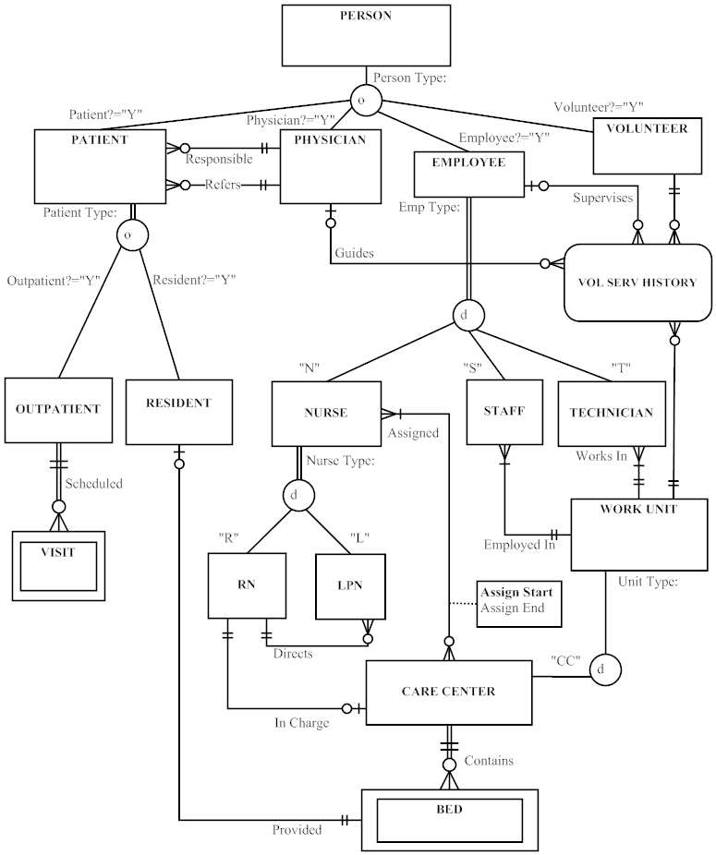

CE1: Attributes listed by entity
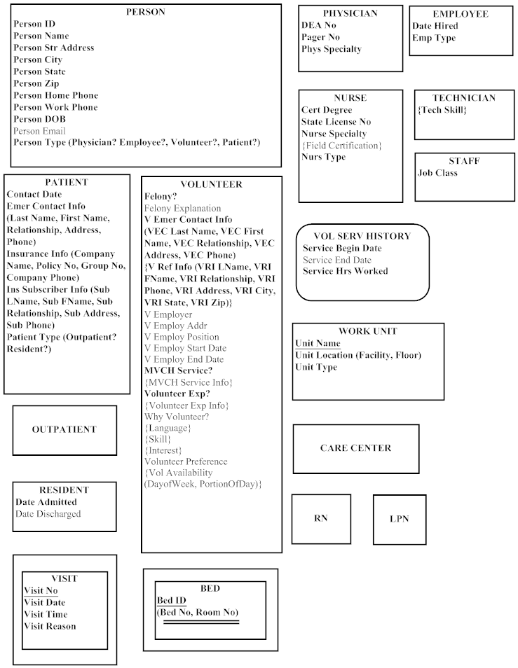

2. A clear approach is to establish two relationships between RN and CARE_CENTER: Day In Charge, Night In Charge. See proposed revision to diagram below.

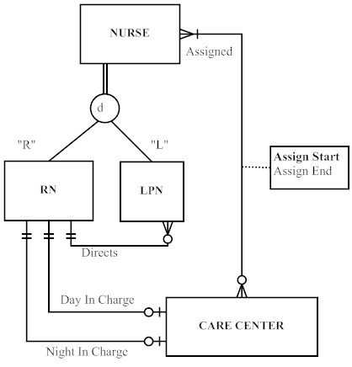

3. Following are some sample definitions:
a. Entity types:
Physician – a person who is licensed to practice medicine in this state.
Patient – a person who has been admitted to Mountain View Community Hospital or who is currently being treated as an outpatient by the hospital.
Employee – a person who has an employment agreement with the hospital and who is on the hospital payroll.
Care center – an organizational unit that performs a related set of services directed toward patient care.

b. Attributes:
Person ID – a unique identifier for each person that does not violate privacy guidelines such as those outlined in HIPAA (e.g., not social security number).
Birth Date – month, day, and year a person was born.
Specialty – a physician’s or nurse’s area of practice.
Location – the floor number and hospital wing for a work unit in the hospital (e.g., care center or diagnostic unit).

c. Relationships:
Provided – associates a resident patient with a hospital bed.
Scheduled – associates an outpatient with an instance of a visit to the hospital.

4. PARTY: Person and Organization/Facility.
PARTY ROLE: There are PersonRoles: Patient, Physician, Employee, Volunteer. Within Employee there are additional roles: Nurse, Staff and Technician. Within Patient, there are additional roles: Resident and Outpatient.
PARTY RELATIONSHIP: There are Person-to-Person relationships: Patient to Physician. There are also Person to Organization: Nurse to Care Center; Staff, Technician to Work Unit.
EVENTS: Communication events include in-person, e-mail and correspondence. Transactions events include orders and tests.
PRIORITY TYPE: If a patient is acute, then his status will be resident.
STATUS TYPE: When a patient is discharged.
EVENT ROLE: Patient, Nurse, Physician.
ROLE TYPE: Person or Organization.

5. A VOLUNTEER may have one EMERGENCY CONTACT. An EMERGENCY CONTACT may be for more than one VOLUNTEER.

A VOLUNTEER must have exactly two REFERENCES. A REFERENCE can act as a
reference for more than one VOLUNTEER.

A VOLUNTEER must have exactly one last EMPLOYER. An EMPLOYER can employ more than one VOLUNTEER.

A VOLUNTEER may have previous volunteer experience.

A VOLUNTEER may have one or more Skills. A VOLUNTEER also may have no Skills.

A VOLUNTEER may have one or more Hobbies. A VOLUNTEER also may have no Hobbies.

A VOLUNTEER may have one or more Interests. A VOLUNTEER also may have no Interests.

A VOLUNTEER may speak one or more Languages (in addition to English).

A VOLUNTEER may have one or more TIMESLOT preferences. A TIMESLOT may be chosen by one or more VOLUNTEERS.

- You can perform a side-by-side comparison to show how the EER diagram provides a more detailed and complete statement of requirements for the hospital. For example, the EER diagram includes information about technicians as well as volunteers.

PROJECT ASSIGNMENTS

P1. A PERSON can be a PATIENT, PHYSICIAN, EMPLOYEE or VOLUNTEER. An instance of PERSON may be more than one of these.

A PATIENT may be only a RESIDENT PATIENT or an OUTPATIENT and cannot be both.

AN OUTPATIENT is scheduled for one or more VISITs. An OUTPATIENT can also be scheduled for no VISITs. A VISIT is for only one OUTPATIENT.

AN EMPLOYEE may only be a NURSE, STAFF or TECHNICIAN and cannot be more than one of these.

A NURSE may be only a Registered Nurse (RN) or Licensed Practical Nurse (LPN) and cannot be both. An RN will direct the work of one, none, or many LPNs: LPN’s work will be directed by only one RN.

A TECHNICIAN is assigned to one or more DIAGNOSTIC UNITs. A DIAGNOSTIC UNIT has one or more TECHNICIANS.

A FACILITY can contain one or more WORK UNITs or may contain no WORK UNITs. A WORK UNIT is part of one and only one FACILITY. Currently defined WORK UNITs include CARE CENTERs and DIAGNOSTIC UNITs.

A CARE CENTER has at least one, and usually many NURSEs assigned to it. Each CARE CENTER has one RN assigned as a Nurse In Charge for the day shift, and one RN assigned as a Nurse In Charge for the night shift. Some NURSEs are floaters and are not assigned to a particular CARE CENTER and will work for more than one CARE CENTER over time; non-floater NURSEs are assigned to a particular CARE CENTER.

A CARE CENTER may contain one or more BEDs or may contain no BEDs, A BED is contained in only one CARE CENTER.

A DIAGNOSTIC UNIT performs one or more TREATMENTs. A TREATMENT is performed by only one DIAGNOSTIC UNIT.

A BED is assigned to one RESIDENT PATIENT or no RESIDENT PATIENTs. A RESIDENT PATIENT is assigned to one BED.

A PHYSICIAN admits one or more PATIENTs or admits no PATIENTs. A PATIENT is admitted by only one PHYSICIAN.

A PHYSICIAN may refer one or more PATIENTs or may refer no PATIENTs. A PATIENT must be referred by one PHYSICIAN.

A PATIENT may consume many ITEMS or may consume no ITEMS. An ITEM is consumed by one or more PATIENTS or may be consumed by no PATIENTS.

An ITEM is supplied by one or more VENDORs. A VENDOR may supply one or more items or may supply no ITEMs.

A PHYSICIAN may write one or more ORDERs or may write no ORDERs for one PATIENT. An ORDER is written by one PHYSICIAN.

An ORDER may consist of one or more ITEMs or no ITEMs. An ITEM may be part of one or more ORDERS or may be part of no ORDERS.

An ORDER may consist of one or more TREATMENTS or no TREATMENTs. A TREATMENT may be part of one or more ORDERs, or no ORDERs.

A PHYSICIAN may complete one or more DIAGNOSES for one or more PATIENTs. A DIAGNOSIS is Completed for one PATIENT by one PHYSICIAN.

P2. Note to instructor: When assigning this exercise to students, be sure to allow a sufficient amount of time for completion. The case scenario is fairly complex and will encourage students to do a lot of thinking and experimenting prior to developing a workable diagram. Due to the large size of the diagram, and the necessary notes to the diagram, this solution is presented in three parts: notes, diagram (without attributes displayed), and a “diagram” of the entities with all attributes displayed.

Business Rules/Notes for EERD (diagram on next page):
1. Only one entry for the Patient’s Emergency Contact Information is stored in the database.
2. Only the primary insurance information for the Patient is stored in the database. Secondary insurance information (if provided by the Patient) will be stored in paper files.
3. Referring/Primary Care Physician Contact information is stored as part of the PHYSICIAN entity in the database.
4. MVCH wants to track the history of all volunteer assignments within the facility, thus there is a need to use an associative entity (VOL SERV HISTORY) to track over time the various volunteer assignments, and each assignment’s supervisor, as well as the total amount of hours worked on each assignment. Some WORK UNITs do not have VOLUNTEERs, thus a 0:M cardinality is required on its relationship with the associative entity.
5. A VOLUNTEER may be supervised by an EMPLOYEE or a PHYSICIAN at one time. Only one of these “supervision” relationships is active at one point in time, although both are shown on the diagram.
6. MVCH wants to track VOLUNTEER information at the point of application, thus it is possible that a VOLUNTEER instance may not yet have a corresponding instance of VOL SERV HISTORY in the database system (this is why there is a 0:M cardinality nearest the VOL SERV HISTORY associative entity on the relationship from VOLUNTEER).
7. A Registered Nurse (RN) may direct one, none, or several Licensed Practical Nurses (LPNs); a single LPN will be directed by only one RN. MVCH wishes to track these RN direction responsibilities for accountability and quality control purposes within the hospital.
8. A Floater nurse is not assigned to a CARE CENTER, thus this is why there is a 0:M cardinality shown near CARE CENTER on the Assigned relationship. If discussion with end users indicate additional attributes or relationships that are associated with Floater nurses, then an alternative solution could be to establish a FLOATER subtype entity on the diagram. The addition of this FLOATER subtype could allow the cardinality of the Assigned relationship for the NURSE supertype to be changed to 1:M.
9. Skill is modeled as a multivalued attribute of TECHNICIAN as it only relates to this entity and has no additional characteristics mentioned in the case. Under different assumptions, an alternative solution could be to model Skill as its own entity type with a relationship to TECHNICIAN (and possibly other entity types in the model).
10. Only current STAFF and TECHNICIAN assignments to WORK CENTERs are necessary for this case.
11. Only current BED to RESIDENT associations are necessary in the database.
12. A NURSE prepares one, none, or many ASSESSMENTs of PATIENTs; A PATIENT receives one to many ASSESSMENTs over time.
13. Assessment ID is unique (surrogate) identifier for ASSESSMENT.
14. A DIAGNOSTIC UNIT is defined to include Labs and other hospital WORK UNITs that perform procedures, tests, and treatments required by ORDERs. A DIAGNOSTIC UNIT performs one to many TREATMENTs; A TREATMENT is performed by one DIAGNOSTIC UNIT.
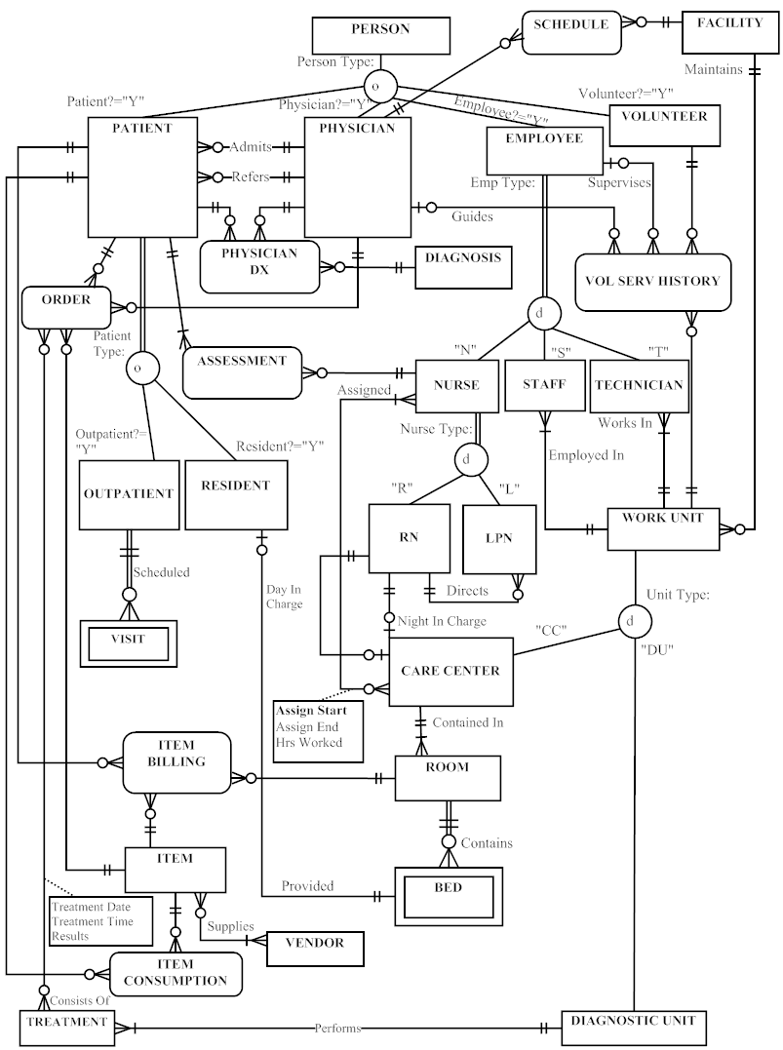
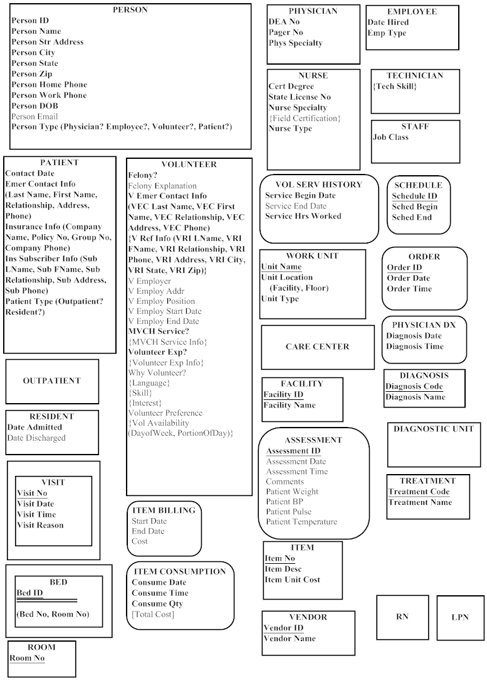
P3. Note to instructors: Student answers may vary slightly; these issues are presented as a possible representation of issues which may be identified. An in-class comparison/contrast of selected student answers to this assignment and that from the prior chapter would be a good hands-on exercise for exploring the upcoming chapter 4 topic of merging issues (homonyms, synonyms, transitive dependencies, and supertype/subtype relationships). Comparing/contrasting the diagrams could lead to a useful discussion of the importance of understanding the meaning of the data in order to resolve issues and ensure appropriate capture of the end user’s data requirements.

Some issues that come up during the merging:
- Should there be a relationship between DIAGNOSTIC UNIT and TECHNICIAN?
- Are items consumed by both resident patients as well as outpatients? (diagram shows current assumption is ‘Yes’)
- What needs to be done to the data model to allow for follow up care for discharged patients?
- We kept the Admits relationship between PATIENT and PHYSICAN in place of the Responsible used in the original EER model (Case Exercise 1, Chapter 3); is this a correct understanding of the relationship, or is another relationship required to show the Responsible association?
- We assumed that the NURSE subtype (both RN and LPN) participates in the ASSESSMENT of PATIENTs and reflects the same relationship as shown by the EMPLOYEE relationship to ASSESSMENT in Chapter 3. Do other EMPLOYEE subtypes (e.g., STAFF or TECHNICIAN) prepare such ASSESSMENTs? Do both types of NURSEs prepare ASSESSMENTs?
- We assumed that a DIAGNOSTIC UNIT is defined to include Labs and other hospital WORK UNITs that perform procedures, tests, and treatments required by ORDERs. Is this a correct assumption or are there other WORK UNITs that need to be tracked in the database?
- In chapter 2, a business rule was indicated that EMPLOYEEs are Assigned to CARE CENTERs and that Hours Worked needed to be tracked for each such assignment in the database. We interpreted this to mean the NURSE subtype in the chapter 3 EER diagram and have added the Hours Worked attribute to the M:N Assigned relationship in the diagram.
- In chapter 2, the identifier for the BED weak entity was described as a composite identifier including Bed No, Care Center ID, and Room No. In chapter 3, the identifier for the BED weak entity was described as a composite identifier including Bed No and Room No. The correct identifier needs to be validated with the end users and finalized in the EER diagram listing of entities.

