Chapter 5 Physical Database Design and Performance

Chapter Overview

This chapter presents the basic steps that are required to develop an effective physical database design. Physical database design is very important as it immediately impacts those factors that are important to the end user: data integrity and security, response times, user friendliness, and so on. First, we present a simple approach to estimating the volume of data in a database, as well as the probable data usage patterns. Next, we discuss issues associated with defining fields, including data type determination, coding and compression techniques, controlling data integrity, and handling missing data. We then discuss designing physical records and include an expanded section on denormalization. Vertical and horizontal partitioning are covered next. We describe the basic file organizations and the trade-offs that are typically involved in selecting a file organization. We examine the use of indexes and have added bitmap indexes to this section. File access performance is discussed, including a discussion of query optimization. The chapter continues to emphasize the physical design process and the goals of that process.

Chapter Objectives

Specific student learning objectives are included at the beginning of the chapter. From an instructor‘s point of view, the objectives of this chapter are to:
- Present physical database design as a critical element in achieving overall database objectives, rather than as an afterthought.
- Ensure that students understand the factors that must be considered in distributing data effectively and how a simple model can be used to obtain at least a first-cut distribution.
- Provide students with a sound understanding of the use of indexes and the trade-offs that must be considered in their use.
- Ensure students understand that denormalization must be used with great care and for specific reasons.

Key Terms

Data type | Hashed file organization | Physical file
Denormalization | Hashing algorithm | Pointer
Extent | Horizontal partitioning | Secondary key
Field | Index | Sequential file organization
File organization | Indexed file organization | Tablespace
Hash index table | Join index | Vertical partitioning

Classroom Ideas
- Point out to your students that physical database design is the last step in the database design process. Suggest to your students that this step is where the “rubber meets the road,“ since regardless of how well previous steps may have been completed, users will not be happy with a sloppy physical design.
- Discuss data volume and usage analysis, using Figure 5-1.
- The Y2K problem can be used to highlight the process of selecting data types. The DATE data type is particularly interesting, both because of this problem, and because of its capability to calculate using date arithmetic in most RDBMSs.
- Using examples of each type of constraint can bring the importance of data integrity home. For instance, you can encourage the students to think through on their own or in small groups, situations where default values will improve data integrity, and situations where using them may decrease data integrity. Range controls, null value controls, and referential integrity can also be addressed this way.
- Discuss denormalization and the conditions under which this approach may be considered, referring to the discussion in the text. Be sure to describe the trade-offs in denormalization.
- Start a discussion of indexes by having the students give common examples (index at the end of their database text, Yellow Pages, card catalog, etc.). Then describe and illustrate the use of each type of index using Figure 5-7.
- Review the basic types of file organizations. Ask your students to give examples other than those described in the text for each organization.
- Query optimization is a fascinating subject that is only touched on lightly in the book. Further examples, perhaps taken from the work of Joe Celko (Joe Celko‘s SQL Puzzles and Answers, and so forth), will be interesting to the students if time permits.

Review Questions
- Define each of the following terms:
- File organization A technique for physically arranging the records of a file on secondary storage devices.
- Sequential file organization Records in the file are stored in sequence according to a primary key value.
- Indexed file organization Records are either stored sequentially or non-sequentially, and an index is created that allows software to locate individual records.
- Hashing file organization The address for each record is determined using a hashing algorithm.
- Denormalization The process of transforming normalized relations into unnormalized physical record specifications.
- Composite key A key made up of more than one column.
- Secondary key One or a combination of fields for which more than one record may have the same combination of values.
- Data type Each unit of a detailed coding scheme recognized by system software, such as a DBMS, for representing organizational data.
- Join index An index on columns from two or more tables that come from the same domain of values.

2. Match the following terms to the appropriate definitions:
d extent
f hashing algorithm
b index
g physical record
e pointer
a data type
c physical file

- Contrast the following terms:
- Horizontal partitioning; vertical partitioning. Horizontal partitioning is very similar to creating a supertype/subtype relationship because different types of the entity (where the subtype discriminator is the field used for segregating rows) are involved in different relationships, hence different processing. Neither horizontal nor vertical partitioning prohibits the ability to treat the original relation as a whole.
- Physical file; tablespace. A physical file is a named portion of secondary memory (magnetic tape, hard disk) allocated for the purpose of storing records; a tablespace is a named set of disk storage elements in which physical files for database tables may be stored.
- Normalization; Denormalization. Normalization is the process of breaking up larger relations with data maintenance issues (i.e., anomalies) into smaller, well-structured relations. Denormalization is the opposite process of normalization, as it takes smaller relations and combines them into bigger relations to produce relations that are processed with less management overhead for queries, reporting, and sometimes data maintenance purposes.
- Range control; Null control. Range controls are upper and lower bound limits on the values that a database field can take, such as 00 to 99 on a two-digit year field as in the Year 2000 issue. Null control refers to whether or not a database field can have a null (empty) value; another way of saying whether or not the field is required (or not) for entry when an instance is created in the database.
- Secondary key; primary key. A secondary key is one or a combination of fields for which more than one record may have the same combination of values; the primary key is one or a combination of fields for which every record has a unique value. Hence, the primary key is a unique identifier for a row.

- Three major inputs to physical design:
- Logical database structures developed during logical design
- User processing requirements identified during requirements definition
- Characteristics for the DBMS and other components of the computer operating environment

- Key decisions in physical database design:
- Choosing the storage format (called data type) for each attribute from the logical data model: the format is chosen to minimize storage space and to maximize data integrity.
- Grouping attributes from the logical data model into physical records: you will discover that although the columns of a relational table are a natural definition for the contents of a physical record, this is not always the most desirable grouping of attributes.
- Arranging similarly structured records in secondary memory (primarily hard disks) so that individual and groups of records can be stored, retrieved, and updated rapidly (called file organizations): consideration must also be given to protecting data and recovering data after errors are found.
- Selecting structures for storing and connecting files to make retrieving related data more efficient (called indexes and database architectures).
- Preparing strategies for handling queries against the database that will optimize performance and take advantage of the file organizations and indexes that you have specified: efficient database structures will be of benefit only if queries and the database management systems that handle those queries are tuned to intelligently use those structures.

- Developing field specifications:
- Define the data type used to represent values of the field.
- Establish data integrity controls for the field, including default values, ranges, null value controls, and referential integrity.
- Determine how missing values for the field will be handled.
- Other field specifications, such as display format, must be made as part of the total specification of the information system; those specifications are typically handled by programs rather than by the DBMS.

- Physical database design and regulatory compliance:
More recent international and national regulations (such as SOX and Basel II) have been enacted to curb instances of fraud and deception in financial reporting of companies. Most companies’ financial reporting rests on the quality of the data stored in the information systems of the companies. One of the best ways to ensure data quality and integrity of an organization’s data is to build the basic data integrity controls into the field level specifications of a database, a key step in physical database design. By ensuring field level data integrity controls are present and enforced by the organization’s database management system (DBMS), a company can show its ready compliance with regulations, guidelines, and rules mandated by society and governments. Additionally, advanced DBMS feature use of triggers, stored procedures, audit trails, and activity logs can also contribute to a company’s controls over the data values that are stored in a company’s database.

- These four objectives will have varying relative importance for different applications:
- Minimize storage space
- Represent all possible values
- Improve data integrity
- Support all data manipulations

- More space for a numeric field:
More space may need to be allocated for a numeric field if the DBMS uses the field’s data type specification for the results of any calculations on that field. The chapter example cites the use of a QuantitySold field of two bytes that is sufficient for the storage of a specific instance, but is insufficient in size for the result of a summing calculation of that field.

- Coding or compressing field values:
Where attributes have a sparse set of values or a volume so large that considerable storage space will be consumed, possibilities for coding or compressing field values should be considered. Large data fields mean that data are further apart, which yields slower data processing. Where the set of valid values is small, translation into a code that requires less space is a possibility. Data compression techniques also use coding to reduce the storage space required for commonly recurring patterns of data.

- Controlling field integrity:
- Specify default values.
- Specify a range or list of permissible values.
- Set null value permissions.
- Establish referential integrity.

- Three ways to handle missing field values:
- Substitute an estimate of the missing value: for example, for a missing sales value when computing monthly product sales, use a formula involving the mean of the existing monthly sales values for that product indexed by total sales for that month across all products. Such estimates must be marked so users know that these are not actual values.
- Track missing data so that special reports and other system elements cause people to quickly resolve unknown values. Setting up a trigger in the database can accomplish this. A trigger is a routine that will automatically execute when some event occurs or time period passes. One trigger could log the missing entry to a file when a null or other missing value is stored, and another trigger could run periodically to create a report of the contents of this log file.
- Perform sensitivity testing so that missing data are ignored unless knowing a value might significantly change results. For example, if total monthly sales for a particular salesperson were almost over a threshold that would make a difference in that person’s compensation, then attention would be drawn to the missing value. Otherwise, it would be ignored. This is the most complex of the methods mentioned; it requires the most sophisticated programming, which must be written in application programs since DBMSs do not have the sophistication to handle this method.

- Effect of normalizing relations on physical record storage:
One goal of physical record design is efficient use of storage space. In most cases, the second goal of physical record design—efficient data processing—dominates the design process. Efficient processing of data, just like efficient accessing of books in a library, depends on how close together related data (or books) are. Often, all the attributes that appear within a relation are not used together, and data from different relations are needed together to answer a query or produce a report. Thus, although normalized relations solve data maintenance anomalies, normalized relations, if implemented one for one as physical records, may not yield efficient data processing.

- Situations that suggest the possibility of denormalization:
- Two entities with a one-to-one relationship: Even if one of the entities is an optional participant, if the matching entity exists most of the time, then it may be wise to combine these two relations into one record definition (especially if the access frequency between these two entity types is high). Figure 6-3 shows student data with optional data from a standard scholarship application a student may complete. In this case, one record could be formed with four fields from the STUDENT and SCHOLARSHIP APPLICATION normalized relations. (Note: In this case, fields from the optional entity must have null values allowed.)
- A many-to-many relationship (associative entity) with nonkey attributes: Rather than joining three files to extract data from the two basic entities in the relationship, it may be advisable to combine attributes from one of the entities into the record representing the many-to-many relationship, thus avoiding one join in many data access modules. Again, this would be most advantageous if this joining occurs frequently. Figure 6-4 shows price quotes for different items from different vendors. In this case, fields from ITEM and PRICE QUOTE relations might be combined into one record to avoid having to join all three files together. (Note: This may create considerable duplication of data—in the example, the ITEM fields, such as Description, would repeat for each price quote—and excessive updating if duplicated data changes.)
- Reference data: Reference data exists in an entity on the one-side of a one-to-many relationship, and this entity participates in no other database relationships. You should seriously consider merging the two entities in this situation into one record definition when there are few instances of the entity on the many-side for each entity instance on the one-side. See Figure 6-5 in which several ITEMs have the same STORAGE INSTRUCTIONs, and STORAGE INSTRUCTIONs only relate to ITEMs. In this case, the storage instruction data could be stored in the ITEM record, creating, of course, redundancy and potential for extra data maintenance.

- The major reasons critics caution the use of denormalization include:
- It can increase the chance of errors and inconsistencies being introduced into the database by re-introducing anomalies, for example, the unsynchronized updating of data.
- It can cause increased costs for re-programming of systems if business rules change
- It optimizes certain data processing (e.g., query processing) at the expense of others (e.g., accurate updating of data), so if the frequency of query processing reduces, the benefits of denormalization may disappear.
- It almost always leads to the use of more storage space for raw data, and possibly more space for database overhead (e.g., indexes).
- Some critics contend that the joining of many tables in database processing may not actually slow database processing, thus the argument to denormalize for performance efficiencies may be unfounded. These critics suggest that advanced DBMS features permit other ways to optimize performance such as file organizations, clustering, query design, and query optimization.

Advantages of partitioning:
- Efficiency: Data used together are stored close to one another and separate from data not used together.
- Local Optimization: Each partition of data can be stored to optimize performance for its own use.
- Security: Data not relevant to one group of users can be segregated from data they are allowed to use.
- Recovery and uptime: Smaller files will take time to recover, and other files are still accessible if one file is damaged, so the effects of damage are isolated.
- Load balancing: Files can be allocated to different storage areas (disks or other media), which minimize contention for access to the same storage area or even allows for parallel access to the different areas.
Disadvantages of partitioning:
- Inconsistent access speed: Different partitions may yield different access speeds, thus confusing users. Also, when data must be combined across partitions, users may have to deal with significantly slower response times.
- Complexity: Partitioning is usually not transparent to programmers, who will have to write more complex programs due to violations of third normal form.
- Anomalies: Insertion, deletion, and update anomalies are possible, and special programming is required to avoid these problems.
- Extra space and update time: Data may be duplicated across the partitions, taking extra storage space, compared to storing all the data in normalized files. Updates, which affect data in multiple partitions, can take more time than if one file were used.

17. Seven criteria for selecting a file organization:
- Data retrieval speed
- Data input and maintenance transaction processing throughput rate
- Storage efficiency
- Failure or data loss protection level
- Frequency of data reorganization required
- Ability to accommodate growth
- Security protection provided

18. The benefits of a hash index table:
Using a hashing algorithm allows for rows stored independently of the address, so that whatever file organization makes sense can be used for storage. Also, because index tables are much smaller than a data table, the index can be more easily designed to reduce the likelihood of key collisions or overflows.

19. The purpose of clustering data in a file:
Some database systems allow physical files to contain records with different structures, e.g., rows from different tables may be stored in the same disk area. This clustering reduces the time to access related records compared to the normal allocation of different files to different areas of a disk. Time is reduced since related records will be closer to each other than if the records are stored in separate files in separate areas of the disk.

20. Nine rules of thumb for choosing indexes for relational databases.
- Indexes are more useful on larger tables.
- Specify a unique index for the primary key of each table.
- Indexes are more useful for columns that frequently appear in WHERE clauses of SQL commands, either to qualify the rows to select (e.g., WHERE ProductFinish = ‘Oak’, for which an index on ProductFinish would speed retrieval) or for linking (joining) tables (e.g., WHERE Product_T.ProductID = OrderLine_T.ProductID, for which a secondary key index on ProductID in the OrderLine_T table and a primary key index on ProductID in the Product_T table would improve retrieval performance). In this second case, the index is on a foreign key in the OrderLine_T table that is used in joining tables.
- Use an index for attributes referenced in ORDER BY (sorting) and GROUP BY (categorizing) clauses. You do have to be careful, though, about these clauses. Be sure that the DBMS will, in fact, use indexes on attributes listed in these clauses (e.g., Oracle uses indexes on attributes in ORDER BY clauses but not GROUP BY clauses).
- Use an index when there is significant variety in the values of an attribute. Oracle suggests that an index is not useful when there are fewer than 30 different values for an attribute, and an index is clearly useful when there are 100 or more different values for an attribute. Similarly, an index will be helpful only if the results of a query that uses that index do not exceed roughly 20 percent of the total number of records in the file (Schumacher, 1997).
- Before creating an index on a field with long values, consider first creating a compressed version of the values (coding the field with a surrogate key) and then indexing on the coded version (Catterall, 2005). Large indexes, created from long index fields, can be slower to process than small indexes are.
- If the key for the index is going to be used for determining the location where the record will be stored, then the key for this index should be a surrogate key so that the values cause records to be evenly spread across the storage space (Catterall, 2005). Many DBMSs create a sequence number so that each new row added to a table is assigned the next number in sequence; this is usually sufficient for creating a surrogate key.
- Check your DBMS for the limit, if any, on the number of indexes allowable per table. Some systems permit no more than 16 indexes and may limit the size of an index key value (e.g., no more than 2000 bytes for each composite value). So, you may have to choose those secondary keys that will most likely lead to improved performance.
- Be careful about indexing attributes that have null values. For many DBMSs, rows with a null value will not be referenced in the index (so they cannot be found from an index search of ATTRIBUTE = NULL). Such a search will have to be done by scanning the file.

21. Why not index every column of every table?
Although indexing can be beneficial, the use of indexing is not without its costs. There is a trade-off between improved performance for retrieval operations by using indexes, and degraded performance (due to overhead associated with index maintenance) for inserting, updating, and deleting indexed records in a file. So, if you chose to index every column in a table, you may be creating a very costly database for updating operations. Indexes are best reserved for databases that primarily support data retrieval operations (e.g., decision support and data warehousing), and used with caution for databases that support heavy transaction processing needs.

22. Explain how parallel processing can improve query performance:
Parallel processing can improve query performance by utilizing the advanced features of a particular DBMS that take advantage of symmetric multiprocessor (SMP) technology in database servers. More sophisticated DBMSs may achieve better query performance through three possible ways: (1) changing how tables and/or indexes are scanned by the query processor (e.g., changing the physical design to horizontally partition the data); (2) changing how query elements are processed (e.g., how joins of related tables are completed, grouping query results into categories, combining several parts of a query result together, sorting rows, and computing aggregate values); and (3) the query optimizer’s use of physical database design specifications and characteristics of the data (e.g., a count of the number of different values for a qualified attribute) to determine whether to take advantage of parallel processing capabilities.

Answers to Problems and Exercises

- StudentID in STUDENT because it is a primary key and the index would enforce uniqueness of the key; also, StudentID in STUDENT and in REGISTRATION is used in a WHERE clause for joining the STUDENT and REGISTRATION tables, so it likely makes sense to create an index on StudentID in REGISTRATION as well.

GPA in STUDENT because it is a nonkey cluster attribute used to qualify record retrieval

StudentName in STUDENT because it is a nonkey attribute used to sort records

StudentID, CourseID in REGISTRATION because it is a concatenated primary key and the index would enforce uniqueness of the key

- CREATE UNIQUE INDEX STUPKINDX ON STUDENT (StudentID);
CREATE INDEX STUDREGINDX ON REGISTRATION (StudentID);
CREATE INDEX CLUST_INDX
ON STUDENT (GPA)
CLUSTER;
CREATE INDEX NAMEINDX ON STUDENT (StudentName);
CREATE UNIQUE INDEX REGSPKINDX
ON REGISTRATION (StudentID, CourseID);

- Suggested Oracle data types for Figure 5-4b:
VendorID INTEGER
Address VARCHAR2(40)
ContactName VARCHAR2(25)
ItemID INTEGER
Description VARCHAR2(35)
Price NUMBER(5,2)

Relation | Attribute | Oracle data type | Comments/Notes
REGION | RegionID | Integer
 | RegionName | VARCHAR2(50) | Check with client as to maximum Region Names
COUNTRY | CountryID | Integer
 | CountryName | VARCHAR2(50) | Check with client as to maximum Country Names
 | RegionID | Integer | Must match attribute in Region relation (FK)
EMPLOYEE | EmpID | Integer
 | EmpName | VARCHAR2(50) | Ask client if they need this broken into Last, First, MI
 | CountryMgr? | VARCHAR2(1) | Y or N
 | DevelopMgr? | VARCHAR2(1) | Y or N
 | Developer? | VARCHAR2(1) | Y or N
COUNTRY MGR | CMID | Integer | Must match EmpID (FK)
 | CountryID | Integer | Must match CountryID (FK)
DEVELOP MGR | DMID | Integer | Must match EmpID (FK)
 | CMID | Integer | Must match CMID (FK)
DEVELOPER | DevID | Integer | Must match EmpID (FK)
 | DMID | Integer | Must match DMID (FK)
 | DeveloperType | VARCHAR2(1) | S, W, or J
SrDev | SrDevID | Integer | Must match DevID (FK)
WizDev | WizID | Integer | Must match DevID (FK)
JrDev | JrDevID | Integer | Must match DevID (FK)
 | SrDevID | Integer | Must match SrDevID (FK)
ASSIGNMENT | AssignID | Integer
 | Score | Integer
 | Hours | Integer
 | Rate | NUMBER(5,2)
 | DevID | Integer | Must match DevID (FK)
 | ProjID | Integer | Must match ProjID (FK)
PROJECT | ProjID | Integer
 | ProjStartDate | DATE
 | ProjEndDate | DATE
 | TeamID | Integer | Must match TeamID (FK)
TEAM | TeamID | Integer
 | TeamName | VARCHAR2(20)
 | TeamStartDate | DATE
 | TeamEndDate | DATE
 | SrDevLead | Integer | Must match SrDevID (FK)
 | SrDevDeputy | Integer | Must match SrDevID (FK)
MEMBERSHIP | MbrshipID | Integer
 | Joined | DATE
 | Left | DATE
 | DevID | Integer | Must match DevID (FK)
 | TeamID | Integer | Must match TeamID (FK)

- What do precision (p) and scale (s) parameters for Oracle NUMBER data type mean?

Precision refers to the length of the number in digits. For example, NUMBER(5) refers to a 5-digit numbers such as 99999. Scale refers to the number of places after the decimal point; a negative value for a scale parameter refers to the number of significant places before the decimal point. For example, NUMBER(5,2) refers to a 5-digit number, with two decimal places, such as 345.50.

- How will numeric value 3,456,349.2334 be stored assuming various Oracle data types?

 | Oracle data type | Stored Value
a. | NUMBER(11) | 3456349
b. | NUMBER(11,1) | 3456349.2
c. | NUMBER(11,-2) | 3456300
d. | NUMBER(6) | Not accepted; exceeds precision
e. | NUMBER | 3456349.2334

- The answer to this question will vary for different universities, but common situations are used here. Since the majority of students are accepted in the first year after high school graduation and university attendance is increasing, the average age of students in the first year of college would be a good choice for a default value. Often students are accepted different schools within the university after the second year. Therefore we need to add two years to the first answer if we design the system for a business school, for example. Degree seeking students are generally younger than non-degree seeking students, and the default value for this field might be a higher number for non-degree seeking students. Graduate students have already completed a degree, which usually takes at least four years, so a graduate university would also use a higher default value.

- Since every student who hasn‘t explicitly declared a major of his or her choice would be assigned this value, it can be considered a default value. The null value is an empty value, thus assigning a default value of “Undecided“ is not the same as setting the value to null.

- Recommendations for denormalization:
EMPLOYEE SCHEDULE
(DepartmentID, EmployeeID, WhereWork, EmployeeName, EmployeeAddress, Date)

A many-to-many relationship (associative entity) with nonkey attributes: Rather than joining three files to extract data from the two basic entities in the relationship, it may be advisable to combine attributes from one of the entities into the record representing the relation in the many-to-many relationship, thus avoiding one join in many data access modules. This approach is advantageous as this joining will occur frequently.

DEPARTMENT
(DepartmentID, ManagerID, SalesGoal, StoreID, Region, ManagerID, SquareFeet)

This reference data denormalization option wouldn't be recommended since the table STORE is further related to a table MANAGER, and there are probably more than just a few departments in each STORE.

- Recommendations for denormalization:

One possibility for denormalization would be the inclusion of SpecialtyDescription attribute in the PLAYER relation. It appears that the PlayerSpecialtyCode refers to the SpecialtyCode in the SPECIALTY relation, using SPECIALTY as reference information for Players. To make the right decision, you would need to know more about Player specialties, in terms of occurrence (can they have more than one, in the future?) and the expected size of the SpecialtyDescription attribute. Denormalizing the relations by adding the SpecialtyDescription data to the PLAYER relation might be adding a lot of redundant information that could take up a great deal of storage.

There might be opportunities for further denormalization in these relations, but the following questions need to be asked before proceeding with any further denormalization:

- What is the meaning and the contents of the TeamLocation attribute in the TEAM relation? Is this a code used to reference the LocationID in the LOCATION relation? Or is this a character field storing different information about the Team’s location? Can a TEAM instance have more than one location?
- What is the meaning and the contents of the ManagerTeam attribute in the MANAGER relation? Does this attribute refer to the TeamID attribute in the TEAM relation? Is a Manager instance also a Player instance?

Disadvantages of partitioning:
- Inconsistent access speed: Different partitions may yield different access speeds, which may confuse users.
- Complexity: Partitioning is usually not transparent to programmers, who will have to write more complex programs due to the violations of third normal form.
- Anomalies: The violations of third normal form will lead to anomalies.
- Extra space and update time. Duplication of data across the partitions will use more storage space than data stored in normalized files. Updates may well affect data in multiple partitions.

Conditions that influence the use of partitioning:
- Criticalness of fast and consistent record access times to users
- Sophistication of in-house programming talent
- Storage space availability

- A sequential file organization arranges the records in physical sequence based on one sorting criterion, so scanning the file in that sequence is possible and efficient. For sequential media (e.g., magnetic tape), the only practical scanning sequence is the sequence in which the records are stored. If the sequential file is, however, stored on a random access device, then although the storage sequence is still the fastest scanning sequence, other sequential scans are possible by using physical pointers to link the records according to alternative sequences.

- Records can be accessed sequentially in two directions: from start to end and vice versa. As a corollary, it is easy to find the next or prior record in sequence if you know the address of a particular record.
- What is described is a simple, bi-directional pointer—which will allow traversal through the records in two directions forward and backward—but does not allow for different sequences. However, by adding a pair of bi-directional pointers for each sequence, multiple sequences can be maintained without repeating the data.

- A row selection qualification clause will be used:

WHERE (Major = “MIS“ or Major = “Computer Science“) And Age > 25 And MaritalStatus = “single“) Or (Major = “Computer Engineering“ And MaritalStatus = “single“ And HomeZipcode = 45462). Indexes on these fields can be used to considerable advantage in this situation. Assume that each index qualification (e.g., Major = “MIS“) produces a list of record numbers for the records satisfying that qualification. Lists can be merged to process OR operators, and lists can be intersected to process AND operators. Indexes may be scanned in main memory, and the list operations also done without accessing secondary memory, thus composing the list of qualified records very quickly. Only then does secondary memory need to be accessed for only those records that satisfy the whole query.

14. Consider Figure 5-7b.
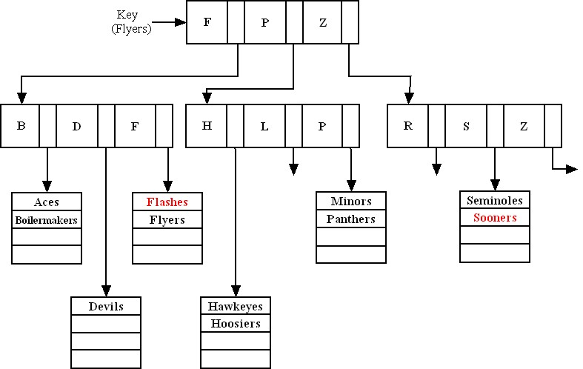

When one of the leaves is full and a new record needs to be added to that leaf, the leaf node may be turned into an intermediate parent node. This node would then serve as an index to those records, and an additional leaf node (containing the actual records) will be attached to that intermediate node. The parent node will contain pointers to the records in the leaf node.

15. All Primary Keys in each relation should receive an Index. In addition, based on the reporting needs, the following indices could be useful:
- DevID and ProjID in Assignment relation
- DevID and TeamID in Membership relation
- CountryID in Country Mgr relation, CMID in Develop Mgr relation, DMID in Developer relation, DevID in Assignment relation, ProjID in Assignment relation
- ProjEndDate in Project relation

CREATE INDEX ASSIGNDEVINDX ON ASSIGNMENT (DevID);
CREATE INDEX ASSIGNPROJINDX ON ASSIGNMENT (ProjID);
CREATE INDEX PROJCOMPLETE ON PROJECT (ProjEndDate);

16. A cluster is defined by the tables and the column or columns by which the tables are usually joined. The column by which they are joined (foreign key) would need to have the same value in the two tables for the adjacent records. If the tables are populated with data before clustering occurs, this is much harder to achieve. Hence, in Oracle, tables are assigned to a cluster at the time of their creation.

- In general, the answer depends on the number of processors available. For the general structure mentioned in the problem, each set of conditions within parentheses (called a conjunction) could be given to a separate processor, then the results from each processor would be intersected to obtain the final result. If more processors are available, then each condition within a conjunction could be assigned to its own processor.

As an illustration of what might typically happen, consider the qualification clause from Problem and Exercise 13:

SELECT StudentID, StudentName
FROM STUDENT
WHERE (Major = “MIS“ or Major = “Computer Science“) And Age > 25 And
MaritalStatus = “single“ Or (Major = “Computer Engineering“ And MaritalStatus = “single“ And HomeZipcode = 45462);

There are two general approaches for parallel processing of a query:

- To ensure that subsequent scans of this table are performed in parallel using at least three processors, you would first alter the structure of the table with the SQL command:

ALTER TABLE STUDENT PARALLEL 3,

and then run the query itself.

- The second option would be to give the DBMS a hint within the query. This will force it to process the query in a certain way. In Oracle:

SELECT /*+ FULL(STUDENT) PARALLEL(STUDENT,3) */ COUNT(*)
FROM STUDENT
WHERE (Major = “MIS“ or Major = “Computer Science“) And Age > 25
And MaritalStatus = “single“ Or (Major = “Computer Engineering“ And MaritalStatus = “single“ And HomeZipcode = 45462);

would enforce a full scan on the table STUDENT, and its processing in parallel, by three CPUs. Note: In Oracle, parallel processing is possible only when a table is scanned, not when it is accessed through an index.

18.
CustRowID | OrderRowID | Cust#
10001 | 30004 | C2027
10002 | 30002 | C1062
10003 | 30003 | C1062
10004 | 30001 | C3861
… | … | …

19.

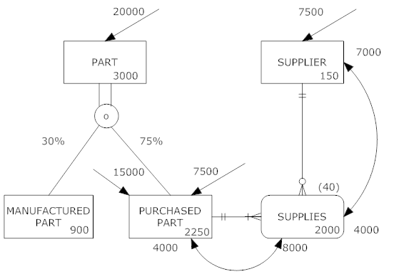

20.
a.
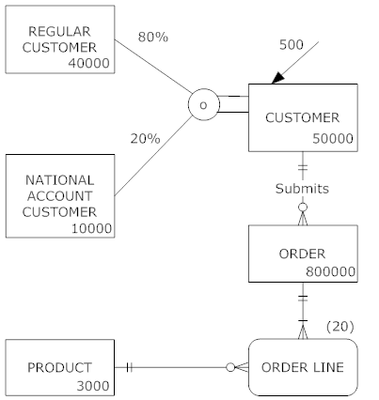

It might also be useful to ask your students what type of additional usage data might need to be gathered to make a complete analysis.

b. Since only employees are using the system, one possibility might be to eliminate the regular customer and national account customer subtypes and only have one customer type. We might also assume that only national account customers would be serviced by employees. Depending on how much National Account Customer data there is, this and the Order Line entities might be merged.

21.
a. An index on the State field of the customer table would help with grouping and sorting. An index on OrderDate in the order table would help with qualifying to the desired period. If rows are sorted by description within state, it would seem that an index on ProductDescription in the product table might be helpful, but such an index would likely not be used by most DBMSs because the number of rows to sort within each category is so few.

b. An index on ProductFinish in the Product table would help to compute the totals by product finish.

- An index on OrderDate would help to quickly find the desired orders, and an index on OrderID in the order line table would speed joining.

- An index on ProductLineID in product would speed grouping, and an index on ProductID in the order line table would speed joining.

Suggestions for Field Exercises

- A good starting point for the purposes of this assignment would be to identify any DBMSs that support complex data types like graphics, video, and sound. Object-oriented databases will stand out for their abilities in this regard. This is the newest DBMS technology and larger organizations are gaining experience with it by selectively using it when complex data or event-driven programming is appropriate for the application.

- Students who investigate this question may become interested in understanding the difference between symmetric multiprocessing (SMP) and massively parallel processing (MPP), topics that are covered in more depth in a later chapter (see index for page reference). In a typical SMP architecture, the machine has up to a few dozen processors, and each processor shares all hardware resources, including memory, disks, and the system bus. Because each processor can see all of the available memory, communicating between processors is straightforward: one processor can easily view the results generated by another processor simply by looking at the appropriate section of memory. MPP machines support multiple nodes that each have their own private memory and that communicate via passing messages over an interconnect. SMP systems seem to be best suited for either mission-critical or OLTP applications, where the application‘s growth rate is slow and steady at less than 20 percent annually and the amount of raw data is in the range of 10 to 100GB. MPP systems are best suited for either complex analytical or very large decision-support applications.

Students may also discover that several options exist for breaking apart a query into modules that can be processed in parallel. All options are not available with every DBMS, and each DBMS often has unique options due to its underlying design.

- Student answers will vary based on the organization, its standards, and the people they actually contact within the organization. Answers should evidence a belief (fully normalized or denormalized databases) as well as a rationale for the belief.

- In choosing a file organization for a particular file in a database, students should find that database designers consider many of these seven factors:
- Fast data retrieval
- High throughput for processing data input and maintenance transactions
- Efficient use of storage space
- Protection from failures or data loss
- Minimizing need for reorganization
- Accommodating growth
- Security from unauthorized use

Secondary key indexes are important for supporting many reporting requirements and for providing rapid ad hoc data retrieval. Indexed sequential in comparison to indexed nonsequential allows more efficient use of space and faster sequential data processing without much, if any, sacrifice in random data record accessing speed. A bitmap is ideal for attributes that have even a few possible values, which is not true for conventional tree indexes. Indexes may be deleted because of storage space constraints or to reduce maintenance overhead.

Project Case

Case Questions
1. Additional information needed for physical database design:
a. Data volume estimates (data volume and frequency-of-use statistics, representing them by adding notation to the EER diagram)
b. Definitions of each attribute
c. Descriptions of where and when data are used: entered, retrieved, deleted, and updated (including frequencies)
d. Expectations or requirements for response time and data security, backup, recovery, retention, and integrity
e. Descriptions of the technologies (database management systems) used for implementing the database. The efficient use of secondary storage is influenced both by the size of the physical record and the structure of secondary storage. Hence, we need to know the page size, whether a physical record is allowed to span two pages, and the blocking factor, etc.
2. Some types of data that are collected include medical records (e.g., scanned from manual systems), lab results, test results, hand written doctor notes, doctor dictations, etc. Some data, such as audio clips, MRI images, or x-rays could not be captured using standard data types. Some items can be converted to alphanumeric datatypes (e.g., dictation can be transcribed). One option would be to use other datatypes such as binary large objects (BLOBS). Increasingly, jpeg, mpeg, and other rich media objects need to be accommodated.
3. Data partitioning would be beneficial if the database is going to be distributed among different machines. Horizontal partitioning distributes all the rows of a table in separate files, based upon common column values. When data need to be viewed together the SQL union operator may be used to display all rows of data in one table. Vertical partitioning, or distributing the columns of a relation in separate files by repeating the primary key for each file, would be another possibility. By joining the tables together, all data may be viewed together. Where the natural divisions are to partition the data are not clear. Some labs may run rather independently, so some data only for use in one or a few labs could be stored in a separate partition. However, the push for integrated, electronic medical records encourages one integrated database of medical data. Some hospitals use different applications for medical records and for practice management (the back office functions). Thus, these applications may be supported by separate partitions (possibly with some planned redundancy).
4. One possible join index would be CareCenterID in the NURSE relation and the BED relation. This might be useful in a data warehousing application, particularly if you would like to report on what nurses could potentially work in what rooms and care for patients in what beds.
5.
a. The following secondary indexes are recommended:
TreatmentDate on the OrderTreatment table since this indicates the date of treatment

TreatmentCode on the OrderTreatment table since we will group by TreatmentCode

PPersonID on the OrderTreatment table since this will link to the Physician table

PhysicianName on the Physician table since we will also want to search by PhysicianName

b. The statements are:
create index tdate on OrderTreatment_T(TreatmentDate);
create index tcode on OrderTreatment_T (TreatmentCode);
create index rphys on OrderTreatment_T (PPersonID);
create index RphysName on Physician_T(PhysicianName);

6.
a. MVCH could benefit from voluntary compliance since this would increase the quality of the data. While MVCH would have to provide more detailed reporting on financials, it still would stand to gain much in terms of quality that would be looked upon favorably by accrediting agencies such as JCAHCO. Also, SOX compliance might help MVCH justify some quality awards, which could be used for competitive advantage in promoting the hospital against alternative healthcare providers.

- Accuracy and completeness of MCVH is attained through including some range controls and other integrity controls during physical database design.

Elimination of duplicates and data inconsistencies will be achieved by using a data model in 3NF (or with planned denormalization) as well as including appropriate referential integrity.

MVCH data will be more understandable if some physical data naming conventions and standards are used.

Case Exercises

a. Yes, change all TEXT to VARCHAR since this would allocate memory space for the fields dynamically and will help to minimize storage space.

b. Yes, include lookup tables for SocialWorker, PainLevel and reason for visit, for example.

c. PatientNbr, PatientName, and SocialWorker in the patient table should have values. FirstSeen could be null, since the patient info may be entered before the patient is seen.

In the Visit table, NewSymptoms could be null.

d. We would recommend writing a trigger to write to an exceptions table. This table would then be used to generate a report. Do not use a default value for social worker. For VisitReason, we suggest using “Routine“ as the default value. Alternatively, applications that populate these fields could force these data to be included, otherwise a transaction (e.g., recording a visit) cannot be entered. It might be possible to reuse the most recent value for reason for a visit, assuming the most likely reason is a continuation of the most recent reason. However, in this case, or any case of entering a value for a missing field, it is best to indicate that the value stored is an estimate, and that the real value is unknown, until the value can be verified.

e.
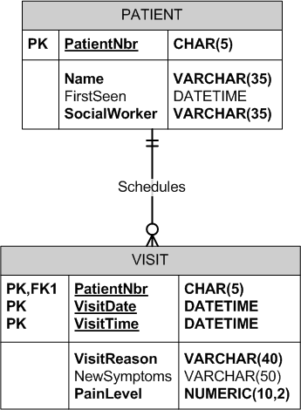

2.
a. Yes. We suggest creating a User-defined data type (UDT) called TestResults that contains the TestName, last date, and result. This would eliminate separate fields in the PATIENT table for each type of test (MRI, FSS, etc.).

b. Yes, presenting symptoms and active meds in the visit table both could be coded with a list. Stage in the patient could also be coded with a list.

- ActiveMeds could take on a null value, since the patient does not always need to be on meds. The same is true for LastMRIResults and MRIResults since some patients will not have an MRI. The same would be true for FSS, EDSS and neuro assessment.

d. We do not see any possibilities for denormalization here.

e. Yes, one possibility is stage, since there would be a limited number.

f. Perhaps using a join index across all tables since MRN is a common field.

3.
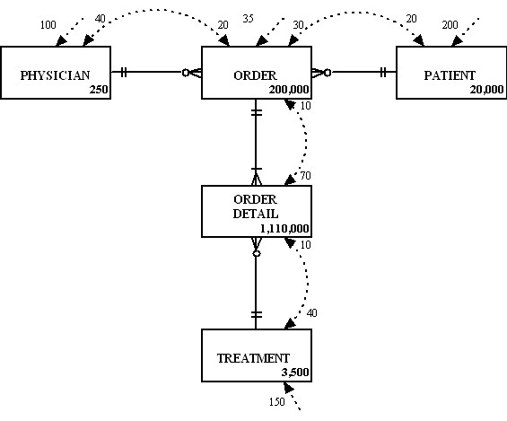

The following notes accompany the data volume and usage diagram above to explain how the access frequencies are calculated:
- ORDER [30 from PATIENT (200 direct accesses), 20 from PHYSICIAN (100 direct accesses), 10 from TREATMENT (150 direct accesses)]
- PHYSICIAN [40 calculated from 20 from ORDER (30 from PATIENT 200 direct access) plus 10 from ORDER (35 direct accesses) plus 10 from TREATMENT (150 direct accesses)]
- ORDER DETAIL [70 calculated from 30 from ORDER (30 from PATIENT 200 direct access) plus 20 from ORDER (35 direct accesses) plus 20 from PHYSICIAN (100 direct accesses)]
- ORDER DETAIL [10 from Treatment (150 direct accesses)]
- PATIENT [20 from ORDER (35 direct accesses)]
- TREATMENT [40 calculated from 20 from ORDER (35 direct accesses) plus 20 from PHYSICIAN (100 direct accesses)]

4. Clustering order and order_detail, using the order_id as the cluster key due to data volumes. SQL Server does support clustering through a cluster key, which physically rearranges the order of the records. The Oracle implementation actually stores the two or more tables next to each other on the disk.

Project Assignments

P1. The data types for each field in the database are defined in P2 solution (the data dictionary). Following is a discussion of each of the raised issues:

P1.1 Opportunities for user-defined data types: User-defined data types are discussed in the context of evolving SQL standards in chapter 7 of the textbook. There do not appear to be any opportunities to use user-defined data types in this case exercise.

P1.2 Coding possibilities. The following fields are candidates for coding:

Table Name | Field Name | Coding Scheme
VolLanguage_T | Language | List most common (e.g., French, Spanish, etc.)
VolSkill_T | Skill | List out possible values
VolInterest_T | Interest | List out possible values
VolAvailability_T | DayOfWeek | List
VolAvailability_T | PortionOfDay | List
Employee_T | EmpType | Staff, Technician, Nurse
Nurse_T | NurseType | RN, LPN
Physician_T | PhysicianSpecialty | List those recognized by professional medical associations
Nurse_T | NurseSpecialty | List those recognized by professional medical assoications
WorkUnit_T | UnitType | CC, DU
TechnicianSkill_T | TSSkill | List recognized professional skills
Staff_T | JobClass | List recognized job classes for MVCH

P1.3 Null values. The following fields could have null values (selected examples), however it might be a good design idea to set up default values for a “not applicable“ value for text-based data rather than leaving fields null:

Table Name | Field Name | Explanation
Assessment_T | Comments | There could be no comments at time of assessment.
TreatmentOrder_T | Results | A treatment’s results might not be filled in yet
ItemBilling_T | EndDate | It might not be the end of an item’s usage for billing yet.
Person_T | PersonWorkPhone | A patient that is a child/minor may not have a work phone
Volunteer_T | FelonyExplanation | No felony to report.
 | VEmployerAddr, Position, StartDate, EndDate | Volunteer may not be working, or with current work may not have an end-date
VolServHistory_T | ServiceEndDate | May be currently volunteering, thus no end date yet
Resident_T | DateDischarged | Not yet discharged
CCAssignment_T | AssignEnd | Assignment not yet completed

P1.4 Indexed fields: Primary key and Foreign Key fields should be indexed. Additional suggestions for secondary indexes are noted in the solution to P2.

P2. Please see the table-by-table solution for the data dictionary; the solution assumes usage of Oracle data types for fields, there may be slight differences for MS SQL Server, MySQL, or MS Access implementation specifics.

Table: Person_T
Data Item |  | Value
Name | Type | Length | Min | Max | Description | Index | PK | FK | References
PersonID | Varchar | 5 |  |  | Person ID |  | Y
PersonName | Varchar | 35 |  |  | Name
PersonStrAddress | Varchar | 20 |  |  | Address
PersonCity | Varchar | 20 |  |  | City
PersonState | Varchar | 2 |  |  | State
PersonZip | Varchar | 10 |  |  | ZipCode
PersonHomePhone | Varchar | 14 |  |  | Phone Number
PersonWorkPhone | Varchar | 14 |  |  | Phone Number
PersonDOB | Date |  |  |  | Date of Birth
Physician? | Varchar | 1 | “N“ | “Y“ | Subtype Discriminator
Employee? | Varchar | 1 | “N“ | “Y“ | Subtype Discriminator
Volunteer? | Varchar | 1 | “N“ | “Y“ | Subtype Discriminator
Patient? | Varchar | 1 | “N“ | “Y“ | Subtype Discriminator

Table: Physician_T
Data Item |  | Value
Name | Type | Length | Min | Max | Description | Index | PK | FK | References
PhysicianID | Varchar | 5 |  |  | Person ID |  | Y | Y | Person(PersonID)
DEANo | Varchar | 20 |  |  | DEA number
PagerNo | Varchar | 14 |  |  | Number for pager
Specialty | Varchar | 20 |  |  | Physician medical specialty

Table: PhysicianDX_T
Data Item |  | Value
Name | Type | Length | Min | Max | Description | Index | PK | FK | References
PDID | Number | 5 |  |  | Unique ID for Physician & Diagnosis instance |  | Y
DiagnosisDate | Date |  |  |  | Date of diagnosis
DiagnosisTime | Timestamp |  |  |  | Time of diagnosis
PhysicianID | Varchar | 5 |  |  | Physician ID who made the diagnosis | Y secondary |  | Y | Physician(PhysicianID)
DiagnosisCode | Varchar | 5 |  |  | Diagnosis Code | Y secondary |  | Y | Diagnosis(DiagnosisCode)

Table: Diagnosis_T
Data Item |  | Value
Name | Type | Length | Min | Max | Description | Index | PK | FK | References
DiagnosisCode | Varchar | 5 |  |  | Hospital recognized codes for medical diagnoses |  | Y
DiagnosisName | Varchar | 60 |  |  | Name of diagnosis

Table: Employee_T
Data Item |  | Value
Name | Type | Length | Min | Max | Description | Index | PK | FK | References
EmpID | Varchar | 5 |  |  | Person ID |  | Y | Y | Person(PersonID)
DateHired | Date |  |  |  | Hire date of employee
EmpType | Varchar | 1 | “N“ | “T“ | Subtype discriminator; values of N, S or T only

Table: Technician_T
Data Item |  | Value
Name | Type | Length | Min | Max | Description | Index | PK | FK | References
TechnicianID | Varchar | 5 |  |  | Person ID |  | Y | Y | Employee(EmpID)
UnitName | Varchar | 15 |  |  | FK to WorkUnit where technician assigned |  |  | Y | WorkUnit(UnitName)

Table: TechnicianSkill_T
Data Item |  | Value
Name | Type | Length | Min | Max | Description | Index | PK | FK | References
TSID | Varchar | 5 |  |  | Unique ID for Technician skill instance |  | Y
TechnicianID | Varchar | 5 |  |  | FK to Technician |  |  | Y | Technician  (TechnicianID)
TSSkill | Varchar | 20 |  |  | Specific recognized medical skill

Table: Staff_T
Data Item |  | Value
Name | Type | Length | Min | Max | Description | Index | PK | FK | References
StaffID | Varchar | 5 |  |  | Person ID |  | Y | Y | Employee(EmpID)
JobClass | Varchar | 3 |  |  | Job classification code | Y bitmapped
UnitName | Varchar | 15 |  |  | FK to WorkUnit where staff assigned |  |  | Y | WorkUnit(UnitName)

Table: WorkUnit_T
Data Item |  | Value
Name | Type | Length | Min | Max | Description | Index | PK | FK | References
UnitName | Varchar | 15 |  |  | Name of WorkUnit in hospital |  | Y
Floor | Varchar | 3 |  |  | Floor where WorkUnit is located
FacilityID | Varchar | 10 |  |  | FK to Facility |  |  | Y | Facility(FacilityID)
UnitType | Varchar | 2 | “CC“ | “DU“ | Subtype discriminator; values of CC or DU only

Table: Volunteer_T
Data Item |  | Value
Name | Type | Length | Min | Max | Description | Index | PK | FK | References
VolID | Varchar | 5 |  |  | Person ID |  | Y | Y | Person(PersonID)
Felony? | Varchar | 1 | “N“ | “Y“ | Yes/no for felony question
FelonyExplanation | Varchar | 50 |  |  | Text explanation
VECLastName | Varchar | 20 |  |  | Last name of emergency contact
VECFirstName | Varchar | 20 |  |  | First name of emergency contact
VECRelationship | Varchar | 15 |  |  | Relationship of emergency contact to volunteer
VECAddress | Varchar | 55 |  |  | Street, city, zip address of emergency contact
VECPhone | Varchar | 14 |  |  | Phone number of emergency contact
VEmployer | Varchar | 25 |  |  | Name of volunteer’s employer
VEmployerAddr | Varchar | 55 |  |  | Address of volunteer’s employer
VEmployPosition | Varchar | 20 |  |  | Volunteer’s employment position
VEmployStartDate | Date |  |  |  | Starting date of volunteer employment
VEmployEndDate | Date |  |  |  | Ending date of volunteer employment
MVCHService? | Varchar | 1 | “N“ | “Y“ | Yes/no answer to volunteer having served at MVCH
VolunteerExp? | Varchar | 1 | “N“ | “Y“ | Yes/no answer to volunteer having experience
WhyVolunteer? | Varchar | 50 |  |  | Text explanation

Table: VolService_T
Data Item |  | Value
Name | Type | Length | Min | Max | Description | Index | PK | FK | References
VMSID | Varchar | 5 |  |  | Unique ID for Volunteer’s MVCH Service experience |  | Y
MVCHServiceInfo | Varchar | 25 |  |  | Service information
VolID | Varchar | 5 |  |  | FK to Volunteer |  |  | Y | Volunteer(VolID)

Table: VolRefInfo_T
Data Item |  | Value
Name | Type | Length | Min | Max | Description | Index | PK | FK | References
VRIID | Varchar | 5 |  |  | Unique ID for Volunteer’s Reference Info instance |  | Y
VRILname | Varchar | 20 |  |  | Last Name of Volunteer’s reference person
VRIFname | Varchar | 20 |  |  | First Name of Volunteer’s reference person
VRIRelationship | Varchar | 15 |  |  | Relationship of volunteer’s reference
VRIPhone | Varchar | 14 |  |  | Phone number of volunteer’s reference
VRIAddress | Varchar | 20 |  |  | Street address of volunteer’s reference
VRICity | Varchar | 20 |  |  | City of volunteer’s reference
VRIState | Varchar | 2 |  |  | State of volunteer’s reference
VRIZip | Varchar | 10 |  |  | Zip code of volunteer’s reference
VolID | Varchar | 5 |  |  | FK to Volunteer |  |  | Y | Volunteer(VolID)

Table: VolExperience_T
Data Item |  | Value
Name | Type | Length | Min | Max | Description | Index | PK | FK | References
VEID | Varchar | 5 |  |  | Unique ID for Volunteer’s experience instance |  | Y
VolunteerExpInfo | Varchar | 25 |  |  | Experience information
VolID | Varchar | 5 |  |  | FK to Volunteer |  |  | Y | Volunteer(VolID)

Table: VolLanguage_T
Data Item |  | Value
Name | Type | Length | Min | Max | Description | Index | PK | FK | References
VLID | Varchar | 5 |  |  | Unique ID for Volunteer’s Language instance |  | Y
Language | Varchar | 15 |  |  | Language spoken by volunteer
VolID | Varchar | 5 |  |  | FK to Volunteer |  |  | Y | Volunteer(VolID)

Table: VolSkill_T
Data Item |  | Value
Name | Type | Length | Min | Max | Description | Index | PK | FK | References
VSID | Varchar | 5 |  |  | Unique ID for Volunteer’s skill instance |  | Y
Skill | Varchar | 25 |  |  | Skill information for volunteer
VolID | Varchar | 5 |  |  | FK to Volunteer |  |  | Y | Volunteer(VolID)

Table: VolInterest_T
Data Item |  | Value
Name | Type | Length | Min | Max | Description | Index | PK | FK | References
VIID | Varchar | 5 |  |  | Unique ID for Volunteer’s interest instance |  | Y
Interest | Varchar | 25 |  |  | Interest information
VolID | Varchar | 5 |  |  | FK to Volunteer |  |  | Y | Volunteer(VolID)

Table: VolAvailability_T
Data Item |  | Value
Name | Type | Length | Min | Max | Description | Index | PK | FK | References
VAID | Varchar | 5 |  |  | Unique ID for Volunteer’s availability instance |  | Y
DayOfWeek | Varchar | 8 |  |  | Day of the week
PortionOfDay | Varchar | 15 |  |  | Timeslot of availability
VolID | Varchar | 5 |  |  | FK to Volunteer |  |  | Y | Volunteer(VolID)

Table: VolServHistory_T
Data Item |  | Value
Name | Type | Length | Min | Max | Description | Index | PK | FK | References
VSHID | Varchar | 5 |  |  | Unique ID for Volunteer’s Service history instance |  | Y
ServiceBeginDate | Date |  |  |  | Date of service (start)
ServiceEndDate | Date |  |  |  | Date of service (end)
ServiceHrsWorked | Varchar | 3 |  |  | Aggregate of hours worked for this particular service instance
VolID | Varchar | 5 |  |  | FK to Volunteer |  |  | Y | Volunteer(VolID)
UnitName | Varchar | 15 |  |  | FK to WorkUnit |  |  | Y | WorkUnit(UnitName)
PhysicianID | Varchar | 5 |  |  | FK to Physician; supervisor |  |  | Y | Physician(PhysicianID)
EmpID | Varchar | 5 |  |  | FK to Employee; supervisor |  |  | Y | Employee(EmpID)

Table: Outpatient_T
Data Item |  | Value
Name | Type | Length | Min | Max | Description | Index | PK | FK | References
OPatientID | Varchar | 5 |  |  | Person ID |  | Y | Y | Patient(PatientID)

Table: Resident_T
Data Item |  | Value
Name | Type | Length | Min | Max | Description | Index | PK | FK | References
RPatientID | Varchar | 5 |  |  | Person ID |  | Y | Y | Patient(PatientID)
DateAdmitted | Date |  |  |  | Date of Admission | Y Secondary
DateDischarged | Date |  |  |  | Date of discharge | Y Secondary
BedNo | Varchar | 3 |  |  | Bed Number |  |  | Y | Bed(RoomNo, BedNo)
RoomNo | Varchar | 5 |  |  | Room Number |  |  | Y | Bed(RoomNo, BedNo)

Table: Visit_T
Data Item |  | Value
Name | Type | Length | Min | Max | Description | Index | PK | FK | References
VisitNo | Varchar | 5 |  |  | Unique ID for patient’s visit instance |  | Y
OPatientID | Varchar | 5 |  |  | Outpatient Person ID |  |  | Y | Outpatient(OPatientID)
VisitDate | Date |  |  |  | Date of Visit
VisitTime | Timestamp |  |  |  | Time of Visit
VisitReason | Varchar | 50 |  |  | Reason for visit

Table: Patient_T
Data Item |  | Value
Name | Type | Length | Min | Max | Description | Index | PK | FK | References
PatientID | Varchar | 5 |  |  | Person ID |  | Y | Y | Person(PersonID)
ContactDate | Date |  |  |  | Date of first contact
ECLastName | Varchar | 20 |  |  | Emergency Contact (EC) Last Name
ECFirstName | Varchar | 20 |  |  | EC First Name
ECRelationship | Varchar | 15 |  |  | Relationship of EC to patient
ECAddress | Varchar | 55 |  |  | Street, City, State, Zip address of EC
ECPhone | Varchar | 14 |  |  | Phone for EC
SubLName | Varchar | 20 |  |  | Insurance Subscriber Last Name
SubFName | Varchar | 20 |  |  | Insurance Subscriber First Name
SubRelationship | Varchar | 15 |  |  | Relationship of Insurance subscriber to patient
SubAddress | Varchar | 55 |  |  | Street, City, State, Zip address of Ins. Subscriber
SubPhone | Varchar | 14 |  |  | Phone for Ins. Subscriber
Outpatient? | Varchar | 1 | “N“ | “Y“ | Subtype Discriminator
Resident? | Varchar | 1 | “N“ | “Y“ | Subtype Discriminator
AdmitPhys | Varchar | 5 |  |  | FK to Admitting Physician |  |  | Y | Physician(PhysicianID)
ReferPhys | Varchar | 5 |  |  | FK to Referring Physician |  |  | Y | Physician(PhysicianID)

Table: Bed_T
Data Item |  | Value
Name | Type | Length | Min | Max | Description | Index | PK | FK | References
BedNo | Varchar | 5 |  |  | Bed Number |  | Y
RoomNo | Varchar | 5 |  |  | Room Number |  | Y | Y | Room(RoomNo)

Table: Room_T
Data Item |  | Value
Name | Type | Length | Min | Max | Description | Index | PK | FK | References
RoomNo | Varchar | 5 |  |  | Room Number |  | Y
CCUnitName | Varchar | 20 |  |  | FK to Care Center table |  |  | Y | CareCenter(CCUnitName)

Table: CareCenter_T
Data Item |  | Value
Name | Type | Length | Min | Max | Description | Index | PK | FK | References
CCUnitName | Varchar | 20 |  |  | Care Center Name |  | Y
DayInCharge | Varchar | 5 |  |  | FK to RN; shows daytime in-charge RN |  |  | Y | RN(RNID)
NightInCharge | Varchar | 5 |  |  | FK to RN: shows nighttime-in-charge RN |  |  | Y | RN(RNID)

Table: RN_T
Data Item |  | Value
Name | Type | Length | Min | Max | Description | Index | PK | FK | References
RNID | Varchar | 5 |  |  | ID of RN |  | Y | Y | Nurse(NurseID)

Table: LPN_T
Data Item |  | Value
Name | Type | Length | Min | Max | Description | Index | PK | FK | References
LPNID | Varchar | 5 |  |  | ID of LPN |  | Y | Y | Nurse(NurseID)
Supervisor | Varchar | 5 |  |  | FK to RN |  |  | Y | RN(RNID)

Table: CCAssignment_T
Data Item |  | Value
Name | Type | Length | Min | Max | Description | Index | PK | FK | References
CCAID | Varchar | 5 |  |  | Unique ID for Care Center assignment instance |  | Y
AssignStart | Date |  |  |  | Start date of assignment to Care Center
AssignEnd | Date |  |  |  | End date of assignment to Care Center
HrsWorked | Number | 5 |  |  | Aggregate number of hours worked
CCUnitName | Varchar | 20 |  |  | FK to CareCenter of assignment |  |  | Y | CareCenter(CCUnitName)
NurseID | Varchar | 5 |  |  | FK to Nurse; shows Nurse assigned |  |  | Y | Nurse(NurseID)

Table: Nurse_T
Data Item |  | Value
Name | Type | Length | Min | Max | Description | Index | PK | FK | References
NurseID | Varchar | 5 |  |  | Person ID |  | Y | Y | Person(PersonID)
CertDegree | Varchar | 5 |  |  | Degree preparation
StateLicenseNo | Varchar | 15 |  |  | License No.
NurseSpecialty | Varchar | 20 |  |  | Nurse medical specialty
NurseType | Varchar | 3 | “LPN“ | “RN “ | Subtype discriminator; LPN or RN values

Table: FieldCertification_T
Data Item |  | Value
Name | Type | Length | Min | Max | Description | Index | PK | FK | References
FCID | Varchar | 5 |  |  | Unique ID for Field certification instance |  | Y
FCDescription | Varchar | 30 |  |  | Description
NurseID | Varchar | 5 |  |  | FK to Nurse |  |  | Y | Nurse(NurseID)

Table: Facility_T
Data Item |  | Value
Name | Type | Length | Min | Max | Description | Index | PK | FK | References
FacilityID | Varchar | 10 |  |  | Facility ID |  | Y
FacilityName | Varchar | 40 |  |  | Name of Facility

Table: DiagnosticUnit_T
Data Item |  | Value
Name | Type | Length | Min | Max | Description | Index | PK | FK | References
DXUnitName | Varchar | 10 |  |  | Unit Name |  | Y

Table: Treatment_T
Data Item |  | Value
Name | Type | Length | Min | Max | Description | Index | PK | FK | References
TrtCode | Varchar | 5 |  |  | Treatment Code |  | Y
TreatmentName | Varchar | 30 |  |  | Name of Treatment
DXUnitName | Varchar | 10 |  |  | ID of Unit performing treatment |  |  | Y | DiagnosticUnit  (DXUnitName)

Table: TreatmentOrder_T
Data Item |  | Value
Name | Type | Length | Min | Max | Description | Index | PK | FK | References
TOID | Varchar | 5 |  |  | Unique ID for treatment order instance |  | Y
TrtCode | Varchar | 5 |  |  | Treatment Code FK |  |  | Y | Treatment(TrtCode)
Results | Varchar | 50 |  |  | Results of treatment
TrtDate | Date |  |  |  | Date of Treatment | Y Secondary
TrtTime | Timestamp |  |  |  | Time of Treatment
OrderID | Varchar | 5 |  |  | FK to Order |  |  | Y | Order(OrderID)

Table: Order_T
Data Item |  | Value
Name | Type | Length | Min | Max | Description | Index | PK | FK | References
OrderID | Varchar | 5 |  |  | Order ID |  | Y
PatientID | Varchar | 5 |  |  | Patient ID FK |  |  | Y | Patient(PatientID)
PhysicianID | Varchar | 5 |  |  | Physician ID FK |  |  | Y | Physician(PhysicianID)
ItemNo | Varchar | 5 |  |  | ItemNo FK |  |  | Y | Item(ItemNo)
OrderDate | Date |  |  |  | Date of Order | Y Secondary
OrderTime | Timestamp |  |  |  | Time of Order

Table: Item_T
Data Item |  | Value
Name | Type | Length | Min | Max | Description | Index | PK | FK | References
ItemNo | Varchar | 5 |  |  | Item Number |  | Y
ItemDescription | Varchar | 40 |  |  | Description of Item
ItemUnitCost | Number | 5 | 0 |  | Cost of Item | Y (Secondary)

Table: Inventory_T
Data Item |  | Value
Name | Type | Length | Min | Max | Description | Index | PK | FK | References
InvID | Varchar | 5 |  |  | Unique ID for inventory instance |  | Y
ItemNo | Varchar | 5 |  |  | Item Number FK |  |  | Y | Item(ItemNo)
VendorID | Varchar | 5 |  |  | Vendor ID FK |  |  | Y | Vendor(VendorID)

Table: Vendor_T
Data Item |  | Value
Name | Type | Length | Min | Max | Description | Index | PK | FK | References
VendorID | Varchar | 5 |  |  | Vendor ID |  | Y
VendorName | Varchar | 40 |  |  | Name of Vendor

Table: ItemConsumption_T
Data Item |  | Value
Name | Type | Length | Min | Max | Description | Index | PK | FK | References
ICID |  |  |  |  | Unique ID for consumption instance |  | Y
ConsumeDate | Date |  |  |  | Date of Consumption
ConsumeTime | Timestamp |  |  |  | Time of consumption
ConsumeQty | Number | 3 | 1 |  | Quantity Consumed | Y Secondary
ItemNo | Varchar | 5 |  |  | Item Number FK |  |  | Y | Item(ItemNo)
PatientID | Varchar | 5 |  |  | Patient ID FK |  |  | Y | Patient(PatientID)

Table: ItemBilling_T
Data Item |  | Value
Name | Type | Length | Min | Max | Description | Index | PK | FK | References
IBID |  |  |  |  | Unique ID for billing instance |  | Y
StartDate | Date |  |  |  | Date of Consumption
EndDate | Timestamp |  |  |  | Time of consumption
Cost | Number | 9,2 | .01 |  | Billing cost
ItemNo | Varchar | 5 |  |  | Item Number FK |  |  | Y | Item(ItemNo)
PatientID | Varchar | 5 |  |  | Patient ID FK |  |  | Y | Patient(PatientID)
RoomNo | Varchar | 5 |  |  | RoomNo FK |  |  | Y | Room(RoomNo)

Table: Schedule_T
Data Item |  | Value
Name | Type | Length | Min | Max | Description | Index | PK | FK | References
ScheduleID | Varchar | 5 |  |  | Unique ID for schedule instance |  | Y
PhysicianID | Varchar | 5 |  |  | Physician Person ID; FK |  |  | Y | Physician(PhysicianID)
SchedBegin | Date |  |  |  | Start date of schedule block
SchedEnd | Date |  |  |  | End date of schedule block
FacilityID | Varchar | 10 |  |  | Facility where Physician is assigned to work the schedule block; FK |  |  | Y | Facility(FacilityID)

Table: Assessment_T
Data Item |  | Value
Name | Type | Length | Min | Max | Description | Index | PK | FK | References
AssessmentID | Varchar | 5 |  |  | Unique ID for patient’s assessment instance |  | Y
PatientID | Varchar | 5 |  |  | Patient Person ID |  |  | Y | Patient(PatientID)
AssessmentDate | Date |  |  |  | Date of Assessment
AssessmentTime | Timestamp |  |  |  | Time of Assessment
Comments | Varchar | 50 |  |  | Comments for visit
PatientWeight | Number | 3 | 1 |  | Weight
PatientBP | Varchar | 7 |  |  | Blood pressure reading
PatientPulse | Number | 4 |  |  | Pulse reading
PatientTemperature | Number | (3,2) |  |  | Temperature reading
NurseID | Varchar | 5 |  |  | Nurse who provided patient assessment; FK |  |  | Y | Nurse(NurseID)

P3. Note to instructor: Selected examples of elements of the physical data model are shown in the following two images, to illustrate interesting data types, choice of primary key, etc. A full solution was not provided in order to save space in the Instructor’s Manual, due to the complexity of the full data model now necessary to depict the rich case information.

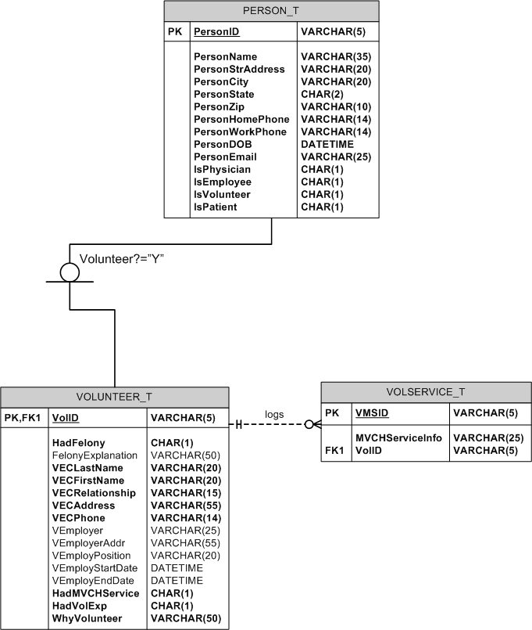
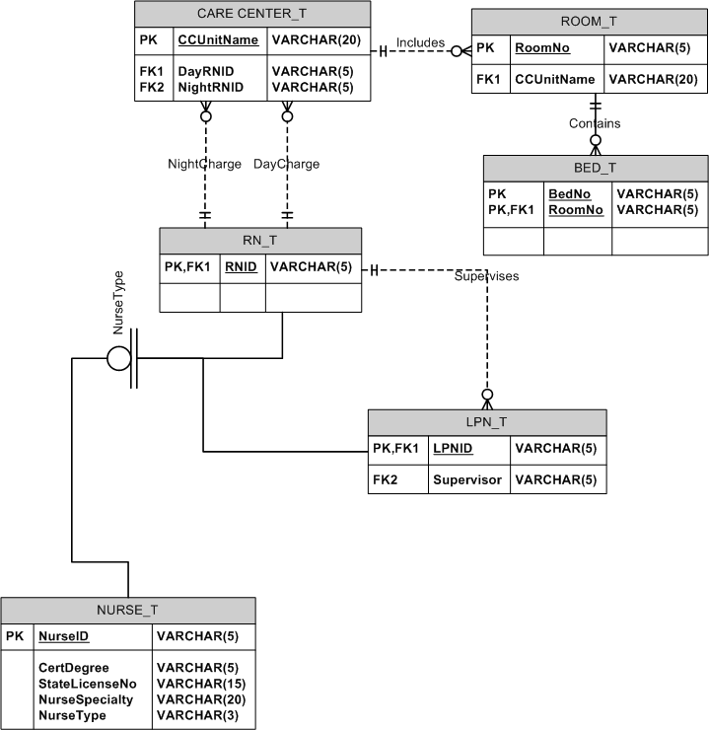

P4.
  - Nurses assigned to each care_center
Assume this report is run 7 times per day, there are 7 Care Centers and 250 Nurses.

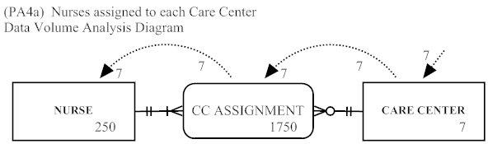

  - 5 most common diagnoses
Again, assume 7 runs per day, 50 different diagnoses and 1,000,000 diagnostic records.

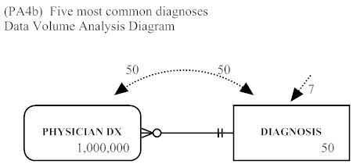

c. Items consumed by each patient; assume run 10 times a day.

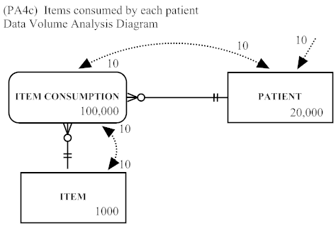

d. Number of items provided by vendors; run 10 times per day; assume 500 vendors.

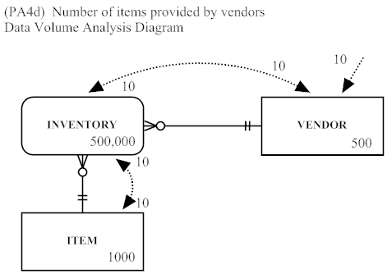

e. Number of patient admissions per physician; run 10 times per day

