Chapter 9 Data Warehousing

Chapter Overview

The purpose of this chapter is to introduce students to the rationale and basic concepts of data warehousing from a database management point of view. We contrast operational and informational processing, and we discuss the reasons why so many organizations are seeking to exploit data warehouses for competitive advantage. We discuss alternative data warehouse architectures (especially the database architectures) and techniques for populating a warehouse.

Chapter Errata

In the first printing of the textbook, a few mistakes were not discovered until after the textbook was printed. The “Errata” document on the textbook website chronicles all known issues with the textbook that were discovered after printing. The list below indicates those specific to this chapter.

- In Problem and Exercise #22, the italicized word in the third last line should be 'scraping' not 'scrapping'.

Chapter Objectives

Specific student objectives are included in the beginning of the chapter. From an instructor’s point of view, the objectives of this chapter are to:

- Establish the fact that many organizations today are experiencing an information gap. That is, they are drowning in data but starving for information.
- Define data warehousing and describe four characteristics of a data warehouse.
- Describe two major factors that drive the need for data warehousing as well as several advances in the field of information systems that have enabled data warehousing.
- Contrast operational systems and informational systems from the view point of data management.
- Describe the basic architectures that are most often used with data warehouses.
- Contrast transient and periodic data, and discuss how data warehouses are used to build a historical record of an organization.
- Discuss the purposes of populating a data warehouse and the problems of data reconciliation.
- Contrast data warehouses and data marts.
- Describe and illustrate the dimensional data model (or star schema) that is often used in data warehouse design.

Key Terms

Conformed dimension | Grain | Periodic data
Data mart | Independent data mart | Real-time data warehouse
Data mining | Informational system | Reconciled data
Data visualization | Logical data mart | Relational OLAP (ROLAP)
Data warehouse | Multidimensional OLAP (MOLAP) | Snowflake schema
Dependent data mart | Online analytical processing (OLAP) | Star schema
Derived data | Operational data store (ODS) | Transient data
Enterprise data warehouse (EDW) | Operational system

Classroom Ideas

- Discuss the importance of data warehousing in organizations today. Over 90 percent of large (Fortune 1000) companies have completed data warehouses or have a warehousing project underway. Ask your students to suggest reasons for this popularity.
- Discuss job opportunities in data warehousing, business intelligence, and data mining. Numerous Web sites have job listings as well as newspaper advertisements.
- Emphasize that a successful data warehousing project requires the integration of everything the students have learned throughout the database course (in fact, everything in the IS curriculum).
- Discuss the idea of heterogeneous data (use Figure 9-1). Ask your students for reasons why such data are so commonplace and what problems they present.
- Compare operational and informational systems using Table 9-1. Ask your students for examples of each type of system.
- Compare the independent data mart (Figure 9-2), dependent data mart and operational data store (Figure 9-3), and logical data mart (Figure 9-4) architectures.
- Discuss the three-layer data architecture (Figure 9-5). Ask your students why it might be necessary to have both a reconciled data layer and a derived data layer.
- Compare transient data (Figure 9-7) with periodic data (Figure 9-8). Explain how periodic data provide a historical record of events.
- Introduce components of a star schema (Figure 9-9) and discuss the example shown in Figures 9-10 and 9-11. Have your students help you diagram another example (university, football team, etc.).
- Discuss some variations of the star schema (Figure 9-13, 9-14).
- Discuss conformed dimensions and how these could be used (Figure 9-13).
- Discuss normalizing dimension tables, highlighting multivalued dimension, hierarchies, and the use of helper tables (Figures 9-14, 9-15, 9-16, and 9-17).
- Discuss slowly changing dimensions and some ways to handle this. Use Figure 9-18 as an example of one possible solution.
- Discuss some of the ways end users can use a data warehouse or data mart (use Figures 9-22, 9-23, 9-24, and 9-25). Ask your students to suggest some advantages of these user interfaces.
- Introduce the topic of data mining (use Table 9-4 and 9-5). If time permits, have your students read a recent article on data mining in a publication such as DM Review (available at www.dmreview.com).
- Have your students register for the Teradata Student Network and show them how they can access extensive material on data warehousing and business intelligence.

Answers to Review Questions

- Define each of the following terms:

- Data warehouse. A subject-oriented, integrated, time-variant, non-volatile collection of data used in support of management decision-making processes (Inmon and Hackathorn, 1994)
- Data mart. A data warehouse that is limited in scope, whose data is obtained by selecting and (where appropriate) summarizing data from the enterprise data warehouse
- Reconciled data. Detailed, historical data that are intended to be the single, authoritative source for all decision support applications and not generally intended to be accessed directly by end users
- Derived data. Data that have been selected, formatted, and aggregated for end-user decision support applications
- Online analytical processing (OLAP). The use of a set of graphical tools that provides users with multidimensional views of their data and allows them to analyze the data using simple windowing techniques
- Data mining. Knowledge discovery using a sophisticated blend of techniques from traditional statistics, artificial intelligence, and computer graphics (Weldon 1996)
- Star schema. A simple database design in which dimensional data are separated from fact or event data. A dimensional model is another name for star schema
- Snowflake schema. An expanded version of a star schema in which all of the tables are fully normalized
- Grain The length of time (or other meaning) associated with each record in the table
- Conformed dimension. One or more dimension tables associated with two or more fact tables for which the dimension tables have the same business meaning and primary key with each fact table

- Match the following terms and definitions:

c periodic data
d data mart
e star schema
f data mining
b reconciled data
g dependent data mart
i data visualization
a transient data
h snowflake schema

- Contrast the following terms:

- Transient data; periodic data. In transient data, changes to existing records are written over previous records, thus destroying the previous data content. In periodic data, the data is never physically altered or deleted once they have been added to the store.
- Data warehouse; data mart; operational data store. A data warehouse is an integrated and consistent store of subject-oriented data that are obtained from a variety of sources and formatted into a meaningful context to support decision making in an organization. A data mart is a data warehouse that is limited in scope and whose data are obtained by selecting and (where appropriate) summarizing data from the enterprise data warehouse. An operational data store is much different from a data warehouse or data mart because it is updatable, has a limited amount of historical data, and is available to operational users for use in decision support.
- Reconciled data; derived data. Reconciled data are intended to be the single, authoritative source for all decision-support applications and not generally intended to be accessed by end users; derived data have been selected, formatted, and aggregated for end-user decision support applications.
- Fact table; dimension table. Fact tables contain factual or quantitative data about a business such as units sold, orders booked, and so on. Dimensional tables hold descriptive data about the business.
- Star schema; snowflake schema. A star schema is a simple database design in which dimensional data are separated from fact or event data, while a snowflake schema is an expanded version of a star schema in which all of the tables are fully normalized.
- Independent data mart; dependent data mart; logical data mart. An independent data mart is populated with data extracted from the operational environment without the benefit of a reconciled data layer; a dependent data mart is populated exclusively from the enterprise data warehouse and its reconciled data layer. A logical data mart is created from a relational view of a data warehouse.
- Five major trends that necessitate data warehousing in many organizations today:

- No single system of record
- Multiple systems are not synchronized
- Organizations want to analyze the activities in a balanced way
- Customer relationship management
- Supplier relationship management

- Major components of a data warehouse architecture:

- Operational data. Stored in the various operational systems throughout the organization (and sometimes in external systems)
- Reconciled data. The type of data stored in the enterprise data warehouse
- Derived data. The type of data stored in each of the data marts

- List three types of metadata that appear in a three-layer data warehouse architecture, and briefly describe the purpose of each type:

- Operational metadata. These are metadata that describe the data in the various operational systems (as well as external data) that feed the enterprise data warehouse. Operational metadata typically exist in a number of different formats, and they are unfortunately, often of poor quality.
- Enterprise data warehouse (EDW) metadata. These metadata are derived from (or at least are consistent with) the enterprise data model. They describe the reconciled data layer. EDW metadata also describe the rules that are used to transform operational data to reconciled data.
- Data mart metadata. These metadata describe the derived data layer. They also describe the rules that are used to transform reconciled data to derived data.

- Four characteristics of a data warehouse:

- Subject-oriented. A data warehouse is organized around the key subjects (or high-level entities) of the enterprise. Major subjects may include customers, patients, students, products, and time.
- Integrated. The data housed in the data warehouse are defined using consistent naming conventions, formats, encoding structures, and related characteristics gathered from several internal systems of record and also often from sources external to the organization. This means that the data warehouse holds the one version of “the truth.”
- Time-variant. Data in the data warehouse contain a time dimension so that they may be used to study trends and changes.
- Nonupdatable. Data in the data warehouse are loaded and refreshed from operational systems, but cannot be updated by end users.

- Five claimed limitations of independent data marts:

a. A separate ETL process is developed for each data mart. This can yield costly redundant data and efforts.
b. A clear, enterprise-wide view of data may not be provided because data marts may not be consistent with one another.
c. Analysis is limited because there is no capability to drill down into greater detail or into related facts in other data marts.
d. Scaling costs are excessive as each new application creates a separate data mart, which repeats all the extract and load steps.
e. Attempting to make the separate data marts consistent generates a high cost to the organization.

- Two claimed benefits of independent data marts:

- Allow for the concept of a data warehouse to be proved by working on a series of small, fairly independent projects
- A reduction in the amount of time until a benefit from data warehousing is perceived by the organization, so that there is not a delay until all data are centralized

- Three types of operations that can be easily performed with OLAP tools:

- Slicing a cube
- Drill-down
- Data mining

- List four objectives of derived data:

- Provide ease of use for decision support applications
- Provide fast response for predefined user queries or requests for information
- Customize data for particular target user groups
- Support ad-hoc queries and data mining and other analytic applications

- Is the star schema a relational data model? Why or why not?

The star schema is a denormalized implementation of the relational data model. The fact table plays the role of a normalized n-ary associative entity that links together the instances of the various dimensions. Usually, the dimension tables are in second normal form or possibly (but rarely) in third normal form. The dimension tables are denormalized and because they are not updated nor joined with one another, provide an optimized user view for specific information needs but could not be used for operational purposes.

- Explain how the volatility of a data warehouse is different from the volatility of a database for an operational information system:

A major difference between a data warehouse and an operational system is the type of data stored. An operational system most often stores transient data, which are overwritten when changes to the data occur. Thus, the data in an operational system are very volatile. On the other hand, a data warehouse usually contains periodic data, which are never overwritten once they have been added to the store. A data warehouse contains a history of the varying values for important (dimensional) data.

- Explain the pros and cons of logical data marts:

Pros:
- New data marts can be created quickly because no physical database or database technology needs to be acquired or created. Also, loading routines do not need to be written.
- Data marts are always up-to-date because data in a view are created when the view is referenced. Views can be materialized.
Con:
Logical data marts are only practical for moderate-sized data warehouses or when high performance data warehousing technology is used.

- What is a helper table and why is it often used to help organize derived data?

A star schema data mart is comprised of fact and dimension tables. Fact tables are completely normalized because each fact depends on the whole composite primary key and nothing but the composite primary key. Dimension tables may not be fully normalized. Helper tables in the data warehouse world act as associative entities in the conceptual model world to link instances of data in M:N relationships. The helper table acts as a way to normalize the relationship between the dimension data and the fact data, such as in the case of a multivalued dimension situation explained in Figure 9-15 in the text.

- The characteristics of a surrogate key as used in a data warehouse or data mart:

All keys used to join the fact table to the dimension tables should be system assigned. The key should be simple as compared to the production or composite key. It is best to maintain the same length and format for all surrogate keys across the entire data warehouse, regardless of the business dimensions involved.

- Time is almost always a dimension in a data warehouse or data mart because data marts and data warehouses record facts about dimensions over time. Date and time are almost always included as a dimension table, and a date surrogate key is usually one of the components of the primary key of the fact table. The time dimension is critical to most of the reporting and analysis needs that end users of the data warehouse have. Often, users will want to view how facts (such as sales) have changed over time or may want to compare one time period against another.

- What is the purpose of conformed dimensions for different star schemas within the same data warehousing environment?

A conformed dimension is one or more dimension tables associated with two or more fact tables for which the dimension tables have the same business meaning and primary keys. Thus, conformed dimensions are important when there are multiple fact tables (often because there are multiple data marts) to be able to have consistent results across the marts and to be able to write queries that cut across the different marts.

Conformed dimensions allow users to:
- Share nonkey dimension data
- Query across fact tables with consistency
- Work on facts and business subjects for which all users have the same meaning

- Can a fact table have no nonkey attributes?

Yes, this would be an example of a factless fact table. There are two general situations in which this might be useful: to track events and to inventory the set of possible occurrences.

- In what way are dimension tables often not normalized?

Most dimension tables are not normalized so that for a given user group the dimension data are only one join away from associated facts. One example might be multivalued data, in which one could store multiple values by using several different fields. Another example would be the incorporation of data from other tables that are not part of the star schema but might be needed for analysis.

- What is a hierarchy as it relates to a dimension table?

A dimension table often has a natural hierarchy among the rows. Some examples might be geographical hierarchies (markets within a state, states within a region) and product hierarchies (products within a product line). These hierarchies can be handled in two ways:
- Include all information for each level of the hierarchy in a single, denormalized table with a helper table (Figure 9-17).
- Normalize the dimension into a nested set of tables (one for each level of the hierarchy) with 1:M relationships between them.

- What is the meaning of the phrase “slowly changing dimension”?

Although data warehouses track data over time, the business does not remain static. We need to keep track of the history of values in order to record the history of facts with correct dimensional descriptions when the facts occurred. Dimension data changes slower than transactional data, thus we can consider dimensions to be slowly changing dimensions.

- Explain the most common approach used to handle slowly changing dimensions.

Create a new dimension table row (with a new key) each time the dimension object changes and this new row will contain all the dimension characteristics. A fact row is associated with the key whose attributes apply at the time of the fact. This approach allows us to create as many dimensional object changes as necessary. It can become unwieldy if rows change frequently. We may also want to store the surrogate key value for the original object in the dimension row so that we can relate changes back to the original object.

- One of the claimed characteristics of a data warehouse is that it is nonupdatable. What does this mean?

Nonupdatable means that data, once put in the data warehouse, are never changed (except to correct errors), but rather new versions of the same data may be stored.

- In what ways are a data staging area and an enterprise data warehouse different?

The data staging area contains only current, consolidated data from source systems whereas an enterprise data warehouse (EDW) contains time-stamped history.

Answers to Problems and Exercises

Note to Instructors: In this Instructor’s Manual section, all table and attribute names in schema graphics follow the naming conventions modeled in textbook Figure 9-20b. Table names are listed in ALL CAPS and attribute/column names are shown in UpperLower case.

- A possible field list for the new table could be: StudentNo, LastName, FirstName, MI, Address, Telephone, Status, Dept, Hours, Insurance.

- a.
- Transient (06/21)

Key Name Major

001 Amy Music
002 Tom Business
003 Sue Art
004 Joe Business
006 Jim Phys Ed

Transient (06/22)
Key Name Major

001 Amy Music
002 Tom Business
003 Sue History
004 Joe Business
006 Jim Bskt Weav

b. It should be noted that the actual PK of the rows of this table is a combination of the original Key and the Date fields.

Periodic (06/21)
Key Date Name Major Action

001 06/20 Amy Music C
002 06/20 Tom Business C
003 06/20 Sue Art C
004 06/20 Joe Math C
004 06/21 Joe History U
005 06/20 Ann Engineering C
005 06/21 Ann Engineering D
006 06/21 Jim Phys Ed C

Periodic (06/22)
Key Date Name Major Action

001 06/20 Amy Music C
002 06/20 Tom Business C
003 06/20 Sue Art C
003 06/22 Sue History U
004 06/20 Joe Math C
004 06/21 Joe History U
005 06/20 Ann Engineering C
005 06/21 Ann Engineering D
006 06/21 Jim Phys Ed C
006 06/22 Jim Bskt Weav U

- Millennium College
a. Star Schema
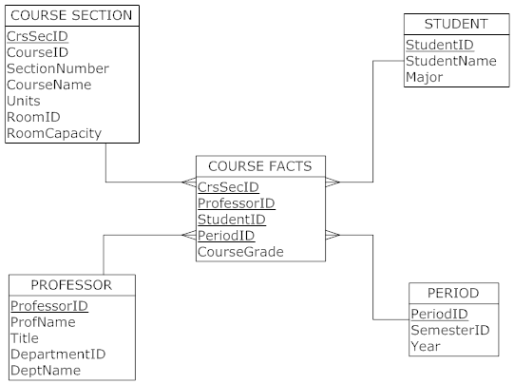

- 500 course sections x 40 students per section x 30 periods (i.e., 3 semesters per year) = 600,000 rows (assuming 1 professor per course section)
c. 600,000 rows * 5 fields per row * 5 bytes per field = 15,000,000 bytes
d. There are several possible options that can be considered if a star schema is not mandated. The following suggestions are all aimed at creating a more normalized data model:

  - Professor does not have to relate directly to the fact table. Professor could snowflake off of the Section (who are the professors teaching a particular section?). Then, there would be no Professor PK in the fact table.
  - Course information could snowflake off of Section (put Course ID, Course Name, and Units in a separate table related to Section). This would normalize Course and Section data.
  - Similarly, Department information (Department ID and Department Name) could be snowflaked off of Professor.

e. Dimensional segmentation is recommended. The student, section, and professor dimensions would be divided into two segments each, one for constant attributes and one for attributes that change. For example, the room might change frequently for the section. This approach would eliminate a large number of rows in the dimension tables if the changing attributes were to change each semester
.

- Snowflake schema for Millennium College
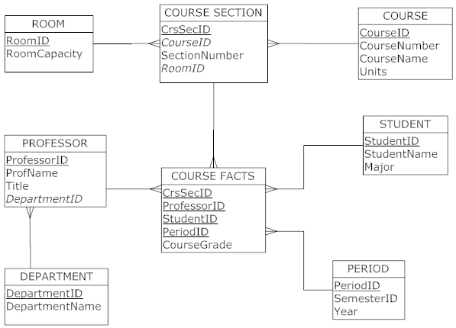

This schema will have no impact on the size of the fact table, which remains the same as for the star schema.

- Simplified Automobile Insurance Company
- Star schema:

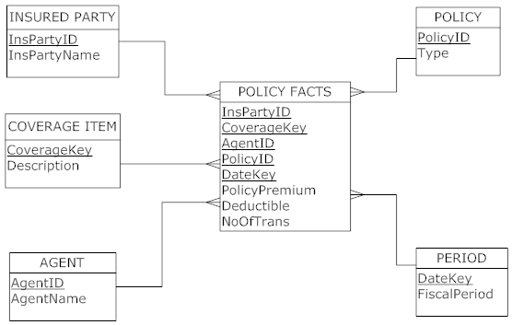

b. To correctly estimate the number of rows, we must make some additional assumptions regarding the fiscal periods and the frequency of changes to policies. We assume the following:
- The length of a fiscal period is one month
- The data mart will contain five years of historical data
- Approximately 5 percent of the policies experience some type of change each month
Therefore, the expected number of rows is:
.05 x 1,000,000 x 10 coverage items x 2 insured parties x 5 years x 12 months per year = 60,000,000

c. Total size of fact table:
60,000,000 rows x 8 fields x 5 bytes = 2,400,000,000 (2.4 Gigabytes)

- Simplified Automobile Insurance Company:
- An initial version of the extended star schema:

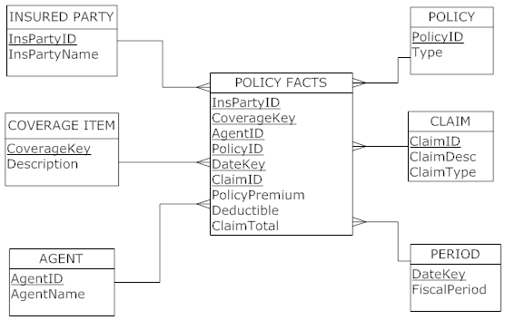

b. Unfortunately, the policy fact table in this schema has a design issue because premium and deductible are not dependent on CLAIM. This would result in two different “grains” or levels of detail in the same table, which is not permitted. A good solution is to create a separate star schema for claim facts (in this case, only ClaimTotal) with all six dimension tables, along with the original star schema. We can then calculate the number of rows in the claims fact table as follows:

60 months x 2,000 claims per month = 120,000 rows in this additional fact table

7.
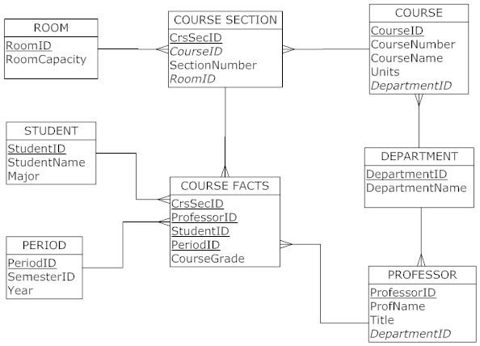

Another dimension table was added with the department information. This will create a snowflake schema. The rationale for doing this is that users may also eventually want similar information for the Professor dimension. If we added the department information only to the Course Section dimension, then this information would need to be replicated in the Professor dimension later.

8. While Ralph Kimball advocates for a dimensional model to solve all of the decision support needs of an organization, Inmon and Armstrong advocate for the creation of one central data warehouse and dependent data marts built from this. Kimball’s position is that a dimensional model, with fact tables and denormalized dimension tables, can be created to meet the needs of an entire organization; this model is far better than the traditional ER model. The opposing view holds that normalized tables are the way to build a data warehouse, because these tables can then be used to feed many different data marts tailored to individual users. Inmon states that building a dimensional model for an enterprise-wide application will result in much duplication of data and inconsistent data. While the dimensional model could be built for a data mart, the data mart must be dependent upon a data warehouse as a central repository.

9. In the initial solution, we assume that the customer is purchasing from a storage location. We also assume that there could be internal transfers both between plants and from plants to storage. Because not all dimensions are used in every movement event, the best solution for this exercise is a multiple fact-table star schema.
a. Initial solution:

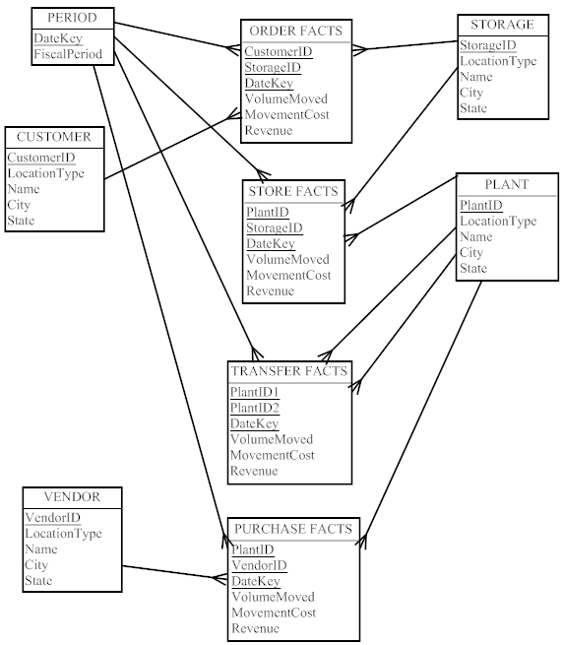

b. Using generalization to simplify solution:

We could simplify this star schema substantially by re-designing the fact table to act more generically. Essentially, the re-designed fact table contains an origin key and a destination key. For example, if a customer was to purchase some items, the origin key would be a storage ID and the destination key would be the CustomerID. OriginRole and DestinationRole will be the name of the role for each fact related to the Location ObjectID (e.g., customer, vendor, plant). TxnType will label the type of transaction that occurred (e.g.,, sale, return, etc.). Also, note the use of an ObjectID as the surrogate key for the Location dimension.

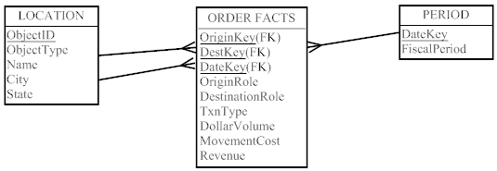

10. Note: Naming conventions in this solution follow those of the www.ralphkimball.com site.

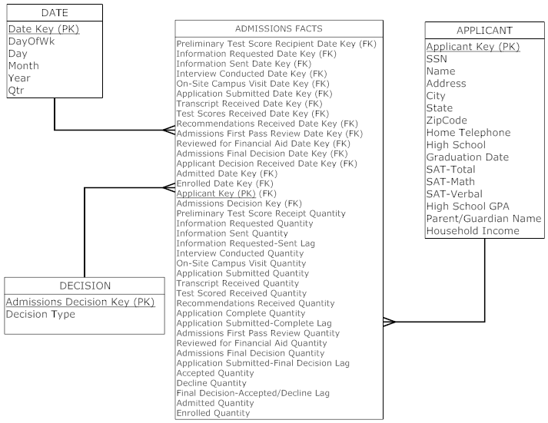

11. Answers to problems 3, 5, 6, and 9 using dimensional modeling tool available on Teradata:

Problem 3:

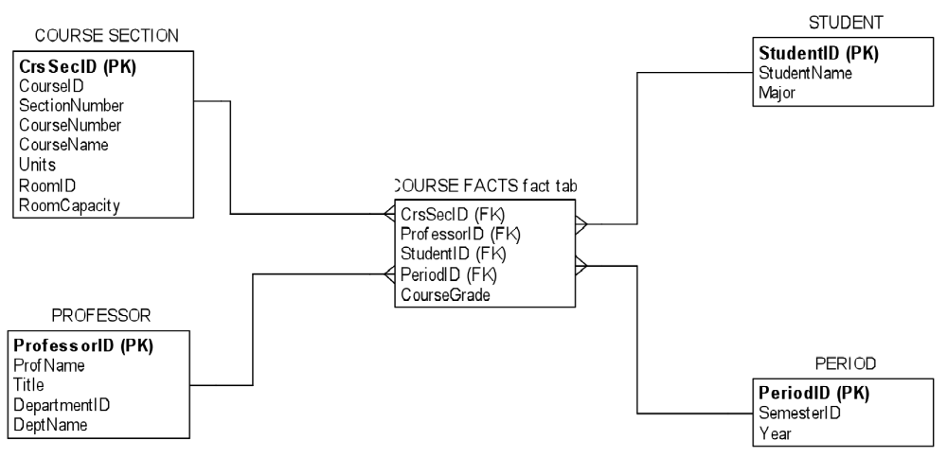

Problem 5:

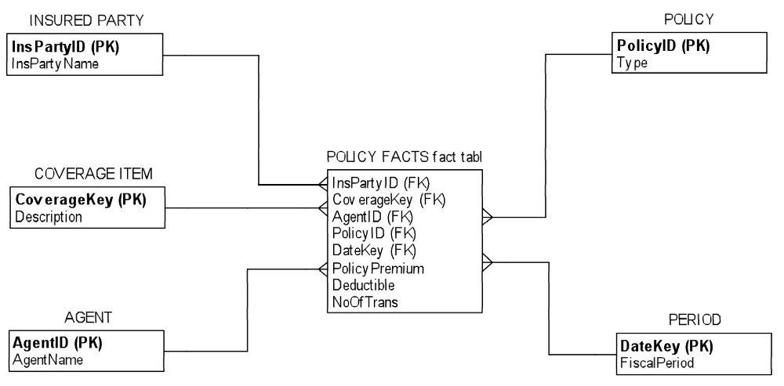

Problem 6:

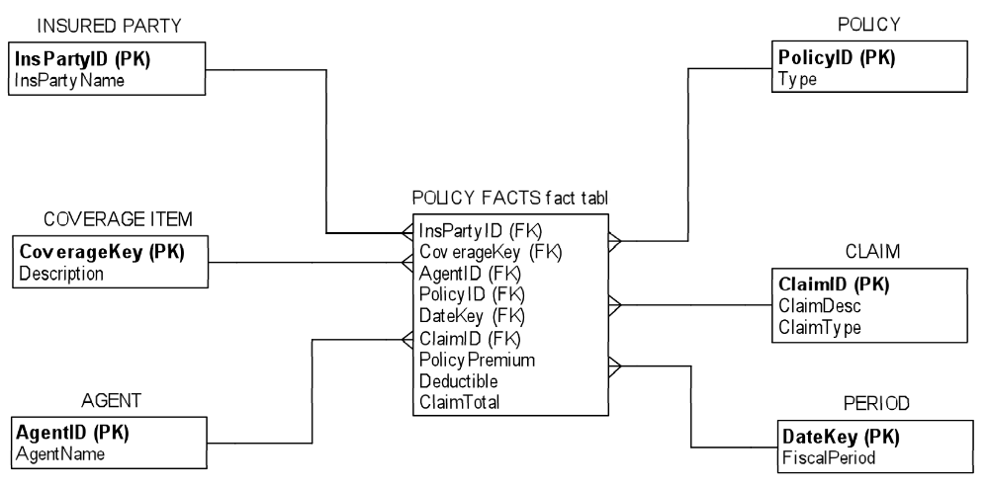

Problem 9 - initial solution:

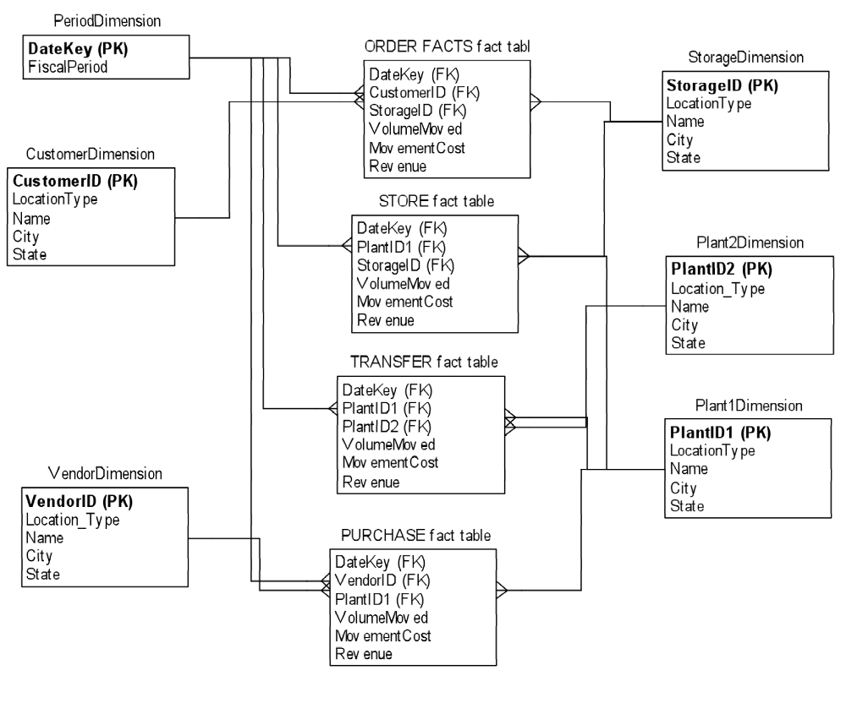

Problem 9 - simplified solution:

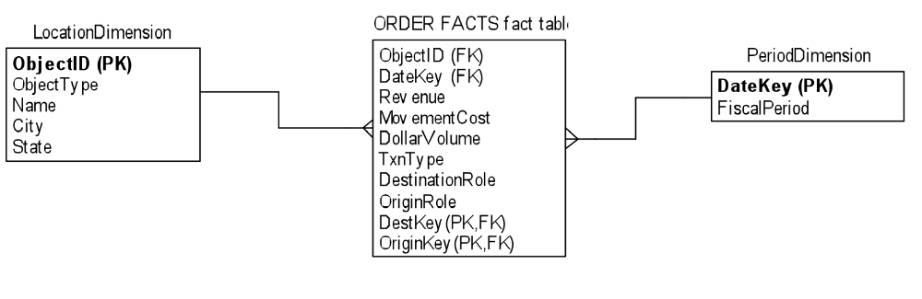

Usefulness of the Fat Free Star dimensional modeling tool:
This modeling tool is useful and easy to use; it is very intuitive. There is a simple Help file that explains the interface and functions of the program. There were a few issues encountered that could not be surmounted: (1) Only one relationship between a dimension table and the fact table can be drawn; the tool will not permit multiple relationships. (2) There did not appear to be a way to adjust the size of the tables so that longer names could be used for table names; the tool just cuts off the display of longer named tables. (3) Attribute names were automatically placed in alphabetical order; there did not appear to be a way to place them in a designer-preferred order. Drawing tools for other diagrams (e.g., Visio, SmartDraw) now seem to come loaded with many sample or standard templates; it would be nice if this tool could also have standard templates for such schemas.

12.
a. Because location is a hierarchy on Customer, it is best to snowflake Location off Customer with a helper table, though Location itself is a hierarchy (location within location), the approach in Figure 9-16 is not sufficient and a solution similar to that shown in Figure 9-17a is necessary.

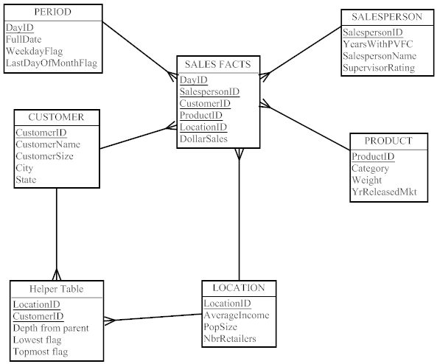

b. In order to keep the history of the changes in Customer information, the model must be adjusted to store date elements in the Customer, helper (even the hierarchy could change over time), and location tables.

The chapter covers several methods for handling slowly changing dimensions. The preferred approach is to expand the PK of the Customer and Location dimension tables, and probably add one non-key attribute. The new PK would become the original surrogate key plus the Date/Time Stamp for when the change reflected by the values in the row of the dimension table occurred. The new non-key could be the date when the row is no longer true (end date). End date would be null or some very large value for the current row. The fact table still has just the original surrogate keys. The Period PK in the fact table is used to figure out which row of the Customer (or Location) table is relevant for that fact (i.e., the Period falls between the start and end dates of the relevant associated Customer row). The new date key in Customer would serve the same purpose as part of the foreign key in Location for linking a customer to changes in characteristics of its location.

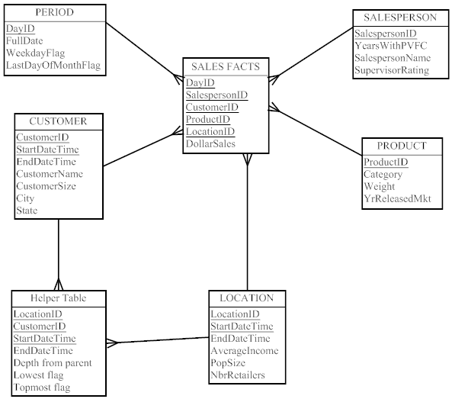

- Star schema for Fitchwood Insurance:

a. The time dimension is handled with the Date Dimension table, which includes a surrogate key, and attributes of DayOfWeek, Day, Month, Year, Qtr, and WeekdayFlag.
b. The multivalued attribute of customer address is handled in this schema with a slowly changing dimension (SCD) element of a start date as part of the surrogate key for the customer dimension table.
c. Territory is snowflaked off of Agent.
d. TransactionID indicates whether the transaction is initial commission, monthly commission, write policy, or discontinue policy.

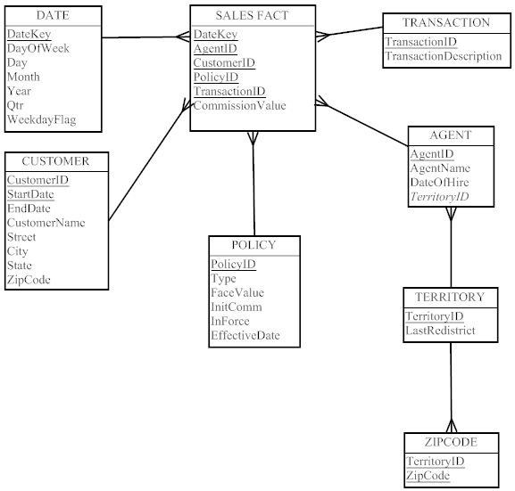

- Is further snowflaking required for the Fitchwood solution in question 13?

The answer to question 13 handles the changing customer address as a slowly changing dimension (SCD), thus there is no reason to snowflake to normalize further for the slowly changing dimension.

15. Revision of Exercise 13 and 14 to address the issue of agents changing territories over time. The solution uses a start date as part of the surrogate key for the agent dimension table to design for this slowly changing dimension (SCD).

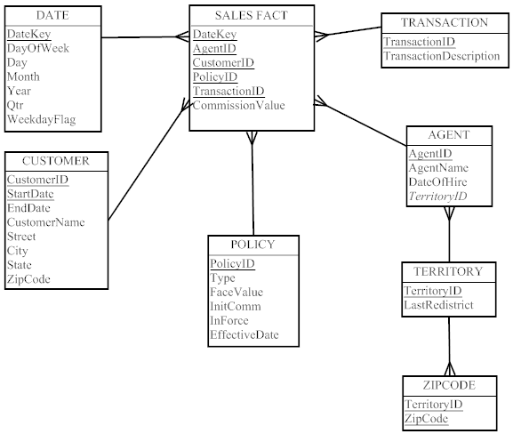

16. Revision of Exercise 15 to address the issue of customers having relationships with other customers (e.g., spouse, etc.). The solution uses a helper table as shown in Figure 9-17 to accommodate the relationships in the new design.

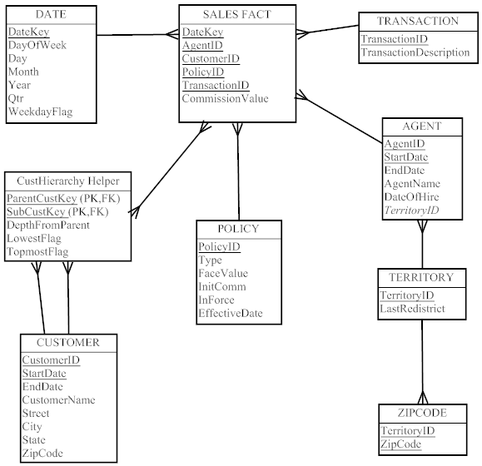

17. The use of an OLAP tool is recommended. The OLAP cube could be built from the existing star schema. Specific scripts would have to be written in order to build the cube to accommodate drill-down capabilities. It would also be necessary to store aggregate data.

18. There is a vast amount of data mining that could be done using this case study. For example, what age groups purchase which policies? What age group of customers is most likely to keep a policy in force? What states have the best sales of policies, and how does this compare with the age demographics for the customers in that state?

The exercise of researching data-mining tools is left to the student; answers will vary depending on depth of research and searching expertise of individual students.

19. The db_samwh appears to model hierarchies by nesting the dimensions, as described in the chapter. The metatdata description in the user manual (and the logical and physical schema diagrams) and the SHOW TABLE commands on selected tables evidence the presence of foreign keys that point back to separate dimension tables in the data. Some of the hierarchies that are evident include: Account (Account – Company – Industry), Product (Product – Product Group), and Sales Organization (Sales Rep – District – Region).

20. Based on a review of the metadata description in the user manual, and selected queries upon physical tables, it appears that dimension data are maintained for the Opportunity section of the data mart/data warehouse by the presence of Open, Close dates for Opportunity. It appears that this slowly changing dimension data is being maintained as described in the chapter.

21. Based on a review of the metadata description in the user manual, and selected queries upon physical tables, it appears that the dimension table data is conformed as the same surrogate primary keys are used throughout the schema.

22. Most BI software generates SQL to retrieve the data from a database to do the analysis requested in the report or graph. SQL may not have the output formatting commands to display the results in a most usable manner, so the BI software does this. Sometimes SQL isn’t capable of doing some analysis, so the BI software takes the SQL result and manipulates it further before formatting the output. This is the typical scenario for MicroStrategy.

In other cases, when you can’t get the BI software to produce exactly the analysis you want, you can use the generated SQL as a starting point. You can develop a report from the BI software that is close to what you desire, “scrape” the generated SQL, modify the SQL code with OLAP extensions, and they manually run the modified code using an SQL engine against the same data to get the desired analysis.

To demonstrate this scenario, run the following MicroStrategy report:

Shared Reports → Sales Performance Analysis → Quarterly Revenue Trend by Sales Region → 2005 → Run Report

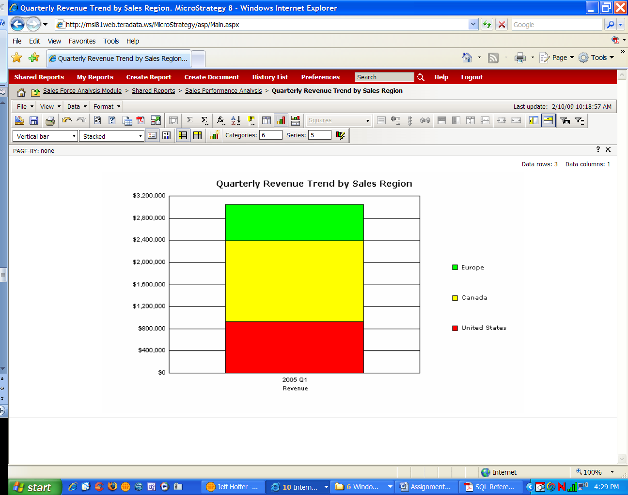

Save the resultant screen display to a Word file, and then “scrape” the query MicroStrategy generated to produce this report (include this scraped query also in the Word file); you can scrape the query with the report result on the screen by using the File menu as follows:

File → Report Details

select a13.SALES_REGN_ID SALES_REGN_ID,
max(a13.SALES_REGN_DESC) SALES_REGN_DESC,
a12.QTR_ID QTR_ID,
max(a14.QTR_DESC) QTR_DESC,
sum(a11.ORDER_AMT) WJXBFS1
from F_ORDER a11
join L_CAL_DATE a12
on (a11.ORDER_DATE = a12.DATE_ID)
join L_SALES_REP a13
on (a11.SALES_REP_ID = a13.SALES_REP_ID)
join L_CAL_QTR a14
on (a12.QTR_ID = a14.QTR_ID)
where a12.YEAR_ID in (2005)
group by a13.SALES_REGN_ID,
a12.QTR_ID;

23. Cut and paste the query you scraped in Question 22 above into the query pane and then run the scraped query on SQL Assistant (implicating using the db_samwh database). The database you are using is the same one that MicroStrategy used for the Sales Force Analysis Module. Save your query and Answer Set to the Word file.

SALES_REGN_ID | SALES_REGN_DESC | QTR_ID | QTR_DESC | WJXBFS1
3.00 | Europe | 20051.00 | 2005 Q1 | 650000.00
2.00 | Canada | 20051.00 | 2005 Q1 | 1475000.00
1.00 | United States | 20051.00 | 2005 Q1 | 925000.00

Then, rewrite the query to show only the United States region grouped by each quarter, not just for 2005 but for all years available, in order by quarter (you should get 6 rows in the Answer Set). Label the total orders by quarter with the heading TOTAL and the region id simply as ID in the display. Save your query and Answer Set to the Word file.

select a13.SALES_REGN_ID ID,
max(a13.SALES_REGN_DESC) SALES_REGN_DESC,
a12.QTR_ID QTR_ID,
max(a14.QTR_DESC) QTR_DESC,
sum(a11.ORDER_AMT) TOTAL
from F_ORDER a11
join L_CAL_DATE a12
on (a11.ORDER_DATE = a12.DATE_ID)
join L_SALES_REP a13
on (a11.SALES_REP_ID = a13.SALES_REP_ID)
join L_CAL_QTR a14
on (a12.QTR_ID = a14.QTR_ID)
where a13.SALES_REGN_ID in (1)
group by a13.SALES_REGN_ID, a12.QTR_ID
order by a12.QTR_ID;

ID | SALES_REGN_DESC | QTR_ID | QTR_DESC | TOTAL
1.00 | United States | 20034.00 | 2003 Q4 | 2150000.00
1.00 | United States | 20041.00 | 2004 Q1 | 2325000.00
1.00 | United States | 20042.00 | 2004 Q2 | 2525000.00
1.00 | United States | 20043.00 | 2004 Q3 | 2725000.00
1.00 | United States | 20044.00 | 2004 Q4 | 2925000.00
1.00 | United States | 20051.00 | 2005 Q1 | 925000.00

24. Using the MDIFF “ordered analytical function” in Teradata SQL (see Functions and Operators manual) show the differences (label the difference CHANGE) in TOTAL from quarter to quarter. Hint: you will likely create a derived table based on your query above, similar to what is shown in examples in the Functions and Operators manual; when you do so you will need to give the derived table an alias name and then use that alias name in the outer select statement when you ask to display the results of the query. Save your query and Answer Set to the Word file.

By the way, MDIFF is not standard SQL; this is an analytical function peculiar to Teradata. Every DBMS that supports BI/OLAP actions will have some proprietary SQL extensions. Besides MDIFF, Teradata has analytical functions such as cumulative frequency (CSUM), identifying position in a sequence (RANK), moving average (MAVG), and identifying the n-tile (e.g., percentile, decile, quartile, etc.) position (QUANTILE); some of these functions are proprietary to Teradata, but some are now standard SQL (e.g., RANK).

select T1.ID, T1.SALES_REGN_DESC, T1.QTR_ID, T1.QTR_DESC,
T1.TOTAL, MDIFF(T1.TOTAL,1,T1.QTR_ID) CHANGE
from
(select a13.SALES_REGN_ID ID,
max(a13.SALES_REGN_DESC) SALES_REGN_DESC,
a12.QTR_ID QTR_ID,
max(a14.QTR_DESC) QTR_DESC,
sum(a11.ORDER_AMT) TOTAL
from F_ORDER a11
join L_CAL_DATE a12
on (a11.ORDER_DATE = a12.DATE_ID)
join L_SALES_REP a13
on (a11.SALES_REP_ID = a13.SALES_REP_ID)
join L_CAL_QTR a14
on (a12.QTR_ID = a14.QTR_ID)
where a13.SALES_REGN_ID in (1)
group by a13.SALES_REGN_ID, a12.QTR_ID) as T1
order by T1.QTR_ID;

ID | SALES_REGN_DESC | QTR_ID | QTR_DESC | TOTAL | CHANGE
1.00 | United States | 20034.00 | 2003 Q4 | 2150000.00 | ?
1.00 | United States | 20041.00 | 2004 Q1 | 2325000.00 | 175000.00
1.00 | United States | 20042.00 | 2004 Q2 | 2525000.00 | 200000.00
1.00 | United States | 20043.00 | 2004 Q3 | 2725000.00 | 200000.00
1.00 | United States | 20044.00 | 2004 Q4 | 2925000.00 | 200000.00
1.00 | United States | 20051.00 | 2005 Q1 | 925000.00 | -2000000.00

25. For this question, you’ll need to refer to the Data Manipulation Statements SQL Assistant manual and the db_samwh metadata manual from MicroStrategy that you downloaded earlier.

There are many OLAP clauses now in standard SQL, and in this question you are asked to use two of these, the SAMPLE and ROLLUP clauses. SAMPLE is often used to create an extract table (flat file) of data, and then to save this sample for some further analysis (e.g., as a market research test group, as input to an analytical tool that does not support SQL, or simply to reduce the analysis time when a sample is sufficient for some (statistical) analysis). ROLLUP is used to see data summarized at different levels in a hierarchy. Most analytical databases have factual data that can be summarized along various geographical, time, product group, or other hierarchies, and along combinations of hierarchical levels. See, starting on p. 124 of the db_samwh pdf document file, an explanation of the hierarchies present in this database, and see p. 123 for an entity-relationship diagram of the database. You can find explanations of SAMPLE and ROLLUP in the Data Manipulation Statements document you downloaded.

Using SQL Assistant, create a sample of orders from 2004; put a randomized allocation of 10% of the rows into the sample. Include in the sample results the order id, prod id, sales rep region id, month description, and order amount. Show results in sequence by month. Run the query two times to check that the sample is actually random. Put your query and Answer Set into the Word file.

select order_id, prod_id, sales_regn_id, mnth_desc, order_amt
from f_order, l_sales_rep, l_cal_date, l_cal_mnth
where l_cal_date.year_id = 2004
and f_order.order_date = l_cal_date.date_id
and l_cal_date.mnth_id = l_cal_mnth.mnth_id
and f_order.sales_rep_id = l_sales_rep.sales_rep_id
sample randomized allocation .10
order by mnth_desc;

First few rows of 45 from first pass:

ORDER_ID | PROD_ID | SALES_REGN_ID | MNTH_DESC | ORDER_AMT
78.00 | 12.00 | 1.00 | Apr 2004 | 75000.00
82.00 | 8.00 | 2.00 | Apr 2004 | 75000.00
74.00 | 4.00 | 1.00 | Apr 2004 | 40000.00
75.00 | 2.00 | 1.00 | Apr 2004 | 125000.00
76.00 | 5.00 | 1.00 | Apr 2004 | 50000.00
85.00 | 10.00 | 3.00 | Apr 2004 | 25000.00
84.00 | 1.00 | 2.00 | Apr 2004 | 150000.00
129.00 | 2.00 | 1.00 | Aug 2004 | 50000.00
126.00 | 5.00 | 3.00 | Aug 2004 | 40000.00
127.00 | 1.00 | 1.00 | Aug 2004 | 125000.00
130.00 | 5.00 | 1.00 | Aug 2004 | 75000.00

Other executions of query did produce different results.

26. Now, using the raw data, not the sample, do a rollup to get total order amounts by product, sales region, and month, and all combinations including a grand total. Display the results sorted by product, region, and month. Put your query and the first portion of the Answer Set including all of product 1 and a few rows for product 2 into the Word file.

Select prod_id, sales_regn_id, mnth_desc, sum(order_amt)
from f_order, l_sales_rep, l_cal_date, l_cal_mnth
where l_cal_date.year_id = 2004
and f_order.order_date = l_cal_date.date_id
and l_cal_date.mnth_id = l_cal_mnth.mnth_id
and f_order.sales_rep_id = l_sales_rep.sales_rep_id
group by rollup (prod_id, sales_regn_id, mnth_desc)
order by prod_id, sales_regn_id, mnth_desc;

Partial result:

PROD_ID | SALES_REGN_ID | MNTH_DESC | Sum(ORDER_AMT)
? | ? | ? | 28270000.00
1.00 | ? | ? | 7360000.00
1.00 | 1.00 | ? | 2610000.00
1.00 | 1.00 | Apr 2004 | 430000.00
1.00 | 1.00 | Aug 2004 | 375000.00
1.00 | 1.00 | Feb 2004 | 75000.00
1.00 | 1.00 | Jan 2004 | 375000.00
1.00 | 1.00 | Jul 2004 | 540000.00
1.00 | 1.00 | Jun 2004 | 250000.00
1.00 | 1.00 | Mar 2004 | 40000.00
1.00 | 1.00 | May 2004 | 95000.00
1.00 | 1.00 | Nov 2004 | 200000.00
1.00 | 1.00 | Oct 2004 | 230000.00
1.00 | 2.00 | ? | 2320000.00
1.00 | 2.00 | Apr 2004 | 275000.00
1.00 | 2.00 | Aug 2004 | 225000.00
1.00 | 2.00 | Dec 2004 | 440000.00
1.00 | 2.00 | Feb 2004 | 325000.00
1.00 | 2.00 | Jan 2004 | 95000.00
1.00 | 2.00 | Jul 2004 | 175000.00
1.00 | 2.00 | May 2004 | 200000.00
1.00 | 2.00 | Nov 2004 | 30000.00
1.00 | 2.00 | Oct 2004 | 405000.00
1.00 | 2.00 | Sep 2004 | 150000.00
1.00 | 3.00 | ? | 2430000.00
1.00 | 3.00 | Apr 2004 | 250000.00
1.00 | 3.00 | Aug 2004 | 155000.00
1.00 | 3.00 | Dec 2004 | 200000.00
1.00 | 3.00 | Feb 2004 | 200000.00
1.00 | 3.00 | Jan 2004 | 150000.00
1.00 | 3.00 | Jul 2004 | 100000.00
1.00 | 3.00 | Jun 2004 | 250000.00
1.00 | 3.00 | Mar 2004 | 200000.00
1.00 | 3.00 | May 2004 | 100000.00
1.00 | 3.00 | Nov 2004 | 375000.00
1.00 | 3.00 | Oct 2004 | 150000.00
1.00 | 3.00 | Sep 2004 | 300000.00
2.00 | ? | ? | 2120000.00
2.00 | 1.00 | ? | 965000.00
2.00 | 1.00 | Apr 2004 | 175000.00

Answers to Field Exercises

- One of two approaches can be used for this exercise:

- Arrange a field trip and interview several persons to obtain answers to the questions stated. This is the preferred approach because it enables students to obtain different perspectives concerning these questions.
- Invite one of the key participants to visit your class and make a short presentation, followed by student questions. The author used this approach in a recent class and found it reasonably effective, although the answers represented the perspective of only the one person.

- These Web sites contain a wealth of information concerning data warehousing. You can focus the search around the following issues:

- What are some of the key data warehouse implementation issues today, and what advice do the data warehouse gurus give concerning these issues?
- What jobs have been spawned by data warehousing, and what are typical salary ranges for these jobs?
- What types of software are available to support data warehouse design, implementation, and maintenance?
- Cite several case examples of data warehouse implementations and document the following: benefits obtained, lessons learned, and pitfalls to avoid.

Project Case Study

Case Questions

- Some of the advantages that a hospital might realize from a data warehouse are:

- Single, organization-wide view of data
- Improved data quality and consistency
- Faster and easier access to data
- Use of powerful data analysis and data-mining tools

All of these more technical advantages can lead directly to the improvements outlined in the question (e.g., data quality can vastly improve patient safety; data analysis and mining can improve clinical research; faster and easier access to data can directly help treatment efficiency).

- A data mart could be used in the emergency room to keep patient information, including test results. It could also be used to keep a knowledge base of medical information. In general, a data mart can be optimized to support the specific needs of the emergency room (which likely has a need for more rapid access to data, often with less patient information availability than other areas of the hospital).

- For reasons explained in the text, Mountain View Community Hospital should avoid developing a series of independent data marts. However, an organization can develop a pilot (or prototype) data mart to investigate “proof of concept,” provided that this development is part of a well-orchestrated plan for data warehouse development. The advantage of this approach is that it can help secure the commitment of top managers and user groups. The disadvantage of this approach is that it may be difficult to avoid short-term pressures that may result in developing independent data marts.

- One possible way to address this would be to code all records so that the identifying information for a patient is not stored with actual data in the same set of tables. Encryption can also be used, however, tight authentication mechanisms will have to be in place. (Look ahead to Chapter 11 for information on the administration of security approaches for databases.)

- OLAP tools would be helpful, especially since one could drill-down into such things as treatment detail records from high-level balanced scorecard metrics. ROLAP would be a good choice because it provides the greatest flexibility. OLAP’s value is the ability to easily “slice and dice” and “drill-down” a view of data. Thus, OLAP helps to create high-level views of hospital operations and then the ability to isolate where data shows abnormalities or interesting results. This might be in quality of care, financials, customer satisfaction, or other metric areas.

- There is an opportunity for several types of data-mining applications. For example, regression analysis could be used to look at historical data and discover trends. Sequence association could be employed to identify trends such as seasonal demands for services. Case-based reasoning could be used to help with determining what was most successful for diagnoses for various ailments.

- A data mart or data warehouse would help to ensure accuracy of financial data because there would be a process to verify data before loading it into the warehouse. Systematic errors made in source systems would be identified. Reports would be timely once the warehouse was developed because front-end tools could be deployed to enable management to generate reports at any time. Also, an EIS application could be deployed on top of the data mart or data warehouse. Trend information could be obtained from data mining. A data warehouse also shows history (whereas operational systems often only show current state), and history provides an audit trail essential for compliance. Overall, a data warehouse forces an organization to have better documentation (metadata), which is critical for compliance.

Case Exercises

- Summary data mart:
Star schema:

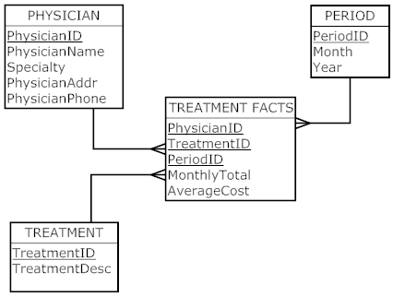

We assume that 150 treatment instances occur per month.

Expected size:
150 treatments x 36 periods = 5,400 rows
No. of bytes per row = 5 + 3 + 2 + 3 + 5 = 18
Total bytes = 5,400 x 18 = 97,200

Detailed data mart:
Star schema:

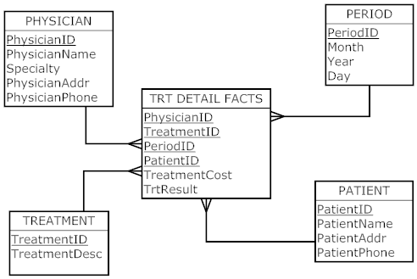

We assume the average patient census is meant to be 100, so two treatments per day per patient gives you 200 treatments per day.

Expected size:
200 treatments per day x 1,000 days = 200,000 rows
Bytes per row = 3 + 5 + 5 + 2 + 4 + 20 + 10 = 49
200,000 rows x 49 bytes per row = 9,800,000 bytes (9.8 Megabytes)

c. The primary key structure is based on this assumption. One way to overcome this limitation is to add the time of day when a treatment is performed to the fact table. Or not be concerned with treatment transactions in the fact table and be satisfied with a summary value of the total costs to apply the treatment, possibly multiple times, by the same physician to the same patient in the same day and with the final treatment result being all that matters.

d. MVCH should implement the detailed data mart as the data will be able to be summarized from the detail, and there would not be any issues encountered with trying to keep the detail and summary data marts synchronized.

- For the summary data mart:

Find the total treatments performed by each physician in 2010:
SELECT Physician.PhysicianName, SUM (TreatmentFacts.MonthlyTotal)
FROM Physician, TreatmentFacts, Period
WHERE Physician.PhysicianID = TreatmentFacts.PhysicianID
AND Period.PeriodID = TreatmentFacts.PeriodID
AND Period.Year = ‘2010’
GROUP BY Physician.PhysicianName;

For the detailed data mart:
Find the total cost of treatments for each patient:

SELECT Patient.PatientName, SUM (TreatmentCost)
FROM Patient, TreatmentFacts
WHERE Patient.PatientID = TreatmentFacts.PatientID
GROUP BY PatientName;

- a.
Dimensions and Facts
Table | Column | Comments
Surgeon Dimension | SurgeonID | Primary Key
Surgeon Dimension | SurgeonName
Surgeon Dimension | Department
Surgeon Dimension | YearsExperience
Disposition Dimension | DispID | Primary Key
Disposition Dimension | DispCode | This field will contain several codes such as cancelled, patient died or had a reaction to blood
Disposition Dimension | Reason | Reason for cancellation
Visit Dimension | VisitID | Primary Key
Visit Dimension | PatientID | FK to Patient dimension (snowflake schema)
Visit Dimension | PatientAge | Age at time of visit
Visit Dimension | VisitType | Outpatient or inpatient
Visit Dimension | InsuranceCo
Visit Dimension | Acuity
Visit Dimension | Diagnosis | Diagnosis for this visit
Patient Dimension | PatientID | Primary key
 | PatientName
 | PatientCity
 | PatientState
 | PatientZip
 | PatientDOB | Date of Birth
 | PatientGender

OperatingRoom Dimension | ORID | Primary Key
OperatingRoom Dimension | Location
SurgeryType Dimension | SurgeryKey | Primary Key
SurgeryType Dimension | Type | Type of surgery
SurgeryType Dimension | Category | i.e. heart, ENT, etc.
Time Dimension | TimeKey | Primary Key
 | Year
 | Quarter
 | Month
 | WeekNumber | Number of week in year
 | WeekofMonth | Number of week in month (1-4)
 | DayofWeek | Sun-Sat
 | Day | Actual day of month (1-31)
SurgeryFacts | SurgeonID | Foreign key to surgeon dimension
SurgeryFacts | VisitID | Foreign key to Visit dimension
SurgeryFacts | ORID | Foreign key to OperatingRoom dimension
SurgeryFacts | DispID | Foreign key to disposition
SurgeryFacts | SurgeryKey | Foreign key to SurgeryType dimension
SurgeryFacts | TimeKey | Foreign key to Time dimension
SurgeryFacts | SurgeryDuration | Length of the surgery
SurgeryFacts | SurgeryStart
SurgeryFacts | SurgeryEnd
SurgeryFacts | AnesthesiaDuration

- Star Schema:
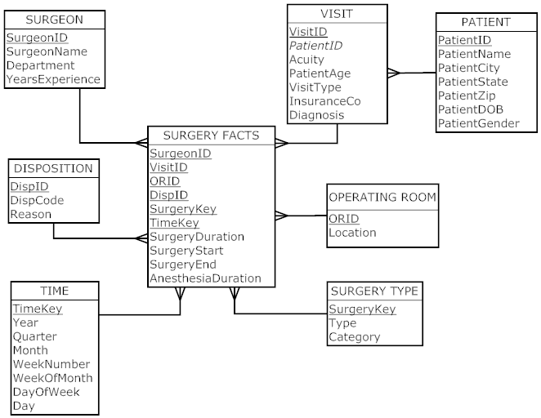

- Three star queries:

List the number of surgeries per week per OR:
SELECT OperatingRoom.Location, Time.WeekNumber,COUNT(*)
FROM OperatingRoom, SurgeryFacts, Time
WHERE OperatingRoom.ORID = SurgeryFacts.ORID
AND Time.TimeKey = SurgeryFacts.TimeKey
GROUP BY OperatingRoom.Location, Time.WeekNumber;

List the average surgery time per OR:
SELECT OperatingRoom.Location, AVERAGE(SurgeryFacts.SurgeryDuration)
FROM OperatingRoom, SurgeryFacts
WHERE OperatingRoom.ORID = SurgeryFacts.ORID;

List the number of negative patient reactions to blood transfusions by surgeon:
Here, we will assume that the disposition dimension table has a DispCode of ‘nb’ to indicate this.

SELECT Surgeon.SurgeonName, COUNT(*)
FROM Surgeon, SurgeryFacts, Disposition
WHERE Surgeon.SurgeonID = SurgeryFacts.SurgeonID
AND Disposition.DispID = SurgeryFacts.DispID
AND Disposition.DispCode = ‘nb’
GROUP BY Surgeon.SurgeonName;

d. The development of a business case for this scenario is left to the student. One thing to focus on is cost savings as well as increased patient quality due to the ability to get accurate, timely reports from the data mart.

- Emergency Room:
Table | Column | Comments
Physician Dimension | PhysicianID | Primary Key
Physician Dimension | PhysicianName
Physician Dimension | Department
Physician Dimension | YearsExperience
Disposition Dimension | DispID | Primary Key
Disposition Dimension | DispCode | This field will contain several codes such as discharged patient admitted, patient died, etc.
Disposition Dimension | Reason | Any reasons
VisitFact | PhysicianID | FK to Physician
VisitFact | PatientID | FK to Patient dimension (snowflake schema)
VisitFact | TRID | FK to TreatmentRoom
VisitFact | DispID | FK to Disposition
VisitFact | TimeKey | FK to Time
VisitFact | VisitStart
 | VisitEnd
 | PatientAge
 | Diagnosis
 | InsuranceCo
 | Symptoms
Patient Dimension | PatientID | Primary key
 | PatientName
 | PatientCity
 | PatientState
 | PatientZip
 | PatientDOB
 | PatientGender
TreatmentRoom Dimension | TRID | Primary Key
TreatmentRoom Dimension | Location
TreatmentFact | PhysicianID | FK to Physician
TreatmentFact | PatientID | FK to Patient
TreatmentFact | TreatmentID | FK to Treatment
 | TimeKey | FK to Time
 | results
Time Dimension | TimeKey | Primary Key
 | Year
 | Quarter
 | Month
 | WeekNumber | Number of week in year
 | WeekofMonth | Number of week in month (1–4)
 | DayOfWeek | Sun – Sat
 | Day | Actual day of month (1–31)

Star Schema:
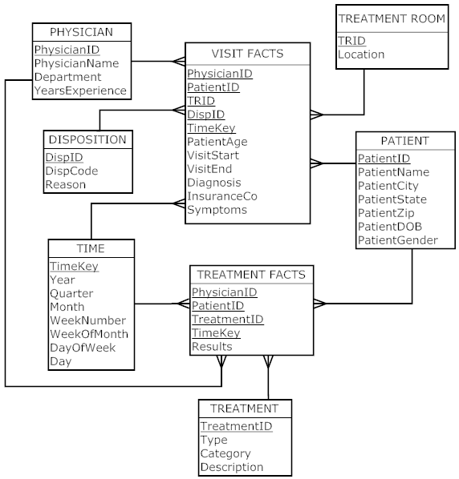

Dr. Z’s MS Center
Table | Column | Comments
Physician Dimension | PhysicianID | Primary Key
Physician Dimension | PhysicianName
Physician Dimension | Department
Physician Dimension | YearsExperience
Medications Dimension | MedID | Primary Key
Medications Dimension | Type
Medications Dimension | Description
VisitFact | PhysicianID | FK to Physician
VisitFact | PatientID | FK to Patient dimension (snowflake schema)
VisitFact | TimeKey | FK to Time
VisitFact | Visit Start
 | VisitEnd
 | PatientAge
 | InsuranceCo
MedFact | PatientID | FK to Patient
MedFact | MedID | FK to medications
MedFact | Dosage
Patient Dimension | PatientID | Primary key
Patient Dimension | PatientName
Patient Dimension | PatientCity
Patient Dimension | PatientState
Patient Dimension | PatientZip
Patient Dimension | PatientDOB
Patient Dimension | PatientGender
Patient Dimension | LastMRIDate
Patient Dimension | LastMRIRes
Time Dimension | TimeKey | Primary Key
Time Dimension | Year
Time Dimension | Quarter
Time Dimension | Month
Time Dimension | WeekNumber | Number of week in year
Time Dimension | WeekOfMonth | Number of week in month (1-4)
Time Dimension | DayOfWeek | Sun – Sat
Time Dimension | Day | Actual day of month (1-31)
Symptom Dimension | SymptomID | PK
Symptom Dimension | Description

LipidFact | PatientID | FK to Patient
LipidFact | TimeKey
LipidFact | LDL
LipidFact | Trig
LipidFact | HDL
LipidFact | Chol
ClinicFact | PatientID | FK to Patient
ClinicFact | TimeKey
ClinicFact | BloodPressure
ClinicFact | Weight
AdvisoryFact | PatientID | FK to Patient
AdvisoryFact | TimeKey
AdvisoryFact | Advisory
SymptomFact | PatientID | FK to Patient
 | SymptomID | FK to Symptom

Star Schema:

