Chapter 13 Object-Oriented Data Modeling

Chapter Overview

Please note that the material for this chapter is based upon the Web version of Chapter 13, not the abbreviated version of Chapter 13 in the text.

The purpose of this chapter is to introduce object-oriented modeling concepts. This chapter presents the UML notation and defines the key terms associated with object-oriented modeling. Most of the concepts learned in Chapters 2 and 3 correspond to concepts in object-oriented modeling, but as this chapter presents, the object-oriented modeling approach builds upon and extends the EER model.

Chapter Errata

In the first printing of the textbook, a few mistakes were not discovered until after the textbook was printed. The “Errata” document on the textbook website chronicles all known issues with the textbook that were discovered after printing. The list below indicates those specific to this chapter.

- In Figure 13-11, the calc-tuition() operation in both Graduate Student and Undergraduate Student subclasses of Student should be called calcTuition().

Chapter Objectives

Specific student learning objectives are included in the beginning of the chapter. From an instructor’s point of view, the objectives of this chapter are to:

- Explore the similarities between the major steps in database development and relevant elements in the object-oriented development process.
- Present the object-oriented model technique using the UML notation to model real-world situations.
- Emphasize the importance of building a model and thinking in abstract terms rather than worrying about implementation details in the analysis phase. Focus on describing what the intended system must do, rather than how it will be done.
- Introduce the terminology associated with object-oriented modeling and recognize when to use generalization, aggregation, and composition relationships to more accurately represent real-world systems.

Key Terms

Abstract class | Class-scope attribute | Object
Abstract operation | Class-scope operation | Object diagram
Aggregation | Composition | Operation
Association | Concrete class | Overriding
Association class | Constructor operation | Polymorphism
Association role | Encapsulation | Query operation
Behavior | Method | State
Class | Multiple classification | Update operation
Class diagram | Multiplicity

Classroom Ideas

- Review the major phases in the object-oriented development life cycle (Figure 13-1).
- Use the sample object-oriented diagram shown in Figure 13-2 to “jump-start” your students’ understanding.
- Use Figure 13-18 to demonstrate how complex business systems can be represented using the object-oriented notation.
- Present the object-oriented concept of encapsulation.
- Discuss the use of generalization and its role in simplifying complex systems. Reference Figure 13-9. Also discuss how this object-oriented feature should facilitate easier maintenance of the system.
- Discuss the use of overriding and the difference between overriding for extension versus restriction.
- Discuss the use of aggregation versus association.
- If your students are familiar with some object-oriented development environment, you can have them investigate (or you can show them in class) the various tools available in the environment to do the type of data modeling illustrated in this chapter.

Answers to Review Questions

- Define each of the following key terms:

- Class. An entity that has a well-defined role in the application domain about which the organization wishes to maintain state, behavior, and identity
- State. Encompasses an object’s properties (attributes and relationships) and the values those properties have
- Behavior. Represents how an object acts and reacts
- Encapsulation. The technique of hiding the internal implementation details of an object from its external view
- Operation. A function or a service that is provided by all the instances of a class
- Method. The implementation of an operation
- Constructor operation. An operation that creates a new instance of a class
- Query operation. An operation that accesses the state of an object but does not alter the state
- Update operation. An operation that alters the state of an object
- Abstract class. A class that has no direct instances, but whose descendants may have direct instances
- Concrete class. A class that can have direct instances
- Abstract operation Defines the form or protocol of the operation, but not its implementation
- Multiplicity. Indicates how many objects participate in a given relationship
- Class-scope attribute. An attribute of a class that specifies a value common to an entire class rather than a specific value of an instance
- Association class. An association that has attributes or operations of its own or participates in relationships with other classes
- Polymorphism. The same operation may apply to two or more classes in different ways
- Overriding. The process of replacing a method inherited from a superclass by a more specific implementation of that method in a subclass
- Multiple classification. An object is an instance of more than one class
- Composition. A part object which belongs to only one whole object and which lives and dies with the whole object
- Recursive aggregation. A part-of relationship between a component object and itself, treating itself as the aggregate object

- Match the following terms to the appropriate definitions:

c concrete class
b abstract operation
f aggregation
e overriding
a polymorphism
h association class
d composition
g class

- Contrast the following terms:

- Class; object. Class refers to the structure of an object, whereas an object refers to the individual instances.
- Attribute; operation. Attribute refers to an object’s data; operation refers to a function or a service that is provided by all the instances of a class.
- State; behavior. State refers to an object’s properties and is characterized by its attributes; behavior refers to how an object acts and reacts.
- Operation; method. An operation refers to an object’s functions or services that are provided by all the instances of a class. A method refers to how these functions or services are implemented.
- Query operation; update operation. Both are operations, but the update operation alters the state of an object.
- Abstract class; concrete class. Instances of objects can be created from concrete classes; they cannot be created from abstract classes.
- Class diagram; object diagram. A class diagram shows the static structure of an object-oriented model, whereas the object diagram depicts instances of objects.
- Association; aggregation. An association indicates a relationship between object classes. An aggregation indicates that an object class is part of another class.
- Generalization; aggregation. Generalization relates object classes through the process of abstracting common attributes, operations, and relationships of a set of object classes; whereas aggregation relates distinct object classes with a part-of association.
- Aggregation; composition. Aggregation relates the part-of relationship between objects that may or may not exist. A composition refers to objects that live and die with the whole object.
- Overriding for extension; overriding for restriction. Both types of overriding reference the overridden method. Overriding for extension adds new processing to the existing method, whereas overriding for restriction adds new restrictions that must be met in order to process the existing method.

- Activities involved in the object-oriented development life cycle phases:

- Object-oriented analysis. Develop a model of the real-world application showing its important properties
- Object-oriented design. Define how the application-oriented analysis model will be realized in the implementation environment
- Object-oriented implementation. Implement the design using a programming language and/or a database management system

- Compare and contrast the object-oriented model with the EER model.

An object-oriented model is built around classes of objects, just as the E-R model is built around entity types. However, an object encapsulates both data and behavior, implying that we can use the object-oriented approach not only for data modeling, but also for process and event modeling.

- When to model an association relationship as an association class:

When an association itself has attributes or operations of its own or when it participates in relationships with other classes, it is useful to model the association as an association class. Using an association class allows us to capture the behaviors/operations related to the association, rather than the participating classes.

- Class diagrams of unary, binary, and ternary relationships, specifying multiplicities:

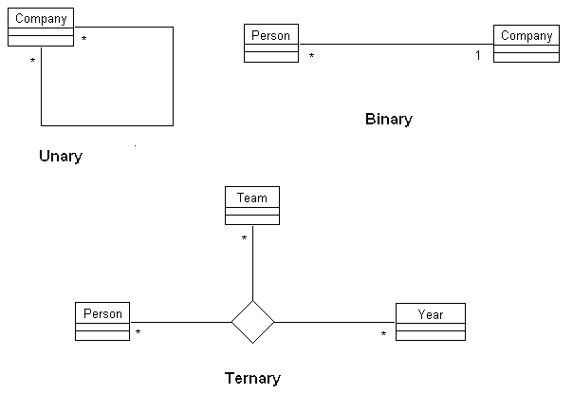

- Difference between the name of the association relationship and the role names linked to an association:

The name of the association relationship refers to the association between or among instances of object classes. The role names linked to an association refer to the role played by the class attached to the end of the association near which the name appears.
- Role names for Review Question 7 association relationships:

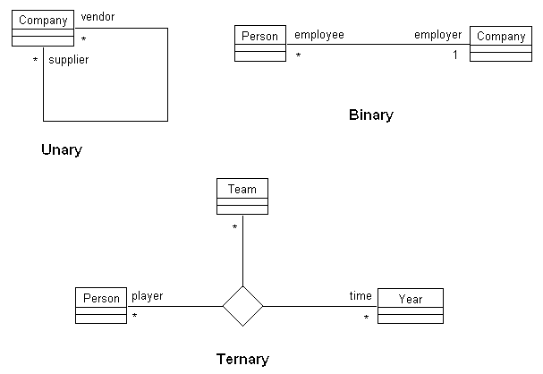

- Add operations to some of the classes you identified in Review Question 7:

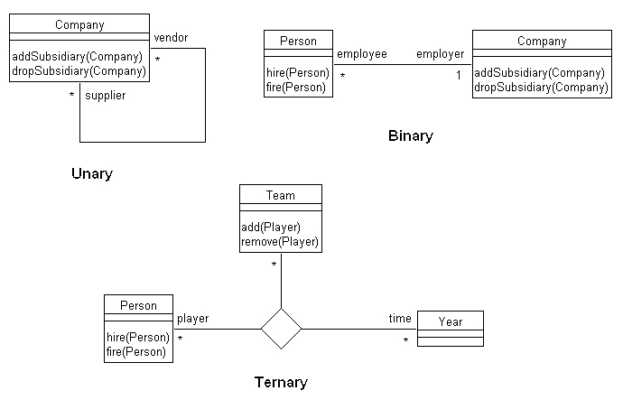
- An example of generalization:

The discriminator is empType. The purpose of the discriminator is to show which property of an object class is being abstracted by a particular generalization relationship.

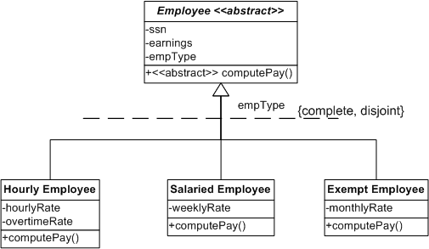

- Extension of Review Question 11 adding at least one abstract class with at least one abstract operation, and indicating which features of a class are inherited by other classes:

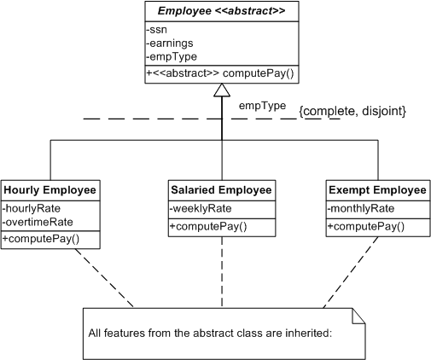

- Extension of Review Question 11, giving an example of polymorphism. The specific details of the implementation of the method computePay() depend on the subclass even though they all receive the same message from the classes that request the computePay() service.

- Aggregation example:

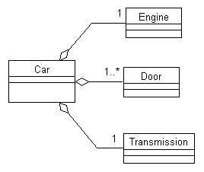

15. The concepts of encapsulation, inheritance, and polymorphism make object-oriented modeling a powerful tool for developing complex systems.

16. Because Vehicle is an abstract class, it cannot have any direct instances.

17. In order to effectively model a complex system, it is necessary to have a small set of independent views illustrating the problem from multiple perspectives. The UML provides many different types of diagrams in order to provide these different perspectives.

18. The assignment class is an association class.

19. A unary relationship would have to be represented as an association class if the relationship has attributes, such as quantity or begin and end dates.

20. /availBalance is a derived attribute. /purchases is a derived relationship. /availBalance can be computed from the valued for creditLine and balance. /purchases can be determined by examining the association between customers and items.

21. checkFee and monthlyFee are examples of class-scope attributes. calcFee is an abstract operation.

22. The class diagram shown in Figure 13-23 is an example of multiple-inheritance.

23. The class diagram shown in Figure 13-24 is an example of aggregation. Although faculty could be represented as an aggregate of department, there really is not a need to do this because there will not be operations on department that will carry through to faculty. Also, faculty has independent relationships with other objects, such as courses.

Answers to Problems and Exercises

1. Sample class diagram with at least four association roles:

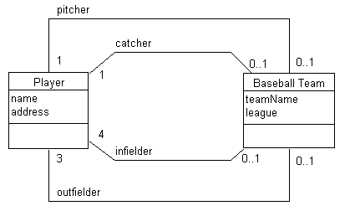

2. Student, University, Activity class diagram:

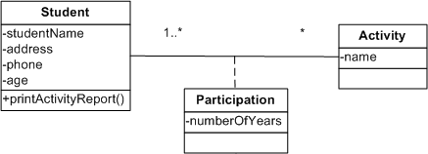

3.
a. Middle-sized software vendor class diagram:

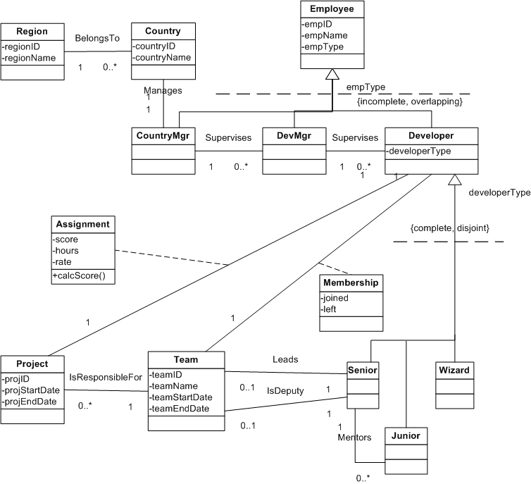

b. The class diagram allows us to capture the calcScore operation that underlies the problem domain.

4. Class diagrams:

- Employee, Project class diagram

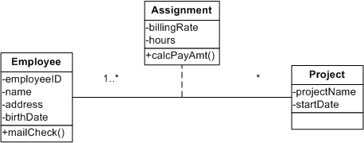

b.
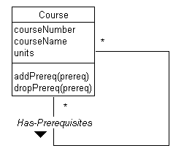
c.
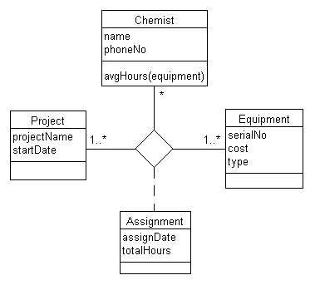

d. Note: Because primary keys are not included on class diagrams, there is no need to consider weak classes in this solution.
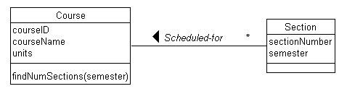

e.
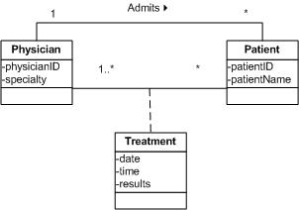

5. Student, Advisor class diagram:

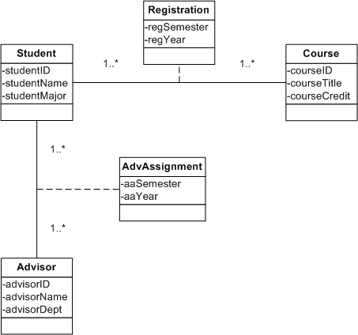

5. Student, Advisor data model:

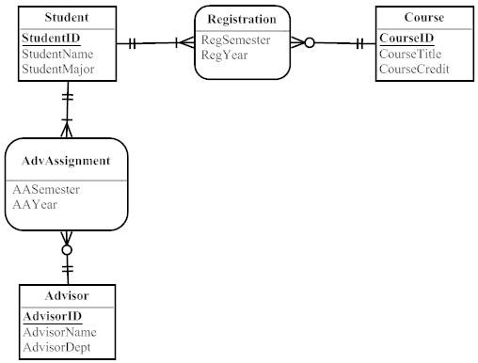

6. Class diagram with subset constraint:

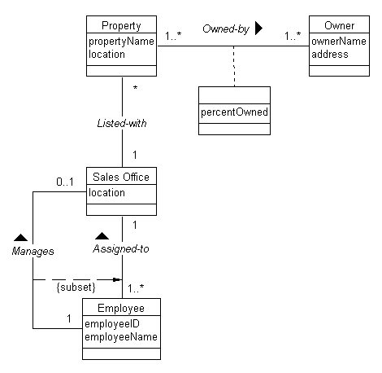

7. Stillwater Antiques class diagram:
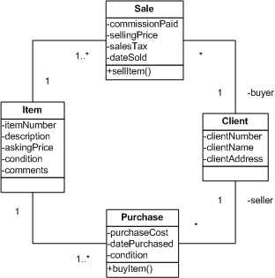

8. Bottled Water distributor class diagram

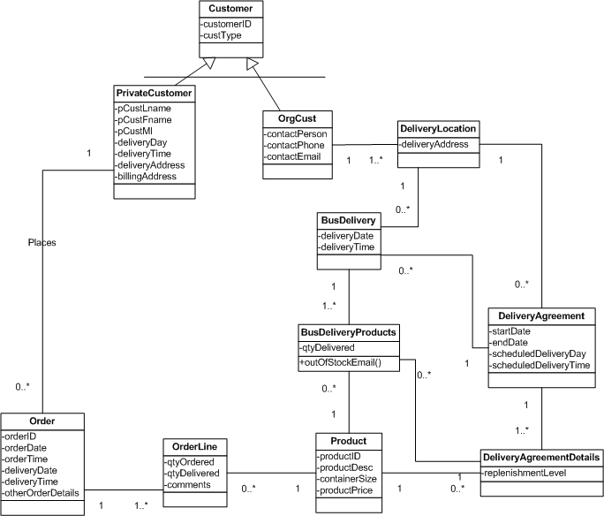

- Frequent Flyer class diagram, alternative A:

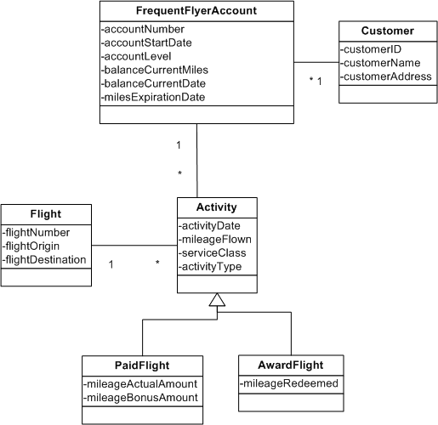

Frequent Flyer class diagram, alternative B:

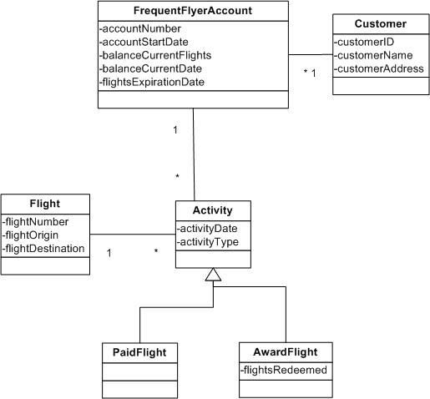

10. This is a simple library solution; more classes could be added such as author, categories, etc. itemType includes Paperback, Hardback, audiobook CD, audiobook tape, audio CD, audio tape, video DVD, and videotape; this could also be set up as reference data to the itemType in Item class. Based on reading the problem description, there do not appear to be special attributes or relationships based on the itemType thus no subclasses for itemType are presented in this solution.

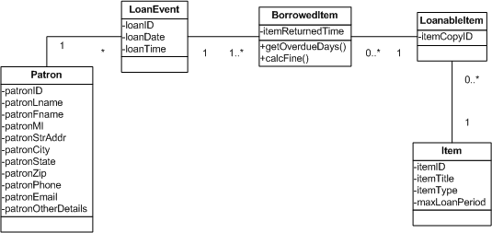
11.

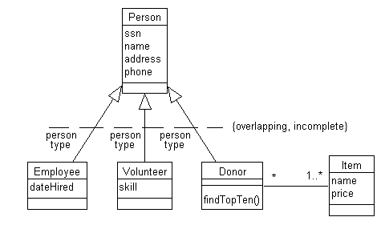

12. Consulting firm class diagram:

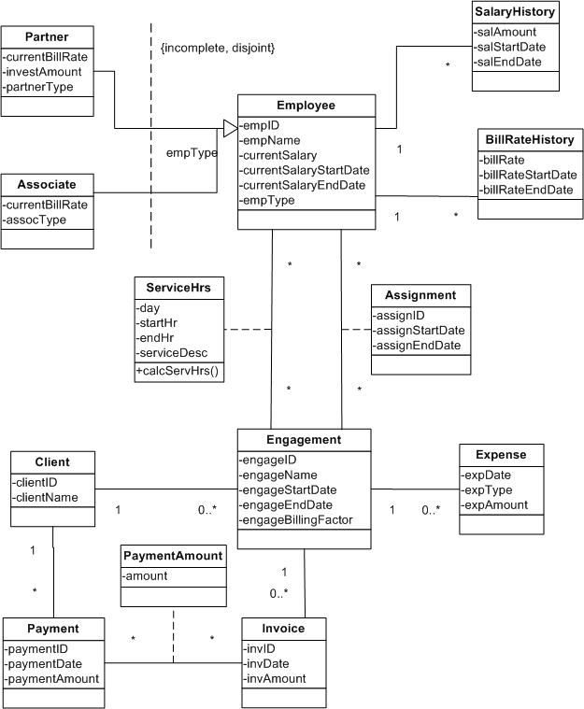

13. See A Leopard Tours class diagram:

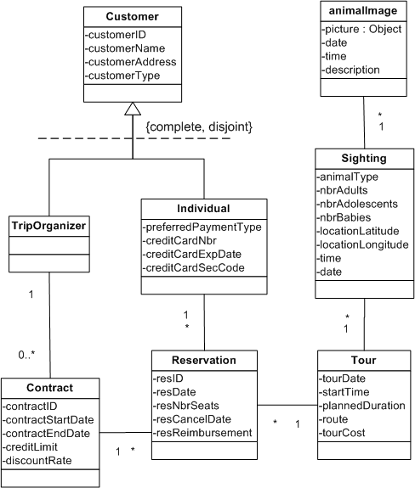
14. Bank Accounts class diagram:

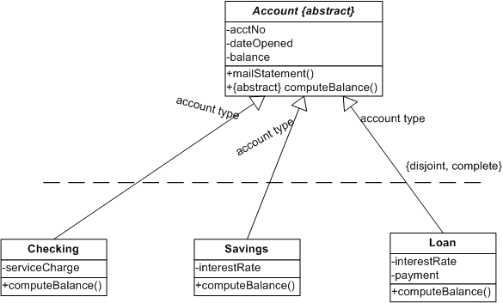

15.

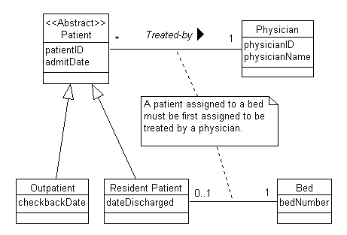

16.
a.

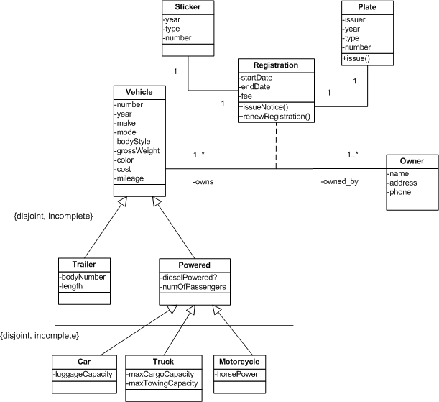

b.
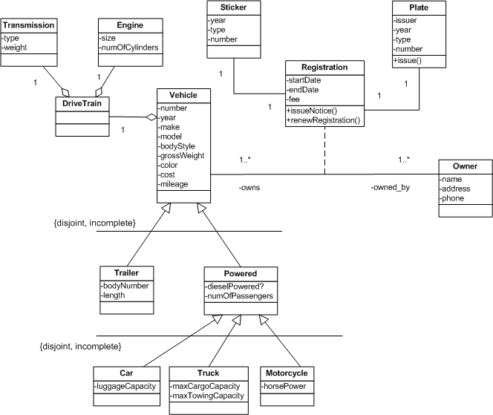

c.
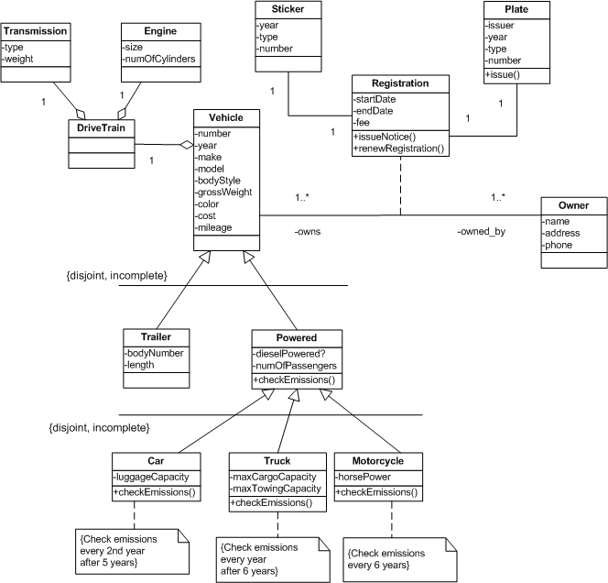

17. Please note for this exercise that the composite attribute of Address could be a class also, because both customer and location have common address attributes.

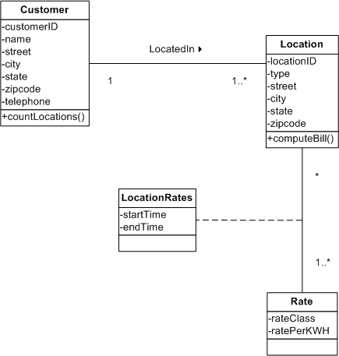

18.
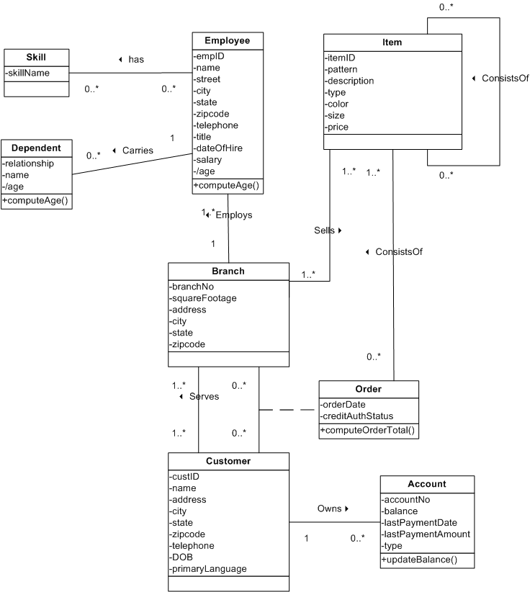

19.

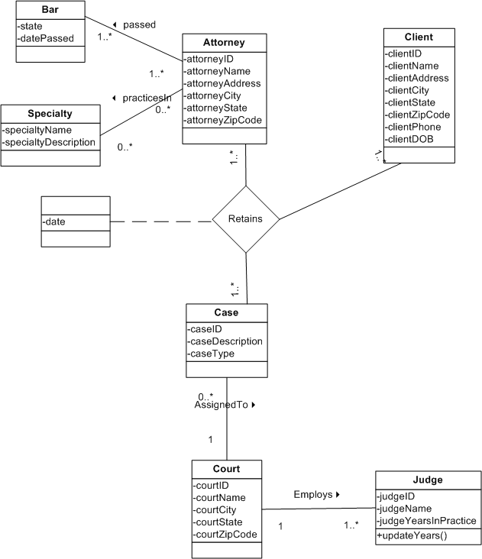

20. Class diagram
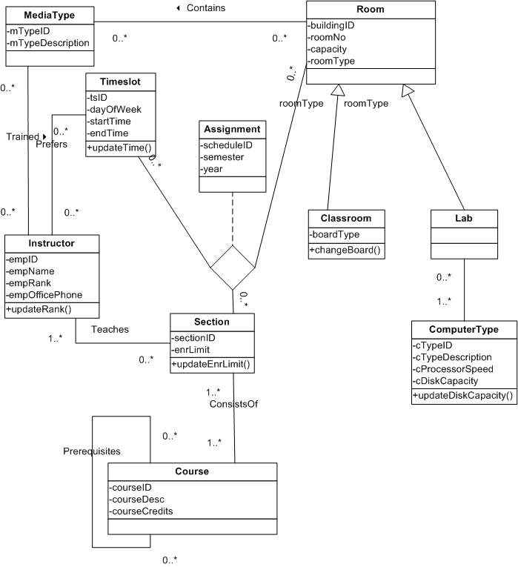
21. Please note in this solution that Estimates and ServicesPerformed both are related to location rather than customer. Although the exercise does not explicitly state this as a business rule, it has been assumed that an estimate or service performed would be for only one location, even if a customer owned multiple locations.
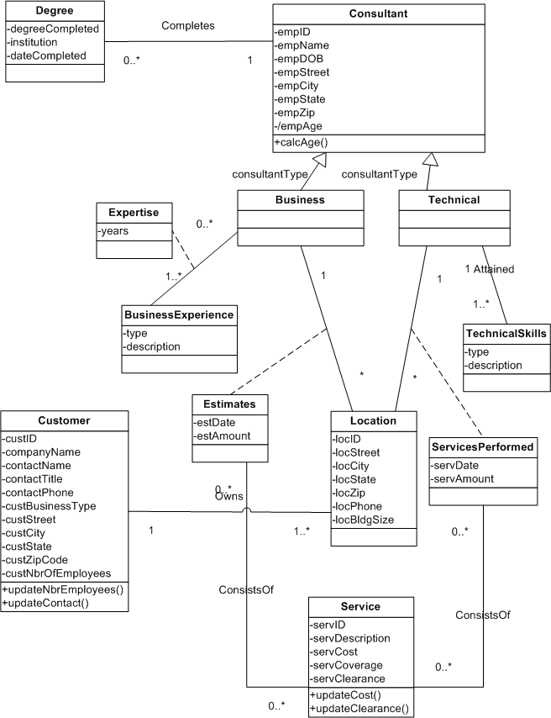
22.

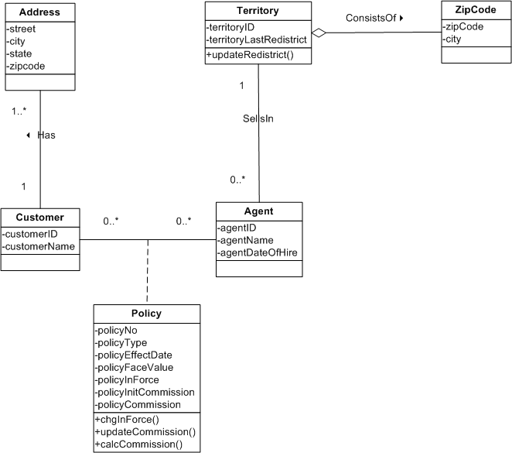

23. This solution assumes that a single issue might have several “history instances” associated with each issue.

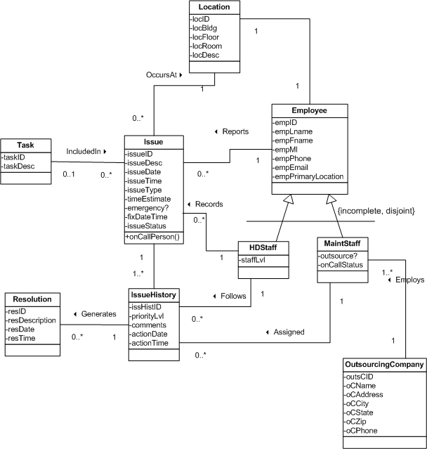
24.

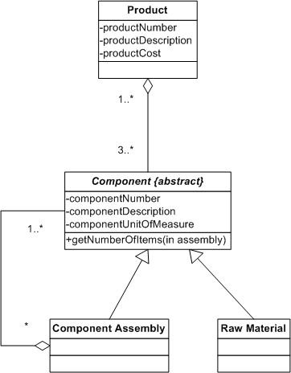

25. Note: This solution refers to Figure 13-18 in the text. For this solution, the receivePaymt method has been overloaded for cases where an electronic payment is needed.

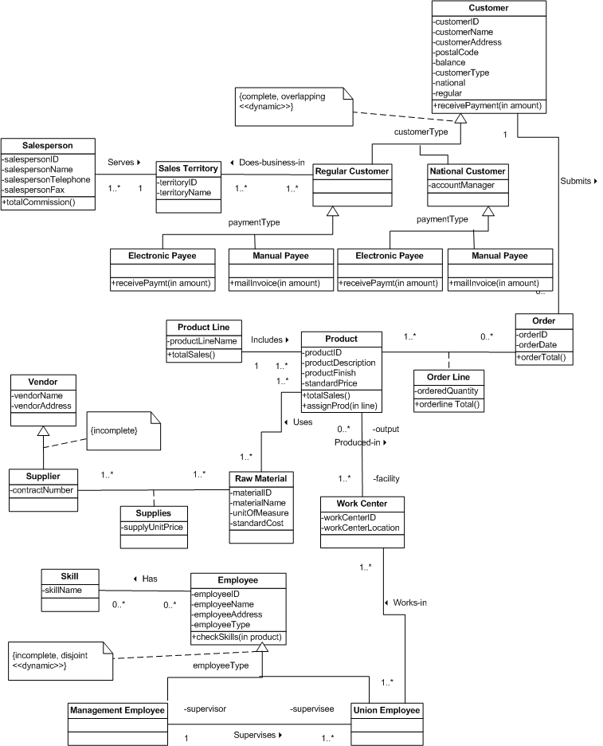

26. This solution identifies several derived associations (Customer purchases Product, Salesperson sells Product, Union Employee produces Product, Supplier supplies_for Product), although there are more to be found.

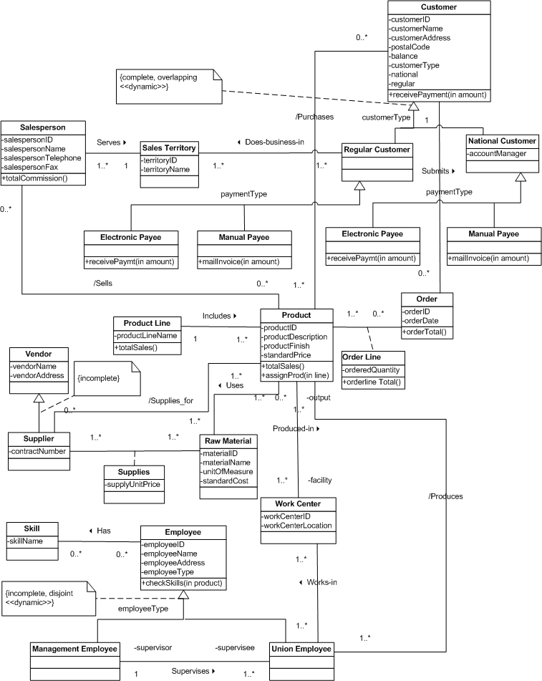

Answers to Field Exercises

1. An example of a superclass/subclass relationship is with equity securities. Equity securities represent ownership shares in a corporation. Equity securities have attributes such as name, symbol, exchange, and price. A particular type of equity security is common stock. Preferred stock is another type of equity security that offers the holders fixed dividends each year. An attribute for preferred stock would be dividend rate.

2. Examples of superclass/subclass relationships should be available in both service and manufacturing businesses. In the service business you will find several classes of employees, ranging from part-time to full-time with benefits. In the manufacturing business you might find several types of engineers (electrical, mechanical). Numerous operational business rules can be found in both types of businesses. In manufacturing, rules exist regarding quality standards and how overhead should be allocated to jobs. In the service industry, rules related to processes, such as how an item is purchased, represent sequences in the object-oriented models.

3. The translation of the EER (or E-R) diagram should map the entity types and attributes into classes. EER diagrams can represent generalizations that also map to class diagrams. EER and E-R notation are different than UML. Association relationships remain the same. E-R diagrams usually show keys. Keys can be represented with class attribute names followed by the {key} notation.

4. The main differences will most likely be in the notation used to describe the model. Students may find systems analysts using Booch, OMT, or their own custom notation. Students should see if the notations in use by systems analysis can represent use cases and class diagrams as shown in the chapter.

