
Website: http://weareyourdevs.com Contact: start@weareyourdevs.com
Call for price extension guide
Version 1.0.1 – October 2016

Integrate template of Call for price extension with your theme. Before going to the configuration, You can please read the file
guide_put_code_into_template to integrate with current your theme.
- Configuration
Go to V2Agency Extension -> Call for price to configure the extension:
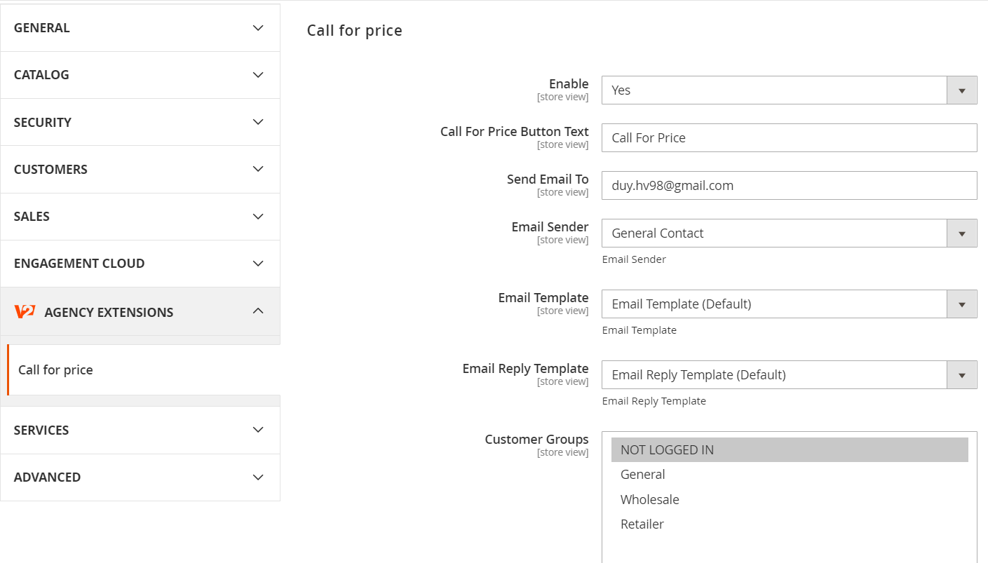
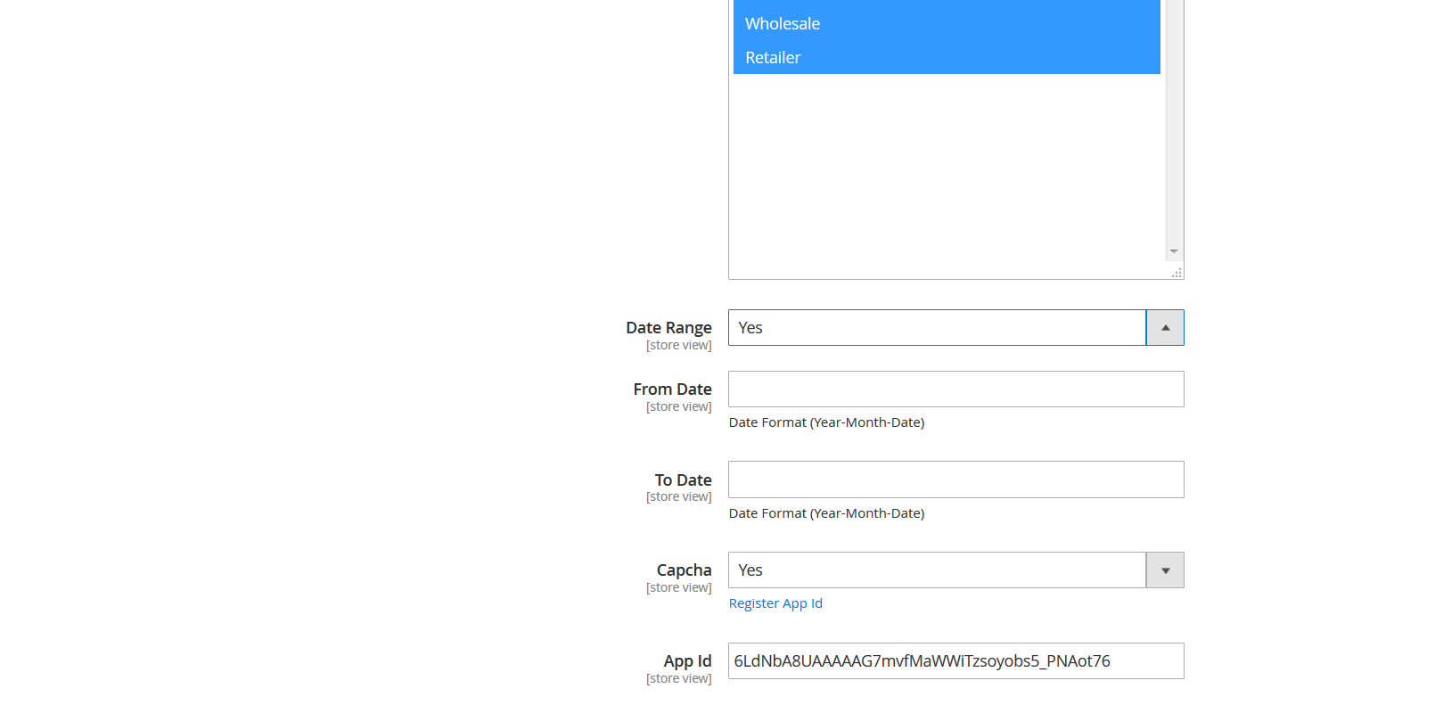

Call for price
- In the Enable field, you can choose yes/no to enable/disable extension.
- In the Call For Price Button Text field, you can put title that will display in button.
- In the Send Email To field, you can put email when client send request.
- In the Email Sender field, you can choose list sender in store.
- In the Email Template field, you can choose email template when send request to store manager (default email provide by V2Agency).
- In the Email Reply Template field, you can choose email reply template when reply request to client (default email provide by V2Agency).
- In the Customer Groups field, you can choose assign customer in groups.
- In the Date Range field, you can choose yes/no to configuration show date range below.
- In the From Date field, you can choose date start apply callforprice product.
- In the To Date field, you can choose date end apply callforprice product.
- In the Captcha field, you can choose yes/no use captcha from google.
- In the App Id field, you can fill secret key when register captcha from google.

- Set Product to Callforprice.
1. Set Category :
To enable "Call For Price" functionality, add/edit any category from admin and Set Call For Price to Yes
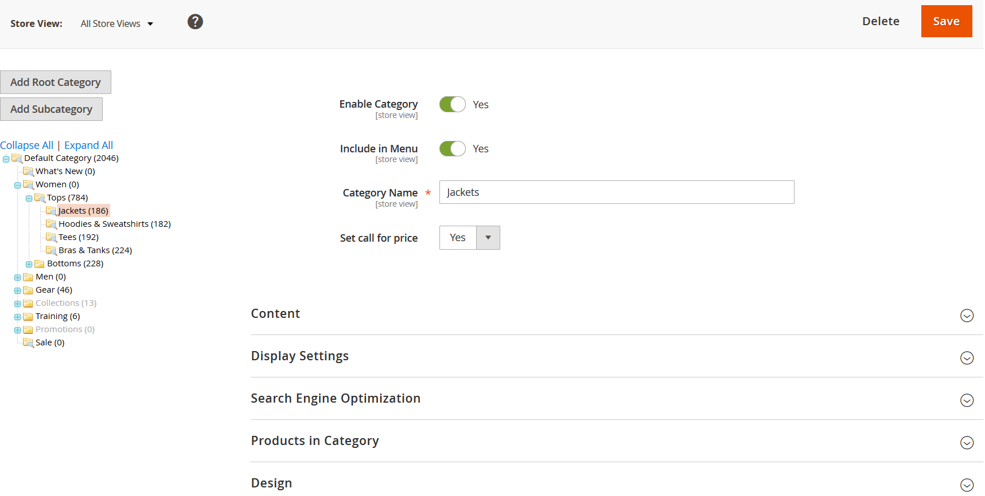

2. Set manually product.
To enable "Call For Price" functionality, add/edit any product from admin and Set Call For Price to Yes from General tab. 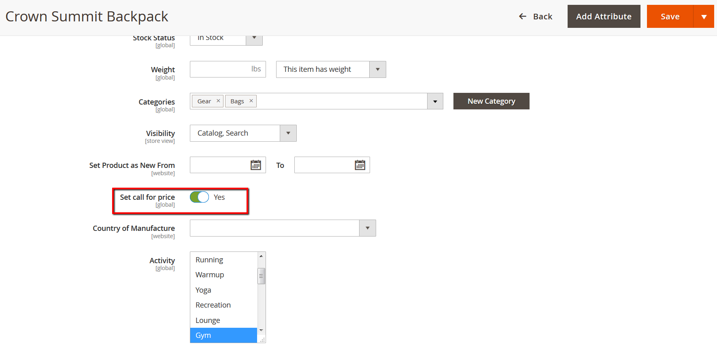

And clear the cache when you have any changes for our extension.

+ How to install extension :
- Unpack the extension ZIP file on your computer and connect ftp/sftp to server, then upload extension package to the corresponding root folder of your Magento installation.
- Connect SSH to server and run command:
php bin/magento module:enable V2Agency_Core V2Agency_Callforprice
php bin/magento setup:upgrade
rm -rf var/cache/ var/generation/ var/page_cache/ var/view_preprocessed/
- And clear cache in backend.
+ How to customize for theme :
1. For custom theme you find path : .../app/code/V2Agency/Callforprice/view/frontend/templates/button.phtml
2. Open and edit other configuration selector how to fit custom theme ()
Example : ( all selector use for library jQuery )
- $itemSelector = '. product-item'; ( in this define container class have info of product )
- $priceElementSelector = '.price-box'; ( in this define class price to disabled )
- $cartButtonElementSelector = '. tocart'; ( in this define class cart to disabled )
- $classActionButton = 'form'; ( in this define class append callforprice button )
3. Customize for any page : product view, product list, ......
4. Clear cache.

