# In praise of those ‘imperfect’ trees

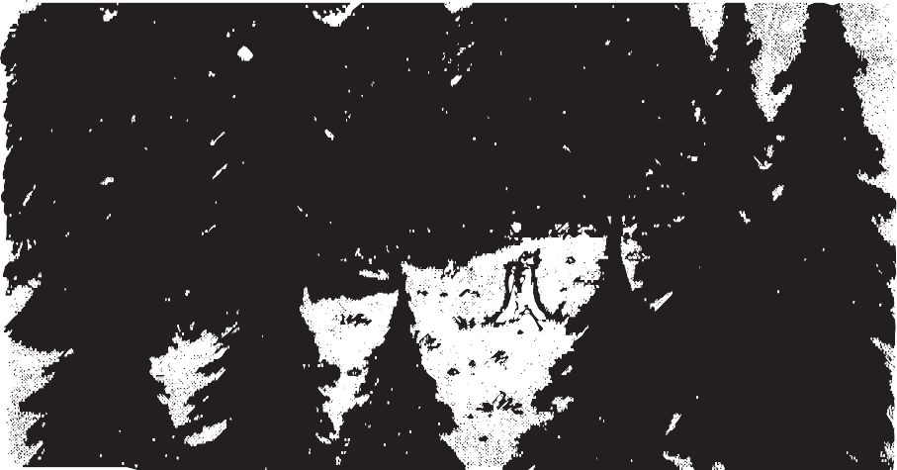

## For my son who wanted to know why I wouldn’t buy the ‘perfect’ Christmas tree he saw. (The one with the $60 price tag.)

The forester in charge of these decisions passed judgment with a calculating eye. He tagged it with a ribbon in September. (A tag that meant the tree was fit to die.)

November winds that whispered in the branches could not be heard above an angry whine:

a dozen goggled men, a dozen chainsaws. “Get that one, Ben.This skinny one is mine.” The sun spun by.The surgery was sudden.

The tree was bound, its branches pulled in tight.

It joined a hundred others on, a flatbed that roared along the highways of the night.

It languished in a corner of the tree lot. Ignored or criticized: “Too bare.” “Too thin.”

Its needles fell like green and narrow raindrops. An overzealous salesman snapped a limb.

As Christmas carols crackled in the speakers, some people looked, said “No” and walked away. It stood there on the 25th, still waiting.

The Christmas tree unsold on Christmas day.

It whispered as the cars roared past the tree lot: “Remember me next year. Remember, please.

We all leave empty spaces in the forest:

the ‘perfect’ and ‘imperfect’ Christmas trees.”

*(J.D. Evans, a pseudonym, is a New Jersey writer who thinks about*

*buying an artificial tree ... occasionally.)*

# Space shuflle speculations: some ‘inside’ information

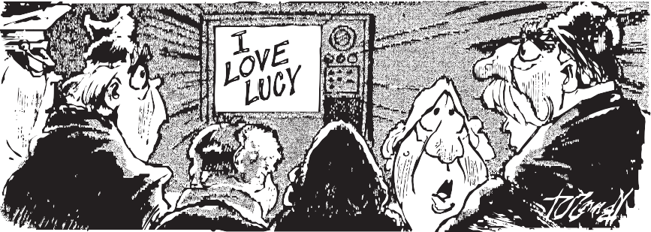

## News item: On Jan. 23, the space shuttle will carry a top-secret payload into space. The Pentagon has warned news organizations that any speculation about the nature of the payload might result

**in investigations to locate the source of the information.**

I heard it from a friend of mine whose sister dates a chemist

who went to school with someone else who heard this from his dentist:

It seems an airline stewardess (who flew for AIA)

was strapping in a passenger when she heard a woman say:

“My son (the psychoanalyst) had a patient hypnotized,

and he (the patient, not my son) said he had supervised

the secret cargo-loading

for a hush-hush shuttle flight. Don’t tell a soul I told you this:

they’ve built a satellite

that (once it’s placed in orbit) sends signals to TVs.

They’re aiming it at Russia.

It will bring them to their knees. It’s horrible! Outrageous!

It’s disgusting, heaven knows! Next month on Russian TV sets they’ll only get our shows!”

*(J.D. Evans, a pseudonym, is a New Jersey writer who refuses to divulge his sources ... occasionally.)*

# What fun it is to ... complicate

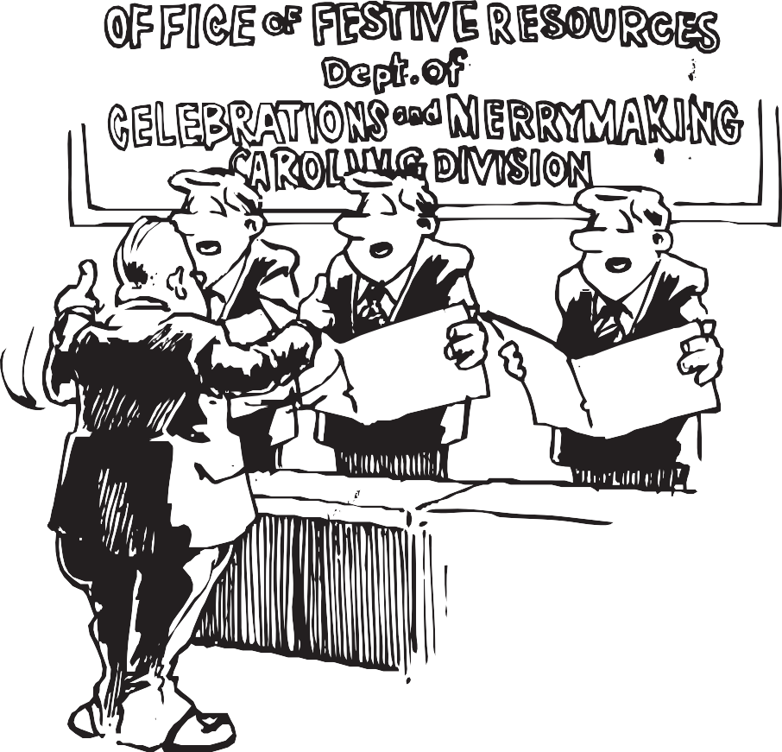

## A Christmas carol for bureaucrats:

M

OVING impetuously through the crystalized water vapor in a solitary, equine-powered, non-canopied inclement weather vehicle, transecting pastoral expanses, we progress expressing merriment and amusement throughout the journey:

– Ha, ha, ha.

Tubular, tintintabulating devices on severed follicular appendages reverberate, generating illuminated subliminal consciousnesses, what jubilation we experience in creating oral expressions of pleasure and syncopation relevant to an inclement weather vehicle this nocturnal period.

Oh.

Tubular, tintintabulating devices: tubular, tintintabulating devices: tintintabulating throughout the journey. Oh what jubilation it is to be transported in a solitary, equine-powered, non-canopied inclement weather vehicle.

*(M.J. Evans, a pseudonym, is a New Jersey writer and the wife of*

*J.D. Evans. She understands bureaucratese (and her husband) ... occasionally.)*

# In "nancial circles, he’s a square

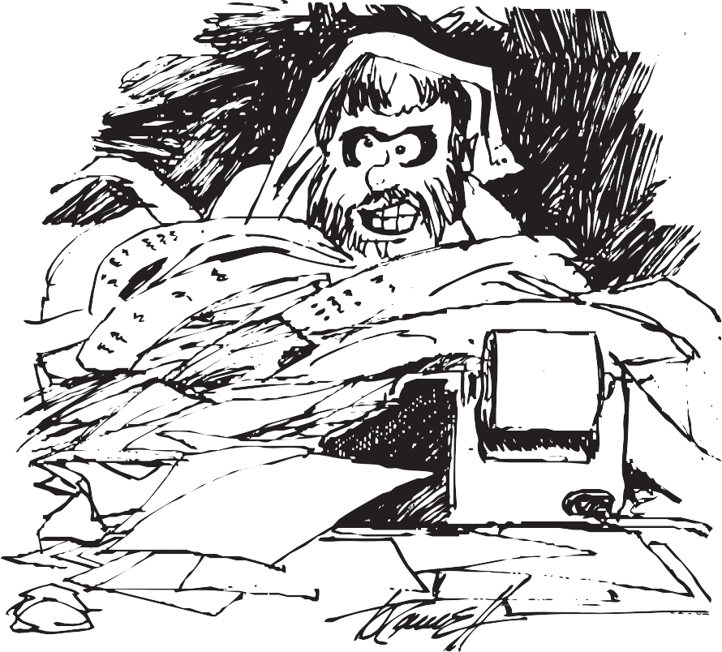

I do not own a tax-free bond or blue-chip stocks like IBM. I have no shares of anything. (It’s almost un-American.)

I have no gold bars tucked away, or silver ingots I can trade.

At cocktail parties I cannot discuss the killings I have made.

I do not deal in puts and calls. I have no foreign currency.

I do not speculate in land at all. Pork futures do not interest me.

A J.P. Morgan I am not.

I run with neither bull nor bear.

I come from cautious, common stock that never spawned a millionaire.

Casino stocks are not for me. Let others gamble, my cash stays. I have no need for stock reports, for brokers or for CPAs.

My ways and means are cut and dried. My only income’s what I earn.

Then why is it so tough each year to figure out this $#%! tax return?!!

*(J.D. Evans, a pseudonym, is a New Jersey writer who loses his place on Schedule W ... occasionally.)*

# Old soldiers still remind us of what they can’t forget

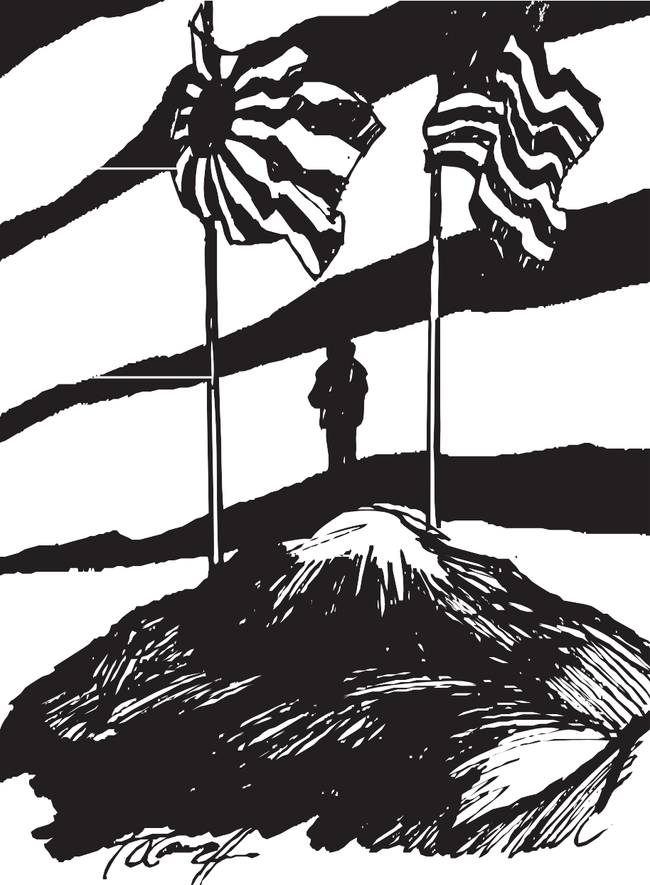

## On seeing photographs of American and Japanese veterans of World War II standing side by side

**at Iwo Jima during ceremonies marking the 40th anniversary of that battle.**

Old warriors.They’re stooped and gray. Their age collects at jowl and belt.

They stand grim-faced, remembering the way it was.The way it felt.

The air is sweet now; skies are clean. No bombs explode. No mortars roar. As waves lap gently on the beach, they stand for those who fell before. Their guns are silent, gone to rust.

Their ships and planes were turned to scrap. But they are tied – eternally –

to one small spot on one vast map. Here they fought: opposing sides.

Here they cursed, wept, trembled, prayed.

Here they wrestled fear and death

as brothers dropped and flags were raised.

Youths who offered up their lives for God, for country, emperor, return: old men who still recall

the crazed and howling face of war. Nature heals our battlefields,

but battle scars in us endure. So Iwo Jima’s warriors pray:

“God help us. Help us war no more.”

*(J.D. Evans, a pseudonym, is a New Jersey writer who wonders if we are doomed to forget ... occasionally.)*

# Pin-pointing the personalities with nicknames

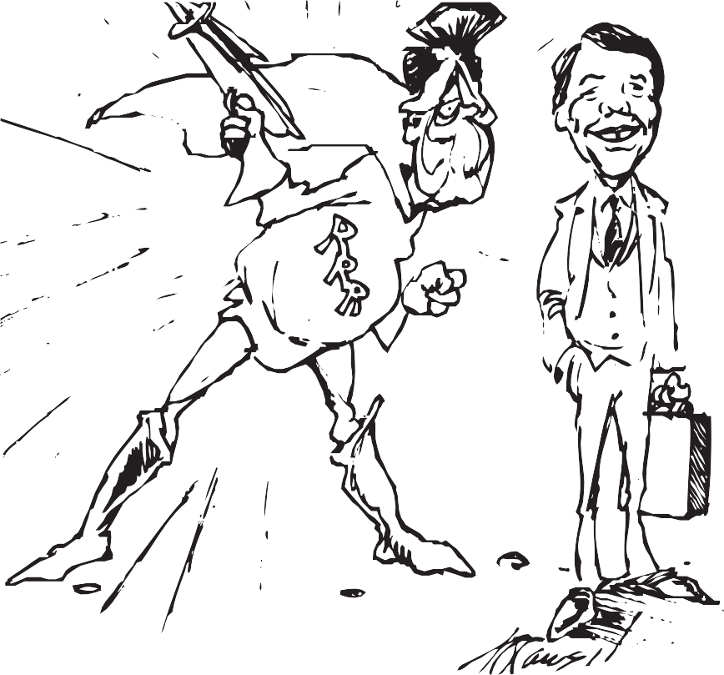

## News item: Among nine alleged mob figures indicted by a federal grand jury Tuesday in New York were Anthony ‘Fat Tony’ Salerno, Antonio ‘Tony Ducks’ Corallo, Gennaro ‘Jerry Lang’ Langella, Philip ‘Rusty’ RastelIi, Aniello ‘O’Neill’ Dellacroce, Salvatore ‘Tom Mix’ Santoro and Christopher ‘Christy Tick’ Furnari.

The world is full of ‘Jims’ and ‘Franks,’ a million ‘Joes’ and ‘Andys.’

The mob, I think, may have a point:

strange nicknames come in handy.

They make it clear which ‘Phil’ one means, they minimize confusion.

Each time I see a mobster’s name I reach the same conclusion.

Nicknames can be practical. They also can be fun.

Imagine how the news would sound if everyone had one:

Ron ‘The Raygun’ Reagan

met with Tom ‘The Smiler’ Kean.

Lech ‘The Pipe’ Walesa called a labor strike again.

Paul ‘The Stogie’ Volcker said the deficit’s too fat,

but George ‘Good Golly’ Bush insists it’s not as bad as that.

Leonard ‘Mr. Gimme’ Tose will move his team away

it Wilson ‘Goody’ Goode can’t find the cash to make him stay.

The world is too much with us. The news, alas, is too.

If everyone had nicknames, though, at last we’d know who’s who.

*(J.D.‘The Pen’ Evans, a pseudonym, is a New Jersey writer who watches Dan ‘The Sweater’ Rather ... occasionally.)*

# here’s no place like home



We took a ride to Grandmom’s house, but made a small detour

to drive around the neighborhood where I had lived before.

New buildings blossomed everywhere, whole streets had been replaced.

So little seemed familiar of the past that I retraced.

“That used to be a candy store.” “My best friend’s house was there.”

I marvelled at the way things changed. My sons, though, didn’t care.

When we arrived at Grandmom’s house a worse shock was in store:

My favorite boyhood climbing trees were gone.They were no more.

The maple trees had been removed and just two stumps remained. “The roots were causing problems with the sidewalks,” Mom explained.

My trees! My secret pirate ships! My leafy hideaways!

The branches where I climbed and played in sunny yesterdays!

Gone for good and always. Lost. Just memories.

(My sons were sympathetic. They, too, have favorite trees.)

The hardest part of growing old is watching how things change

and knowing that you’re powerless:

You can’t keep things the same.

My Mom in time may plant new trees. My sons may climb them, too.

But what they see when they climb up won’t be the world I knew.

*(J.D. Evans, a pseudonym, is a New Jersey writer who thinks Thomas Wolfe was right ... occasionally.)*

# Starting an I.R.A. can be hazardous to your youth



Mileposts in our lives are few, but presidential terms will do. Too young to vote for JFK,

I served (alas) for LBJ,

saw Richard Nixon quit That Day, endured poor Gerald Ford’s brief stay, watched Jimmy Carter grin and pray, saw Reagan get THE role to play.

Life races by, so yesterday I opened up an I.R.A.

Time, you thief, you’ve struck again! You’ve robbed me (as you rob all men) of youth! Of friends! Of energy!

Retirement now looms for me. Oh, sure, it’s not for 20 years,

and time remains for new careers. But five short presidential terms! That’s sobering. (It makes me squirm.) I’m aging as I work and sleep!

(A thought that’s neither new nor deep.) A pensioner? Retiree?

A senior citizen? Gulp. Me?

These I.R.A.’s are troublesome.

They make one dwell on what’s to come. I’ve glimpsed the future. One thing’s clear:

I’ll get depressed same time next year.

*(J.D. Evans, a pseudonym, is a New Jersey writer who wonders how he’ll like Florida ... occasionally.)*

# DH rule ruins purity of baseball

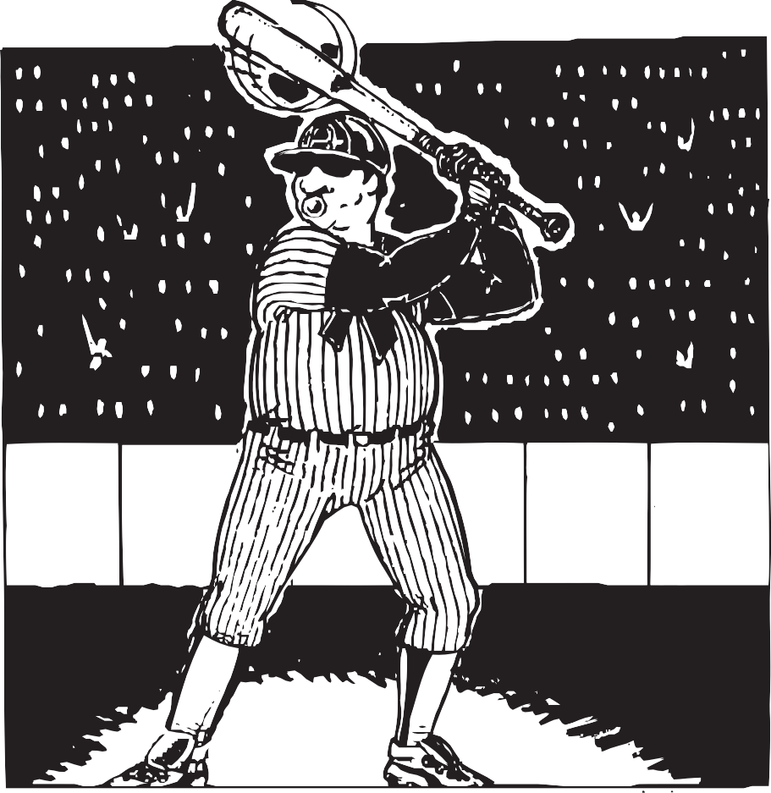

## News item: Baseball commissioner Peter Ueberroth may conduct an opinion poll to determine public sentiment about the Designated Hitter rule.

Ueberroth, forget your poll.

The DH rule’s ruined baseball’s soul. The greatest teams used just nine men. The game was not designed for ten.

The DH rule’s an aberration, a cultural abomination.

Abner Doubleday would have a fit if he knew pitchers didn’t hit.

DHers are mere “hired guns” rescued from oblivion.

Too old (or fat) to play the field, they’re hired for the bats they wield.

Part-time players, they sit all day

and watch the game.They do not play. Dugout squatters, specialists,

paid assassins, terrorists. The DH rule is odious. Inelegant. Superfluous.

The basic rule of baseball’s that:

“You play the field, you get to bat.”

Who cares if pitchers aren’t good hitters? The DH rule just breeds more sitters.

*(J.D. Evans, a pseudonym, is a New Jersey writer who takes his baseball seriously ... occasionally.)*

# Marching towards his independence a step at a time

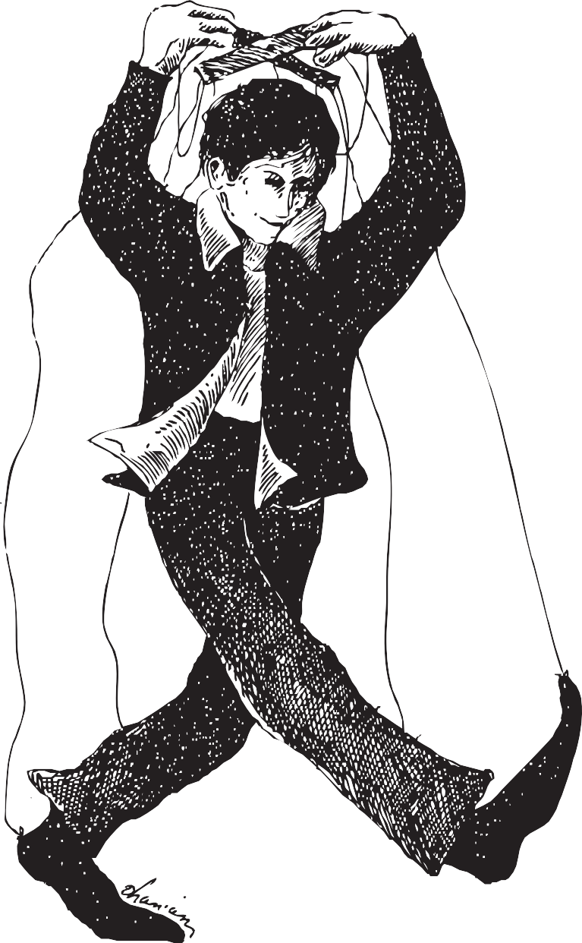

Because my eyes feel grungy and my throat is raw and dry; because the surgeon general isn’t paid to tell a lie:

I do not think that I shall smoke today.

Because my office banned it and I’d have to go outside;

because I’m sure there must be faster forms of suicide:

I do not think that I shall smoke today.

Because a dollar fifty

is an awful Iot to spend; because that rascal nicotene is really not my friend:

I do not think that I shall smoke today.

Because it’s not as sexy

as the ads would have me think; because it makes my car and clothes and breath and fingers stink:

I do not think that I shall smoke today.

Because I’m in control here, or at least I’d better be!

Because I don’t like anything to be in charge of me.

Because it won’t be easier tomorrow anyway:

I do not think I know that I

just WILL NOT smoke today.

*(J.D. Evans, a pseudonym, is a New Jersey writer who believes in the power of positive thinking and carrot sticks ... occasionally.)*

# he Laws and Rules that really count

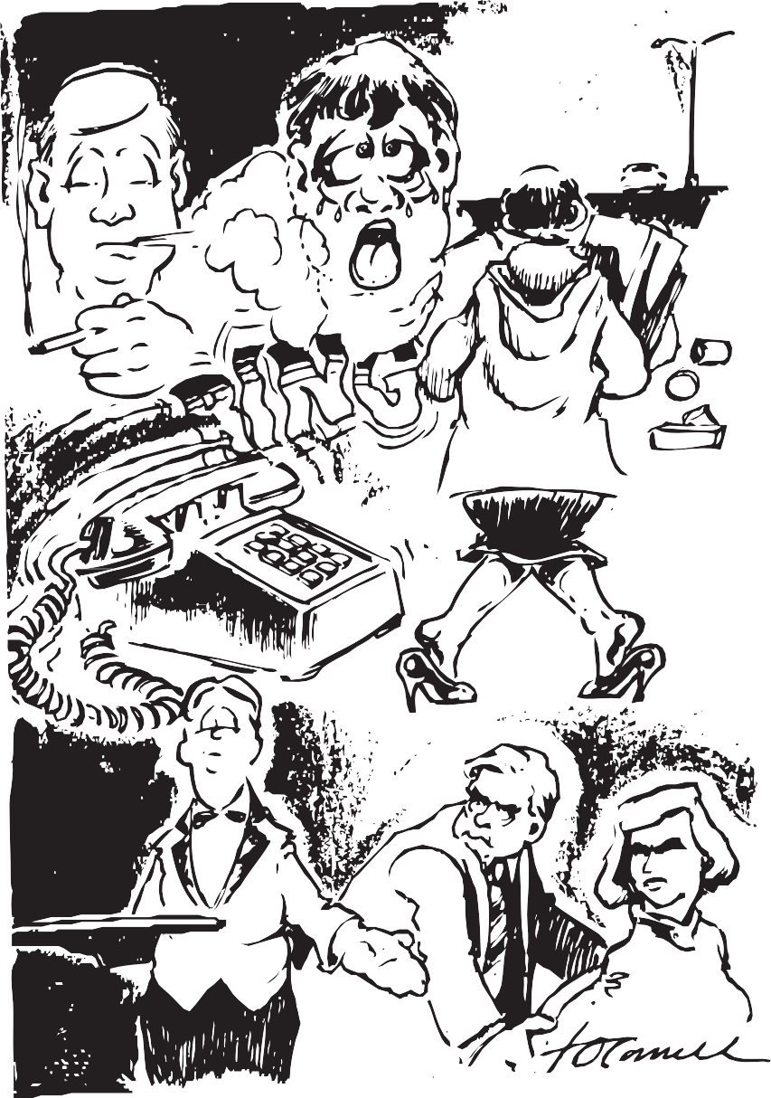

There’s a logic in life that is hard to ignore, a statistical balance that’s shining and pure.

But the most profound truths are not taught in our schools, they’re the real facts of life,The Laws and The Rules:

* A hike through a parking lot’s never as far as when you have boxes to haul to your car.
* Waiters who foul up and give you some lip are the ones who expect you to leave a big-tip.
* Whatever you’re seeking you’re certain to find in the last place you look before losing your mind.
* The greater the number of people at meetings, the greater the number of statement-repeatings.
* If you stick with a slot machine all through the night it’ll finally pay off (when you’ve moved to the right.)
* The week you stop smoking, all cigarette fumes will manage to drift where you stand in ALL rooms.
* The phone call you patiently wait for all day won’t ring in your office ‘til you step away.
* At checkouts, no matter which line you select the other line’s faster (as one might expect.)
* When writing a verse that must rhyme at the end

the right word won’t rhyme but the wrong word will fit.

*(J.D. Evans, a pseudonym, is a New Jersey writer who observes The Laws and The Rules ... occasionally.)*

# Raindrops on roses? Whiskers on kiflens? Bah, humbug

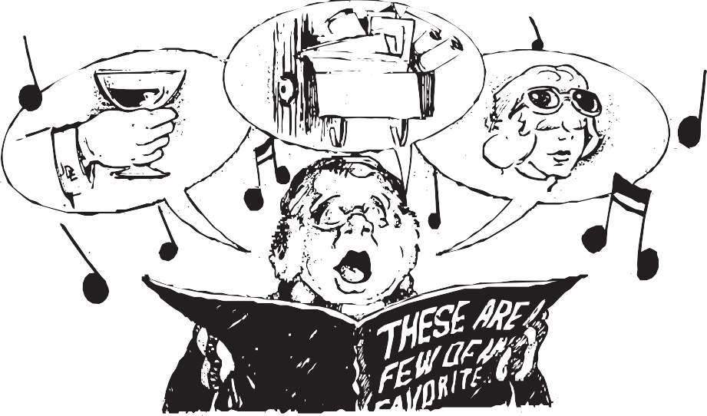

Monogrammed shirt cuffs that stick out discreetly, people whose desk tops are organized neatly,

cats who throw up on my new, carpeting:

these are a few of my least favorite things.

Sons who blame brothers for new toys that THEY wreck, overdue raises that aren’t in my paycheck,

ALL of the lyrics that Manilow sings:

these are a few of my least favorite things.

When the rain stops.When the snow melts. When I’m praised a lot.

I simply remember my least favorite things and then I don’t feel ... so hot.

Horoscope addicts who ask what my sign is, all of the junk that the morning mail brings:

these are a few of my least favorite things.

People on diets who bore me with details,

ski buffs who show me dull photos of ski trails, folks who “touch base” when they “give me a ring”: these are a few of my least favorite things.

Overpriced sunglasses perched over foreheads, pet snobs who only buy pets that are pure-breds, ethnic joke tellers and their slanderings:

these are my least-favorite, least favorite things.

When the rain stops.When the snow melts. When I’m praised a lot.

I simply remember my least favorite things and then I don’t feel ... so hot.

*(J.D. Evans, a pseudonym, is a New Jersey writer who can sit through*

*five minutes of “The Sound of Music” … occasionally.)*