# Christmas greetings to all the forgoflen



“They weren’t on my list. (An easy mistake

for a take-things-for-granted type-person to make.) No ribbons, no wrappings, no garlands or bows,

to acknowledge the debt that each of us owes. Not the tiniest part of the thanks they deserve: the knights in cloth armor who selflessly serve. – Police (men and women) routinely assigned, to hazardous duty on life’s battle line.

* The rescue squad angels who race out to save a life from an unscheduled trip to the grave.
* The helmeted heroes who walk into blazes without thoughts of glory, of tributes or praises.
* The nurses and doctors who wrestle with Death, Despair and Disease without pausing for breath.
* The volunteer workers who will not ignore

the needs of the helpless, the weak and the poor.

* The soldier who serves at a base far away, a sentry for peace drawing marginal pay.

They weren’t on my list that seemed thorough and long, (they weren’t on yours either unless I guess wrong.) And a day after Christmas is late, it is true,

but a debt that’s postponed is a debt overdue. So to all unsung heroes this poem celebrates:

“Merry Christmas. God bless you. I’m sorry I’m late.”

*(J.D. Evans, a pseudonym, is a New Jersey writer who forgets his wife’s birthday ... occasionally.)*

# Wipe out literacy or learn

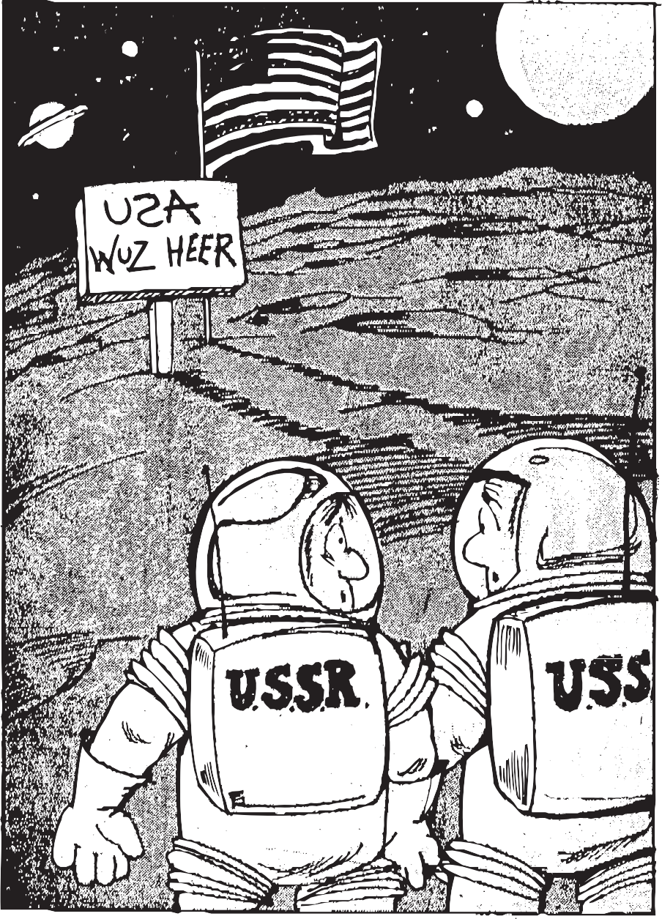

## News item: School officials in Land 0’ Lakes, Fla., made a small mistake in a pamphlet sent out to promote an anti-illiteracy campaign. “The Pasco County School District’s Reading Assistance Program (RAP) is striving to overcome literacy by the year 2000,“ the flyer read. “In a technological age, America will only stay competitive in the world market by overcoming literacy.”

We ken not hoap to keap are edje and beet the Japaknease

as long as young Amuricans are learned there ABCs.

This reeding stuff is gone to far. We got to just say: “NO!”

Don’t order no more magazeens; let yore supscripshuns go.

Don’t reed no books to litle kids. It’s evel and it’s sick!

They gradjuate from fairy-tails to stuff like “Mobie Dick!”

Next thing, there reeding everything! Ignoaring there TVs!

Do what you ken to help us fight this horrable diseese.

The future of Amurica is up to you and me. Together, we ken do it:

we ken wipe out literacy!

*(J.D. Evans, a pseudonym, is a New Jersey writer who proofreeds what he rites ... occasionally.)*

# Most lads and lasses contemplate passes in college classes

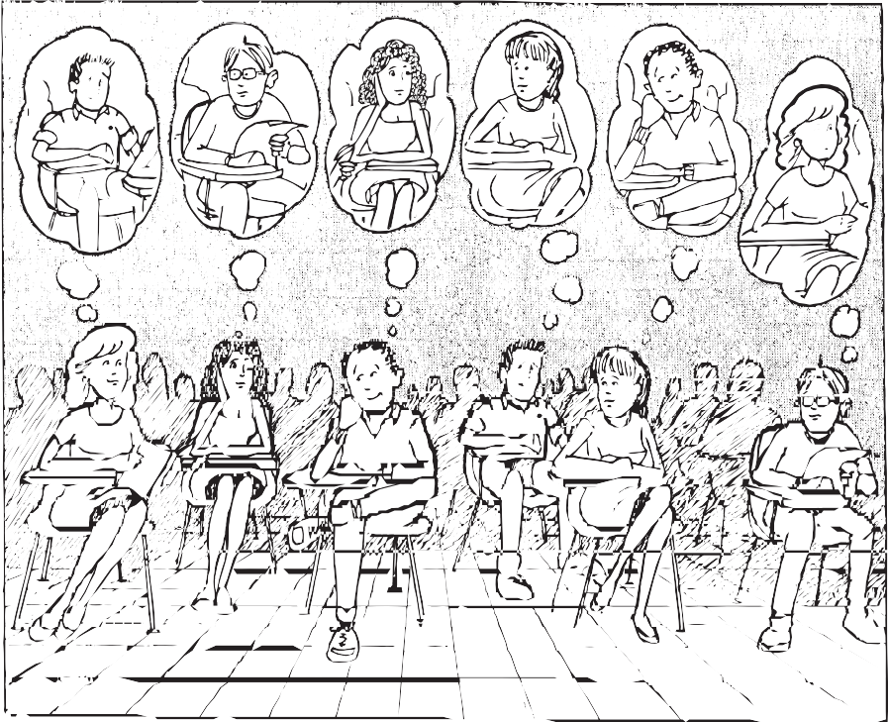

## News item: Behavioral scientists report that at any given moment in a college classroom, 80 percent of the students are thinking about sex.

“The Battle of Hastings in 1066...”

(The blonde with her hand raised has beautiful lips.)

“So Einstein concludes: MC squared equals E...” (The hunk in the sweater keeps staring at me!)

“The square root of 60 divided by pi...”

(This teaching assistant is one gorgeous guy.)

An ethical question:Was Socrates right...?

(That perfume she wore drove me crazy all night.)

“From liquid to gas: an abrupt change of state...” (I’ll bet she says “No” if I ask for a date.)

“Municipal planners devised a new zone.”

(This teacher’s so sexy! He looks like Stallone!)

“His plots now seem tame and a trifle bourgeois...” (That girl in the front row’s not wearing a bra!)

No wonder a college degree takes four years. Eight-tenths of the lessons just fall on deaf ears. So much time is spent thinking X-rated stuff,

a cynic might worry: Are four years enough?

*(J.D. Evans, a pseudonym, is a New Jersey writer who used to hang on his western civilization professor’s every word ... occasionally.)*

# Lengthy line keeps aspirations high for society’s riffraffie

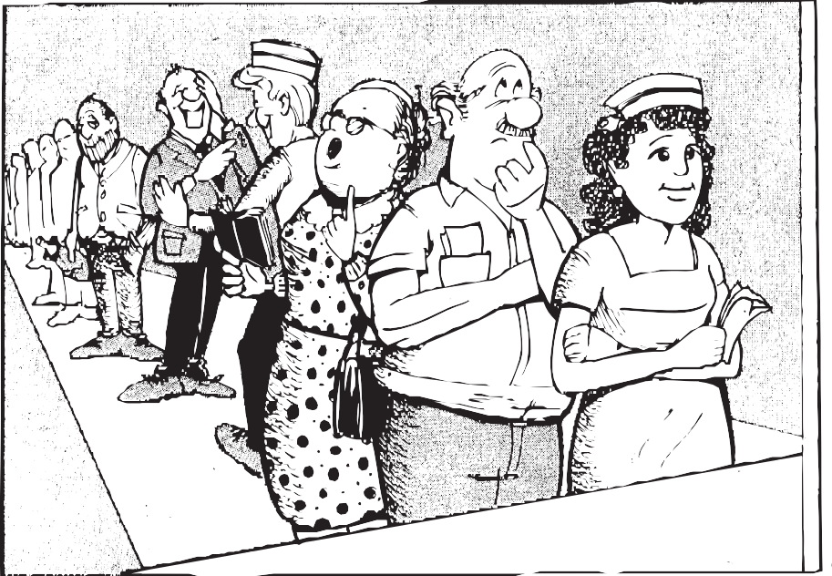

We’re lined up again here on Millionaires’ Row: Rebecca the nurse and a dealer named Joe; Louanne from the bank’s at the front of the line, and Doc’s at the back with his bottle of wine.

Aunt Sarah reads scriptural verses out loud

as Tom from McDonald’s tells jokes to the crowd. We gather each week here on Millionaires’ Row, undaunted by rainstorms, indifferent to snow.

What draws us to Millionaires’ Row once a week, the pompous, the hungry, the proud and the meek?

Each Thursday, like clockwork, we get into line and argue the merits of “13” and “9.”

Aunt Sarah says “18” has cosmical powers; Rebecca will celebrate “19” for hours.

Louanne thinks it’s stupid to pick “33,”

while Doe will take anything: “Pick 6 for me.”

What brings us together to Millionaires’ Row? A chance in a million, of course. Now you know.

*(J.D. Evans, a pseudonym, is a New Jersey writer who thinks Doc has the right idea ... occasionally.)*