# Hogging heat keeps kifly quite comfy

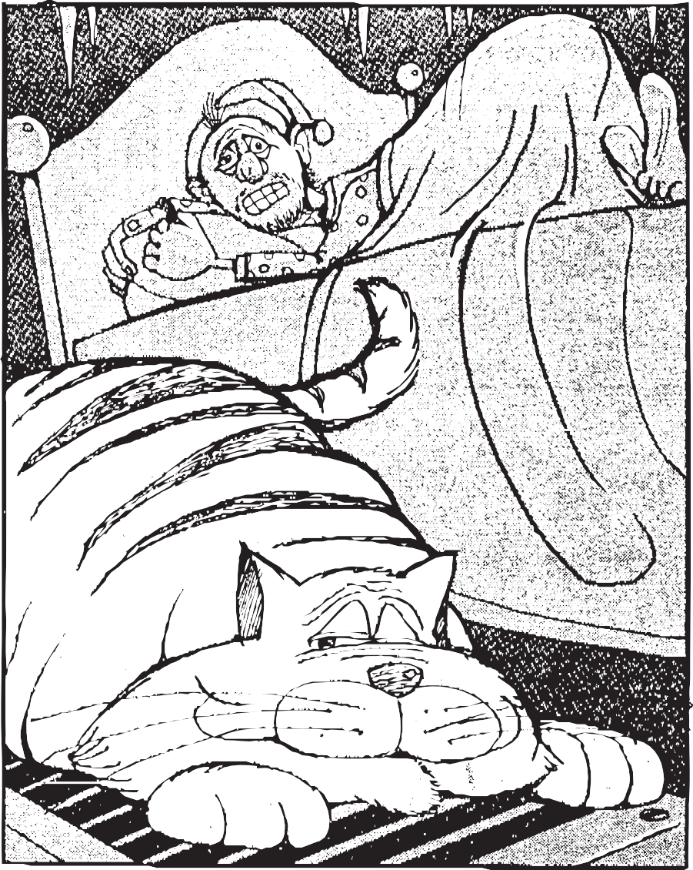

The cat’s on the heat vent. That means winter’s here. (He doesn’t go near it

the rest of the year.)

He heads for the heat vent as temperatures fall,

The furnace kicks on and he answers its call. He plops himself down just as smug as can be and hogs the hot air

that was meant to warm me! He’ll sit there all night.

If I shout, he’ll just stare. My bedroom’s an icebox? The cat doesn’t care.

The Cat of Gibraltar.

He sits like a rock

while my teeth ch-chatter and my knees kn-knock. All night he’ll stay warm and I’ll hear the beast purr as I shiver and wonder:

‘How come HE has fur?!”

*(J.D. Evans, a pseudonym, is a New Jersey writer who moves the Cat of Gibraltar into his teenage son’s bedroom ... occasionally.)*

# Yuletide chores leave Dad decked by boughs of holly

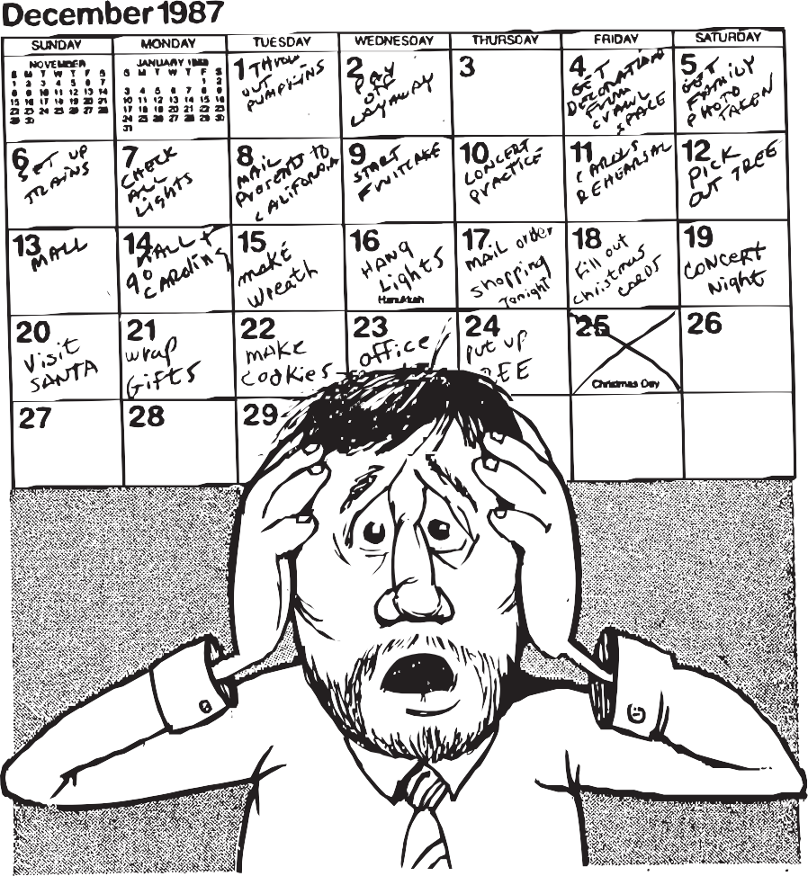

Each year, December somehow seems a trifle short of days and nights.

Today is Make The Front Door Wreath. Tomorrow’s set for Hang The Lights.

Next Friday’s Christmas Caroling. Tonight’s Mail Order Shopping Spree. This Sunday’s Fill Out Christmas Cards. Next Saturday is Pick The Tree.

There’s Christmas Concert Night at school and Visit Santa at The Mall.

So many things we HAVE to do. So little time to do them all!

There’s Office Party, Cookie Night. There’s Wrap And Hide Kids’ Gifts Away.

An endless list of things to do before it’s even Christmas Day.

It’s hard to keep one’s spirits up and keep the Scrooge within at bay

when Christmas starts to seem much more like work than like a holiday.

It’s Christmas, though. And, in the end, it’s worth the time we sacrifice. (Thank Claus it comes but once a year. I’m not sure I could handle twice!)

*(J.D. Evans, a pseudonym, is a New Jersey writer who makes it to December 25th without saying ‘Humbug!’ even once ... occasionally.)*