# Hours of showers make one feel the cold shoulder

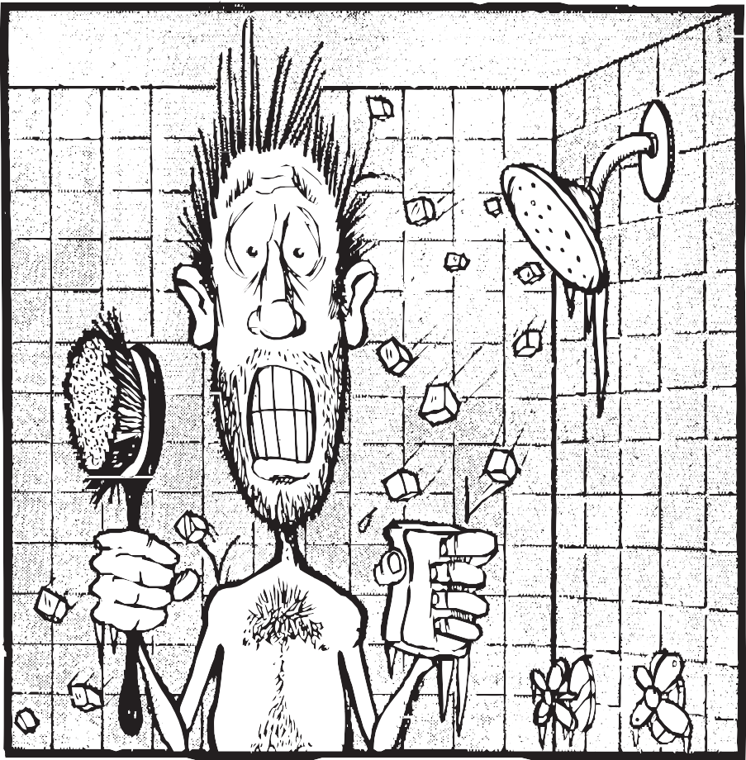

I ought to be proud of my sons, I suppose.

They take out the trash and hang up their clothes. They both get good grades (straight A’s and some B’s)

and know when they ought to say “thank you” or “please.”

I have one complaint, though:

their marathon showers. They turn on the water and stand there for hours! Sure,THEY leave the house just as clean as can be,

but by my turn the shower has no hot for me!

*(J.D. Evans, a pseudonym, is a New Jersey writer who hops in and out of the shower VERY quickly ... occasionally.)*

# Master answers domestic crifler’s call all the time

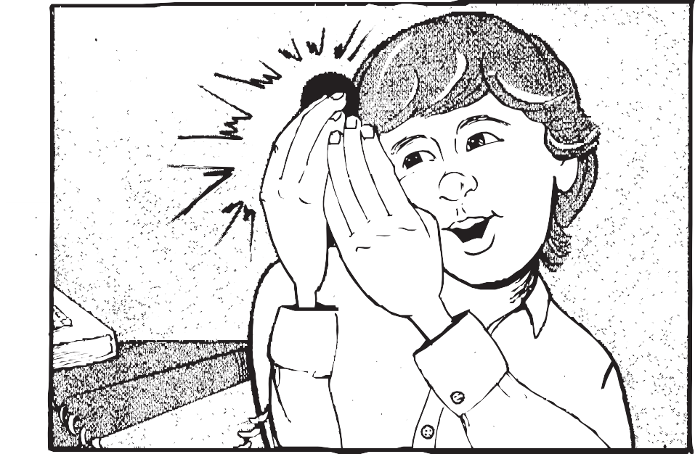

My son has a pet that his friends all adore.

It waits on its perch till he walks in the door

then it flies to his side where it sticks just like glue. He talks to it often. (It answers him, too.)

He’s taught it a trick: It can make a bell ring.

He whispers and giggles and hugs the darned thing. He’ll hold it for hours, and just say: “Hello.”

(He’ll bring it to dinner if we don’t say no.) It stays near his ear while he watches TV.

He asks its opinion: “Are you sure?” “Who? Me?” You won’t see this creature locked up at a zoo. (But if you have teenagers, you have one, too.)

My son says his pet makes him feel less alone. Companion and playmate, my son’s pet: the phone.

*(J.D. Evans, a pseudonym, is a New Jersey writer who thinks the inventor of call waiting deserves a Nobel Prize ... occasionally.)*

# Resolved to pay,

**he’s giving up credit ... again**

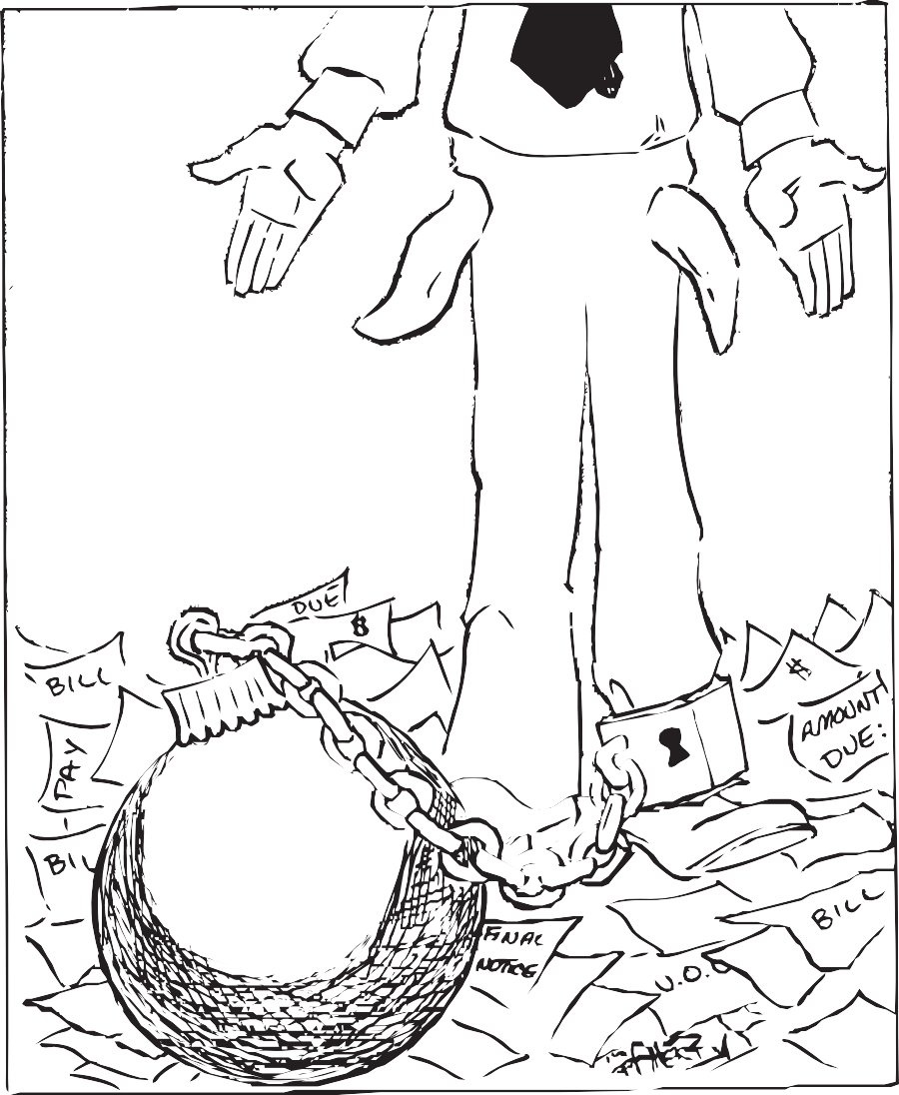

‘Twas the week after Christmas, and all our new debts

were causing me nightmares and giving me sweats.

The bills were arriving in droves and in flocks, each shipment of mail

bringing more budget shocks.

Each new U.O. US.

made me tremble and swoon, and cry in despair:

“We’ll be paying till June!”

The red ink kept rising. My spirits, they sank.

(I caught myself eyeing the kids’ piggy bank.)

I whined to my wife.

“What happened?” I roared. “What made us buy presents we couldn’t afford?!

Next Christmas, let’s promise to stay out of debt

and not charge a thing. Only CASH! Don’t forget!

No charge cards. All right?” Said my wife: “Of course, dear.

Don’t I say it’s all right

when we promise each year?”

*(J.D. Evans, a pseudonym, is a New Jersey writer who wishes credit cards were a little less convenient ... occasionally.)*

# Missing the list of rich evokes tender feelings

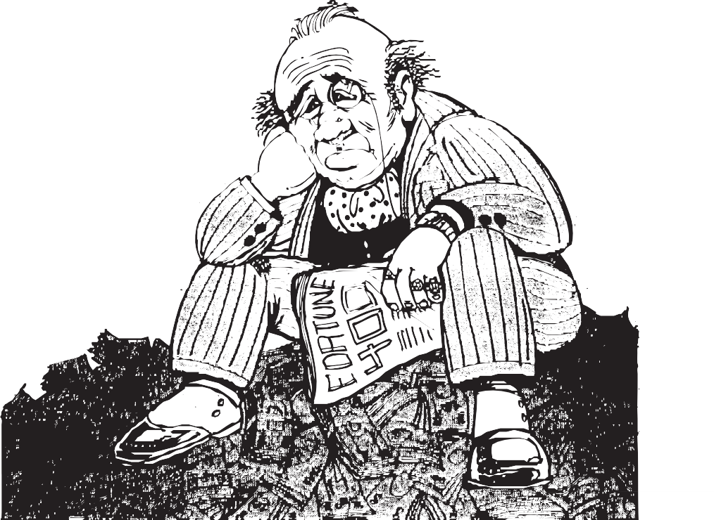

## News item: It now requires a fortune of $225 million to be included on Forbes magazine’s list of the 400 richest Americans, $45 million more than it did a year ago.

Poor millionaire four hundred one came up a million short.

The super-rich who made The List ignore him. (“Not our sort.”)

Unfit to dine with billionaires; not-one of The Elect;

a Rodney Dangerfield of wealth, he “don’t get no respect.”

Poor millionaire four hundred one. A “mere” one million shy.

Unlisted, hence unknown, again. Have pity on the guy.

His name is not a household word. His entrance prompts no fuss.

Poor millionaire four hundred one. He might as well be ... us!

*(J.D. Evans, a pseudonym, is a New Jersey writer who just misses making the 400 list ... occasionally.)*

# An ILLegal gang launches assault on the senses

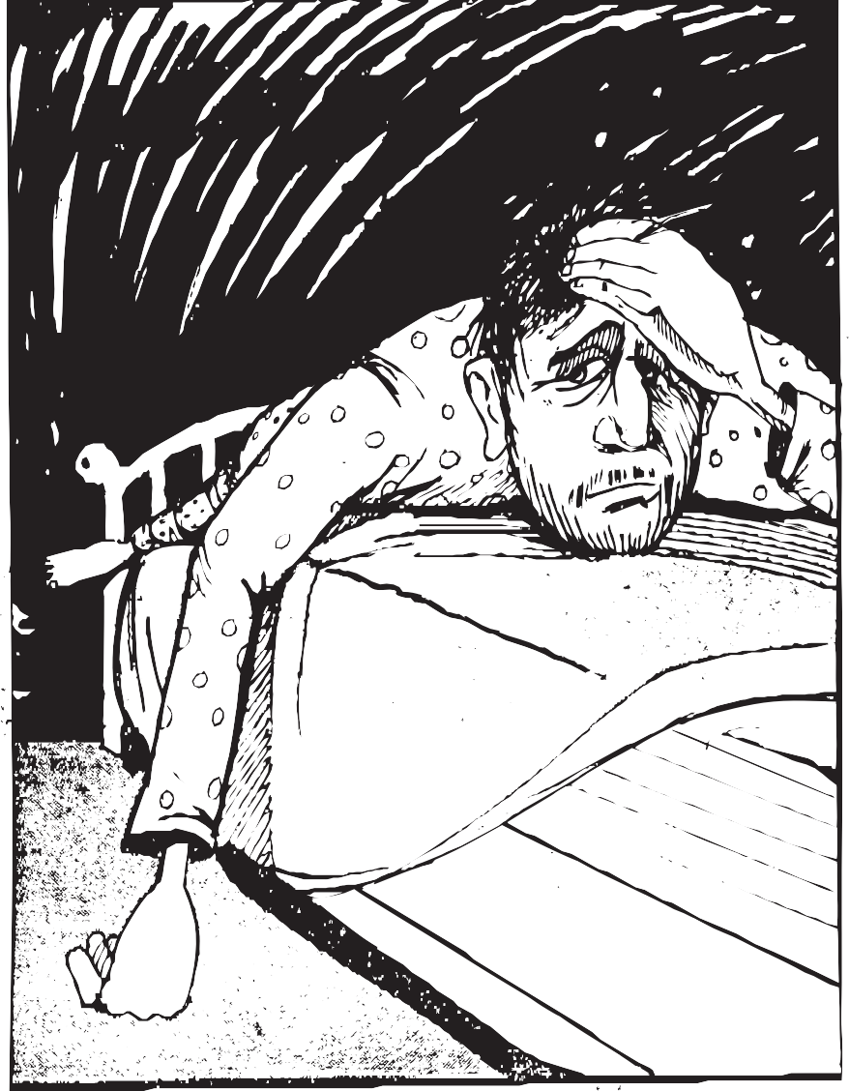

I sensed The Gang’s presence before it got light.

They’d camped in my bedroom and waited all night.

I stirred, and they pounced! All their tiny fists flew!

Though I tried to fight back, it was hopeless, I knew.

One went for my nostrils; a second, my eyes;

a third started punching my knees and my thighs.

My windpipe got hammered:

I gasped for my breath. Each second that passed edged me closer to death. My ears started ringing The room seemed to spin. The gang leader chortled “Give up! You can’t win!” My vision grew blurry.

My heartbeat grew weak. I fought to stay conscious, and struggled to speak:

“OK! Stop! I’ve had It! Call off your sick crew! I quit. I surrender.

You’ve won again, Flu!”

*(J.D. Evans is a New Jersey writer who goes down swinging ... occasionally.)*

## In which the poet comforts an NFL fan who is dying (slowly).

Why grieveth thus? Why dost despair? No football? Tush.Why spend a care? What virtue’s served by backs and ends

Who’d pummel those who could be friends?

What higher truths are e’er approached by men whose smallest steps are coached?

What glory flows to those who cheer or losing teams year after year?

Why rail at calls with angry shouts when instant replay murders doubts? The “game” was joyless all in all:

sad struggles for a misshaped ball.

Arise! Turn off thy TV set

and mourn for neither Ram nor Jet. No Eagles soar to seal thy fate.

No Giant strides toward thee ... but wait! What cometh on? A football game?

They’re “scabs”? Who cares! It’s all the same! Away foul gloom! Grief disappear!

Thou get the chips, I’ll get the beer!

*(J.D. Evans, a pseudonym, is a New Jersey writer who has misplaced whole Sundays ... occasionally.)*

# A feline’s "xity has whole family quite domesticated

My wife, our two children and I have agreed: one pet is the most we will keep.

A home’s not a zoo or an ark, after all, and caring for pets isn’t cheap.

The trips to the vets, the shots and the pills, the pet food, flea collars and lotions

add up in a hurry (like raindrops that fall and turn into rivers and oceans).

“One pet for four people’s enough,” we agreed. One pet.We would keep it at that.

We’d own just one pet at a time, we concurred. Alas, what that’s meant is:The Cat.

The Cat once was frisky. He’s not any more. (He sleeps l4 hours a day.)

All night, he’s outside chasing rabbits and mice. All day, he’s too tired to play.

The Cat’s not much fun. As a pet, he’s a flop. He won’t chase a stick or a ball.

He won’t let us pet him (he’ll scratch if we try), and never appears when we call.

210

He whines till we feed him. He claws at the couch till somebody opens the door.

We’re servants, not masters.We dance to his tune. The Cat’s an impossible bore.

He’s shown no intention of running away. He’s healthy and fit as a horse.

He’ll be here forever! Our family’s ONE pet. (As long as we feed him, of course.)

Our children will leave us. Get married. Have kids. The Cat will not notice or care.

Our grandchildren’s children will come to our door and find that The Cat is still there!

One son wants a ferret that’s playful and sleek ... My wife wants a dog she can walk ...

Our other son dreams of a parrot named Bill, and teaching the bird how to talk ...

We all have our notions of what would be fun. We all have our “ideal” pet.

But the one-creature rule’s in effect, so for now The Cat is the best we will get.

*(J.D. Evans, a pseudonym, is a New Jersey writer who thinks The Cat would make a great doorstop ... occasionally.)*